1. Smart Contracts

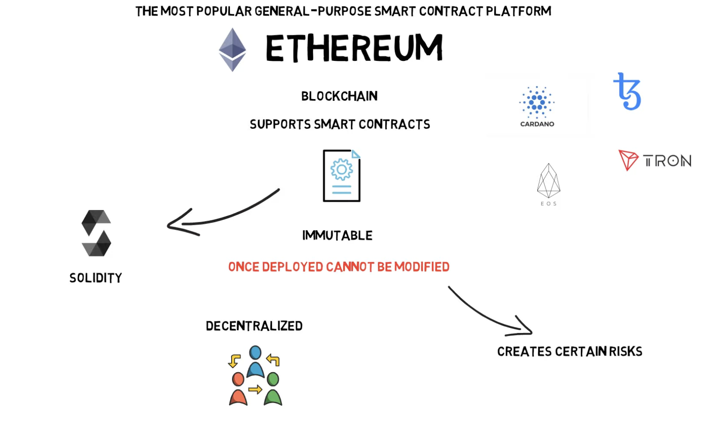

Decentralised Finance

1. Money - Stable Coins
   1. Non-Algorithmic - USD Tether (USDT), USD Coin (USDC), PAX Gold (PAXG)
   2. Algorithmic (Smart Contract Managed) - DAI (Maker DAO)

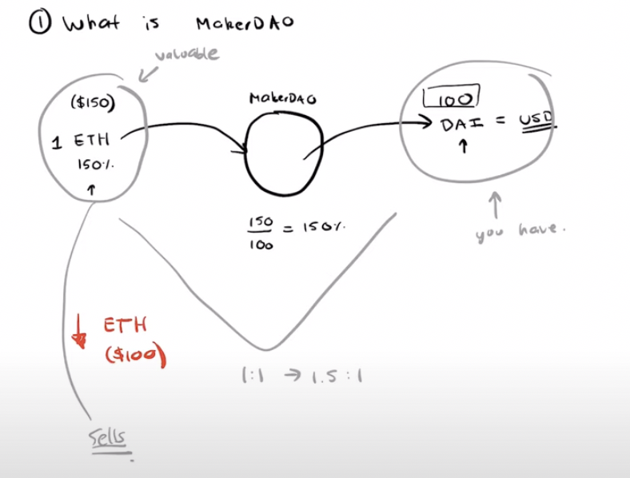

Black Thursday

2. Lending & Borrowing

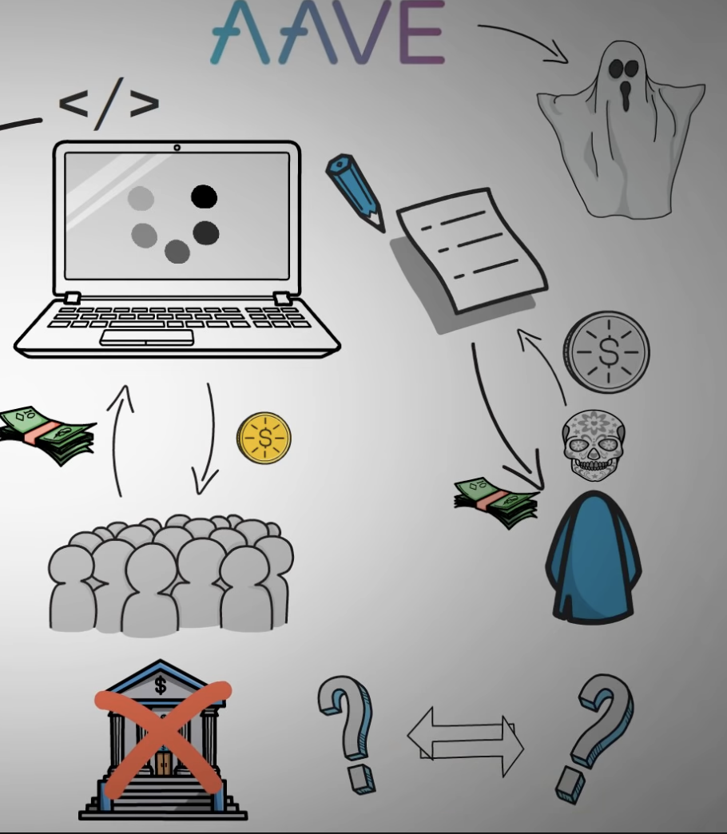

3. Decentralised Exchanges (Dexes) -

Centralised Crypto Exchanges - Coinbas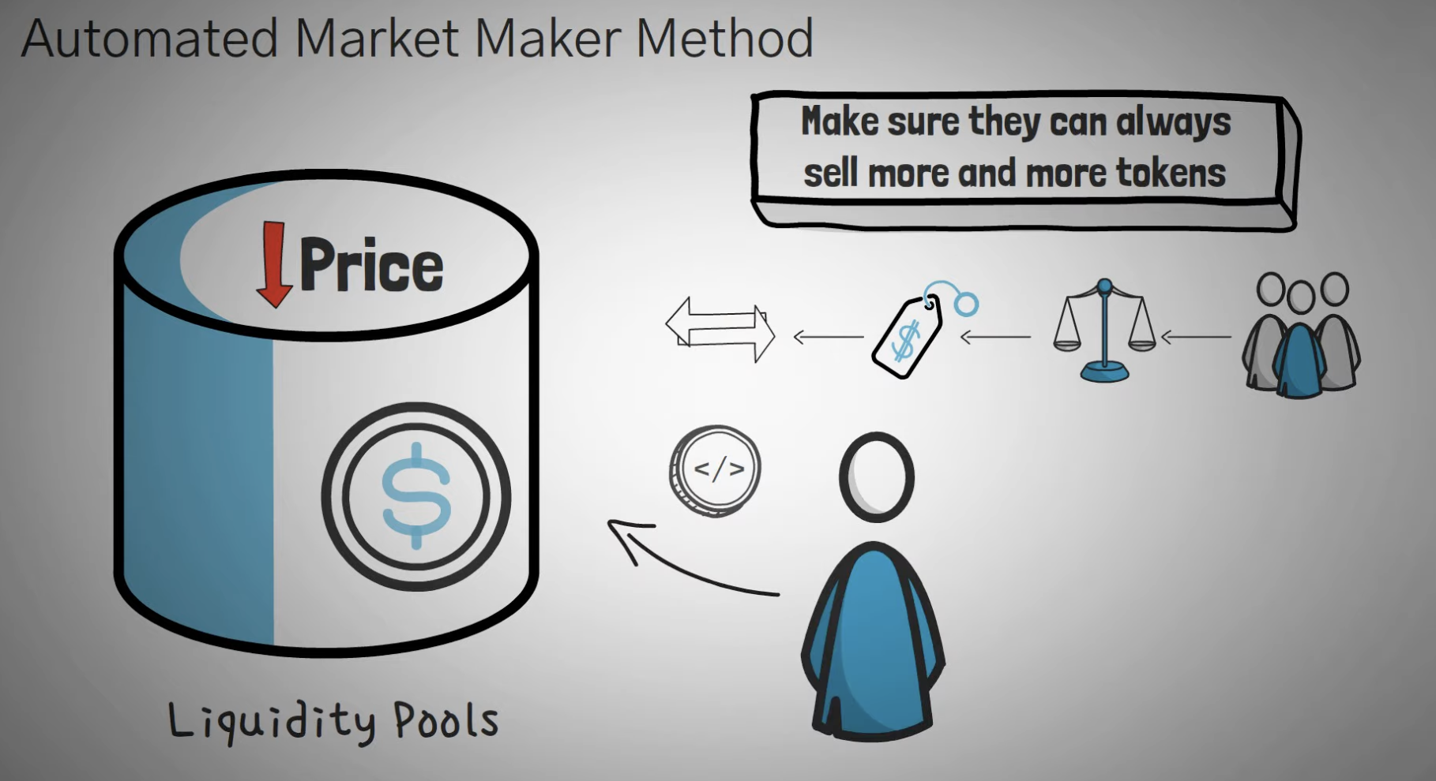e, Binance - Order Books

Completely Decentralised - UniSwap, SushiSwap, PancakeSwap - Liquidity Pools

Insurance

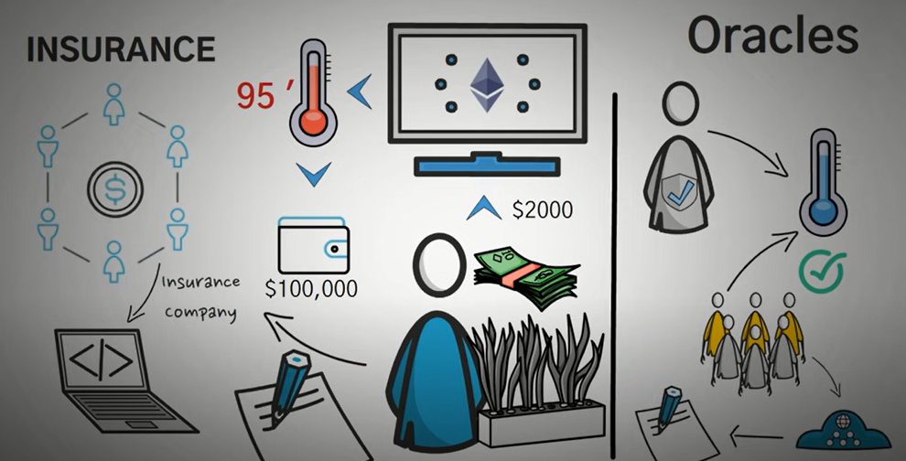

Risks

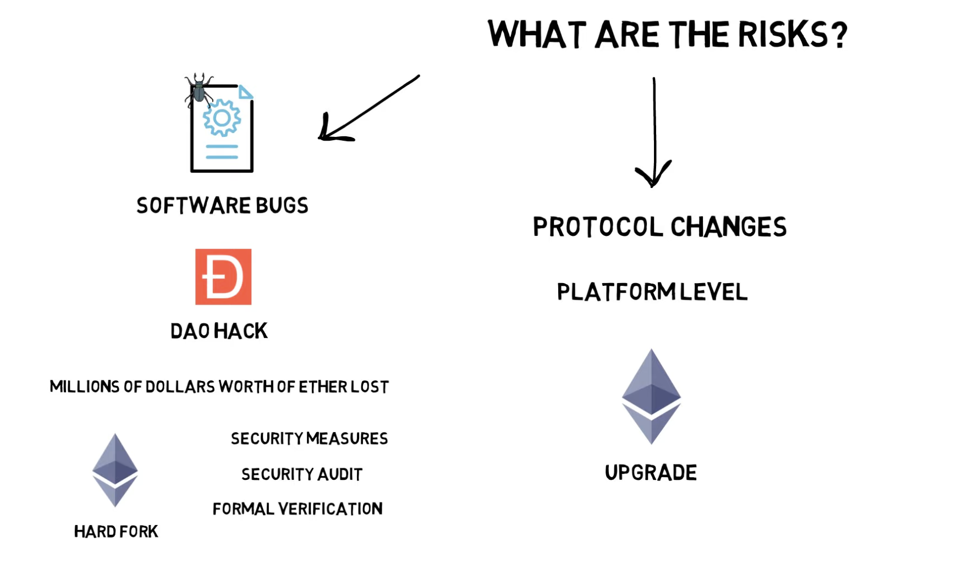

And also Real World Circumstances

DAAPS -

Tokens -

**Platform tokens**

Platforms tokens are created to support a decentralized application on the blockchain.

**Security tokens**

Security tokens are minted to represent ownership of another asset.

**Transactional tokens**

Transactional tokens are used as a fast and easy way to transfer money.

**Utility tokens**

Utility tokens are tokens that have a value tied to their ownership.

**Governance tokens**

Governance tokens allow token holders to vote on certain things.