**Sanatbek Matlatipov**

September 14, 2021

**Report: act_report**

**Introduction.**

**WeRateDogs is** the famous Twitter account that rates people’s dogs with humorous comment about their dogs. Basically, WeRateDogs account is for posting photos of dogs where it will be rated on a sacle of 1 to 10. However, invariably given ratings in excess of the maximum such as 13/10, 11/10, 15/10. The twitter account has over 9 million followers internationally.

I am going to use WeRateDogs datasets for my data visualization. To do that, I’ve firstly wrangled three unclean datasets provided by Udacity and saved the desired file as `twitter_archive_master.csv`.

**Visualizations produced from wrangle-act process.**

In the first visualization, I’ve analyzed Percentage of dogs stage distribution where dog_stage column has following unique types of dogs: ['pupper', 'floofer', 'doggo', 'puppo', 'doggo,pupper'] . The result is shown in the below:

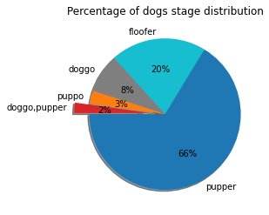

It is obvious from the pie chart that, the most common types of dogs are “*pupper”* which is 66% of all other types. Then, it followed by *“floofer”, “doggo”, “puppo” and “doggo,pupper” types.*

In the second visualization, I’ve analyzed the **“The most common names of dogs”**

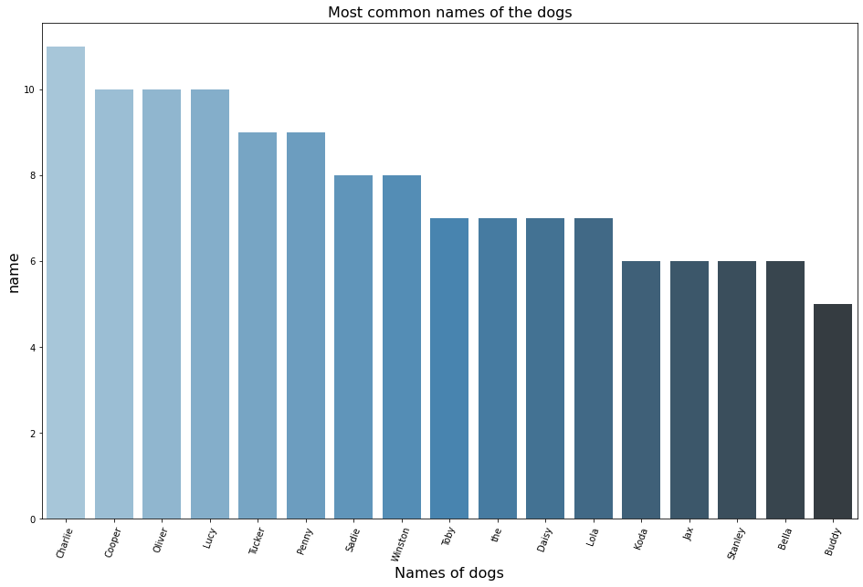

It is obvious from bar chart that, the most common Charlie, Cooper, Oliver and Lucy names are appeared around 10 times followed by Tucker, Penny, Sadie and Winston.

In the third visualization, I’ve tried to analyze the correlation between variables (especially, *fovourites_count* vs *retweet_count).* However, tweet-json.txt provided by the course has same user inner JSON values for all tweets.

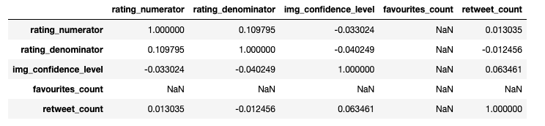

**Conclusion.**

To sump up, `pupper` is most common breed of dogs and the most common name is `Charlie`.