*Project Report On*

**GESTURE RECOGNITION USING MYOARM BAND**

*Submitted by*

**Samarth M (15IT236)**

**Sanjeev U Rao (15IT240)**

**Sanath Kumar (15IT237)**

**VI SEM B.Tech (IT)**

*Under the guidance of*

**Prof G. Ram Mohana Reddy**

**Dept of IT, NITK Surathkal** *in partial fulfillment for the award of the degree of*

**Bachelor of Technology**

In

**Information Technology**

At



**Department of Information Technology**

**National Institute of Technology Karnataka, Surathkal**.

***March 2018***

`

**Department of Information Technology**

**National Institute of Technology Karnataka, Surathkal**

**Mid Semester Evaluation (March 2018)**

*Course code :* IT 399

*Course Title:* Minor Project

*Title of the Project: Gesture Recognition using Myo Armband*

*Details of Project Group*

|  |  |  |  |
| --- | --- | --- | --- |
| *Name of the Student* | | *Register No.* | *Signature with Date* |
| 1. | Samarth M | 15IT236 |  |
| 2. | Rohit Kumar Gautam | 15IT239 |  |
| 3. | Sanath Kumar | 15IT237 |  |



**Name of Project Guide:**

Signature of the Project Guide: Prof G Ram Mohana Reddy

Place: NITK Surathkal

Date: 12/03/2018

# Acknowledgement

We would like to thank our guide Prof. G Ram Mohan Reddy for guiding us throughout the project. We would like to offer our gratitude for having given us an opportunity to learn and understand concepts related to Human Computer Interaction. Last but not the least we are grateful to the Information Technology Department, National Institute of Technology Karnataka, Surathkal for providing us all the facilities and resources required to successfully complete the report.

# Abstract

Hand gesture recognition consists of identifying the class and the instant of occurrence of a given movement of the hand. The solutions to this problem have many applications in science and technology. Here, we propose a model for hand gesture recognition in real time. This model takes as input the surface electromyography (EMG) measured on the muscles of the forearm by the Myo armband. For any user, the software can learn to recognize any gesture of the hand through a training process. The K-nearest neighbor algorithm is used for classifying the EMGs seen through a window. We tested the proposed model at recognizing the 5 gestures defined by the proprietary recognition system of the Myo armband, achieving an accuracy of 89.5%.

**Table of Contents**

1. Introduction 6

2.Requirement Analysis 7

2.1 Functional Requirements 7

2.2 Non Functional Requirements 7

2.3 Use Case Scenarios 7

3.System Design 9

4.Work Done 14

4.1 Development Environment 14

4.2 Individual Contributions 14

4.3 Results 14

5. Future Work 15

# 

# 

**List of Figures**

## 

1. Use Case Diagram 5

2. Welcome Page 6

3. Home Page 7

4. Demo Page 8

5. Add Gesture Page 9

6. Gesture EMG Values and functions 10

7. Servo Motor 11

# 

# 

# 1. Introduction

**Gesture recognition** is a topic in computer science and language technology with the goal of interpreting human gestures via mathematical algorithms. Gestures can originate from any bodily motion or state but commonly originate from the face or hand. Current focuses in the field include emotion recognition from face and hand gesture recognition. Users can use simple gestures to control or interact with devices without physically touching them. Many approaches have been made using cameras and computer vision algorithms to interpret sign language. However, the identification and recognition of posture, gait, proxemics, and human behaviours is also the subject of gesture recognition techniques.Gesture recognition can be seen as a way for computers to begin to understand human body language, thus building a richer bridge between machines and humans than primitive text user interfaces or even GUIs (graphical user interfaces), which still limit the majority of input to keyboard and mouse. Gesture recognition enables humans to communicate with the machine (HMI) and interact naturally without any mechanical devices. Using the concept of gesture recognition, it is possible to point a finger at the computer screen so that the cursor will move accordingly. This could make conventional input devices such as mouse, keyboards and even touch-screens redundant.

**Myo Armband**

The Myo armband is a commercial sensor that contains 8dry and bipolar surface EMG pods. This sensor measures the electrical activity of the muscles of the forearm, close to the elbow, at 200 Hz with 8 bits. For a user it is very easy to adjust the diameter of the Myo to fit well his forearm. The length of the Myo circumference is expandable between 19 and 34 cm. Additional to the 8 EMG pods, the Myo also provides haptic feedback through vibrations and contains an IMU that measures acceleration, angular velocity, and orientation in the x, y and z, axes. In this work, we use only the data from the EMG pods. The data from all these sensors is transmitted to the computer via Bluetooth. The weight of the Myo is approximately 93 g. The Myo armband also contains a proprietary recognition system, which is capable of identifying in real time 5 gestures of the hand: wave in, wave out, fist, pinch and open.

In this module, we try to build our own gesture recognition software. The readings from the device is noted and using machine learning techniques, the application predicts the gesture made by the user. The K nearest neighbour algorithm is used to predict the gesture. The gestures are predicted in real time.

# 

# 2.Requirement Analysis

## **2.1 Functional Requirements**

1. Take readings from the Myo device.
2. Plot graph of the readings taken.
3. Predict the gesture based on the users’ actions.
4. Add a new gesture for the algorithm to learn.

## **2.2 Non Functional Requirements**

1. Take readings and visualise them in real time.
2. Make predictions with a high accuracy.

## **2.3 Use Case Scenarios**

1. User :
   1. Make a gesture
   2. Add new gesture
2. Device
   1. Take readings
3. System
   1. Predict gesture
   2. Plot graph from the readings in real time

**Use Case Diagram**

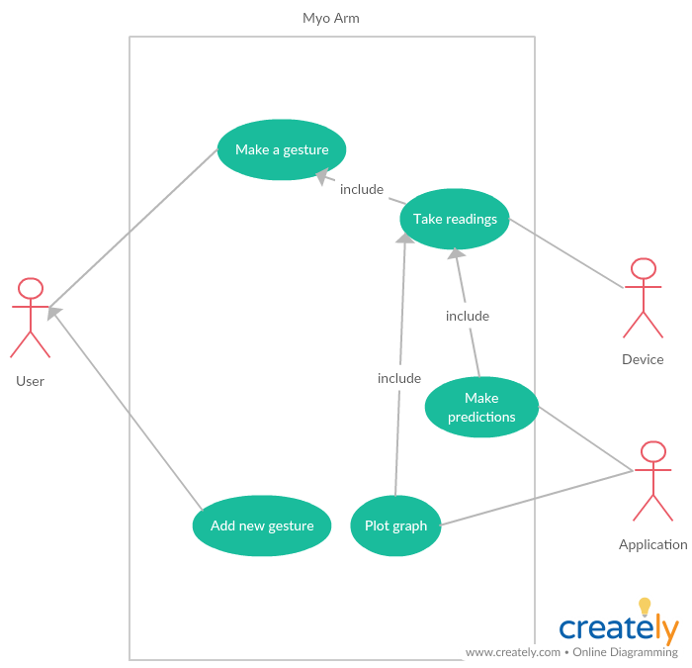

Figure 1: Use Case Diagram

# 

# 3.System Design

**3.1 The User Interface**

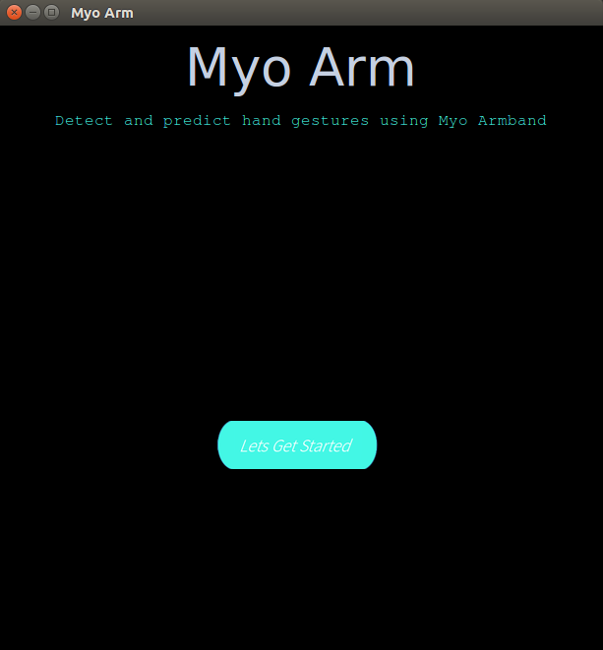

Figure 2: Welcome Page

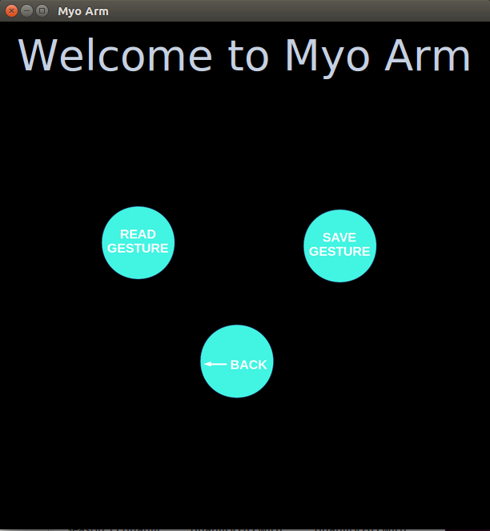

Figure 3: Home Page

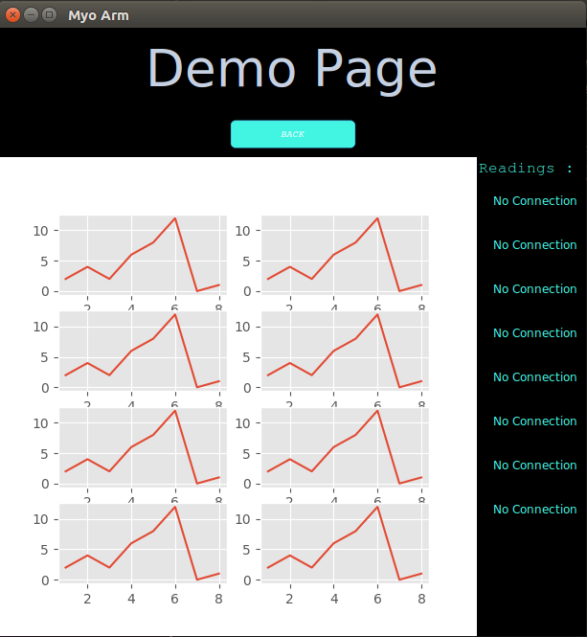

Figure 4: Demo Page



Figure 5: Add Gesture Page

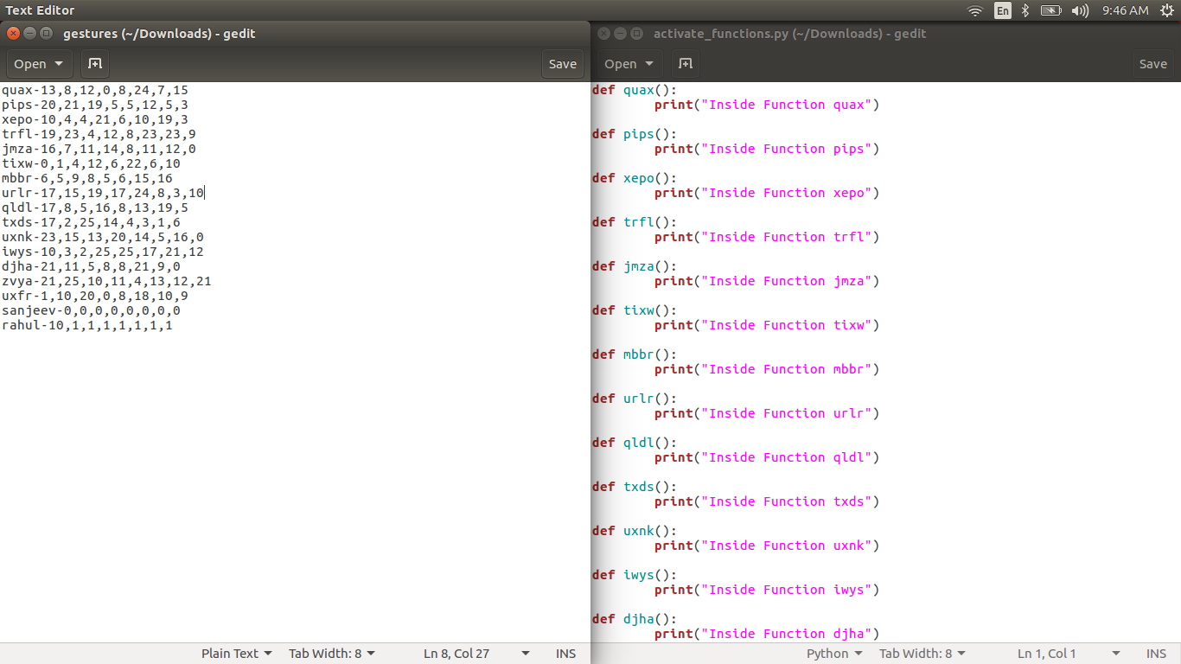

Figure 6: Gesture EMG Values and functions

**3.2 The Servo Motor**

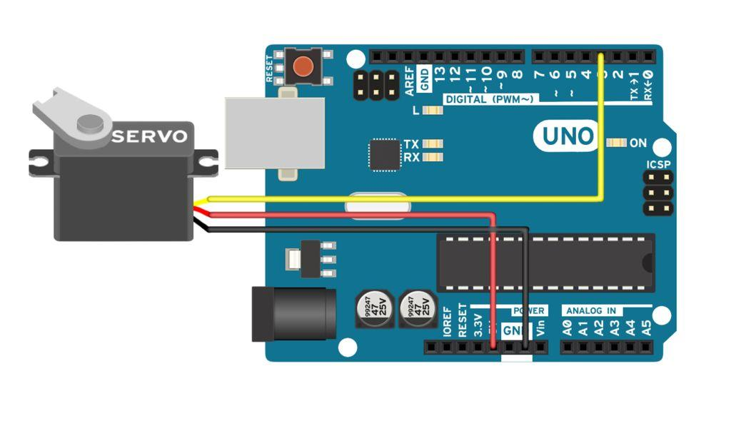  
 Figure 7: Servo Motor

# 4.Work Done

## **4.1 Development Environment**

1. Software Requirements
   1. Operating System: Windows , Ubuntu
   2. Python
   3. Myo Sdk for windows/linux
2. Hardware Requirements
   1. Core i5 processor
   2. Myo Armband and connectors
   3. 4GB Ram

## **4.2 Individual Contributions**

1. Sanjeev U Rao:

Made GUI using tkinter library for python. The UI consists of three pages Homepage, Demo page, and Add gesture page. The user can make a gesture whose readings are taken by the device and displayed in the application. A graph of the values is plot in real time using the matplotlib library in python.

The user can add a new gesture to the list of gestures the device can recognize.

2. Samarth M:

Helped improve the GUI. Set up the backend automation. Wrote code in python to control the Arduino. Coded the nearest neighbours algorithm. Will be taking care of the hardware aspects.

3. Sanath Kumar:

Coded the K nearest neighbours algorithm. By taking the readings from myo arm KNN will help to recognise the gesture made by user.

Based on gesture identified prosthetic arm will do specific required action.

## 

## 

## **4.3 Results**

1. Connect Myo device to PC using the provided SDK.
2. Take readings from the device and store it.
3. Plot graph of the obtained readings.
4. Use python’s matplotlib library
5. Use **K Nearest Neighbour** algorithm to predict what gesture was made.
6. Add a custom gesture for the device to recognize.

# 5. Future Work

* Integrate different components into one working software.
* Create a robotic arm.
* Program servo motors to control individual fingers in the robotic arm.
* Try to optimize the code in order to reduce the time delay.

**References**

1. <https://en.wikipedia.org/wiki/Gesture_recognition>
2. [https://www.technavio.com › Blog](https://www.technavio.com)
3. [www.arcsoft.com/technology/gesture.html](http://www.arcsoft.com/technology/gesture.html)
4. <https://developer.thalmic.com>
5. <https://developer.thalmic.com/docs/api_reference/platform/the-sdk.html>
6. <https://elbruno.com/.../myo-myosharp-a-c-sdk-implementation-for-the-myo-armband/>