AI Assisted Coding
Assignment – 9.5
Name : K.Sanath Kumar
Ht.no : 2303A51698

Batch : 24
Problem 1: String Utilities Function Consider the following Python function:
def reverse_string(text):
return text[::-1] Task:
- Write documentation in:
  - (a) Docstring
  - (b) Inline comments
  - (c) Google-style documentation
- Compare the three documentation styles.
- Recommend the most suitable style for a utility-based string library.
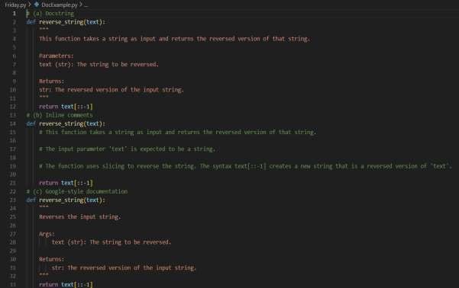

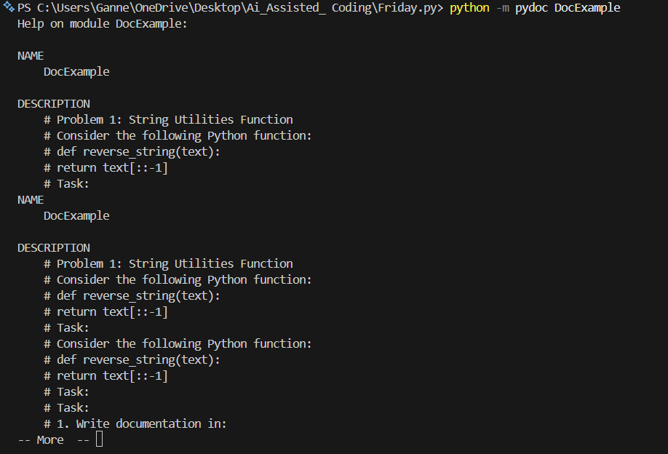

Problem 2: Password Strength Checker
Consider the function:
def check_strength(password):
return len(password) >= 8 Task:
- Document the function using docstring, inline comments, and Google style.
- Compare documentation styles for security-related code.
- Recommend the most appropriate style.

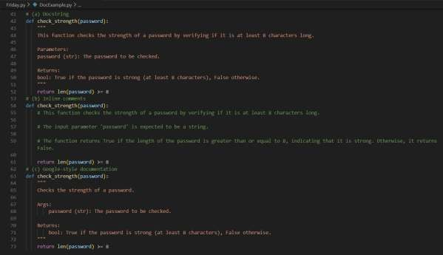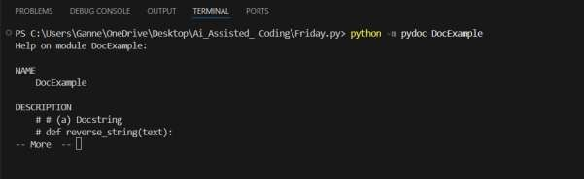

Problem 3: Math Utilities Module
Task:
- Create a module math_utils.py with functions:
o square(n)
o cube(n)
o factorial(n)
- Generate docstrings automatically using AI tools.
- Export documentation as an HTML file.

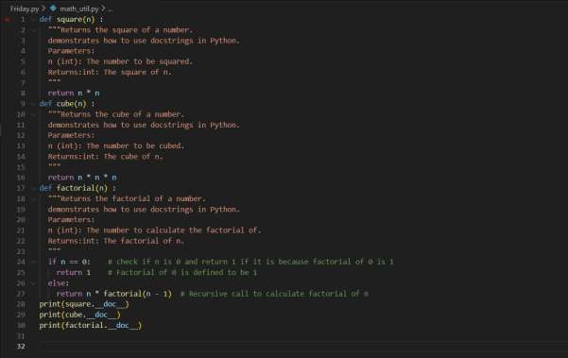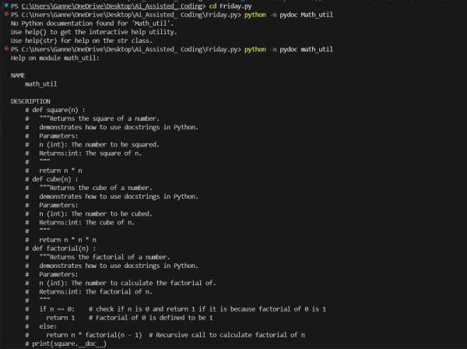

Problem 4: Attendance Management Module
Task:
- Create a module attendance.py with functions:
o mark_present(student)
o mark_absent(student)
o get_attendance(student)
- Add proper docstrings.
- Generate and view documentation in terminal and browse
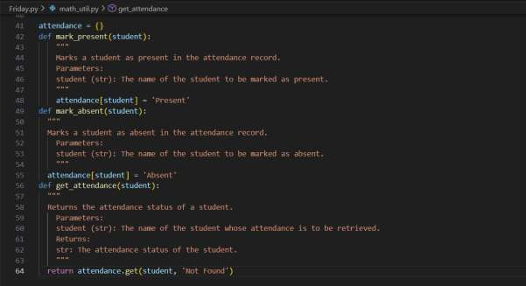

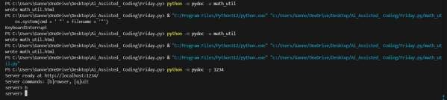

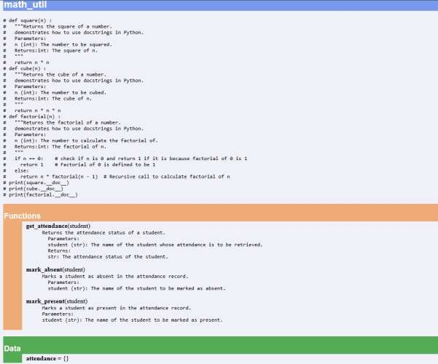

Problem 5: File Handling Function
Consider the function:
def read_file(filename):
with open(filename, 'r') as f:
return f.read() Task:
- Write documentation using all three formats.
- Identify which style best explains exception handling.
- Justify your recommendation.

