Ai Assisted Coding
Assignment-8 Name : K.Sanath Ht.no : 2303A51698
Batch: 24

Task Description #1 (Username Validator – Apply AI in Authentication Context)
- Task: Use AI to generate at least 3 assert test cases for a function is_valid_username(username) and then implement the function using Test-Driven Development principles.
- Requirements:
- Username length must be between 5 and 15 characters.
- Must contain only alphabets and digits.
- Must not start with a digit.
- No spaces allowed. Example Assert Test Cases:
assert is_valid_username("User123") == True assert is_valid_username("12User") == False assert is_valid_username("Us er") == False Expected Output #1:
- Username validation logic successfully passing all AI-generated test cases.

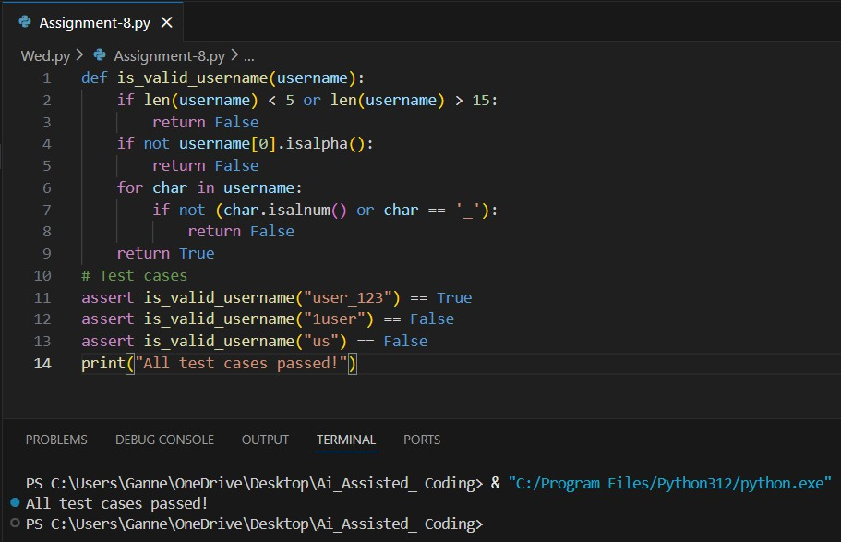

Task Description #2 (Even–Odd & Type Classification – Apply AI for Robust Input Handling)
- Task: Use AI to generate at least 3 assert test cases for a function classify_value(x) and implement it using conditional logic and loops.
- Requirements:
- If input is an integer, classify as "Even" or "Odd".
- If input is 0, return "Zero".
- If input is non-numeric, return "Invalid Input". Example Assert Test Cases:
assert classify_value(8) == "Even" assert classify_value(7) == "Odd"
assert classify_value("abc") == "Invalid Input" Expected Output #2:
- Function correctly classifying values and passing all test cases.

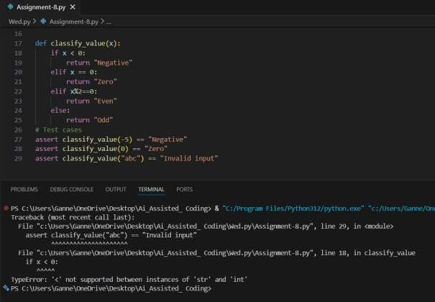

Task Description #3 (Palindrome Checker – Apply AI for String Normalization)
- Task: Use AI to generate at least 3 assert test cases for a function is_palindrome(text) and implement the function.
- Requirements:
- Ignore case, spaces, and punctuation.
- Handle edge cases such as empty strings and single characters. Example Assert Test Cases:
assert is_palindrome("Madam") == True
assert is_palindrome("A man a plan a canal Panama") ==True assert is_palindrome("Python") == False

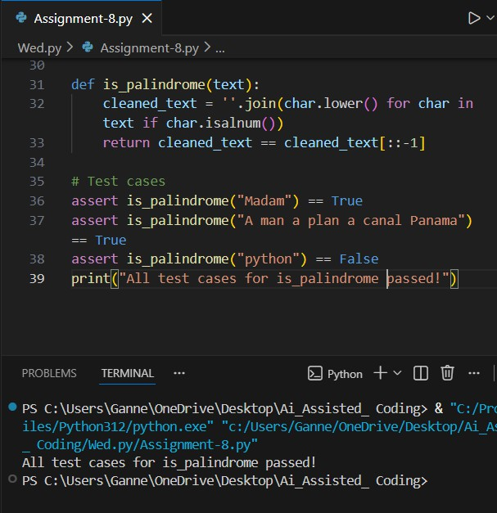

Task Description #4 (Email ID Validation – Apply AI for Data Validation)
- Task: Use AI to generate at least 3 assert test cases for a function validate_email(email) and implement the function.
- Requirements:
- Must contain @ and .
- Must not start or end with special characters.
- Should handle invalid formats gracefully. Example Assert Test Cases:
assert validate_email("user@example.com") == True assert validate_email("userexample.com") == False assert validate_email("@gmail.com") == False

Expected Output #5:
- Email validation function passing all AI-generated test cases and handling edge cases correctly.
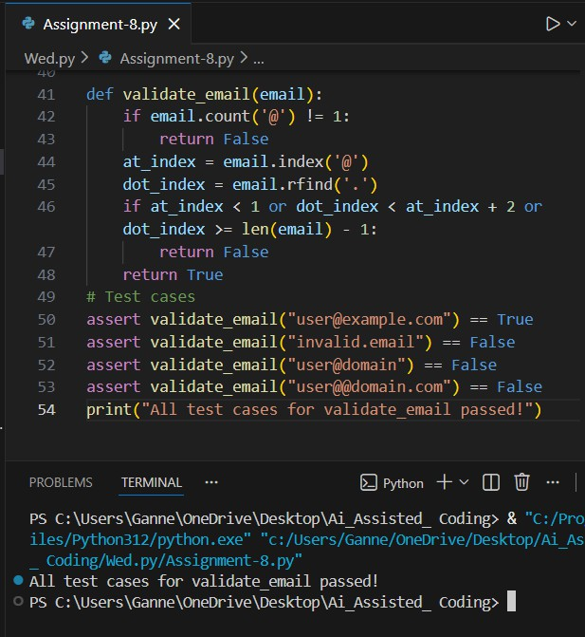

Task 5 (Perfect Number Checker – Test Case Design)
- Function: Check if a number is a perfect number (sum of divisors = number).
- Test Cases to Design:
- Normal case: 6 → True, 10 → False.
- Edge case: 1.
- Negative number case.
- Larger case: 28.
- Requirement: Validate correctness with assertions.

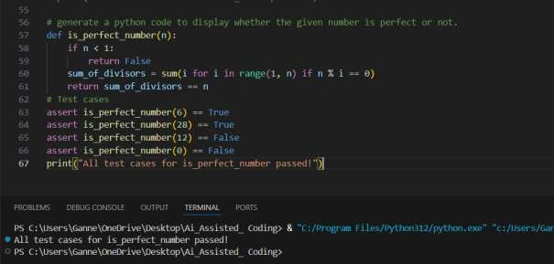

Task 6 (Abundant Number Checker – Test Case Design)
- Function: Check if a number is abundant (sum of divisors >number).
- Test Cases to Design:
- Normal case: 12 → True, 15 → False.
- Edge case: 1.
- Negative number case.Large case: 945. Requirement: Validate correctness with unittest
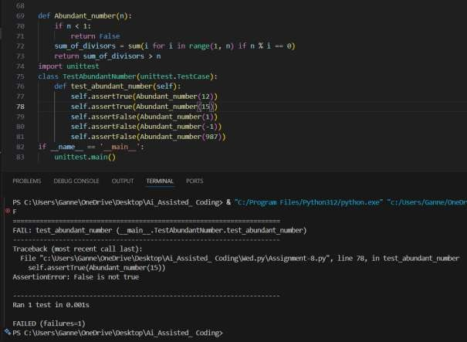

Task 7 (Deficient Number Checker – Test Case Design)
- Function: Check if a number is deficient (sum of divisors <number).
- Test Cases to Design:
- Normal case: 8 → True, 12 → False.
- Edge case: 1.
- Negative number case.
- Large case: 546.
Requirement: Validate correctness with pytest
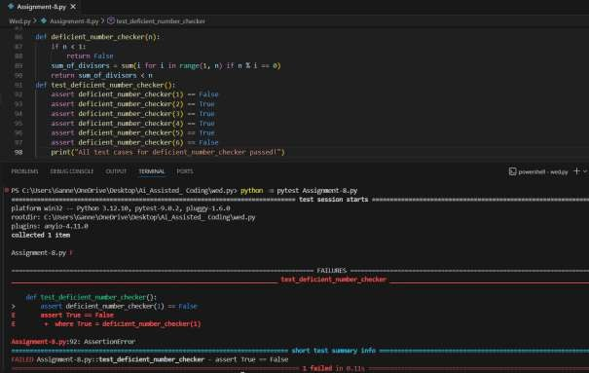

Task 8 :
Write a function LeapYearChecker and validate its implementation using 10 pytest test cases

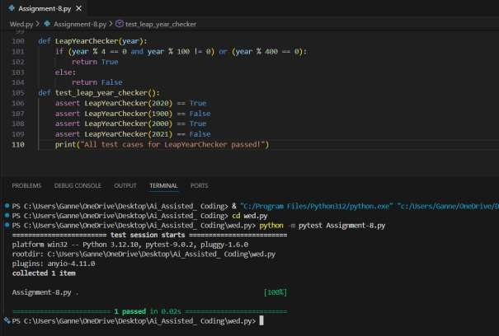

Task 9 :
Write a function SumOfDigits and validate its implementation using 7 pytest test cases.
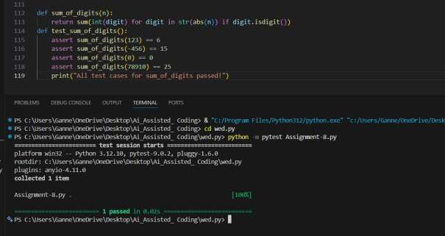

Task 10 :
Write a function SortNumbers (implement bubble sort) and validate its implementation using 25 pytest test cases
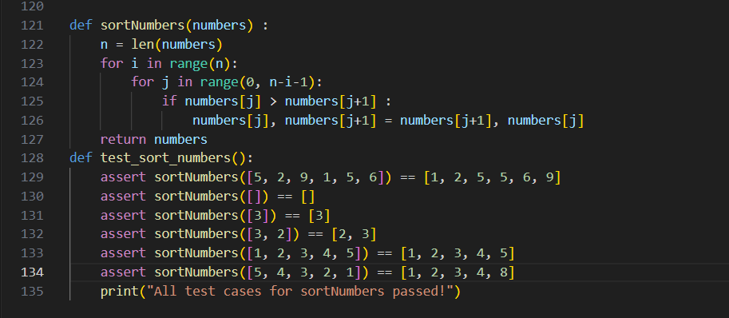
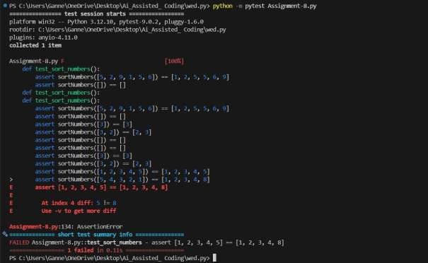
.

Task 11 :
Write a function ReverseString and validate its implementation using 5 unittest test cases
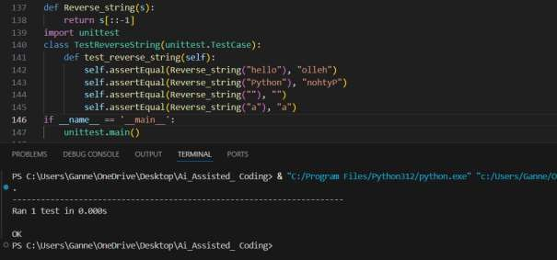

Task 12 :
Write a function AnagramChecker and validate its implementation using 10 unittest test cases.

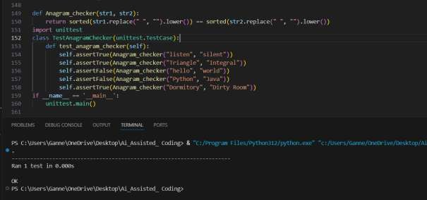

Task 13 :
Write a function ArmstrongChecker and validate its implementation using 8 unittest test cases.
