**4. Try it Out - Branch and Merge Conflicts with**

[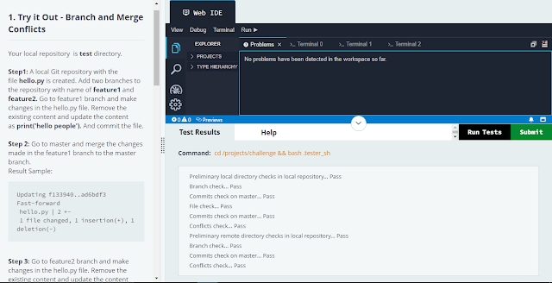](https://1.bp.blogspot.com/-z-QgNOySIY8/YaXdpINsYEI/AAAAAAAAIjw/lmXCkd8F8NUvMXG6cdX0oWLAeALCDuHowCLcBGAsYHQ/s1285/Try%2Bit%2Bout%2B-%2BBranch%2Band%2BMerge%2BConflicts.PNG)

cd test

git init

git checkout -b feature1

git checkout -b feature2

git checkout feature1

vi hello.py

(Press i then make print('Hello people') then esc and type :wq)

git add hello.py

git commit -m 'changed from feature1'

git checkout master

git merge feature1

git checkout feature2

vi hello.py

(print('keep playing'))

git add hello.py

git commit -m 'changed from feature2'

git checkout master

git merge feature2

vi hello.py

(print('keep playing'))

git add hello.py

git commit -m 'resolved conflicts'

git branch -d feature1

git branch -d feature2

cd ../quotes/

vi Quotes.txt

(My life is my message.Mahatma Gandhi.)

git add Quotes.txt

git commit -m 'added gandhi quote'

git pull origin master --allow-unrelated-histories

git checkout --ours Quotes.txt

git add Quotes.txt

git commit -m 'resolved conflicts'

git push origin master

vi Quotes.txt

(My life is my message. Mahatma Gandhi. Adding conflicts )

git add Quotes.txt

git commit -m 'final commit'

git push origin master

**5. Rebase Conflict**

[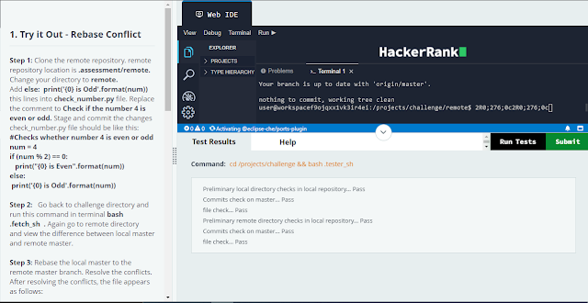](https://1.bp.blogspot.com/-lJNDtAcV8k0/YaXdwp5N48I/AAAAAAAAIj4/yzZFAm2uxp4nKl70yNDXRpjDqAqPtN8CwCLcBGAsYHQ/s1283/Rebase%2BConflict.PNG)

git clone .assessment/remote

cd remote

vi check_number.py

(Press i then

num = 2

if (num % 2) == 0:

print("{0} is Even".format(num))

else: print('{0} is Odd'.format(num))

Press esc then :wq)

git add check_number.py

git commit -m 'modified'

cd ..

bash .fetch_sh

cd remote

git diff master origin/master

(:wq)

git pull --rebase origin master

vi check_number.py

(

num = int(input("Enter a number: "))

if (num % 2) == 0:

print("{0} is Even".format(num))

else: print('{0} is Odd'.format(num))

)

git add check_number.py

git rebase --continue

git push origin master