UNIVERSITY OF BALOCHISTAN

QUETTA

DEPARTMENT OF COMPUTER SCIENCE AND INFORMATION TECHNOLOGY

<

**DATABASE SYSTEM**

DR. Abdul Basit Khan

Project:

**Hospital Management System**

SUBMITTED BY: (SANA ULLAH)

ROLL NUMBER: (68) MCS (1ST SEMESTER Morning)

**HOSPITAL MANAGMENT SYSTEM**

**CONTEXT TABLE**

Acknowledgment--------------------------------------------

Summary------------------------------------------------------

Introduction---------------------------------------------------

Scope of Work-----------------------------------------------

Entities--------------------------------------------------------

Relationship--------------------------------------------------

Entity Relationship Diagram------------------------------

Schema diagram--------------------------------------------

Relational data model--------------------------------------

SQL Queries--------------------------------------------------

Relational data model showing in PHP----------------

PHP SOURCE CODES-----------------------------------

Relational data Model showing in Browser-----------

Conclusion-----------------------------------------------------

**Acknowledgement**

I elaborate several thanks to Dr. Abdul Basit Khan, Who has been the supreme guide without, who i would find it impossible to design database project in a systematic pattern.

Hospital management system provides assistance to the doctors,patients,and the entire records of the relation of doctor with patiens,The patients in rooms, employees categories with their servings,Finally,these all works in hospital management system.

**Summary**

This report carries information to implement a hospital management system.

I used the Entity-Relationship Model to design a database are that will store and organization the hospital’s data. I have created database using MS Access, SQL Workbench and populated it with some simple data, the system can keep hospital management, doctor, treatment, patient, rooms and employees and relationship between them.

**Introduction**

Hospital management system relates to the life of people. The role of technology clears the entire difficulties faced by patients and other staff. It takes to the life matter which is related to hospital.

Hospital management system consists of takes such as registering patients, Attendance of various types of doctor records, patients in deferent rooms, actions of the employees and preparing a final report for hospital history.

**Scope of Work**

The purpose of any new technology is to make people’s life easier. This project is database used to manage the hospital and allows the administrate to register the daily required information of doctor, patients, rooms and hospital staff.

Hospital management system will organize work inside hospital and proposed system will do the following tasks:

* Insert Doctor’s information such as DoctorID, Name, Gender, department, Phone number etc.
* Insert Treatment’s information such as patientid, date, Time, madicine, doctorID etc.
* Insert Patients information such as name, Gender, phone number, address, Date of bith, BedID etc.
* Insert Rooms information such as bedID, Room_Type, Room_No, Room_Cost, employID.
* Insert Employees information such as EmployID, name, Address, Gender, date of birth, Salary, Position.

**Entities**

**Doctor:**

Doctor is an Entity there store all information about doctor, name, Department etc

**Treatment:**

Treatment is an entity there stores all information about treatment like Madicine, etc.

**Patients:**

Patient is an entity there stores all information about patient like name, Gender, Phone number, Address.etc

**Rooms:**

Room is a entity there all information store about room like Room_Type, Room_No etc

**Employees:**

Employ is an entity there all information store about employ like

Name, address position etc.

**Relationships**

**Doctor and Treatment**

Doctor and treatment each relationships are many to one .here doctor is primary key and treatment is foreign key

**Doctor dose Treatment**

**Patients and Treatment**

Patient and treatment each relationships is many to one .here patient is primary key and treatment is foreign key .

**Patient Takes Treatment**

**Patient and Rooms**

Patient and room each relationship is one too many .here rooms are primary key and patient is foreign key

**Patient**

**Room**

Assign

**Employs and Rooms**

Employs and rooms each relationship is one too many .here employ are primary key and room is foreign key

**Employs Arranged Rooms**

**Entity Relationship Diagram**

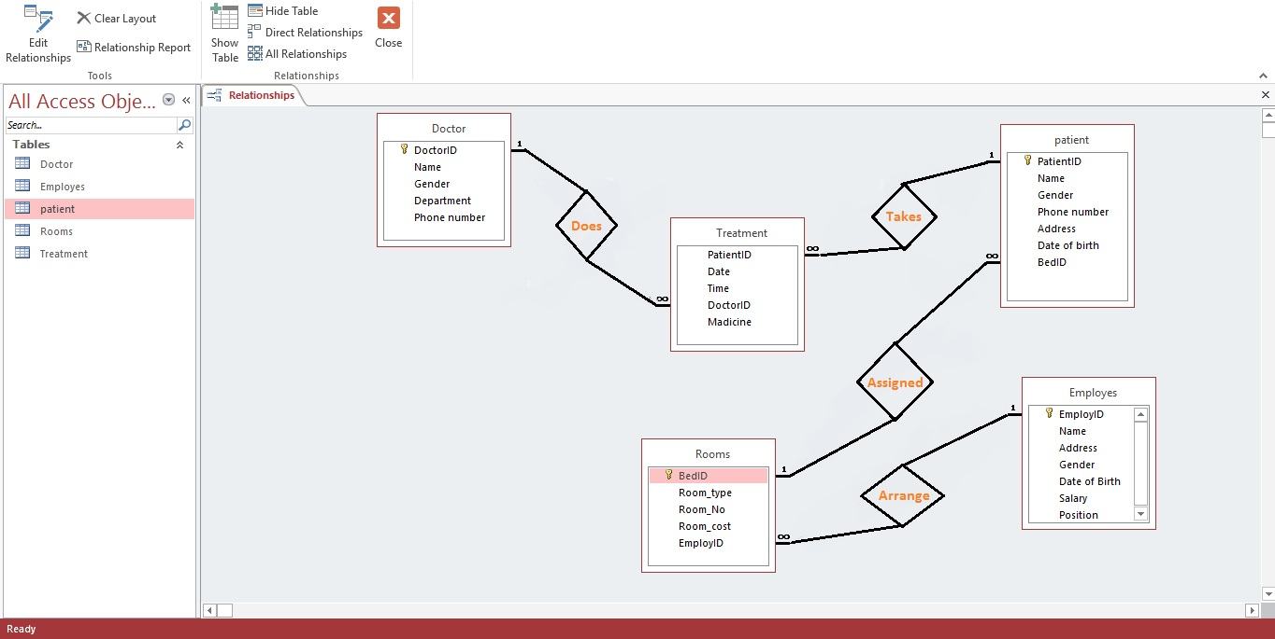

**Schema Diagram**

**Doctor (DocID, F_name, L_, Gender, Department)**

**Doc_phone (DocID, phone)**

**Treatment (PatID, Date, Medicine, DocID, PatientID)**

**Patient(patientID,F_name,L_name,House#,Street#,City,Age,BedID)**

**Room (BedID, Room_Type, Room_No, Room_Cost, EmpID)**

**Employee(EmpID,F_name,L_name,Hosue#,Street,City,Age,Gender,salary,position)**

**Relational Data Model**

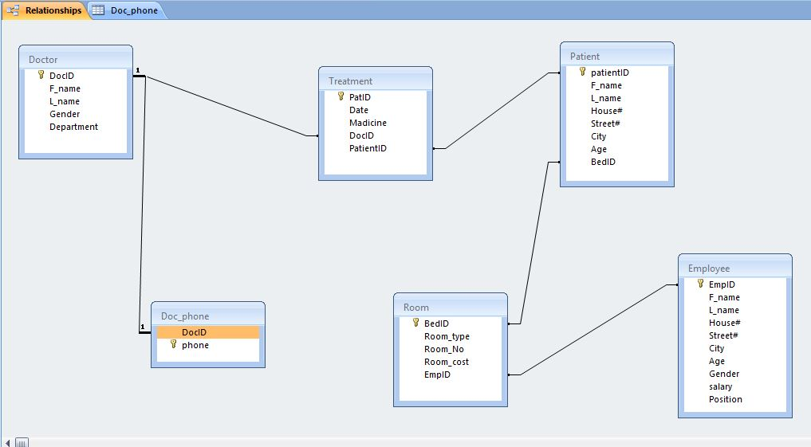

**SQL Queries**

create database hmsys;

usehmsys;

create table Doctor

(DocIDint (12) primary key not null,

First_Namevarchar (255) not null,

Last_Namevarchar (255) not null,

Gender varchar (7) not null,

Departnmentvarchar (255) not null

);

Insert into Doctor

Values (‘1’, ‘Abu’,’Bakar’,’Male’,’Cardio’);

Insert into Doctor

Values (‘2’, ‘Mili’,’Chakravardhi’,’Female’,’Physiotherapy’);

create table Doc_Phone

(DocIDint (12),

Phone int (13) primary key not null,

foreign key(DocID)references Doctor(DocID)

);

Insert into Doc_Phone

Values (‘1’,’03452233775’);

Insert into Doc_Phone

Values (‘2’,’03248836234’);

create table Treatment

(PatID int (12) primary key not null,

Treat_Date datetime not null,

Medicine varchar (400) not null,

DocID int (12) not null,

PatientID int (12) not null,

foreign key (DocID) references Doctor(DocID)

);

Insert into Treatment

Values (‘1’,’12-09-2011 12:26:23’,’Panadol’,’1’,’1’);

Insert into Treatment

Values (‘2’,’12-11-2014 14:46:31’,’Flagyl’,’2’,’2’);

create table Patient

(PatientIDint (12) primary key not null,

First_Name varchar (255) not null,

Last_Name varchar (255) not null,

HouseNo varchar (255),

StreetNo varchar (255),

City varchar (133),

Age varchar (133),

BedID int (12)

);

Insert into Patient

Values (‘1’,’Abdul’,’Haleem’,’122’,’G-12’,’Quetta’,’12 Years’,’2’);

Insert into Patient

Values (‘2’,’Sara’,’Raza’,’32’,’2’,’Quetta’,’23 Years’,’1’);

alter table Treatment

add foreign key (PatientID) references Patient(PatientID);

create table Room

(BedID int (12) primary key not null,

Room_Type varchar (35) not null,

Room_No varchar (123) not null,

Room_Cost int (23) not null,

EmpID int (12)

);

Insert into Room

Values (‘1’,’VIP’,’22’,’4500’,’2’);

Insert into Room

Values (‘2’,’Normal’,’13’,’1500’,’1’);

alter table Patient

add foreign key (BedID) references Room(BedID);

create table Employee

(EmpID int (12) primary key not null,

First_Name varchar (255) not null,

Last_Name varchar (255) not null,

HouseNo varchar (255) not null,

StreetNo varchar (255) not null,

City varchar (133) not null,

Age varchar (23) not null,

Gender varchar (12) not null,

Salary varchar (23) not null,

Position varchar (32) not null

);

Insert into Employee

Values (‘1’,’Ali’,’Gohar’,’G-28’,’F-13’,’Quetta’,’34 Years’,’Male’,’34090’,’Snr Nurse’);

Insert into Employee

Values (‘2’,’Ghulam’,’Fatima’,’2’,’1’,’Quetta’,’26 Years’,’Female’,’22400’,’Nurse’);

alter table Room

add foreign key (EmpID) references Employee(EmpID);

**Relational Data Model showing in PHP**

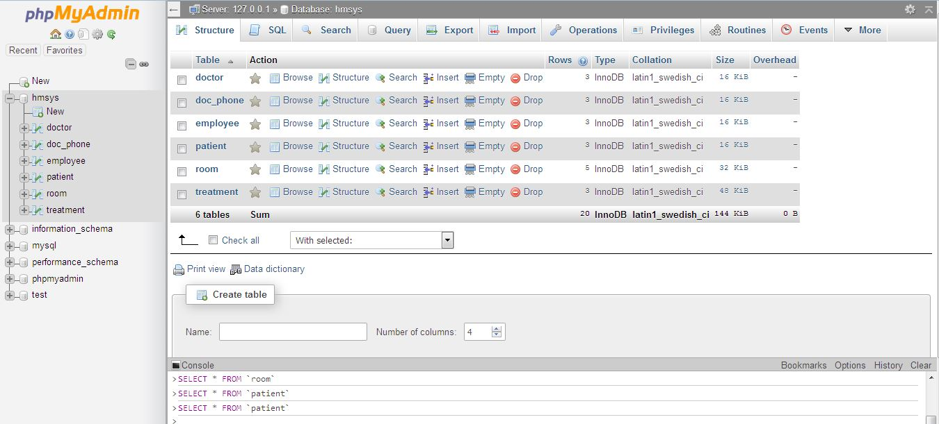

**PHP SOURCE CODES**

<html>

<title>

HOSPITAL MANAGEMENT SYSTEM

</title>

<body>

<?php

$username = "root";

$password = "";

$hostname = "localhost";

/* Connect to database server */

$dbhandle = mysql_connect($hostname, $username, $password)

or die("Unable to connect to MySQL");

echo "Connected to Hospital Management System<br>";

/* Connect to your database such as school, hospital, police etc */

$selected = mysql_select_db("hmsys",$dbhandle)

or die("Could not selected db2");

echo "Hospital Management System Tables<br>", "<br>";

/* Query to fetch records from your database */

$result = mysql_query("SELECT * from Doctor");

/* Display records in the web browser */

echo "<table border =1><tr><th>DocID</td><td>First_Name</td><td> Last_Name </td><td> Gender </td><td> Department</td></tr> ";

while($row = mysql_fetch_array($result)){

echo " <tr><td>".$row['DocID']."</td><td>".$row['First_Name']."</td><td>".$row['Last_Name']."</td><td>".$row['Gender']."</td><td>".$row['Department']."</td>";

}

echo "</table>";

$result = mysql_query("SELECT * from Doc_Phone");

/* Display records in the web browser */

echo "</br><table border =1><tr><th>DocID</td><td>Phone</td></tr> ";

while($row = mysql_fetch_array($result)){

echo " <tr><td>".$row['DocID']."</td><td>".$row['Phone']."</td>";

}

echo "</table>";

$result = mysql_query("SELECT * from Treatment");

/* Display records in the web browser */

echo "</br><table border =1><tr><th>patID</td><td>Date</td><td> Medicine </td><td> DocID </td><td> PatientID</td></tr> ";

while($row = mysql_fetch_array($result)){

echo " <tr><td>".$row['DocID']."</td><td>".$row['Date']."</td><td>".$row['Medicine']."</td><td>".$row['DocID']."</td><td>".$row['PatientID']."</td>";

}

echo "</table>";

$result = mysql_query("SELECT * from Patient");

/* Display records in the web browser */

echo "</br><table border =1><tr><th>PatientID</td><td>First_Name</td><td> Last_Name </td><td> Gender </td><td> House#</td><td>Street#</td><td>City</td><td>Age</td><td>BedID</td>";

while($row = mysql_fetch_array($result)){

echo " <tr><td>".$row['PatientID']."</td><td>".$row['First_Name']."</td><td>".$row['Last_Name']."</td><td>".$row['Gender']."</td><td>".$row['House#']."</td><td>".$row['Street#']."</td><td>".$row['Age']."</td><td>".$row['BedID']."</td><td>".$row['BedID']."</td>";

}

echo "</table>";

$result = mysql_query("SELECT * from Room");

/* Display records in the web browser */

echo "</br><table border =1><tr><th>BedID</td><td>Room_Type</td><td> Room_No </td><td> Room_Cost </td><td> EmpID</td></tr> ";

while($row = mysql_fetch_array($result)){

echo " <tr><td>".$row['BedID']."</td><td>".$row['Room_Type']."</td><td>".$row['Room_No']."</td><td>".$row['Room_Cost']."</td><td>".$row['EmpID']."</td>";

}

echo "</table>";

$result = mysql_query("SELECT * from Employee");

/* Display records in the web browser */

echo "</br><table border =1><tr><th>EmpID</td><td>First_Name</td><td> Last_Name </td><td>House#</td><td>Street#</td><td>City</td><td>Age</td><td>Gender</td><td>Salary</td><td>Position</td></tr> ";

while($row = mysql_fetch_array($result)){

echo " <tr><td>".$row['EmpID']."</td><td>".$row['First_Name']."</td><td>".$row['House#']."</td><td>".$row['Street#']."</td><td>".$row['City']."</td><td>".$row['Age']."</td><td>".$row['Gender']."</td><td>".$row['Salary']."</td><td>".$row['Position']."</td><td>".$row['Position']."</td>";

}

echo "</table>";

mysql_close ();

?>

</body>

</html>

**Relational Data Model showing in Browser**

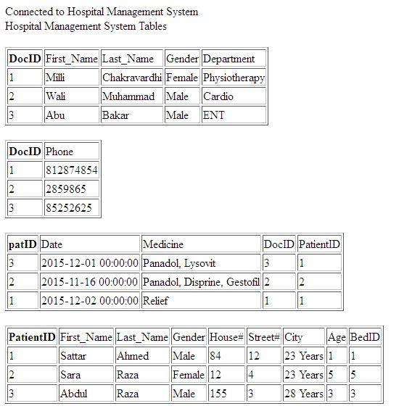

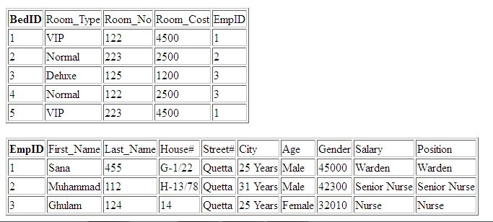

**Conclusion**

The project pinpointed to the hospital management system as there appears entire entity relationship with each other “Hospital management system to doctor and doctor to treatment, treatment to patients, patient to rooms, rooms to employees and courses to relationship with management .and also use PHP, PHP is my last project, there it show all data of hospital management system in browser.

**THANKS**