

**AROR UNIVERSITY ART, ARCHITECTURE, DESIGN AND SHERITAGE SUKKUR**

* **Department: AI**
* **Course Title: DSA**
* **Submitted By: Sanaullah Mahar**
* **Submitted To: Abdul Ghafoor**
* **Enrollment No: ARI-F23-0047**
* **Assignment Title: lab 10**

**TASK#01**

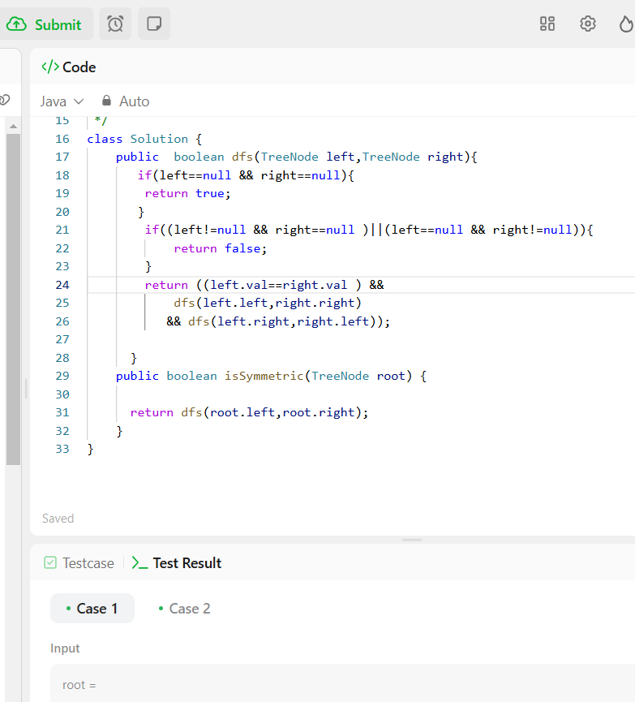

**TASK#02**

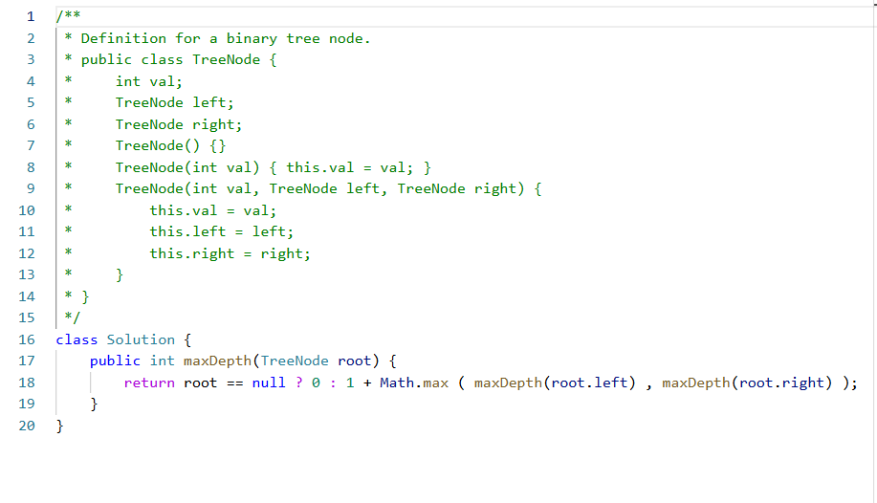

**TASK#03**

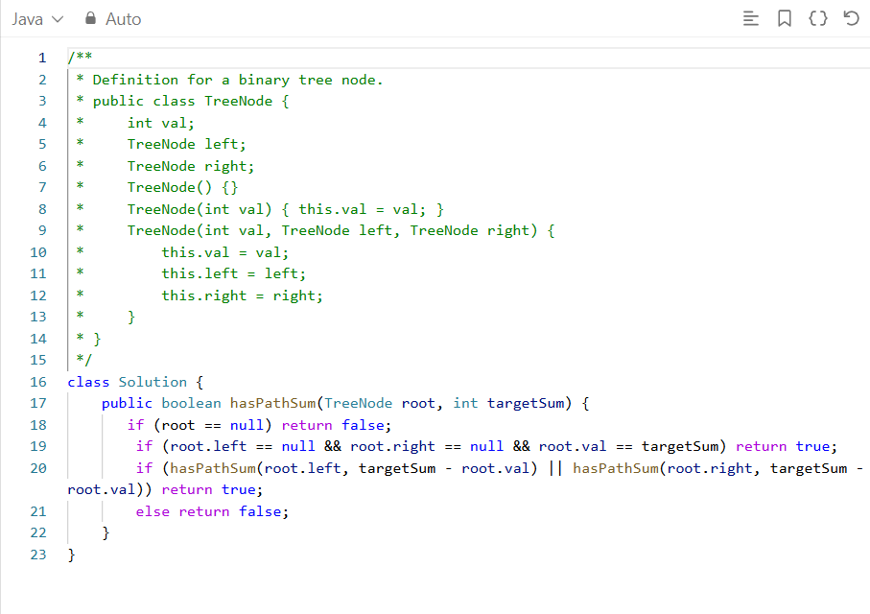

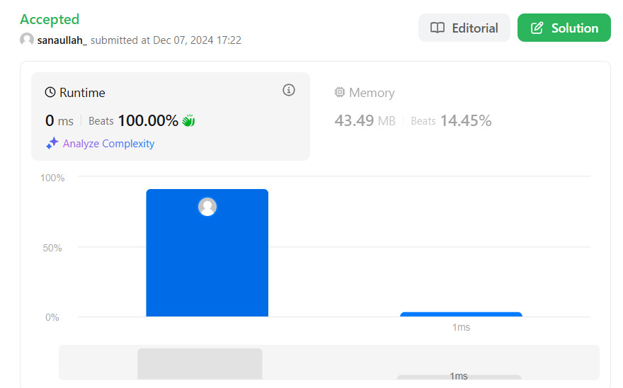

**TASK#04**

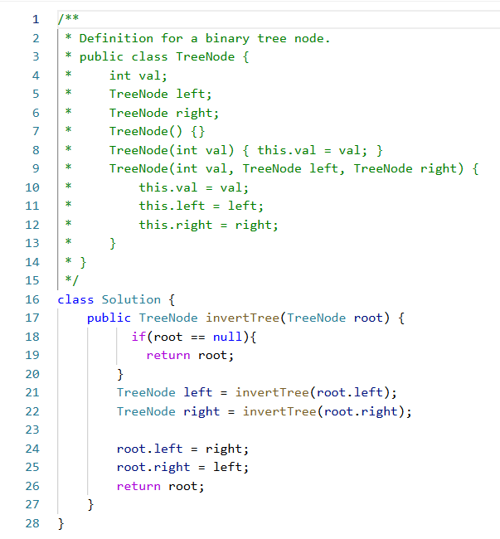

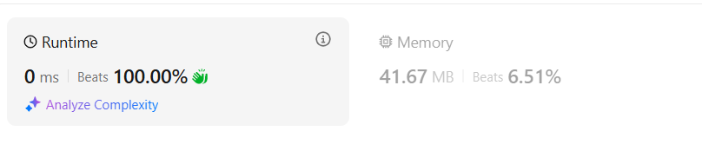

**TASK#05**

