Contents
1. Executive Summary 1
2. Module I: AMM Microstructure & Impermanent Loss 1
2.1 The Mathematics of Slippage 1
2.2 Quantifying Impermanent Loss (IL) 2
3. Module II: High-Frequency Statistical Arbitrage 3
3.1 Cointegration Analysis 3
3.2 Strategy Performance 4
4. Module III: Stochastic Risk Modeling (Monte Carlo) 4
4.1 Methodology 4
4.2 Risk Metrics 5
5. Module IV: Derivatives Pricing (DeFi Options) 6
5.1 Black-Scholes Valuation 6
5.2 The Greeks (Risk Sensitivities) 6
6. Conclusion 7

1. Executive Summary
This research project provides a rigorous quantitative assessment of the DeFi market structure. By synthesizing concepts from Automated Market Makers (AMMs), stochastic calculus, and statistical arbitrage, this study aims to quantify the unique risks and opportunities present in crypto-asset markets.
The analysis led to three critical conclusions:
- Liquidity Provision is effectively a short-convexity strategy; LPs suffer "Impermanent Loss" that mimics the payout profile of a short straddle.
- Statistical Arbitrage strategies must employ strict regime filters (ADF tests), as high correlation (0.98) does not guarantee cointegration in crypto markets.
- Protocol Solvency requires dynamic collateralization; Monte Carlo simulations indicate a 5.87% probability of insolvency events over a 30-day horizon, necessitating conservative Loan-to-Value (LTV) ratios.

2. Module I: AMM Microstructure & Impermanent Loss
Objective: To reverse-engineer the Uniswap V2 Constant Product algorithm $x ⋅y = k$ and quantify the cost of liquidity provision.

2.1 The Mathematics of Slippage
We modeled the "Bonding Curve" to determine the execution price impact of trade size relative to pool depth. The resulting heatmap (Figure 1) demonstrates the exponential relationship between order size and slippage.
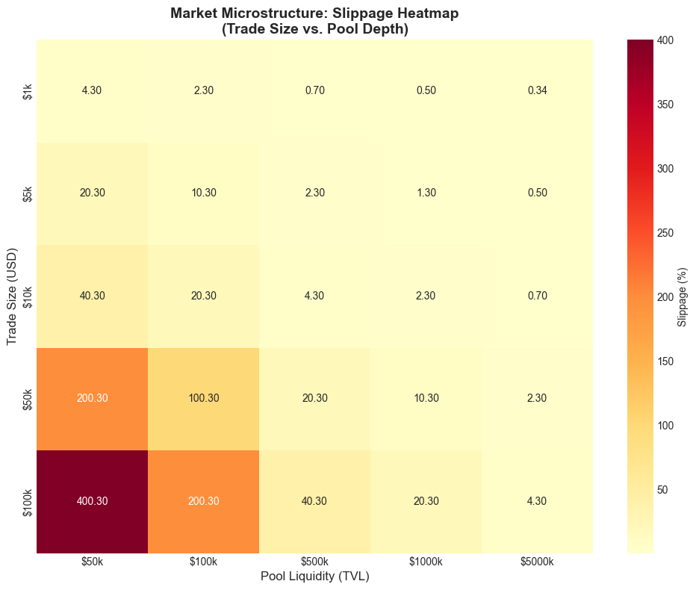
Figure 1: Slippage Heatmap. A $100k trade in a $50k pool results in catastrophic slippage (>400%), illustrating the necessity of deep liquidity.

2.2 Quantifying Impermanent Loss (IL)
Using historical ETH data (2024-2025), we simulated the performance of a Liquidity Provider (LP) versus a HODL strategy.
- Result: The LP strategy consistently underperformed the HODL strategy during trending markets.
- Max Drawdown: The simulation recorded a divergence of -11.2% during peak volatility.
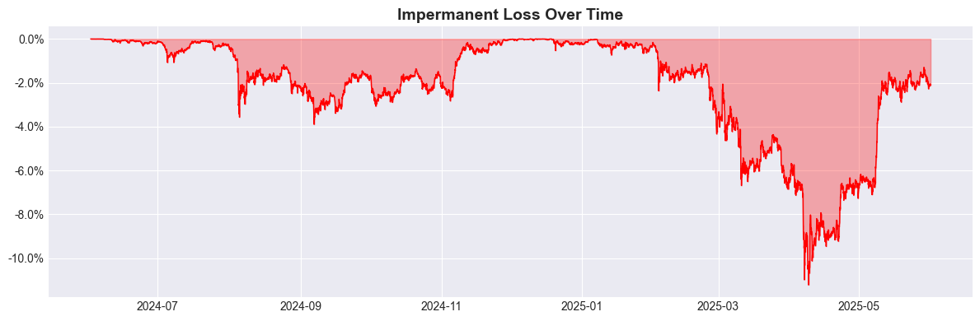
Figure 2: Cumulative Impermanent Loss. The red area represents the value lost by LPs compared to simply holding the assets.

3. Module II: High-Frequency Statistical Arbitrage
Objective: To test a Mean-Reversion strategy on the BTC/ETH pair using 1-minute interval data.

3.1 Cointegration Analysis
While the pair exhibited an extreme correlation coefficient of 0.98, the Augmented Dickey-Fuller (ADF) test revealed a critical insight:
- ADF P-Value: 0.477
- Conclusion: The spread was non-stationary (Random Walk). The null hypothesis of mean reversion could not be rejected.
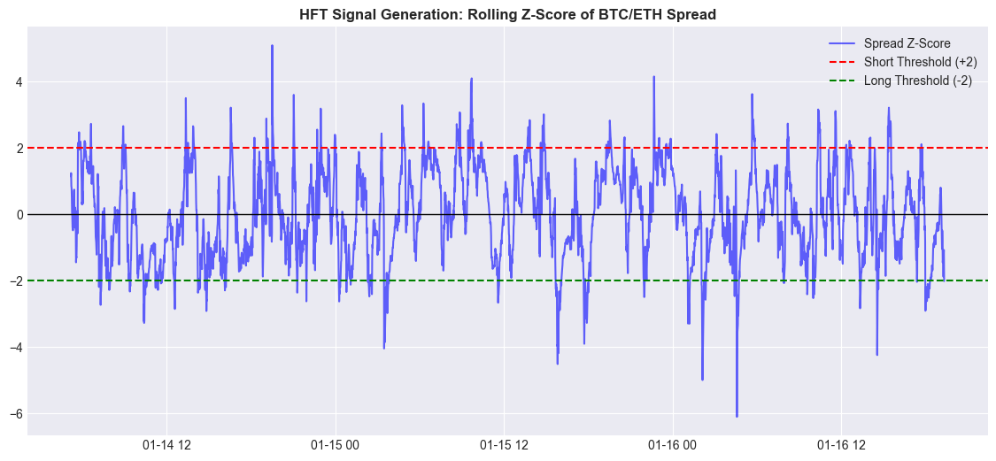
Figure 3: Rolling Z-Score of the Spread. Note the persistent drift away from zero (the mean), indicating a breakdown in the equilibrium relationship.

3.2 Strategy Performance
Due to the lack of stationarity, the mean-reversion algo "fought the trend," resulting in a net loss of -$398.88. This negative result serves as a proof-of-concept for the importance of stationarity testing (ADF) before deploying capital.

4. Module III: Stochastic Risk Modeling (Monte Carlo)
Objective: To estimate the "Value at Risk" (VaR) for a DeFi lending protocol holding ETH collateral.

4.1 Methodology
We calibrated a Geometric Brownian Motion (GBM) model using realized daily drift $μ≈0$ and volatility $σ≈3.8\backslash \%$. We then ran 10,000 simulations over a 30-day horizon.
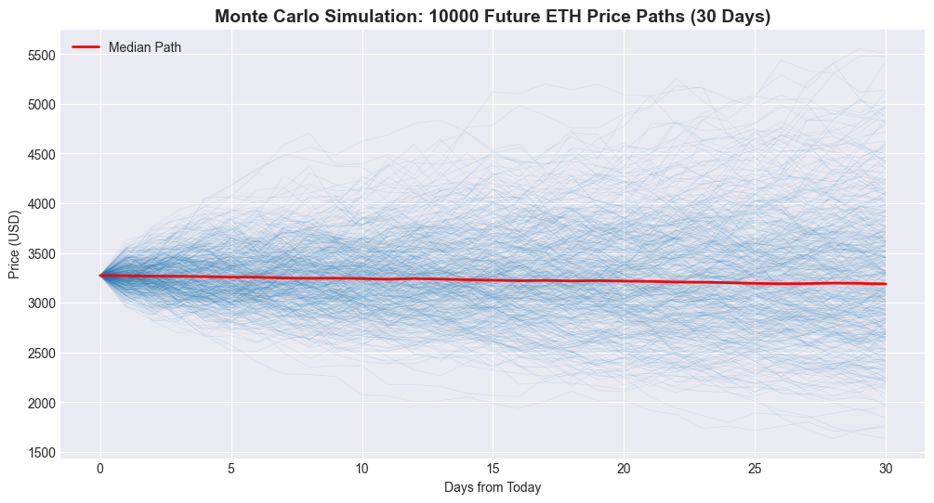
Figure 4: 10,000 simulated future price paths for ETH over 30 days.

4.2 Risk Metrics
The simulation produced the following solvency metrics:
- 95% VaR: $2,255.85. We are 95% confident ETH will stay above this level.
- Liquidation Probability: 5.87%. There is a ~1 in 17 chance of ETH dropping below the liquidation threshold ($2,290) in the next month.
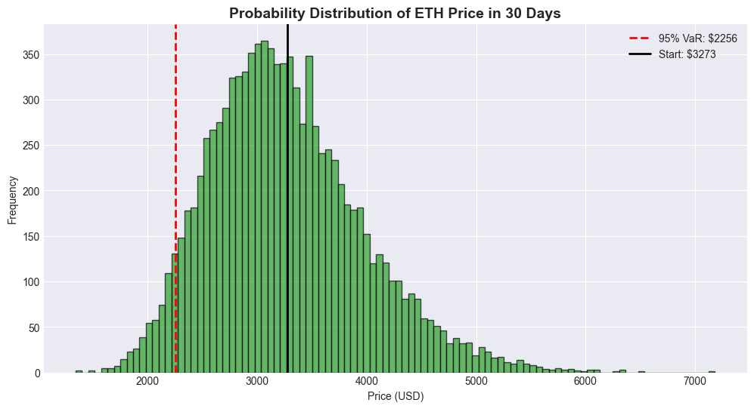
Figure 5: Probability distribution of final prices. The red dashed line indicates the 95% Value at Risk cutoff.

5. Module IV: Derivatives Pricing (DeFi Options)
Objective: To price an ETH Call Option for an Automated Option Vault (DOV) strategy.

5.1 Black-Scholes Valuation
Using the derived volatility from Module III $σ_{annual}=60\%$, we priced an Out-of-the-Money (OTM) Call Option:
- Spot Price: $2,500
- Strike Price: $2,600 (Expiry: 30 Days)
- Theoretical Price: $133.35

5.2 The Greeks (Risk Sensitivities)
- Delta $Δ$: 0.4530.
  - Interpretation: For every $1.00 increase in ETH price, the option value increases by $0.45. To delta-hedge this position, the vault would need to hold 0.45 ETH for every option sold.
- Gamma $Γ$: Visualized in Figure 6, Gamma peaks at the strike price, indicating where hedging risk is highest.
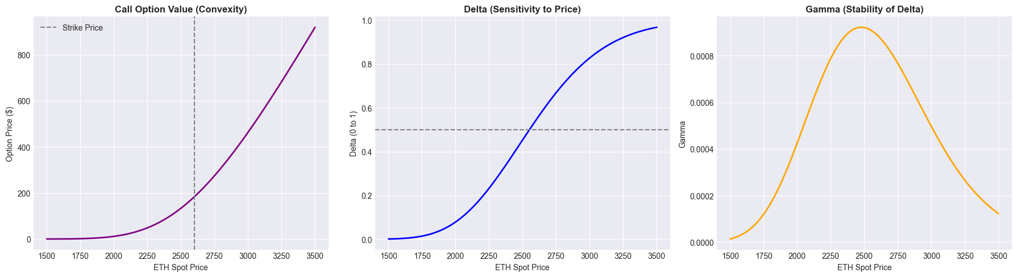
Figure 6: Sensitivity analysis showing Option Price (Convexity), Delta (Velocity), and Gamma (Acceleration).

6. Conclusion
This capstone project demonstrates that DeFi markets, while innovative, adhere to the fundamental laws of financial mathematics.
- Arbitrage: is not guaranteed by correlation alone.
- Risk: is quantifiable via stochastic simulation.
- Yield: (from AMMs or Options) is simply compensation for assuming convexity risk.
Future work will focus on integrating these modules into a live "Vault Strategy" that dynamically hedges AMM Impermanent Loss using the options priced in Module IV.

