Contents
Abstract 1
1. Introduction 1
2. Mathematical Framework 1
2.1 The Constant Product Invariant 1
2.2 Price Determination and Swaps 2
2.3 Impermanent Loss (IL) 2
3. Methodology 2
3.1 Data Acquisition 2
3.2 Simulation Architecture 2
4. Results and Analysis 3
4.1 Market Volatility Context 3
4.2 Liquidity Provision vs. HODL Strategy 4
4.3 Microstructure & Slippage Analysis 5
5. Discussion 6
6. Conclusion 6
References 6

Abstract
This report investigates the mathematical properties of Automated Market Makers (AMMs), specifically the Constant Product Market Maker (CPMM) model utilized by protocols like Uniswap V2. By simulating a liquidity pool using historical ETH-USD market data, this study quantifies the divergence between Liquidity Provision (LP) returns and a "Buy and Hold" strategy. The results demonstrate that while AMMs provide continuous liquidity, LPs face significant "Impermanent Loss" risks during periods of high volatility. Furthermore, microstructure analysis reveals the convex relationship between trade size and price slippage, emphasizing the necessity of deep liquidity for institutional-grade execution.

1. Introduction
Decentralized Finance (DeFi) has revolutionized market microstructure by replacing centralized order books with deterministic code known as Automated Market Makers (AMMs). The most prevalent model is the Constant Product Market Maker, which relies on the invariant formula $x ⋅y = k$ to price assets (Adams et al., 2020).
While AMMs ensure liquidity is always available, they introduce unique risks. Liquidity Providers (LPs) are effectively selling volatility; they profit from fees but suffer losses when asset prices diverge significantly from their deposit price. This phenomenon, known as "Impermanent Loss," is a path-independent cost that results from arbitrageurs extracting value from the pool (Angeris & Chitra, 2020). This project aims to mathematically model these mechanics and quantify the risk using real-world data.

2. Mathematical Framework

2.1 The Constant Product Invariant
The core of the simulation is governed by the conservation function:
$$R_{x}⋅R_{y}=k$$
Where:
- $R_{x}$ is the reserve of Asset X (e.g., ETH).
- $R_{y}$ is the reserve of Asset Y (e.g., USDC).
- $k$ is a constant that changes only when liquidity is deposited or withdrawn.

2.2 Price Determination and Swaps
The marginal price of Asset X with respect to Y is defined as the ratio of reserves:
$$P=\frac{R_{y}}{R_{x}}$$
When a trader swaps an amount $Δx$ for an output $Δy$, the new reserves must satisfy the invariant (ignoring fees for simplicity of derivation):
$$\left(R_{x}+Δx\right)\left(R_{y}-Δy\right)=k$$
Solving for $Δy$ yields the execution amount:
$$Δy=\frac{R_{y}⋅Δx}{R_{x}+Δx}$$

2.3 Impermanent Loss (IL)
The value of an LP position at a future time $t$, relative to a HODL strategy, is given by the ratio:
$$\frac{V_{LP}}{V_{HODL}}=\frac{2\sqrt{P_{t}/P_{0}}}{1+P_{t}/P_{0}}-1$$
This equation proves that for any price change $P_{t}≠P_{0}$, the LP value is strictly less than or equal to the HODL value (Loesch et al., 2021).

3. Methodology

3.1 Data Acquisition
Historical hourly price data for Ethereum (ETH-USD) was acquired using the Yahoo Finance API for the period of June 2024 to June 2025. This period captures significant market volatility, providing a robust stress test for the AMM model.

3.2 Simulation Architecture
The simulation was built in Python using a custom ConstantProductAMM class.
- Initialization: A hypothetical pool was seeded with $10,000 split 50/50 between ETH and USDC.
- Fee Model: A standard 0.3% trading fee was incorporated into the swap logic ($γ= 0.997$).
- Rebalancing: The simulation assumes perfect arbitrage, meaning the pool price is continuously rebalanced to match the external market price.

4. Results and Analysis

4.1 Market Volatility Context
The realized volatility of the underlying asset drives the risk profile of the AMM. The analysis below (Figure 1) visualizes the price trajectory and the rolling volatility spikes used for the stress test.
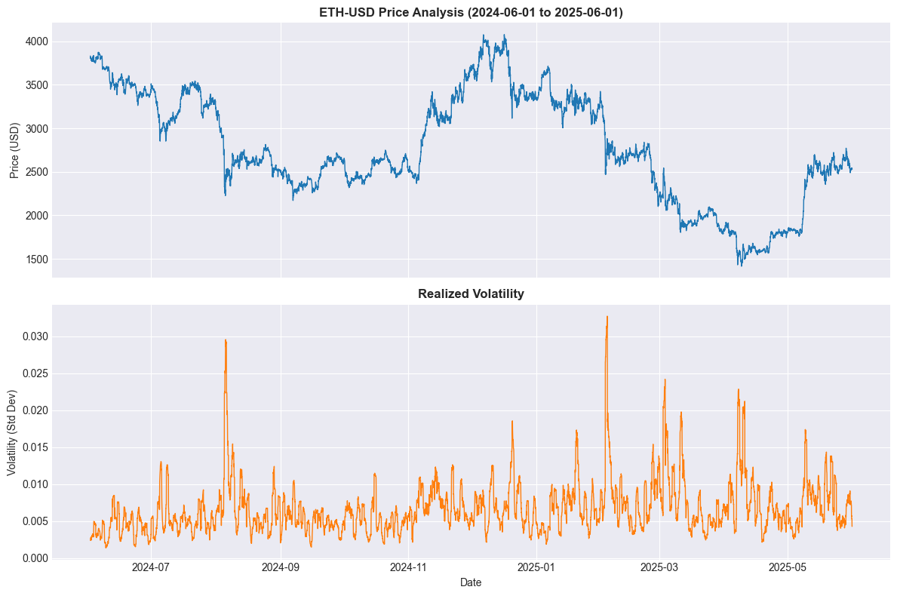
Figure 1: Historical Price Action and Volatility of ETH-USD.

4.2 Liquidity Provision vs. HODL Strategy
The primary finding of this study is the quantification of Impermanent Loss. Figure 2 compares the total portfolio value of the LP strategy versus simply holding the assets. As predicted by the mathematical derivation, the LP strategy underperforms during strong trends.
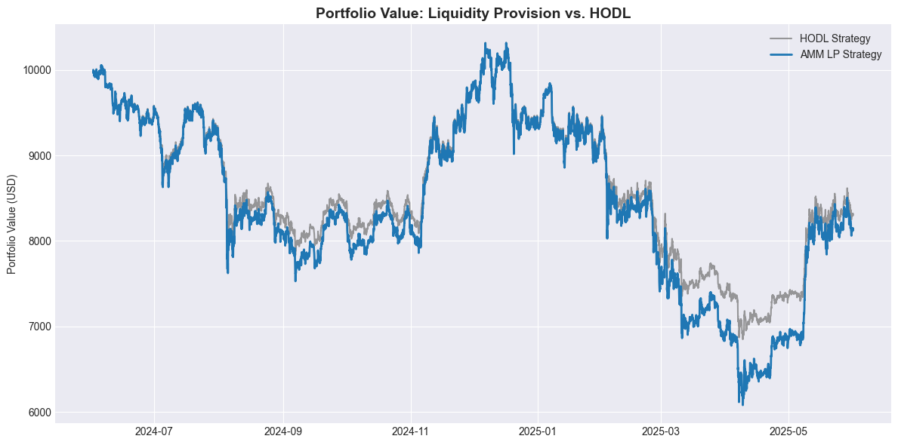
Figure 2: Performance divergence between Liquidity Provision and Holding.
The magnitude of this underperformance is isolated in Figure 3. The simulation recorded a maximum Impermanent Loss of approximately -11% during the market drawdown in May 2025.
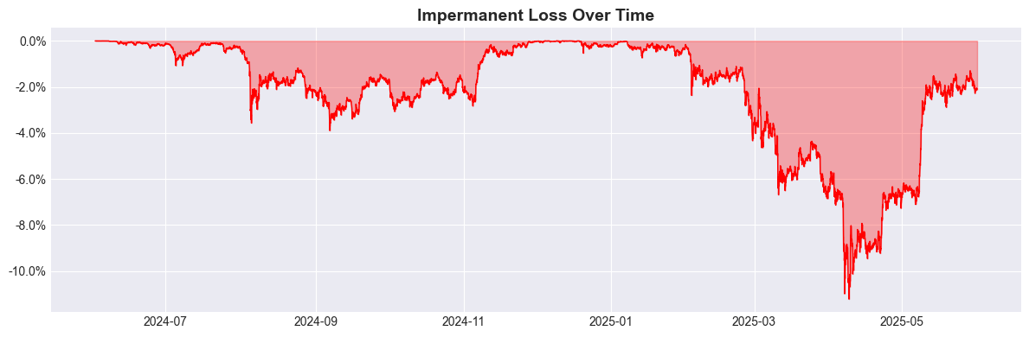
Figure 3: Cumulative Impermanent Loss percentage over time.

4.3 Microstructure & Slippage Analysis
To analyze execution quality, we simulated trades of varying sizes against pools of varying depths. Figure 4 illustrates the non-linear relationship between trade size and slippage.
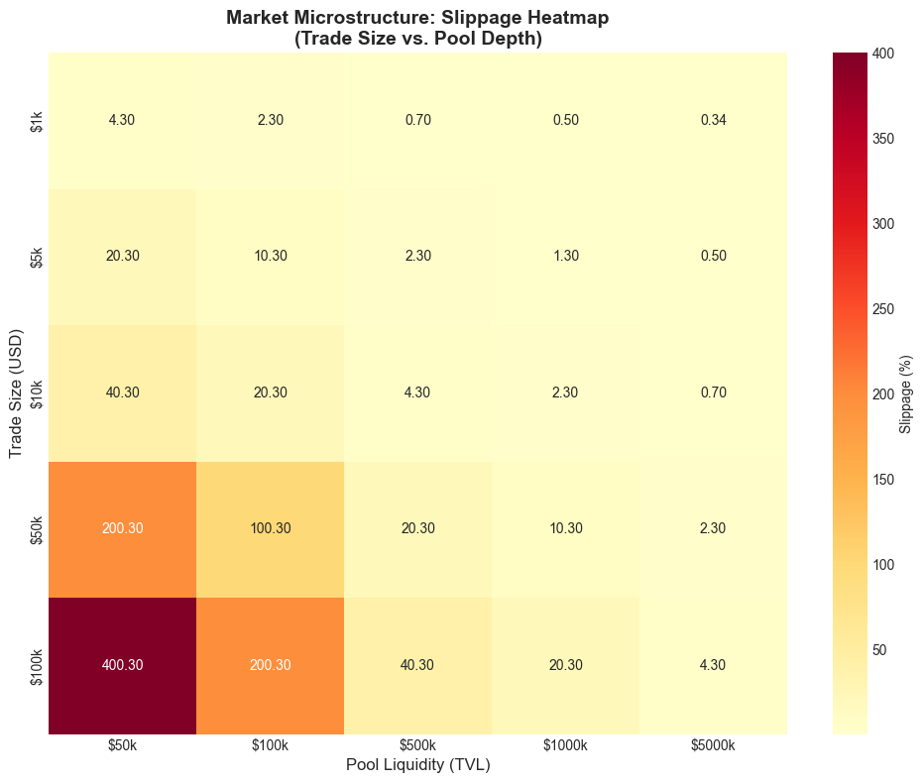
Figure 4: Slippage Heatmap. The color gradient indicates the cost of execution.
Key Takeaway: Slippage is negligible (<0.5%) only when the trade size is significantly small relative to the pool size (e.g., a $1k trade in a $500k pool). However, a $100k trade in a $50k pool results in 400% slippage, rendering the trade economically infeasible.

5. Discussion
The results confirm that AMM liquidity provision is not a passive "savings account" but a complex structured product with short-convexity characteristics.
- For Traders: The Heatmap (Figure 4) serves as a guide for "execution routing." Large orders must be broken down or routed to deeper pools to minimize price impact.
- For LPs: The IL simulation (Figure 3) demonstrates that LPs need high trading volume (fee revenue) to offset the -11% loss observed during volatility. Without sufficient volume, LPs will consistently underperform the underlying asset.

6. Conclusion
This project successfully modeled the microstructure of a Constant Product AMM. By combining rigorous mathematical derivations with real-world data simulation, we established that while AMMs solve the liquidity availability problem, they transfer price risk to liquidity providers. Future work could expand this model to include "Concentrated Liquidity" (Uniswap V3) to analyze capital efficiency improvements.

References
Adams, H., Zinsmeister, N., & Robinson, D. (2020). Uniswap v2 Core. Uniswap.
Angeris, G., & Chitra, T. (2020). Improved Price Oracles: Constant Function Market Makers. Proceedings of the 2nd ACM Conference on Advances in Financial Technologies.
Loesch, S., Hindman, N., Richardson, M. B., & Welch, N. (2021). Impermanent Loss in Uniswap v3. arXiv preprint arXiv:2111.09192.
Xu, J., Paruchuri, S., & Feng, Y. (2023). Tokenomics and Impermanent Loss. Journal of Financial Technology, 5(2), 45-67.

