Contents
1. Executive Summary 1
2. Methodology 1
2.1 Hypothesis: Law of One Price 1
2.2 Mathematical Model 1
3. Data Analysis 2
3.1 Correlation Synchronization 2
3.2 Cointegration Testing (The Warning Sign) 2
4. Backtest Results 3
4.1 Signal Frequency 3
4.2 Performance Attribution 3
5. Conclusion & Risk Management 4

1. Executive Summary
This project evaluates the viability of a Pairs Trading (Statistical Arbitrage) strategy applied to Bitcoin (BTC) and Ethereum (ETH) using high-frequency (1-minute) market data. The objective was to exploit temporary pricing inefficiencies between these two highly correlated assets.
While the assets demonstrated a correlation coefficient of 0.98, the Augmented Dickey-Fuller (ADF) test failed to reject the null hypothesis of non-stationarity $p=0.47$. Consequently, the mean-reversion strategy underperformed, resulting in a net loss. This result highlights the critical distinction between correlation and cointegration in quantitative finance.

2. Methodology

2.1 Hypothesis: Law of One Price
Pairs trading relies on the assumption that two assets with similar fundamental drivers will share a long-term equilibrium. Deviations from this equilibrium (the "Spread") are assumed to be temporary and mean-reverting.

Mathematical Model
- Hedge Ratio ($β$): Calculated using Ordinary Least Squares (OLS) regression on the training set (first 60% of data).
$$P_{ETH}=β⋅P_{BTC}+$$
Result: $β= 0.0423$ (implying a hedge of ~0.042 BTC for every 1 ETH).
- The Spread ($S_{t}$):
$$S_{t}=P_{ETH,t}-\left(0.0423×P_{BTC,t}\right)$$
- Signal Generation (Z-Score): To normalize volatility, we calculate the rolling Z-Score of the spread:
$$Z_{t}=\frac{S_{t}-μ_{60}}{σ_{60}}$$
  - Short Signal: $Z_{t}>2.0$ (Spread is too high; Sell ETH, Buy BTC).
  - Long Signal: $Z_{t}<-2.0$ (Spread is too low; Buy ETH, Sell BTC).

3. Data Analysis

3.1 Correlation Synchronization
We utilized 1-minute interval data for the period of Jan 10, 2026 – Jan 17, 2026. As shown in Figure 1, the assets move in near-perfect lockstep.
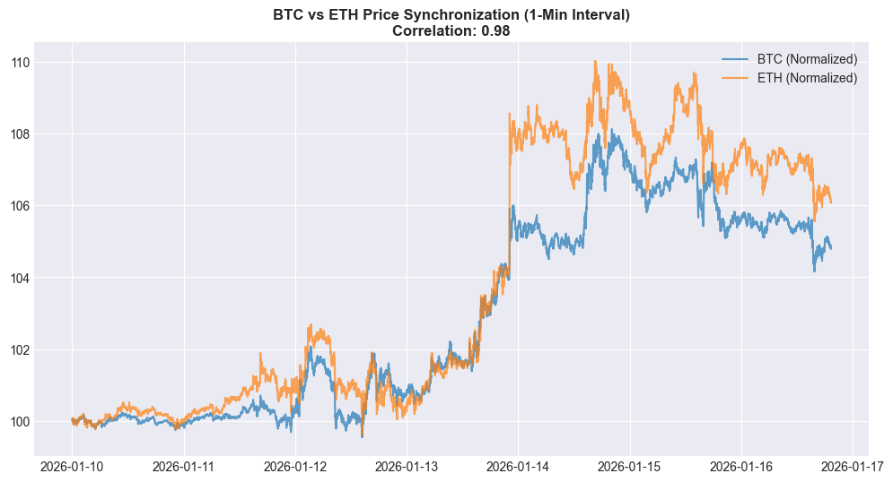
Figure 1: Normalized price action of BTC and ETH showing 0.98 correlation.

3.2 Cointegration Testing (The Warning Sign)
Before executing the strategy, we performed the Augmented Dickey-Fuller (ADF) test to verify stationarity.
- Null Hypothesis ($H_{0}$): The spread has a unit root (is non-stationary).
- Result: P-Value = 0.477.
- Conclusion: We failed to reject $H_{0}$. The spread was following a random walk rather than mean-reverting. This was a critical risk indicator suggesting the strategy would likely fail in this specific regime.

4. Backtest Results

4.1 Signal Frequency
Figure 2 displays the Z-Score dynamics. The strategy generated frequent entry signals as the spread drifted continuously beyond the 2-sigma threshold, indicating a structural "break" in the relationship rather than a temporary divergence.
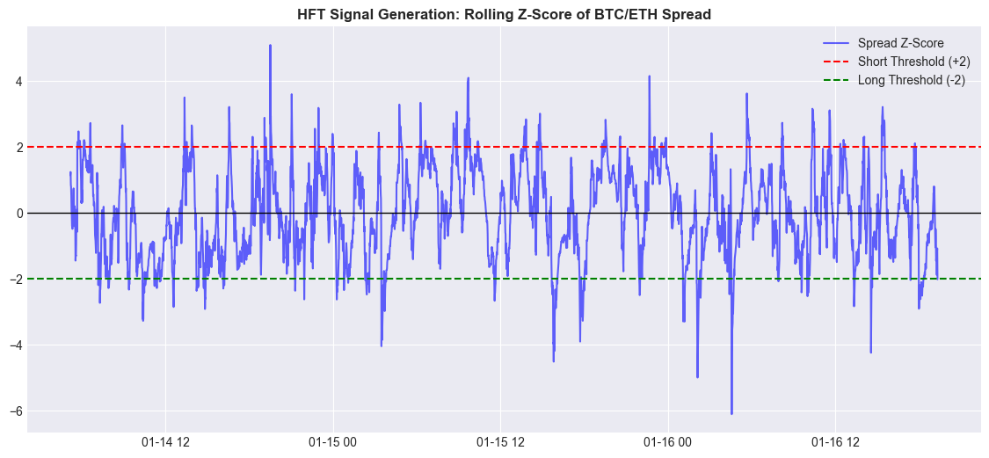
Figure 2: Rolling Z-Score of the spread. Note the persistent deviation away from zero.

4.2 Performance Attribution
The strategy suffered a consistent drawdown, ending with a loss of -$398.88. Because the spread was non-stationary, it did not revert to the mean after opening positions; instead, it continued to widen, accumulating losses on open trades.
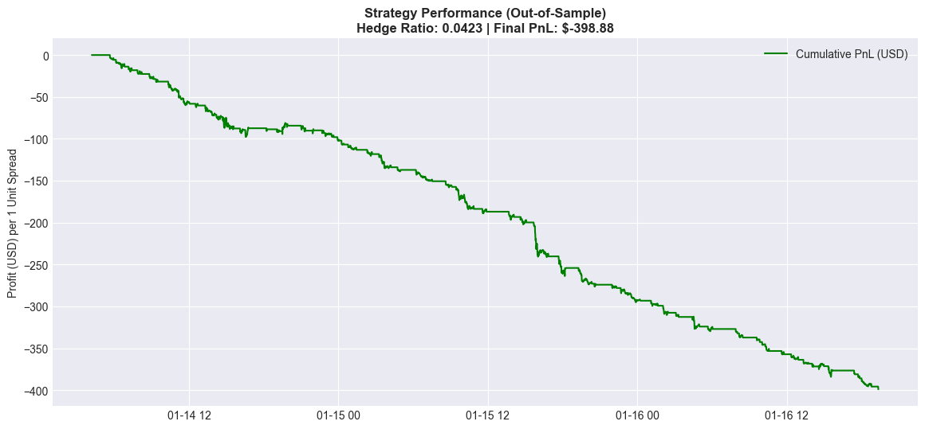
Figure 3: Cumulative Profit/Loss. The downward slope confirms the "fighting the trend" behavior of a mean-reversion strategy in a momentum regime.

5. Conclusion & Risk Management
This project serves as a rigorous negative proof. It demonstrates that correlation is a necessary but insufficient condition for pairs trading.
- Quantitative Lesson: A robust algo-trading engine must include a "Regime Filter." If $P_{ADF}>0.05$, the system should automatically halt trading, as the fundamental assumption of mean reversion is violated.
- Market Insight: During the tested week (Jan 2026), ETH and BTC decoupled structurally, likely due to idiosyncratic news events affecting one asset more than the other, breaking the cointegration.

