Contents
1. Executive Summary 1
2. Methodology 1
2.1 The Geometric Brownian Motion (GBM) Model 1
2.2 Simulation Parameters 1
3. Results and Analysis 2
3.1 Path Generation (The Cone of Uncertainty) 2
3.2 Value at Risk (VaR) 2
3.3 Liquidation Probability 3
4. Conclusion 3

1. Executive Summary
In Decentralized Finance (DeFi), lending protocols (e.g., Aave, Compound) face solvency risks when collateral asset prices decline rapidly. This project engineers a stochastic risk model to quantify the "Tail Risk" of Ethereum (ETH) over a 30-day horizon.
Using Geometric Brownian Motion (GBM) simulations calibrated on historical volatility, we estimated the 95% Value at Risk (VaR) and the probability of catastrophic liquidation events. The model predicts a 5.87% probability of ETH dropping below critical liquidation thresholds ($<$ $2,290) within the next month, suggesting that protocols must maintain conservative Loan-to-Value (LTV) ratios to ensure solvency.

2. Methodology

2.1 The Geometric Brownian Motion (GBM) Model
To model future price paths, we assume asset prices follow a stochastic process defined by:

$$dS_{t}=μS_{t}dt+σS_{t}dW_{t}$$
Where:
- $μ$ (Drift) is the expected daily return (calibrated to ~0.00%).
- $σ$ (Volatility) is the standard deviation of returns (calibrated to ~3.87% daily).
- $dW_{t}$ is a Wiener process (Random Walk).

2.2 Simulation Parameters
- Asset: Ethereum (ETH-USD)
- Current Price $S_{0}$: $3,272.79
- Time Horizon: 30 Days
- Iterations: 10,000 unique price paths

3. Results and Analysis

3.1 Path Generation (The Cone of Uncertainty)
Figure 1 visualizes 10,000 simulated futures. While the "Median Path" (red line) remains relatively flat due to near-zero drift, the variance grows with the square root of time, creating a wide dispersion of possible outcomes ranging from $1,500 to $5,500.
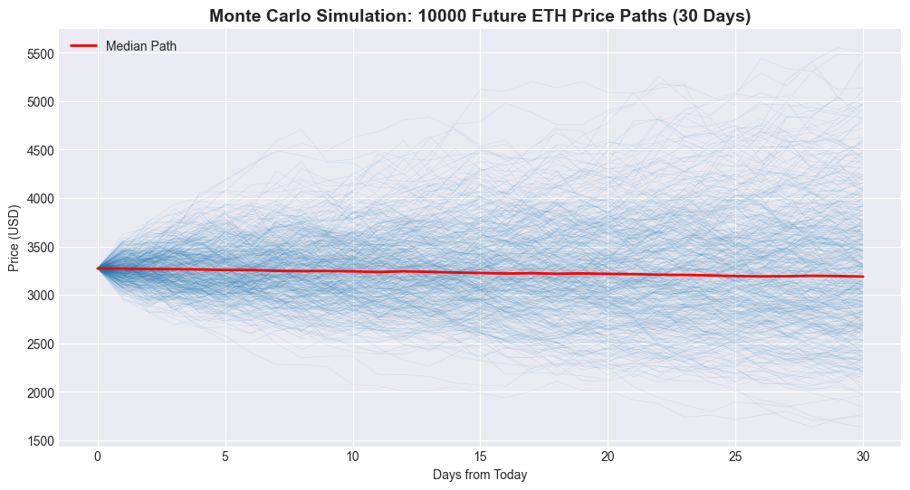
Figure 1: Monte Carlo Simulation showing 10,000 potential price trajectories for ETH over 30 days.

3.2 Value at Risk (VaR)
The distribution of final prices (Figure 2) allows us to calculate risk metrics empirically.
- 95% VaR: $2,255.85
- Interpretation: We are 95% confident that the price of ETH will not fall below $2,255.85 in the next 30 days. Conversely, there is a 5% chance it will fall significantly lower.
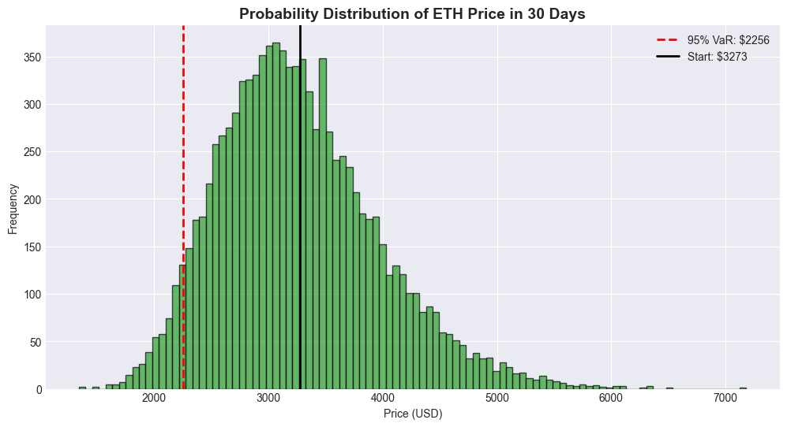
Figure 2: Probability distribution of ending prices. The red dashed line marks the 95% confidence threshold.

3.3 Liquidation Probability
For a hypothetical DeFi loan with a liquidation threshold set at $2,290 (approx. -30% drop), the simulation reveals:
- Insolvency Count: ~587 out of 10,000 paths.
- Probability: 5.87%
This metric is critical for Risk DAOs. A ~6% chance of mass liquidations implies that the protocol is carrying significant tail risk, requiring dynamic interest rate adjustments to compensate LPs.

4. Conclusion
This project successfully demonstrated the application of stochastic calculus to DeFi risk management. By quantifying tail risk, we provide actionable data for setting collateral factors. The results indicate that static risk parameters are insufficient; protocols should employ real-time VaR models to dynamically adjust LTV ratios as market volatility $σ$ changes.

