Contents
1. Executive Summary 1
2. Mathematical Framework 1
2.1 Black-Scholes Model 1
2.2 The Greeks 1
3. Pricing Analysis 1
3.1 Theoretical Valuation 1
3.2 Risk Sensitivities (Visualized) 2
4. Conclusion 2

1. Executive Summary
As institutional capital enters DeFi, the demand for hedging instruments has surged. "DeFi Option Vaults" (DOVs) automate the selling of covered calls to generate yield. This project implements a Black-Scholes-Merton pricing engine to value ETH options and calculate risk sensitivities ("The Greeks").
For an Out-of-the-Money (OTM) ETH Call Option (Strike $2,600, Expiring in 30 days), the model derived a fair value of $133.35. Furthermore, the sensitivity analysis highlights the convexity of the position, with a Delta of 0.45, indicating the specific hedge ratio required to neutralize directional risk.

2. Mathematical Framework

2.1 Black-Scholes Model
The fair price of a European Call Option $C\left(S,t\right)$ is governed by:
$$C=S_{0}N\left(d_{1}\right)-Ke^{-rT}N\left(d_{2}\right)$$
Where:
- $S_{0}$: Current Asset Price ($2,500)
- $K$: Strike Price ($2,600)
- $σ$: Annualized Volatility (60%)
- $r$: Risk-free Rate (5%)
- $T$: Time to Maturity (30/365 years)

2.2 The Greeks
To manage the risk of an option portfolio, we calculate partial derivatives:
- Delta ($Δ=\frac{∂C}{∂S}$): Sensitivity to spot price changes.
- Gamma ($Γ=\frac{∂^{2}C}{∂S^{2}}$): Rate of change of Delta (Convexity).

3. Pricing Analysis

3.1 Theoretical Valuation
Based on the input parameters ($S=\$2500, K=\$2600, σ=60\%$), the model outputs:
- Call Option Price: $133.35
- Yield Generation: If a DOV sells this option weekly, it generates annualized yield for depositors, compensated by the risk of the option expiring In-the-Money (ITM).

3.2 Risk Sensitivities (Visualized)
Figure 1 illustrates the dynamic nature of option pricing.
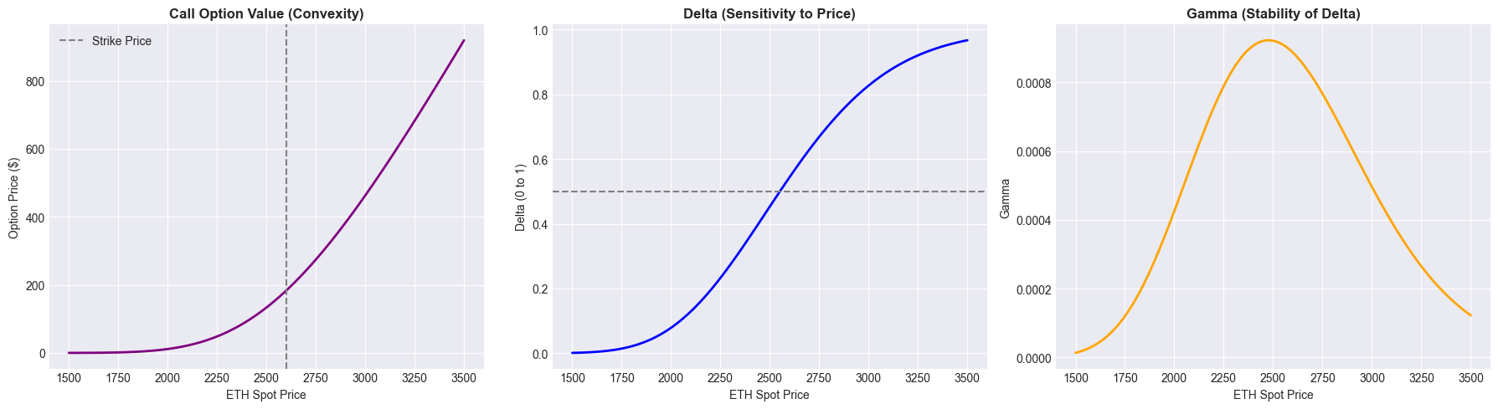
Figure 1: Sensitivity Analysis.
- Left (Price): Shows the non-linear (convex) payoff profile. The option gains value exponentially as ETH approaches the strike.
- Center (Delta): The Delta is 0.4530. This means for a $1 move in ETH, the option moves by $0.45. To be "Delta Neutral," a market maker would need to short 0.453 ETH against this position.
- Right (Gamma): Gamma peaks exactly at the Strike Price ($2,600). This is the "danger zone" for hedgers, where Delta changes most rapidly, requiring frequent rebalancing.

4. Conclusion
This project built a robust pricing engine for DeFi derivatives. The results validate that crypto options command high premiums primarily due to the elevated volatility parameter ($σ=60\%$) compared to traditional equities. For DeFi protocols, this model serves as a foundational component for:
- Automated Market Making for Options (e.g., Lyra).
- Impermanent Loss Hedging (Using puts to offset LP downside).
- Structured Products (Principal-protected yield vaults).

