0.3

0.3

0.3

0.3

5

4

3

2

1

0.4

0.4

0.4

0.4

0.4

0.5

0.5

0.5

0.5

0.2

0.2

0.2

0.2

5

２

4

3

１

0.6

0.6

0.6

0.6

0.6

0.1

0.1

0.1

0.1

10

9

8

7

6

-0.3

-0.3

-0.3

-0.3

$$f_{1}=e_{f1}$$

$$f_{10}=e_{f10}$$

$$f_{2}={0.3f}_{1}$$

$$f_{3}={0.3f}_{2}$$

$$f_{4}={0.3f}_{3}$$

$$f_{5}={0.3f}_{4}$$

$$f_{9}={-0.3f}_{10}$$

$$f_{8}={-0.3f}_{9}$$

$$f_{7}={-0.3f}_{8}$$

$$f_{6}={-0.3f}_{7}$$

$$x_{1}={0.4f}_{1}+{0.6f}_{6}+{0.1f}_{7}$$

$$x_{2}={{0.2x}_{1}+0.5f}_{1}+0.5f_{2}+{0.6f}_{7}+{0.1f}_{8}$$

$$x_{3}={{0.2x}_{2}+0.5f}_{2}+0.5f_{3}+{0.6f}_{8}+{0.1f}_{9}$$

$$x_{4}={{0.2x}_{3}+0.5f}_{3}+0.5f_{4}+{0.6f}_{9}+{0.1f}_{10}$$

$$x_{5}={{0.2x}_{4}+0.5f}_{4}+0.5f_{5}+{0.1f}_{10}$$

0.3

0.3

0.3

0.3

5

4

3

2

1

0.4

0.4

0.4

0.4

0.4

0.5

0.5

0.5

0.5

0.2

5

２

4

3

１

0.6

0.6

0.6

0.6

0.6

0.1

0.1

0.1

0.1

10

9

8

7

6

-0.3

-0.3

-0.3

-0.3

$$f_{1}=e_{f1}$$

$$f_{10}=e_{f10}$$

$$f_{2}={0.3f}_{1}$$

$$f_{3}={0.3f}_{2}$$

$$f_{4}={0.3f}_{3}$$

$$f_{5}={0.3f}_{4}$$

$$f_{9}={-0.3f}_{10}$$

$$f_{8}={-0.3f}_{9}$$

$$f_{7}={-0.3f}_{8}$$

$$f_{6}={-0.3f}_{7}$$

$$x_{1}={0.4f}_{1}+{0.6f}_{6}+{0.1f}_{7}$$

$$x_{2}={0.5f}_{1}+0.5f_{2}+{0.6f}_{7}+{0.1f}_{8}$$

$$x_{3}={0.5f}_{2}+0.5f_{3}+{0.6f}_{8}+{0.1f}_{9}$$

$$x_{4}={{0.2x}_{3}+0.5f}_{3}+0.5f_{4}+{0.6f}_{9}+{0.1f}_{10}$$

$$x_{5}={0.5f}_{4}+0.5f_{5}+{0.1f}_{10}$$

0.3

0.3

0.3

0.3

5

4

3

2

1

0.5

0.4

0.4

0.4

0.4

0.5

0.5

0.5

0.5

0.2

0.2

0.2

２

4

3

１

0.1

0.1

0.1

0.6

0.6

0.6

0.6

0.1

10

9

8

7

6

-0.3

-0.3

-0.3

-0.3

$$x_{1}=e_{1}$$

$$x_{2}={{0.2x}_{1}+0.5f}_{1}+0.4f_{2}+{0.5f}_{3}+{0.5f}_{4}+{0.1f}_{6}+{0.6f}_{7}+{0.1f}_{8}+{0.1f}_{9}$$

$$x_{3}={{0.2x}_{2}+0.2x_{4}+0.4f}_{3}+0.5f_{5}+{0.6f}_{8}+{0.1f}_{10}$$

$$x_{4}={0.5f}_{3}+0.4f_{4}+{0.6f}_{9}$$

$$f_{1}=e_{f1}$$

$$f_{10}=e_{f10}$$

$$f_{2}={0.3f}_{1}$$

$$f_{3}={0.3f}_{2}$$

$$f_{4}={0.3f}_{3}$$

$$f_{5}={0.3f}_{4}$$

$$f_{9}={-0.3f}_{10}$$

$$f_{8}={-0.3f}_{9}$$

$$f_{7}={-0.3f}_{8}$$

$$f_{6}={-0.3f}_{7}$$

5.0

1.2

1.4

2.3

1

0.2

4

0.2

3

２

１

3.0

0.1

1.1

1.6

3

3.0

2

$$f_{2}=e_{f4}$$

$$f_{3}={3.0f}_{2}$$

$$f_{1}={5.0f}_{3}$$

$$x_{1}={2.3f}_{1}+{0.1f}_{2}$$

$$x_{2}={{0.2x}_{1}+3.0f}_{2}+1.6f_{3}$$

$$x_{3}={{0.2x}_{2}+1.4f}_{1}$$

$$x_{4}={1.2x}_{3}+1.1f_{3}$$

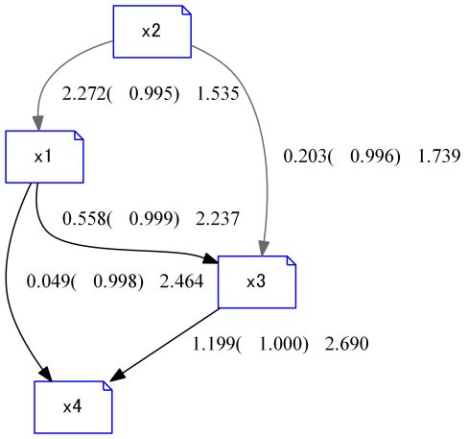

|  |  |  |
| --- | --- | --- |
|  |  | precision |
| true edges | 2 | **40%** |
| all edges | 5 |

|  |  |  |
| --- | --- | --- |
|  |  | precision |
| true edges | 2 | **50%** |
| all edges | 4 |