**検証データ：LiNGAM_latest3.csv**

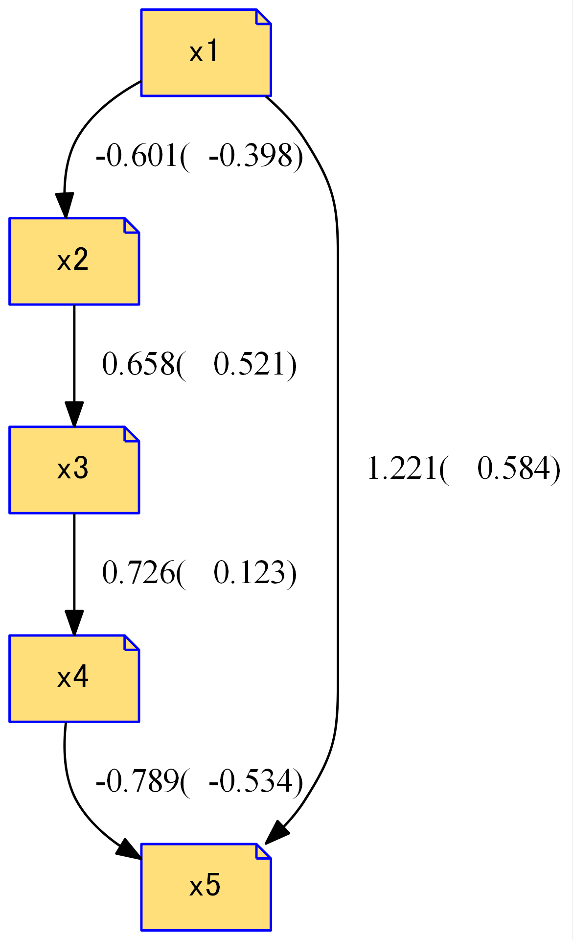

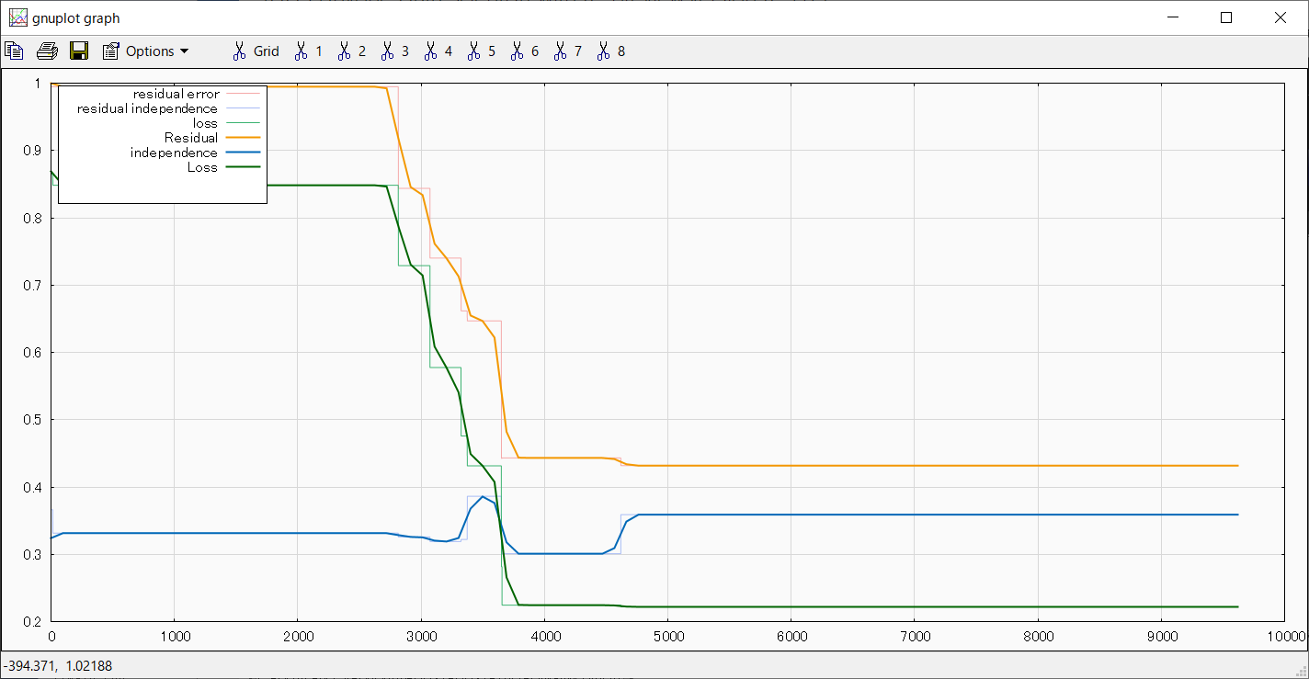

Iter=50000, early_stopping=5000

loss:[0.2220]

residual_independence:[0.0000,0.3591]

residual_error:[-2.5091, 1.8196]

**検証データ：LiNGAM_latest8.csv**



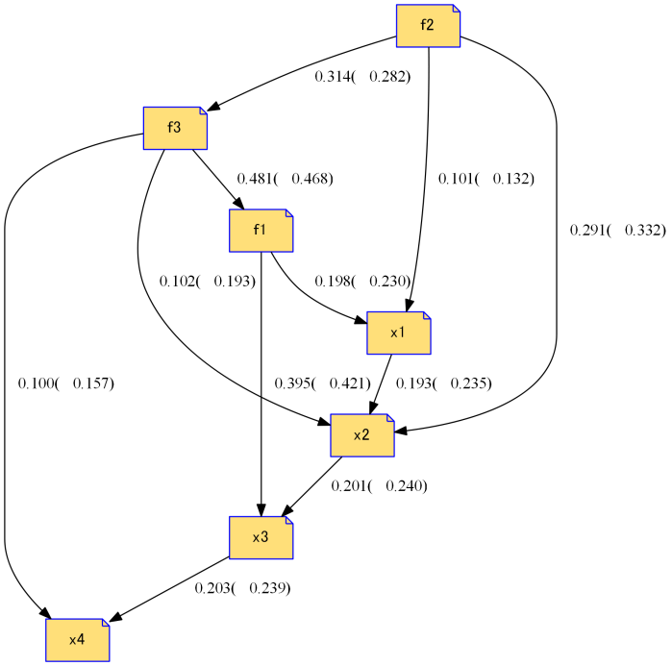



Iter:10000 forced termination:980

loss:[0.5477]

residual_independence:[0.0000,0.4601]

residual_error:[-2.0401, 2.4023]

**検証データ：LiNGAM_latest8.csv**

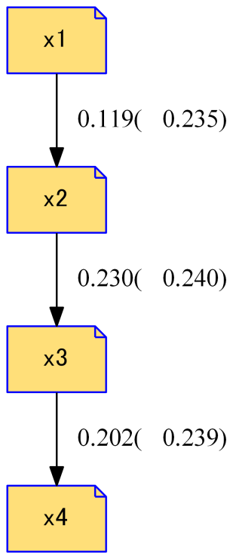



iter:10000 early_stopping:0

loss:[0.2881]

residual_independence:[0.0000,0.1973]

residual_error:[-1.7344, 1.2591]

**検証データ：LiNGAM_latest9.csv**

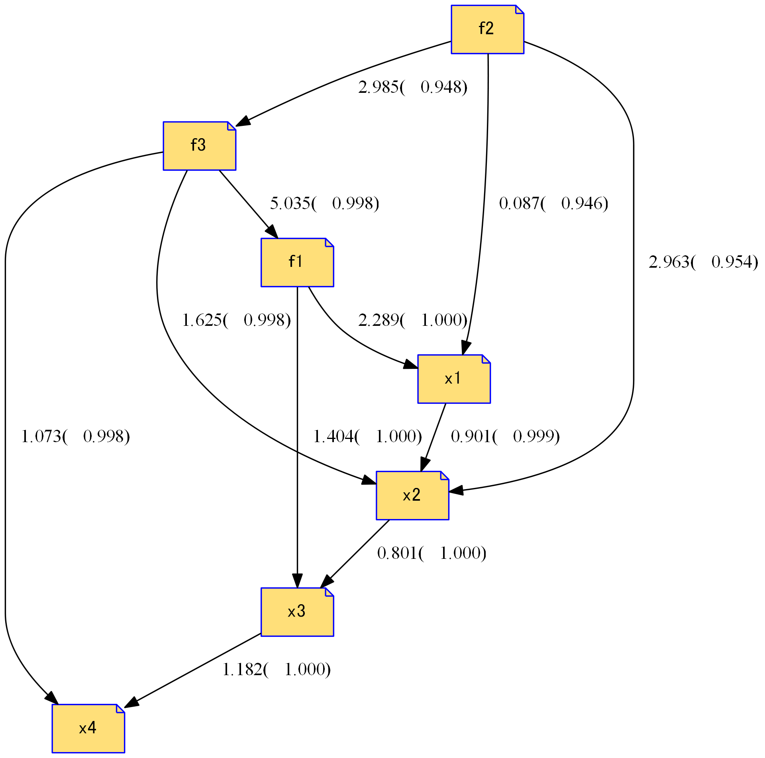****

Iter:10000 forced termination:

loss:[0.0342]

residual_independence:[0.0000,0.1234]

residual_error:[-4.4058, 5.3580]

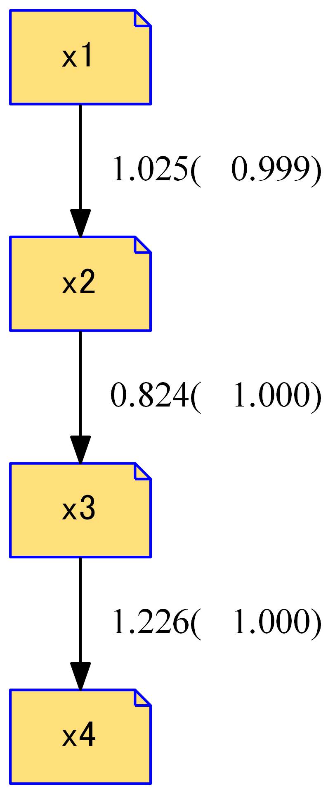



Iter:10000 early_stopping:0

loss:[0.4100]

residual_independence:[0.0000,0.4660]

residual_error:[-2.2168, 46.0150]

**検証データ：LiNGAM_latest9y.csv**

 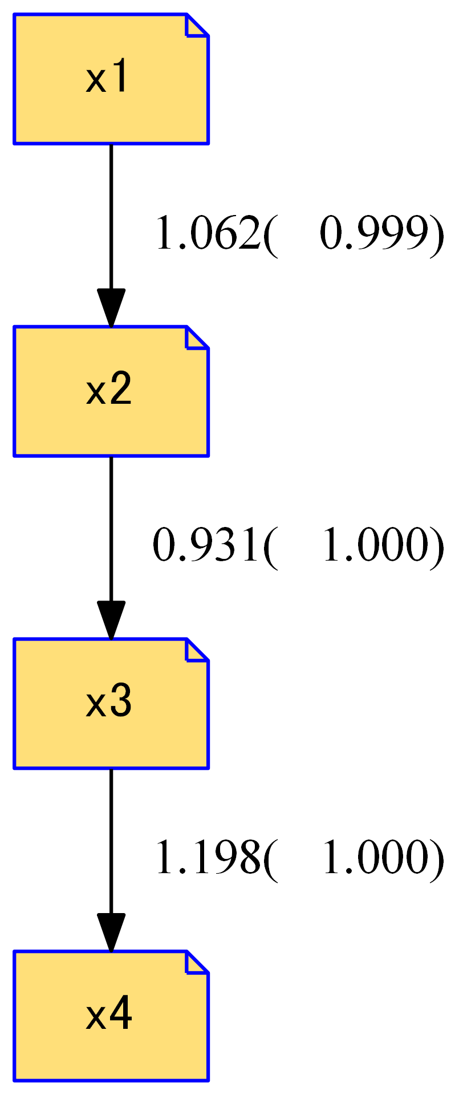



Iter:10000 early_stopping:4000

loss:[0.4249]

residual_independence:[0.0000,0.1248]

residual_error:[-3.8847, 45.6063]

**検証データ：LiNGAM_test.csv**



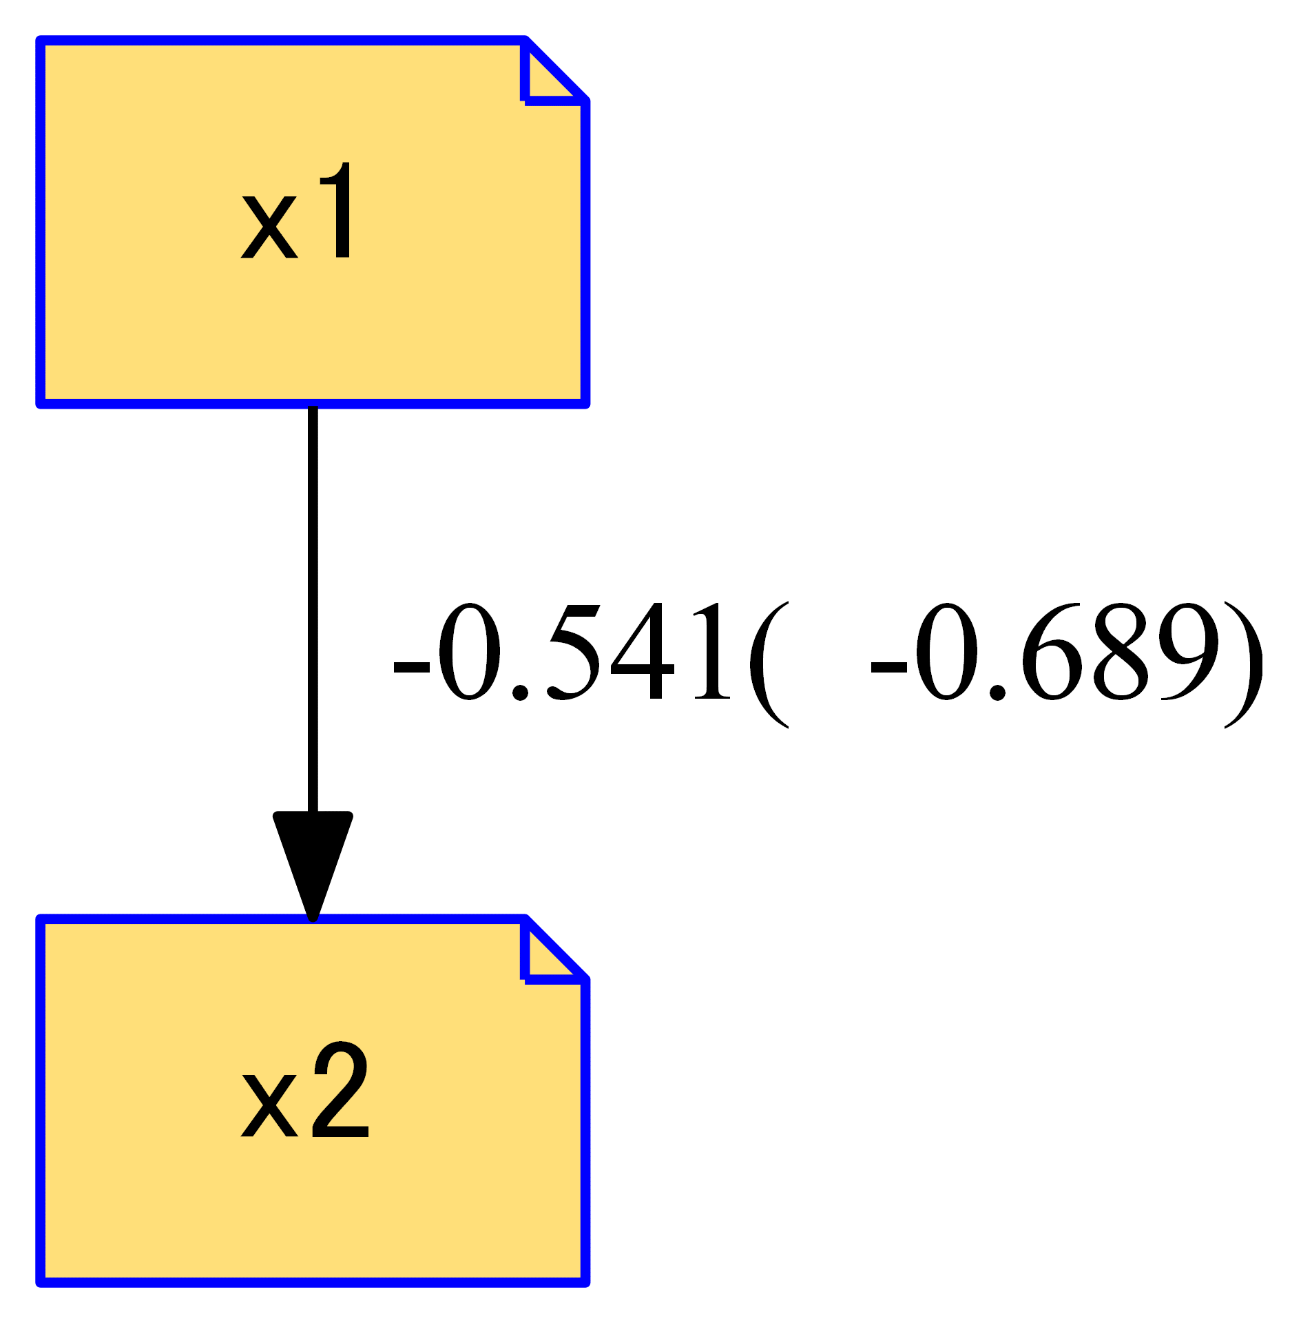

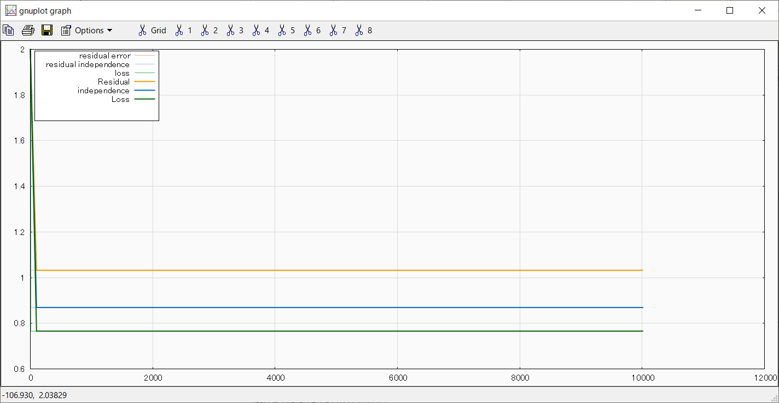

Iter=60000, early_stopping=10000

loss:[0.7656]

residual_independence:[0.0000,0.8692]

residual_error:[-4.7726, -2.0168]

**検証データ：LiNGAM_latest.csv**



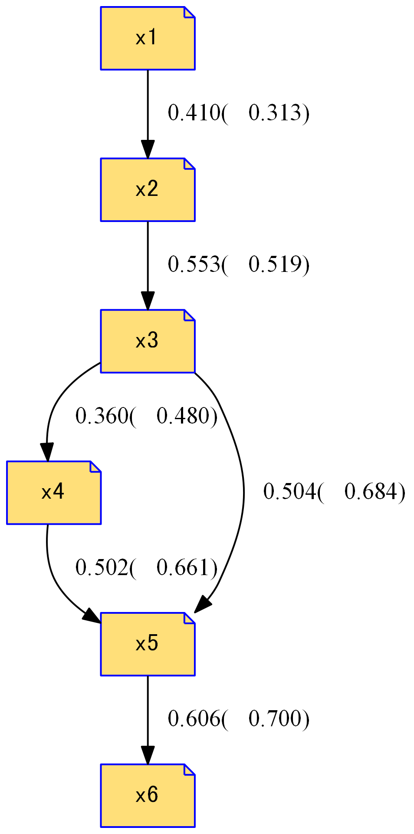

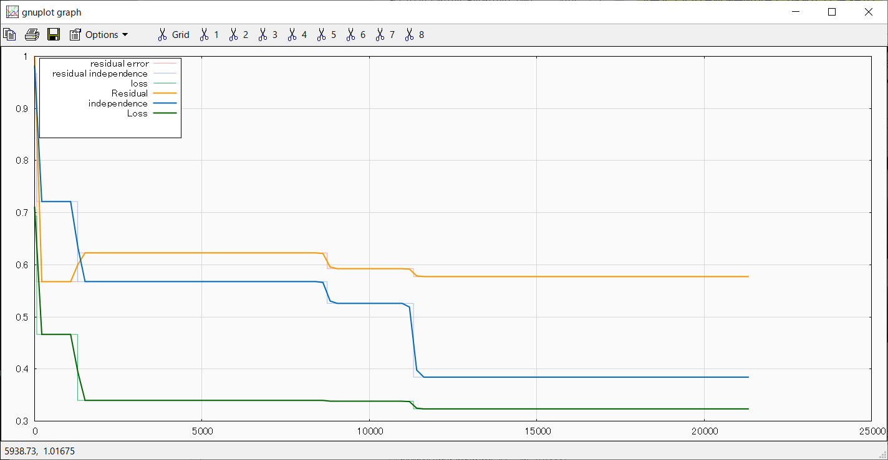

Iter=60000, early_stopping=10000

loss:[0.3235]

residual_independence:[-0.0000,0.3844]

residual_error:[-1.8683, 1.6738]

**検証データ：LiNGAM_latest.csv**



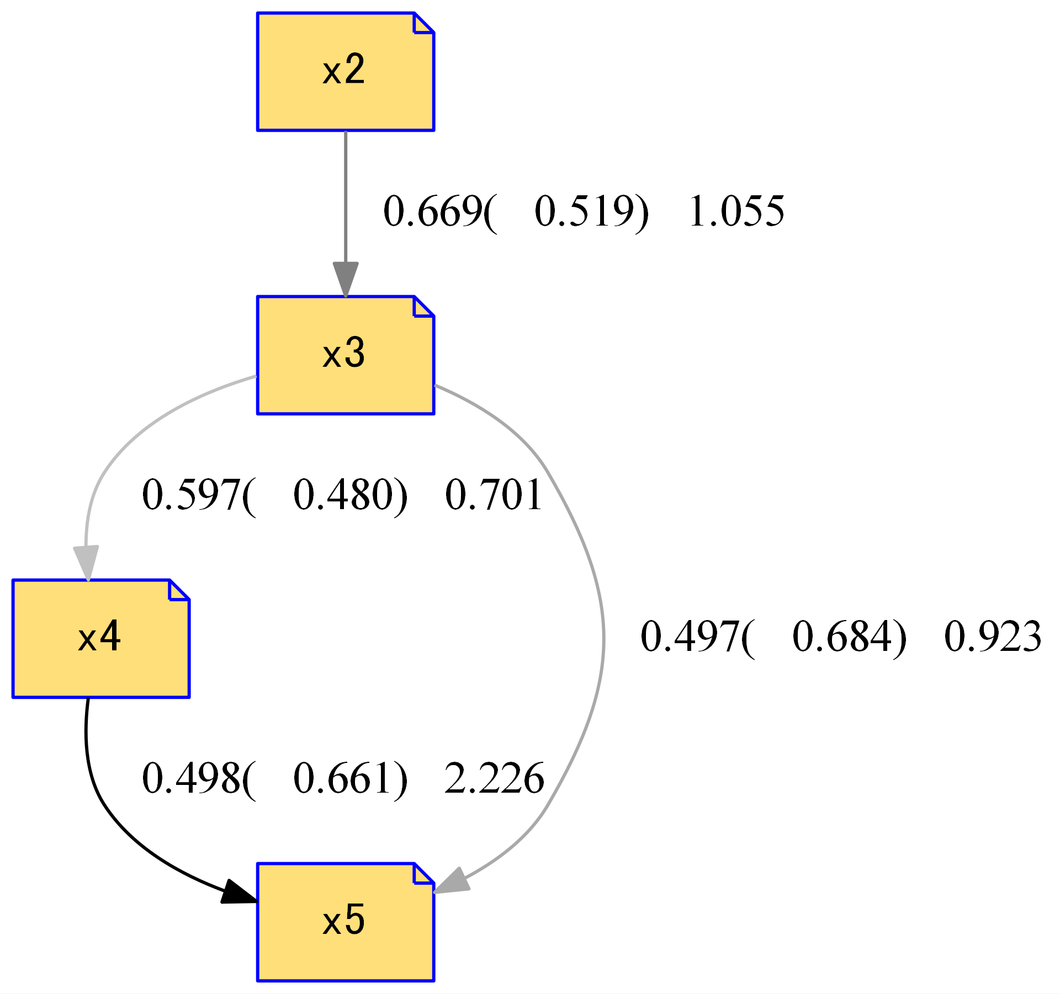



Iter=30000, early_stopping=none

loss:[0.2497]

residual_independence:[0.0000,0.1167]

residual_error:[-1.6355, 1.6538]

**検証データ：LiNGAM_latest.csv**



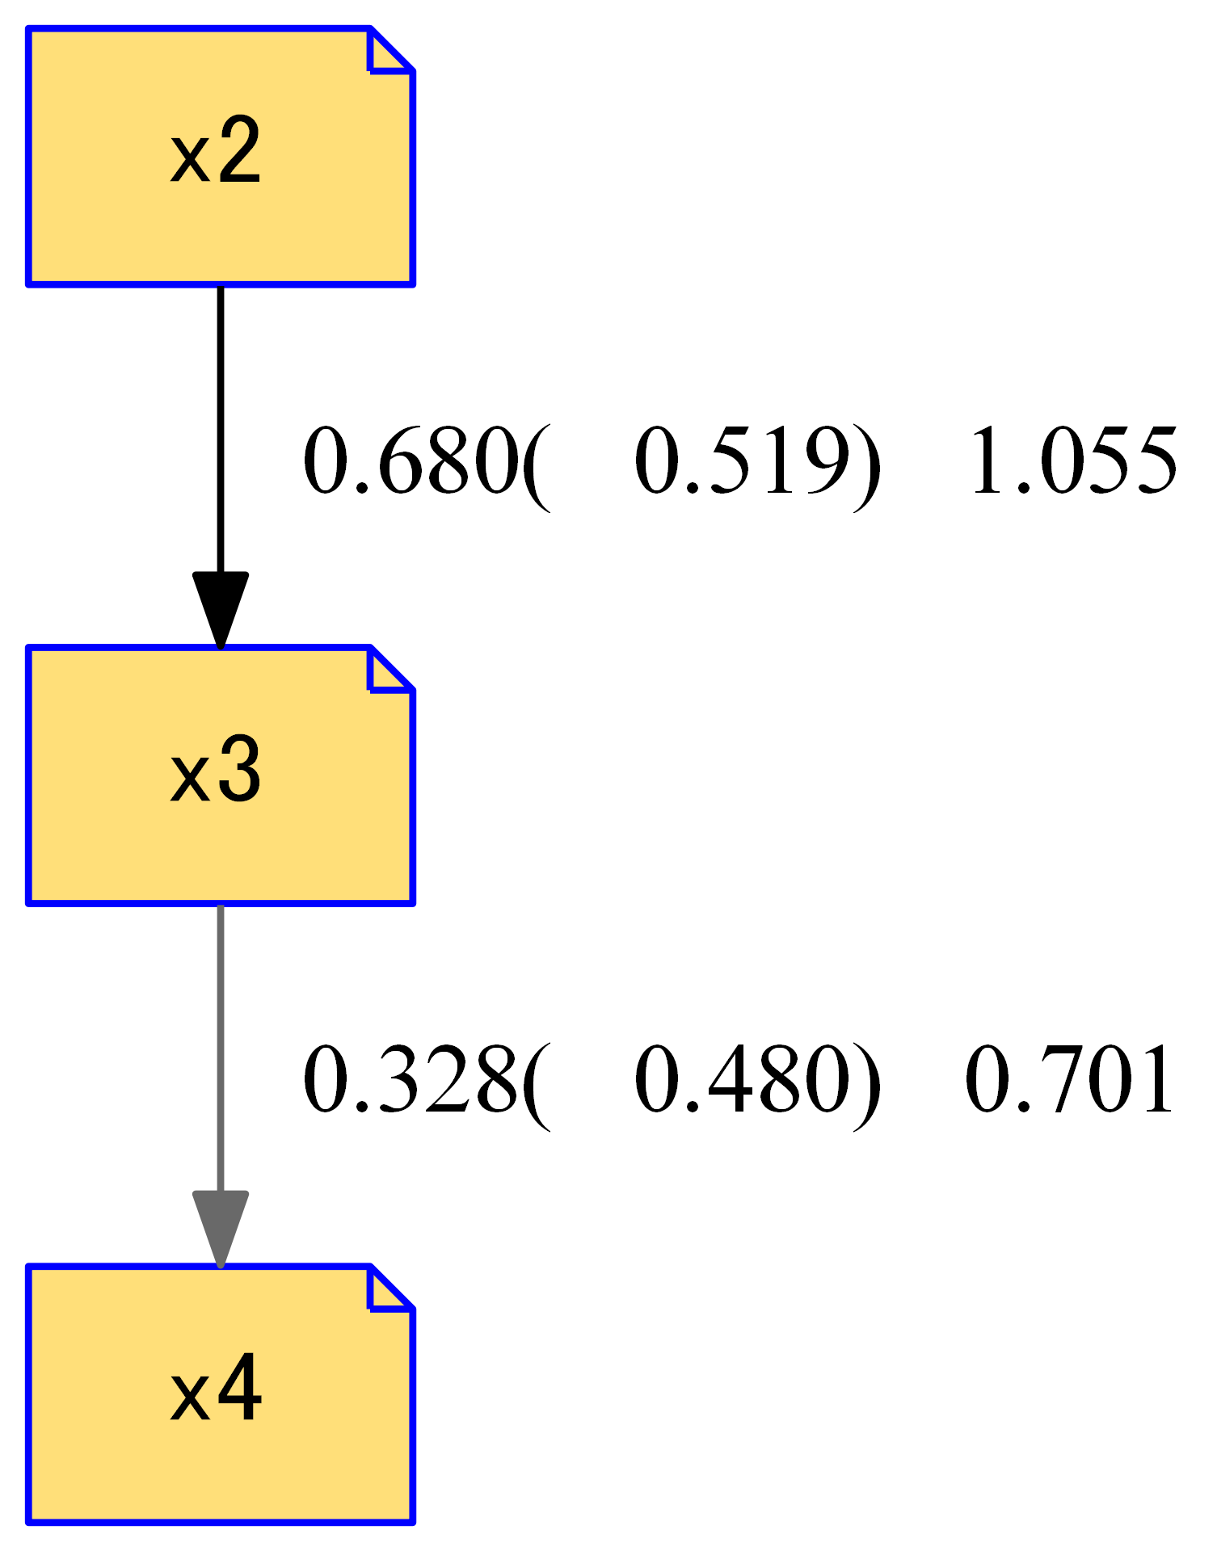



Iter=30000, early_stopping=none

loss:[0.2759]

residual_independence:[0.0000,0.0917]

residual_error:[-1.2933, 1.0619]

**検証データ：GSS_sim.csv**



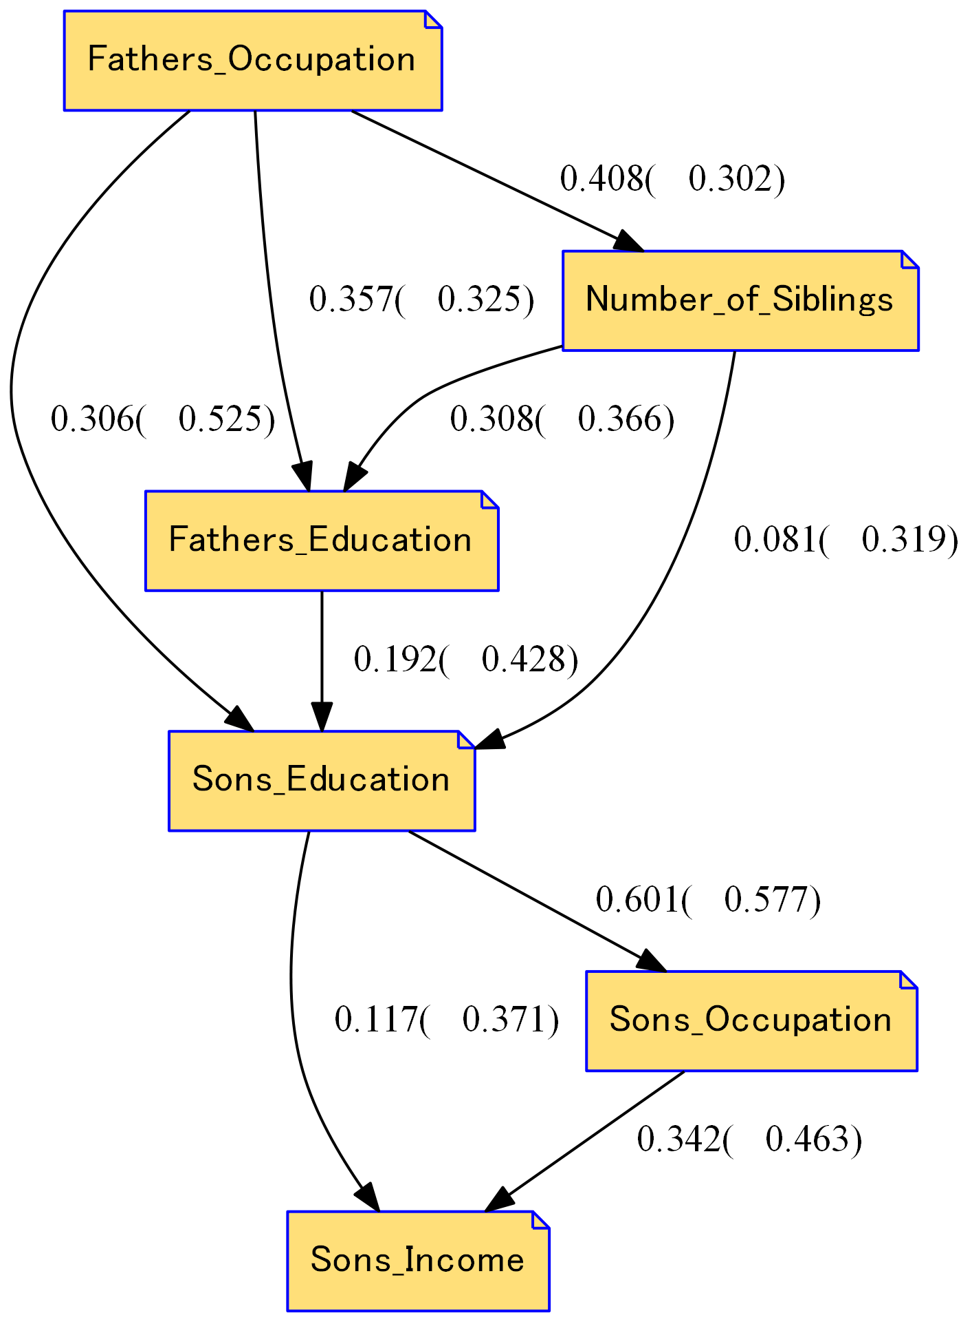 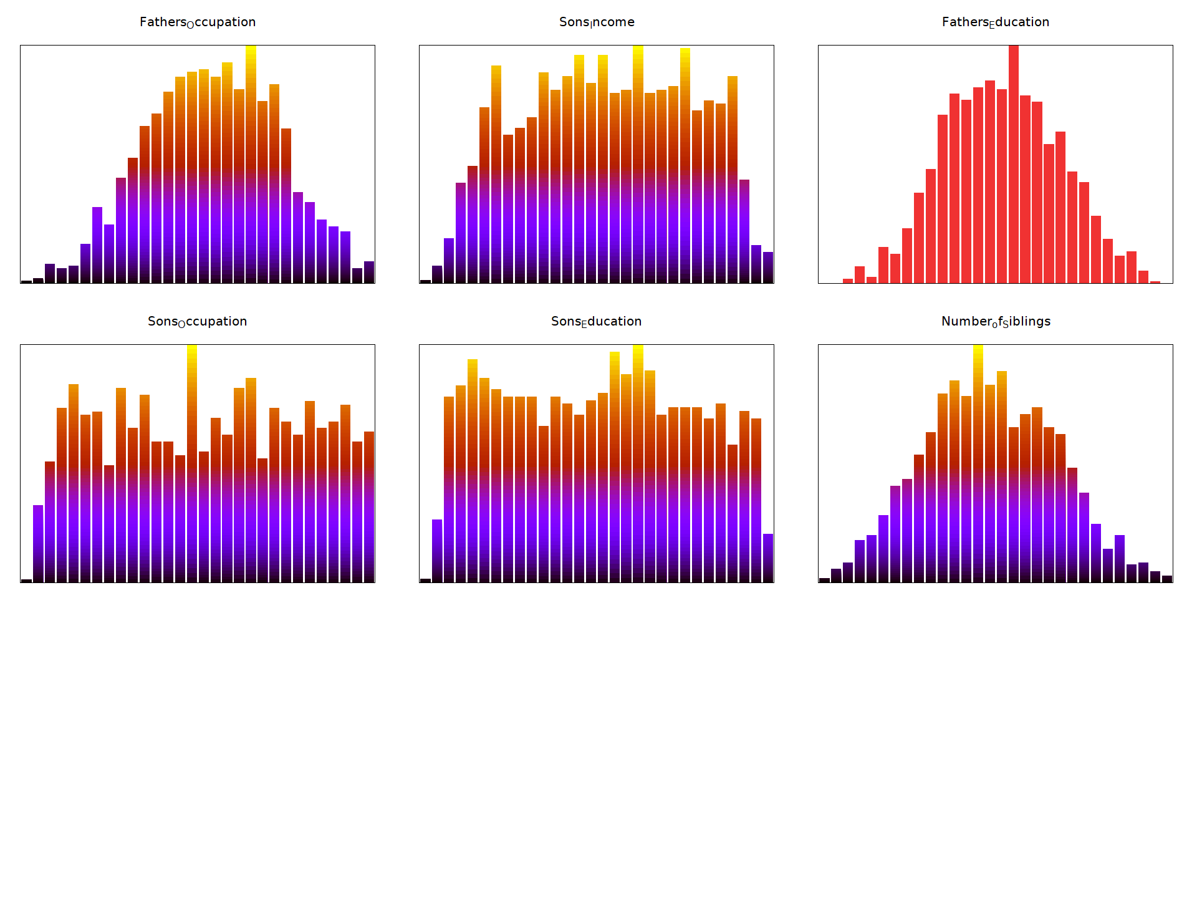

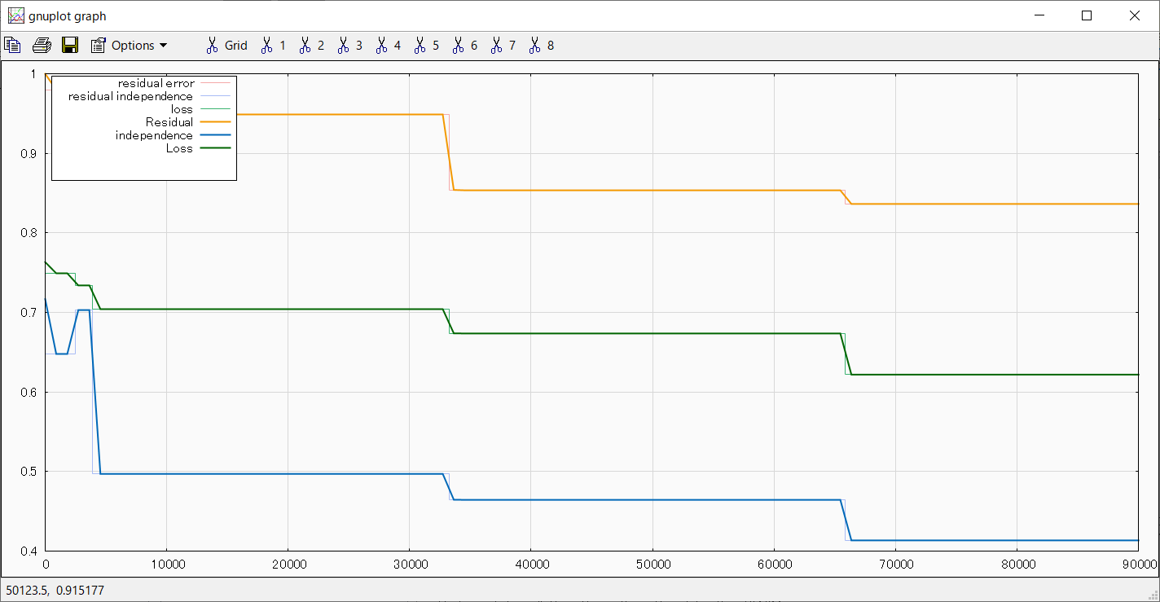

Iter=90000, early_stopping=none

loss:[0.6219]

residual_independence:[0.0000,0.4136]

residual_error:[-2.4652, 1.0854]

**検証データ：GSS_sim(n=13800).csv**



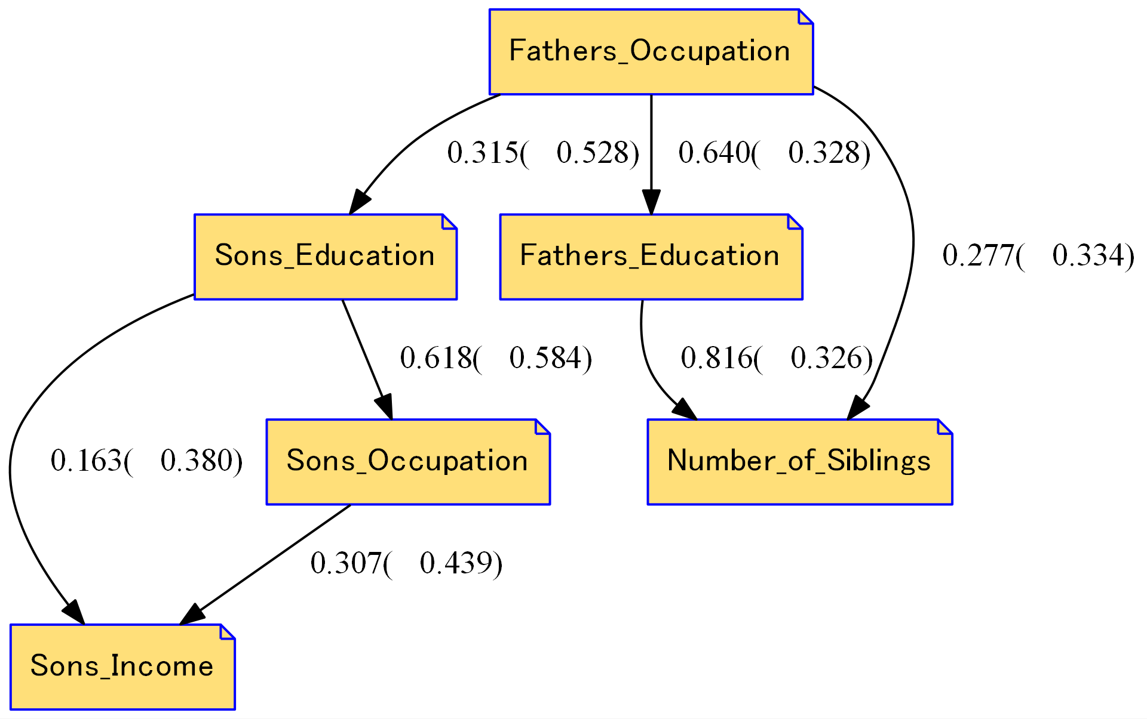

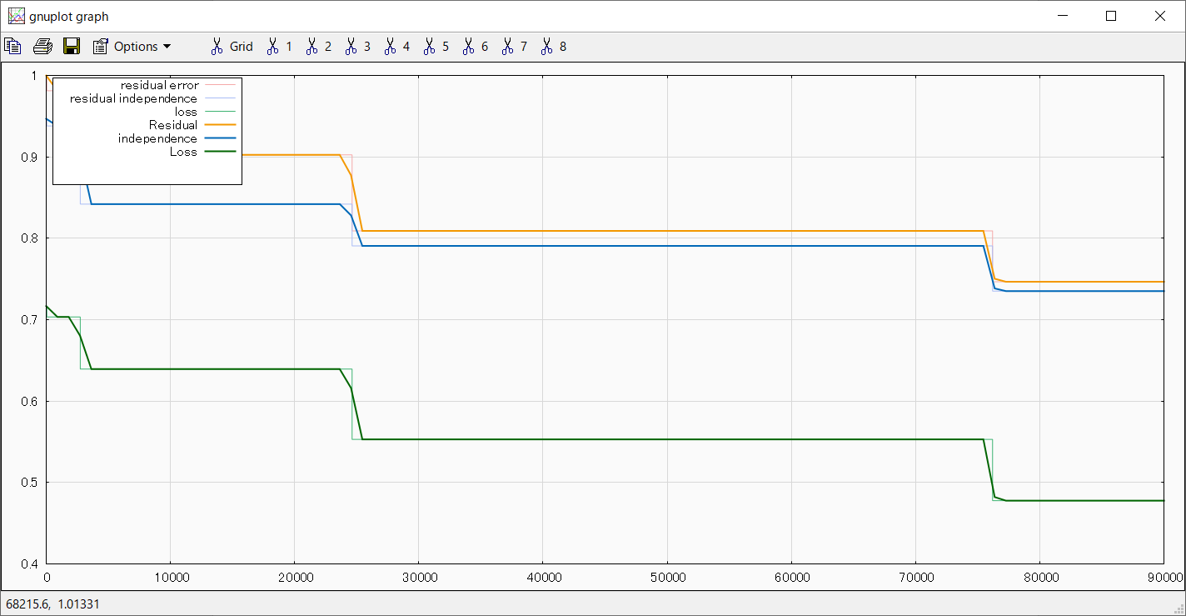

Iter=90000, early_stopping=none

loss:[0.4778]

residual_independence:[0.0000,0.7352]

residual_error:[-1.8252, 2.1949]

**検証データ：GSS_sim(n=13800).csv**

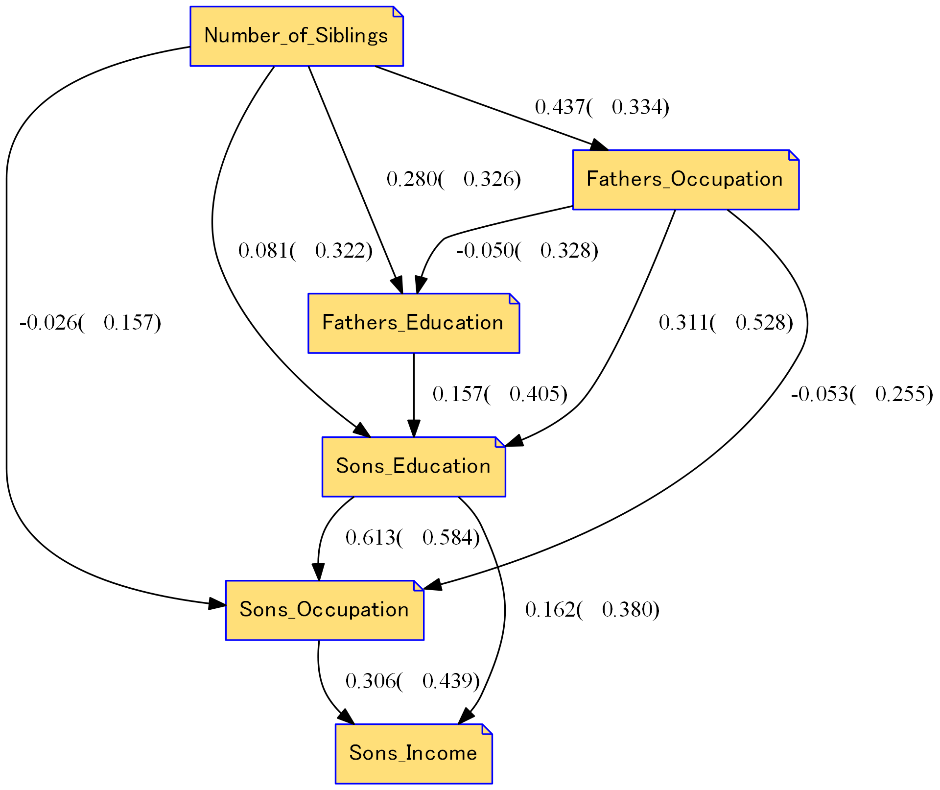

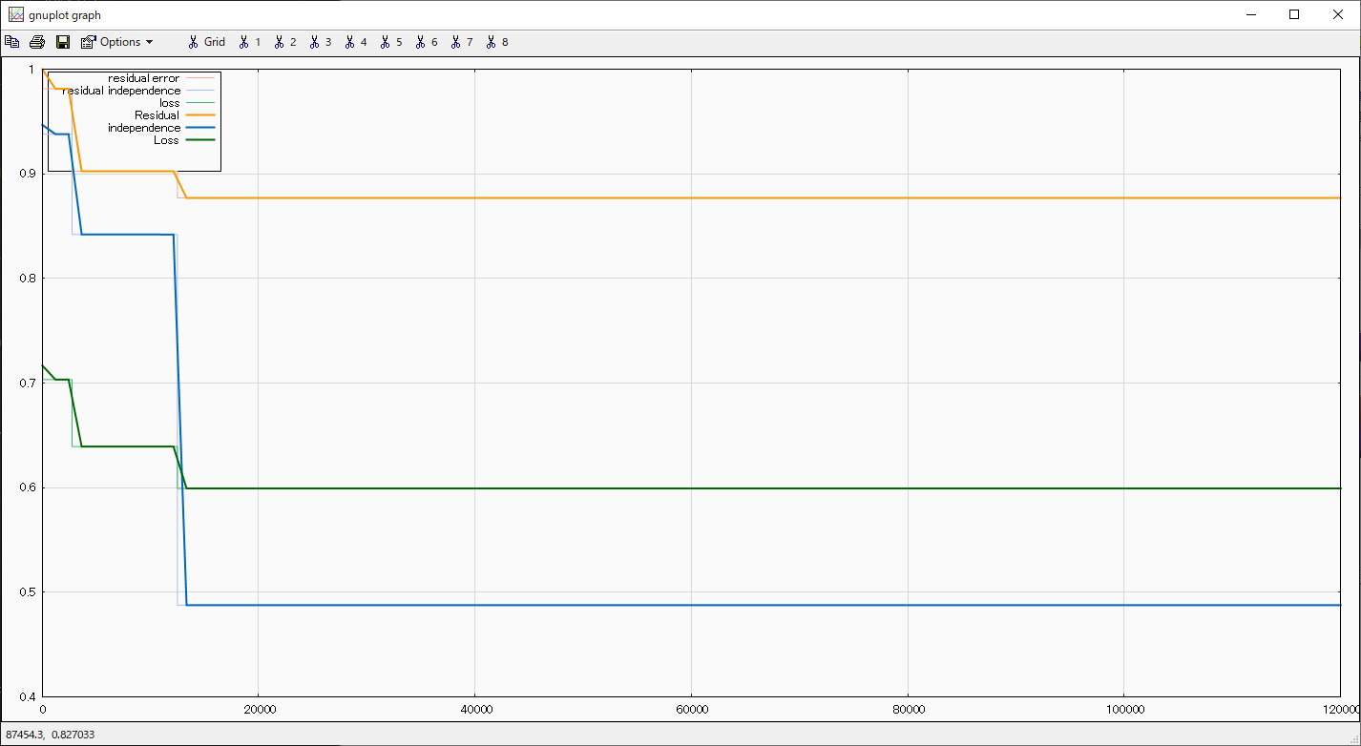

Iter=120000, early_stopping=none

loss:[0.5993]

residual_independence:[0.0000,0.4877]

residual_error:[-2.5057, 2.5779]

**検証データ：LiNGAM_latest2.csv**



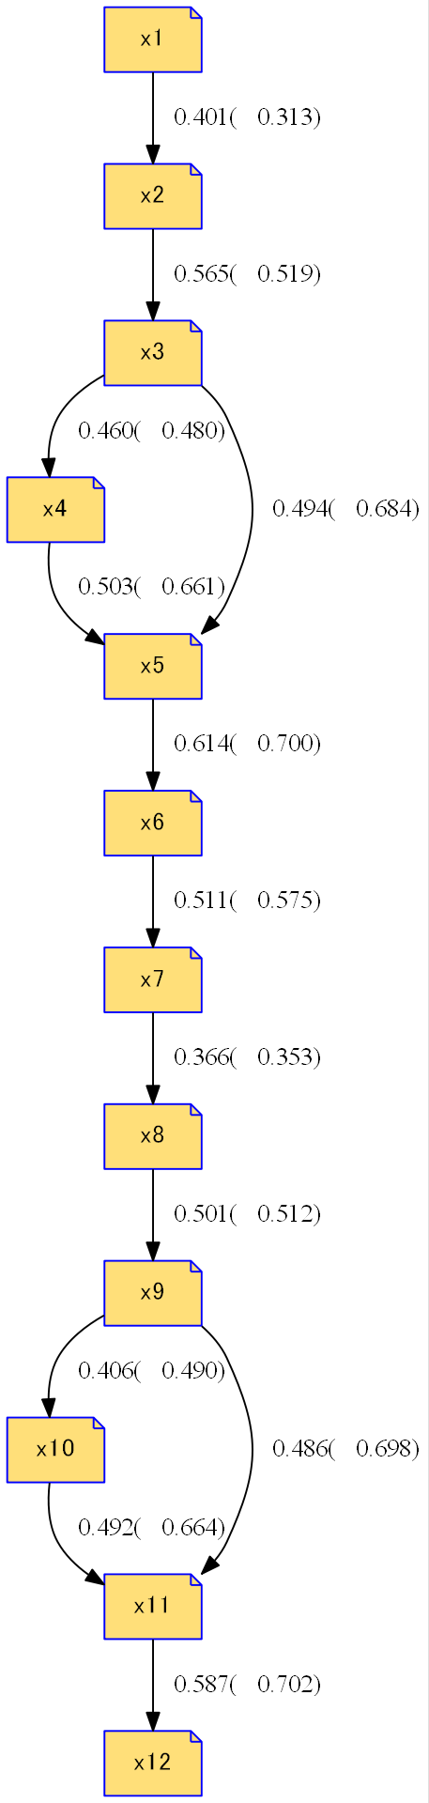



Iter=120000, break=20790[Forcibly terminated because the elapsed time exceeded 8 hours]

loss:[0.6609]

residual_independence:[0.0000,0.5937]

residual_error:[-1.9296, 3.0443]

**検証データ：LiNGAM_latest2.csv**



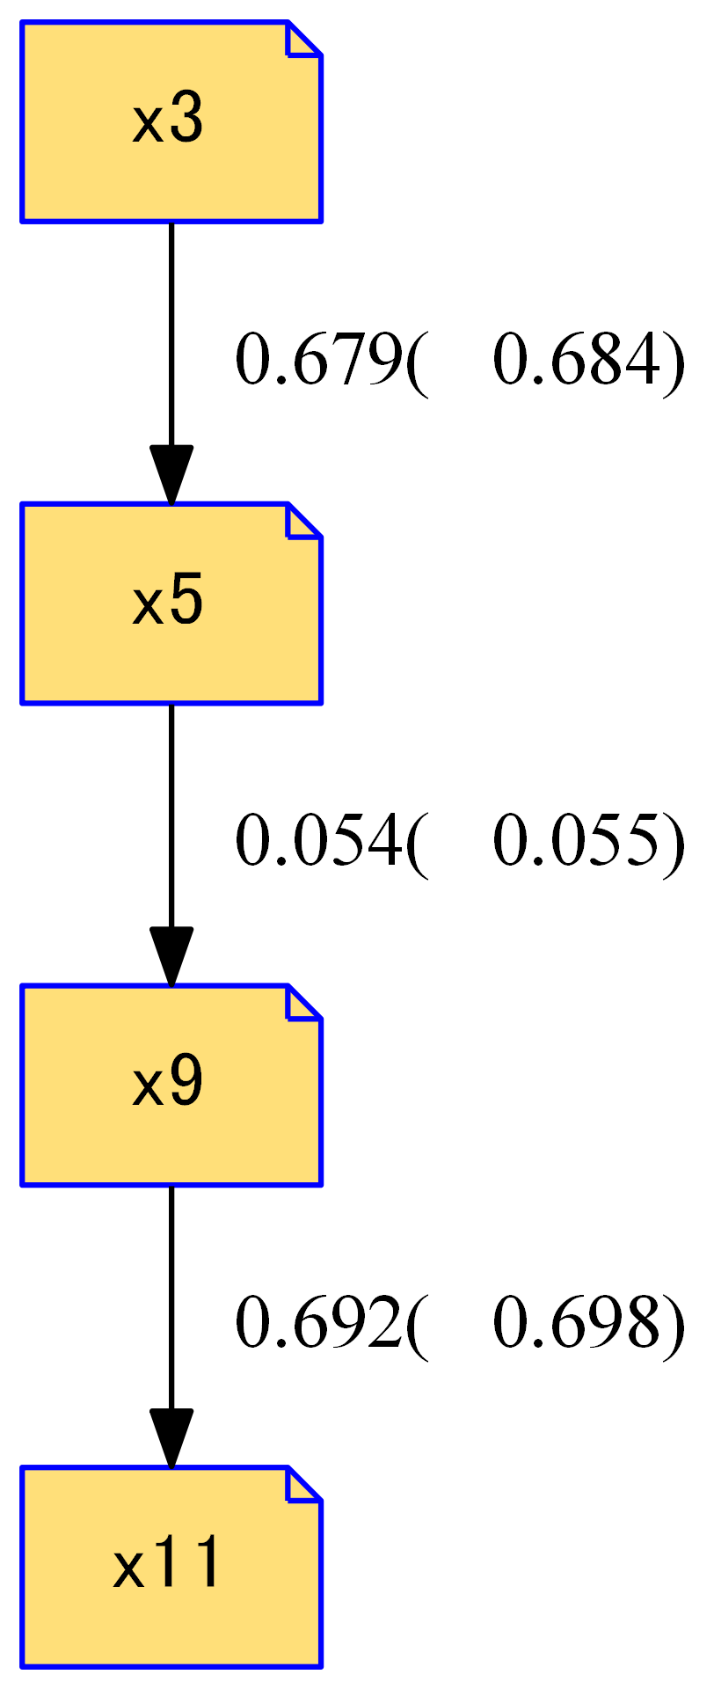



Iter=20000, early_stopping=6000

loss:[0.5196]

residual_independence:[0.0000,0.1672]

residual_error:[-2.3814, 2.6806]