中心半径r
球：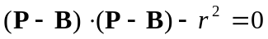

軸ベクトル
円柱：

円錐：
http://en.wikipedia.org/wiki/Cone_(geometry)
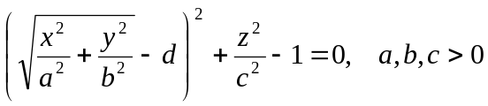
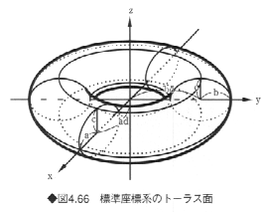

#%
Z=[1,0,0];
Y=[0,1,0];
X=[0,0,1];

extern X;
extern Y;
extern Z;

M=4 4([1,0,0,0],[0,1,0,0],[0,0,1,0],[0,0,0,1]);
Mi=4 4([1,0,0,0],[0,1,0,0],[0,0,1,0],[0,0,0,1]);
Mx = 4 1([1],[1],[1],[1]);

extern M;
extern Mi;
extern Mx;

extern xx;
extern yy;
extern zz;

rotmat2(M,[1,1,1], d2r(45));
sub func(n,xyz)
{
#local2wld(X,Y,Z,M,Mi);

Mx{0} = xyz[0];
Mx{1} = xyz[1];
Mx{2} = xyz[2];
My = M*Mx;
xx = My{0};
yy = My{1};
zz = My{2};

func.ret = 1;

return (xx);
}

#expr = "(sqrt(x^2/3+y^2/3)-5)^2+z^2/3-1";
#implicitsurface2(getstr(expr), [-15,-15,-15],[15,15,15],[0.0, 0.0, 0.0], 1);

put 1;
modalcolor(255,100,0);
expr = "u[0]=x;u[1]=y;u[2]=z;$func(3,u[]);x=xx;y=yy;z=zz;(x^2+y^2+z^2+5^2-3)^2-4*5^2*(x^2+y^2)";

implicitsurface2(getstr(expr), [-15,-15,-15],[15,15,15],[0.0, 0.0, 0.0], 1);

end;

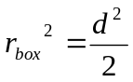

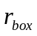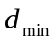
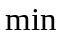

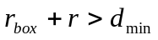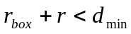

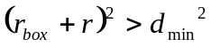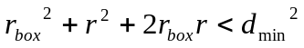
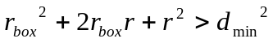

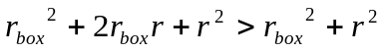

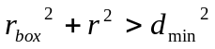

球

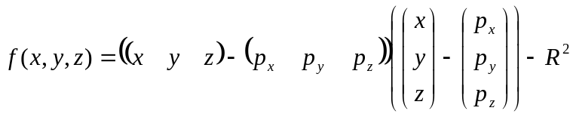
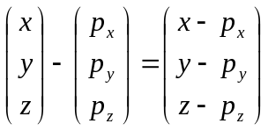
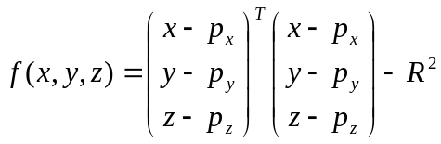

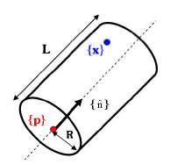
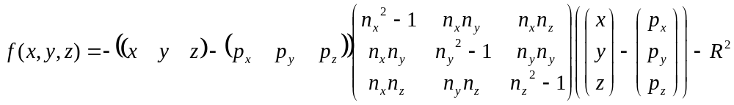
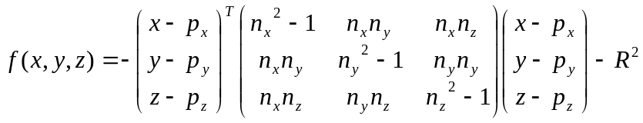
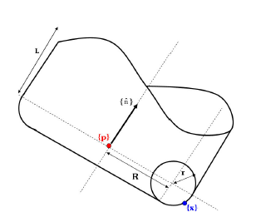
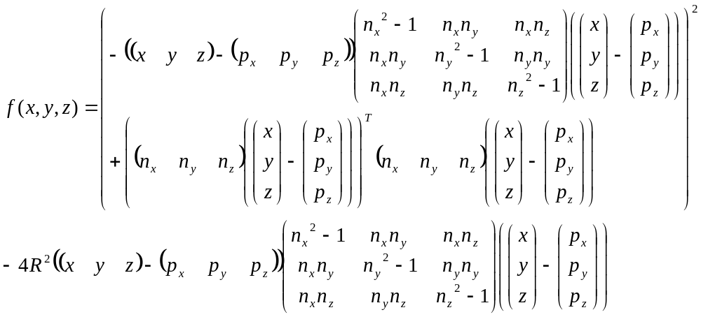
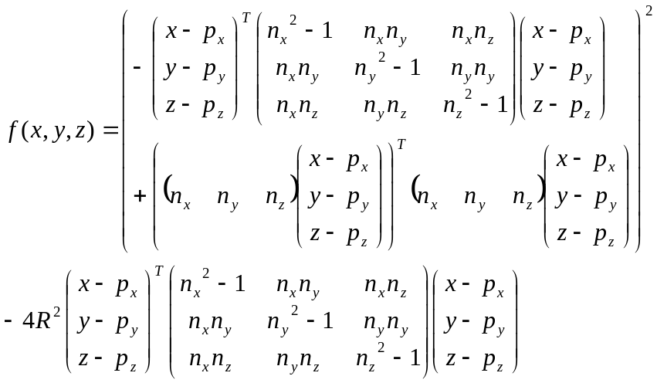

円錐

