中心半径r

球：

軸ベクトル

円柱：

円錐：

http://en.wikipedia.org/wiki/Cone_(geometry)





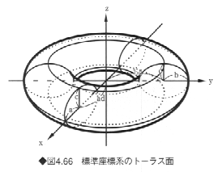





#%

Z=[1,0,0];

Y=[0,1,0];

X=[0,0,1];

extern X;

extern Y;

extern Z;

M=4 4([1,0,0,0],[0,1,0,0],[0,0,1,0],[0,0,0,1]);

Mi=4 4([1,0,0,0],[0,1,0,0],[0,0,1,0],[0,0,0,1]);

Mx = 4 1([1],[1],[1],[1]);

extern M;

extern Mi;

extern Mx;

extern xx;

extern yy;

extern zz;

rotmat2(M,[1,1,1], d2r(45));

sub func(n,xyz)

{

#local2wld(X,Y,Z,M,Mi);

Mx{0} = xyz[0];

Mx{1} = xyz[1];

Mx{2} = xyz[2];

My = M*Mx;

xx = My{0};

yy = My{1};

zz = My{2};

func.ret = 1;

return (xx);

}

#expr = "(sqrt(x^2/3+y^2/3)-5)^2+z^2/3-1";

#implicitsurface2(getstr(expr), [-15,-15,-15],[15,15,15],[0.0, 0.0, 0.0], 1);

put 1;

modalcolor(255,100,0);

expr = "u[0]=x;u[1]=y;u[2]=z;$func(3,u[]);x=xx;y=yy;z=zz;(x^2+y^2+z^2+5^2-3)^2-4*5^2*(x^2+y^2)";

implicitsurface2(getstr(expr), [-15,-15,-15],[15,15,15],[0.0, 0.0, 0.0], 1);

end;



























球









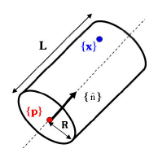





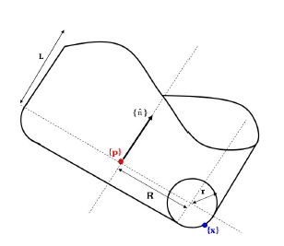





円錐





