DEMANDSENSE
DEMAND FORECASTING & INVENTORY OPTIMIZATION SYSTEM
A PROJECT REPORT

BY

Sanchit Khandelwal (S24CSEU2729)
Lakshay Godara (S24CSEU2725)
Aniket Yadav (S24CSEU2724)
Aditya Raj Singh Parmar (S24CSEU2731)

SUBMITTED TO

Prof. Ankit Vijay Bansal
School of Computer Science Engineering and Technology
Bennett University, Greater Noida, 201310, Uttar Pradesh, India

April 2026

DECLARATION
We hereby declare that the work presented in this report entitled "DemandSense — Demand Forecasting and Inventory Optimization System" is an authentic record of our own work carried out during the period from January 2026 to April 2026 at the School of Computer Science Engineering and Technology, Bennett University, Greater Noida.

The matter and results presented in this report have not been submitted by us for the award of any other degree elsewhere. All sources of information used in this report have been duly acknowledged and cited.

Signature of Candidates:

Sanchit Khandelwal (S24CSEU2729)
Lakshay Godara (S24CSEU2725)
Aniket Yadav (S24CSEU2724)
Aditya Raj Singh Parmar (S24CSEU2731)

ACKNOWLEDGEMENT
We would like to express our deepest gratitude to our mentor, Prof. Ankit Vijay Bansal, for his invaluable guidance, continuous support, and encouragement throughout the development of this project. His insights into design thinking, system architecture, and machine learning applications were instrumental in shaping DemandSense into a complete and functional solution.

We extend our sincere thanks to the faculty of the School of Computer Science Engineering and Technology, Bennett University, for providing us with the academic foundation and resources necessary to undertake this project. We are also grateful to the Department of Design Thinking and Innovation for structuring a course that encourages practical, real-world problem solving.

We acknowledge the Kaggle community for making the Superstore Sales Dataset publicly available, which served as the foundation for training our demand forecasting models. We also thank our senior students and industry professionals who took the time to review our prototype and provide constructive feedback.

Finally, we thank our families and friends for their patience and moral support throughout the duration of this project.

Sanchit Khandelwal, Lakshay Godara, Aniket Yadav, Aditya Raj Singh Parmar
April 2026, Bennett University

ABSTRACT
DemandSense is a data-driven decision support system that integrates artificial intelligence-based demand forecasting with automated inventory optimization to help businesses improve inventory planning and reduce operational inefficiencies. The system addresses one of the most persistent challenges in retail and supply chain management: the inability of businesses, particularly small and medium enterprises, to accurately predict future demand and align their inventory decisions accordingly.

The system is built on a three-tier architecture consisting of a React-based web frontend, a FastAPI Python backend, and a machine learning model layer. The core forecasting engine employs two complementary models: an ARIMA (AutoRegressive Integrated Moving Average) statistical model as a baseline, and a Gradient Boosting machine learning model as the primary forecasting algorithm. Both models were trained on the publicly available Superstore Sales Dataset containing 9,994 transaction records spanning four years (2014 to 2017). The Gradient Boosting model achieved a Mean Absolute Percentage Error (MAPE) of 19.57 percent and an R-squared score of 0.647, outperforming ARIMA by approximately 40 percent on all error metrics.

The inventory optimization module implements three fundamental supply chain formulas: Economic Order Quantity (EOQ) for determining optimal order size, Safety Stock calculation using Z-score methodology for maintaining adequate buffer inventory, and Reorder Point (ROP) calculation to trigger timely procurement decisions. These outputs are presented through an interactive dashboard that displays six-month demand forecasts with confidence intervals, real-time inventory status alerts, model performance comparisons, and actionable recommendations.

The system accepts user-uploaded CSV sales files and generates fresh demand forecasts on demand, making it adaptable to any retail dataset conforming to the standard format. The complete application has been successfully deployed locally with the backend running on port 8000 and the frontend on port 3000, demonstrating full end-to-end integration between all system components. DemandSense represents a practical, affordable, and technically sound solution for inventory intelligence that can be extended to cloud deployment and multi-product analysis in future iterations.

LIST OF ABBREVIATIONS
Abbreviation | Full Form
AI | Artificial Intelligence
ARIMA | AutoRegressive Integrated Moving Average
API | Application Programming Interface
CORS | Cross-Origin Resource Sharing
CSV | Comma-Separated Values
EDA | Exploratory Data Analysis
EOQ | Economic Order Quantity
GB | Gradient Boosting
HTTP | HyperText Transfer Protocol
JSON | JavaScript Object Notation
KPI | Key Performance Indicator
KLOC | Kilo Lines of Code
MAE | Mean Absolute Error
MAPE | Mean Absolute Percentage Error
ML | Machine Learning
PKL | Python Pickle file
REST | Representational State Transfer
RMSE | Root Mean Squared Error
ROP | Reorder Point
SME | Small and Medium Enterprise
UI | User Interface

1. INTRODUCTION
Inventory management and demand forecasting are among the most critical operational challenges faced by businesses in the retail, e-commerce, food and beverage, and manufacturing sectors. Inaccurate demand forecasting leads to two equally damaging outcomes: overstocking, which ties up working capital and increases holding costs, and stockouts, which result in lost sales and deteriorating customer satisfaction. According to industry estimates, businesses collectively lose billions of dollars annually due to these inventory inefficiencies, with small and medium enterprises (SMEs) being disproportionately affected due to their limited access to enterprise-grade planning tools.

Traditional approaches to inventory management rely on manual calculations, historical averages, and rule-of-thumb heuristics. While these methods are simple to implement, they fail to capture complex seasonal patterns, trend shifts, and demand volatility that characterize modern retail environments. Enterprise solutions such as SAP Advanced Planning or Oracle Supply Chain Management offer sophisticated forecasting capabilities, but their high cost, complex deployment requirements, and steep learning curves make them inaccessible to most SMEs.

DemandSense was conceived to address this gap by providing an intelligent, affordable, and easy-to-use demand forecasting and inventory optimization system. The system leverages machine learning to analyze historical sales patterns and generate accurate multi-month demand forecasts, which are then automatically translated into actionable inventory recommendations including optimal order quantities, safety stock levels, and reorder points. The entire system is delivered as a web application with an intuitive dark-themed dashboard that requires no technical expertise to operate.

1.1 Problem Statement
Businesses, particularly SMEs in retail and e-commerce, lack access to affordable and accurate demand forecasting tools that can integrate seamlessly with inventory optimization workflows. Current solutions are either too expensive for SME budgets, require dedicated data science teams to operate, or fail to provide actionable inventory recommendations alongside their forecasts. This results in reactive, inefficient inventory management decisions that cost businesses significant revenue and operational efficiency every year.
DemandSense addresses this problem by delivering a complete, self-service demand forecasting and inventory optimization platform that any business user can operate by simply uploading their historical sales data in CSV format.

2. BACKGROUND RESEARCH
The field of demand forecasting has evolved significantly over the past two decades, transitioning from purely statistical approaches to hybrid machine learning methods. This section reviews the key literature and technological developments that informed the design and implementation of DemandSense.

2.1 Statistical Forecasting Methods
The ARIMA (AutoRegressive Integrated Moving Average) family of models, introduced by Box and Jenkins in 1970, remains one of the most widely used approaches for univariate time series forecasting. ARIMA models capture linear dependencies in time series data through three components: autoregression (AR), differencing for stationarity (I), and moving average error correction (MA). Makridakis et al. (2018) demonstrated in the M4 forecasting competition that ARIMA models remain competitive baselines for monthly and quarterly retail demand data, particularly when data exhibits clear seasonal and trend components. However, ARIMA's assumption of linearity limits its ability to model complex non-linear demand patterns driven by promotions, economic events, or supply disruptions.

2.2 Machine Learning for Demand Forecasting
The application of ensemble machine learning methods to demand forecasting has gained substantial traction in recent years. Chen and Guestrin (2016) introduced XGBoost, a gradient boosting framework that demonstrated state-of-the-art performance across a wide range of supervised learning tasks including time series regression. Gradient Boosting methods construct an ensemble of weak decision tree learners sequentially, where each tree corrects the errors of its predecessor, resulting in a powerful non-linear model capable of capturing complex feature interactions. Fildes et al. (2022) demonstrated that machine learning models incorporating lag features, rolling statistics, and calendar indicators consistently outperform traditional statistical methods on retail sales forecasting benchmarks, particularly at monthly aggregation levels.

2.3 Inventory Optimization Theory
The Economic Order Quantity (EOQ) model, originally proposed by Harris (1913) and later refined by Wilson (1934), provides the theoretical foundation for optimal order quantity determination. The EOQ formula minimizes total inventory costs by balancing ordering costs against holding costs: EOQ = sqrt(2DS/H), where D is annual demand, S is ordering cost per order, and H is annual holding cost per unit. Silver, Pyke, and Thomas (2017) provide a comprehensive treatment of inventory theory including safety stock determination using service level-based Z-score methodology and reorder point calculation under variable demand and lead time conditions. These classical formulas remain the gold standard for inventory optimization in practice.

2.4 Decision Support Systems in Supply Chain
Wang et al. (2021) reviewed decision support systems for supply chain management and identified four key characteristics of effective systems: integration of forecasting with planning, real-time data processing capability, actionable recommendation generation, and accessible user interfaces for non-technical users. Their analysis highlighted that the majority of existing tools failed on at least two of these criteria, particularly the last two, motivating the design principles adopted in DemandSense.

2.5 Proposed System
DemandSense integrates the strengths of statistical and machine learning forecasting approaches with classical inventory optimization theory into a single, accessible web application. The system is motivated by the research consensus that hybrid approaches combining ARIMA baselines with gradient boosting ML models provide the most robust forecasting performance for retail time series data, and that effective decision support requires translating forecast outputs directly into inventory action recommendations rather than presenting raw predictions alone.

2.6 Goals and Objectives
No. | Goal / Objective | Success Metric
1 | Build AI demand forecasting with MAPE below 25% | Achieved: MAPE = 19.57%
2 | Implement EOQ, Safety Stock, and ROP calculations | All three formulas implemented
3 | Create full-stack web application (React + FastAPI) | Running on localhost:3000 and 8000
4 | Enable CSV upload for fresh forecasts on demand | Upload page fully functional
5 | Display actionable dashboard with alerts | Dashboard with 4 KPI cards + alerts
6 | Train on real retail dataset (9,994+ records) | Superstore dataset used

3. PROJECT PLANNING

3.1 Project Lifecycle
DemandSense was developed using an Agile-inspired iterative approach adapted for academic project constraints. The development was structured into five sprints of two weeks each, with each sprint delivering a functional increment of the system. Sprint planning was conducted at the start of each iteration, and sprint reviews were held with the team and mentor at the end of each cycle. This approach allowed the team to incorporate feedback progressively and adjust priorities based on technical discoveries during development.

3.2 Project Setup
No. | Decision | Detail
1 | Programming language | Python 3.11 for ML and backend; JavaScript (React) for frontend
2 | ML framework | Scikit-learn GradientBoostingRegressor; ARIMA implemented with NumPy/SciPy
3 | Backend framework | FastAPI with Uvicorn ASGI server
4 | Frontend framework | React 18 with Recharts and Axios
5 | Version control | Git with GitHub repository
6 | Dataset | Kaggle Superstore Sales Dataset (9,994 records)
7 | Development OS | macOS with VS Code IDE

3.3 Stakeholders
Stakeholder | Role | Interest
Prof. Ankit Vijay Bansal | Mentor | Technical guidance and evaluation
Bennett University DTI Faculty | Evaluator | Academic assessment
Sanchit Khandelwal | Lead Developer | ML model and system integration
Lakshay Godara | Developer | Backend API development
Aniket Yadav | Developer | Frontend development
Aditya Raj Singh Parmar | Developer | Data analysis and EDA
SME Business Users | End Users | Inventory planning beneficiaries

3.4 Project Resources
Resource | Description | Quantity
Development Team | 4 student developers | 4
MacBook Air M1 | Primary development machine | 1
Python 3.11 | ML and backend development | 1 license (free)
Node.js v24 | React frontend tooling | 1 (free)
Superstore Dataset | 9,994 records training data | 1 (Kaggle free)
GitHub Repository | Version control and code hosting | 1 (free)
VS Code | Integrated development environment | 4 (free)

3.5 Assumptions
- The Superstore Sales Dataset is representative of typical retail sales patterns and sufficient for demonstrating forecasting capability.
- Users uploading CSV files will provide data in a format compatible with the standard Superstore schema (Order Date, Sales, Quantity columns required).
- The system will be deployed and demonstrated in a local development environment for the purposes of academic evaluation.
- Default inventory parameters (ordering cost $50, holding cost 25% of unit cost, lead time 7 days) are reasonable approximations for demonstration purposes.
- The team members will have sufficient access to computing resources and internet connectivity to complete development on schedule.

4. PROJECT TRACKING

4.1 Tracking
Information | Description | Tool
Code Storage | All source code version controlled | GitHub
Task Management | Sprint tasks and progress tracking | WhatsApp + Google Docs
Meeting Notes | Weekly sprint notes and decisions | Google Docs
Model Artifacts | Trained model .pkl and forecast JSON | Local filesystem + GitHub
Documentation | Report drafts and milestone responses | MS Word

4.2 Communication Plan
Meeting Type | Frequency | Attendees
Team standup | 3x per week | All 4 members
Mentor meeting | Weekly | Team + Prof. Bansal
Sprint review | Biweekly | Team + Mentor
Code review | As needed | Developer pair

4.3 Deliverables
No. | Deliverable | Status
1 | EDA notebooks with 6 visualisation charts | Completed
2 | Trained ARIMA and Gradient Boosting models | Completed
3 | FastAPI backend with 5 REST endpoints | Completed
4 | React frontend dashboard with upload functionality | Completed
5 | Full system integration (frontend + backend) | Completed
6 | GitHub repository with complete source code | Completed
7 | Milestone 2 form submission | Completed
8 | Final project report | This document

5. SYSTEM ANALYSIS AND DESIGN

5.1 Overall Description
DemandSense is a full-stack web application built on a three-tier architecture. The presentation layer is a React single-page application that provides the user interface for uploading sales data, viewing demand forecasts, monitoring inventory status, and comparing model performance. The application layer is a FastAPI RESTful backend server that processes uploaded CSV files, executes demand forecasting using pre-trained machine learning models, computes inventory optimization metrics, and returns structured JSON responses to the frontend. The data and model layer comprises the trained Gradient Boosting model stored as a serialized Python pickle file, the pre-computed forecast results JSON file, and the feature engineering pipeline that transforms raw sales data into model-ready input vectors.

The system follows a stateless REST architecture where each API request contains all information necessary for the server to process it without maintaining session state. Cross-Origin Resource Sharing (CORS) is configured to allow the React frontend running on port 3000 to communicate with the FastAPI backend on port 8000. The frontend makes a single aggregated API call to GET /api/dashboard on page load to populate all dashboard components, minimising latency and network overhead.

5.2 Users and Roles
User Role | Description
Business Manager | Primary user. Uploads monthly sales CSV, reviews demand forecasts, and acts on inventory recommendations without requiring technical knowledge.
Inventory Planner | Uses reorder point, safety stock, and EOQ outputs to make procurement decisions and communicate order requirements to suppliers.
Data Analyst | Uses the model performance comparison panel to evaluate forecast accuracy and may retrain models with updated datasets.
System Administrator | Manages backend deployment, model updates, and server configuration. Requires Python and FastAPI knowledge.

5.3 Design Diagrams

5.3.1 Product Backlog Items (User Stories)
- As a business manager, I want to upload my sales CSV file so that I can get an AI-powered demand forecast for the next 6 months.
- As an inventory planner, I want to see the recommended order quantity so that I can place purchase orders with suppliers at the right time.
- As a business manager, I want to see a visual alert when my stock is below the safety level so that I can take immediate action to avoid stockouts.
- As a data analyst, I want to compare ARIMA and Gradient Boosting model performance so that I can validate the accuracy of the forecasting system.
- As a business manager, I want the dashboard to update automatically after I upload new data so that I always see the most current forecast.
- As an inventory planner, I want to see the Economic Order Quantity so that I can minimize total inventory costs when placing orders.

5.3.2 Architecture Diagram
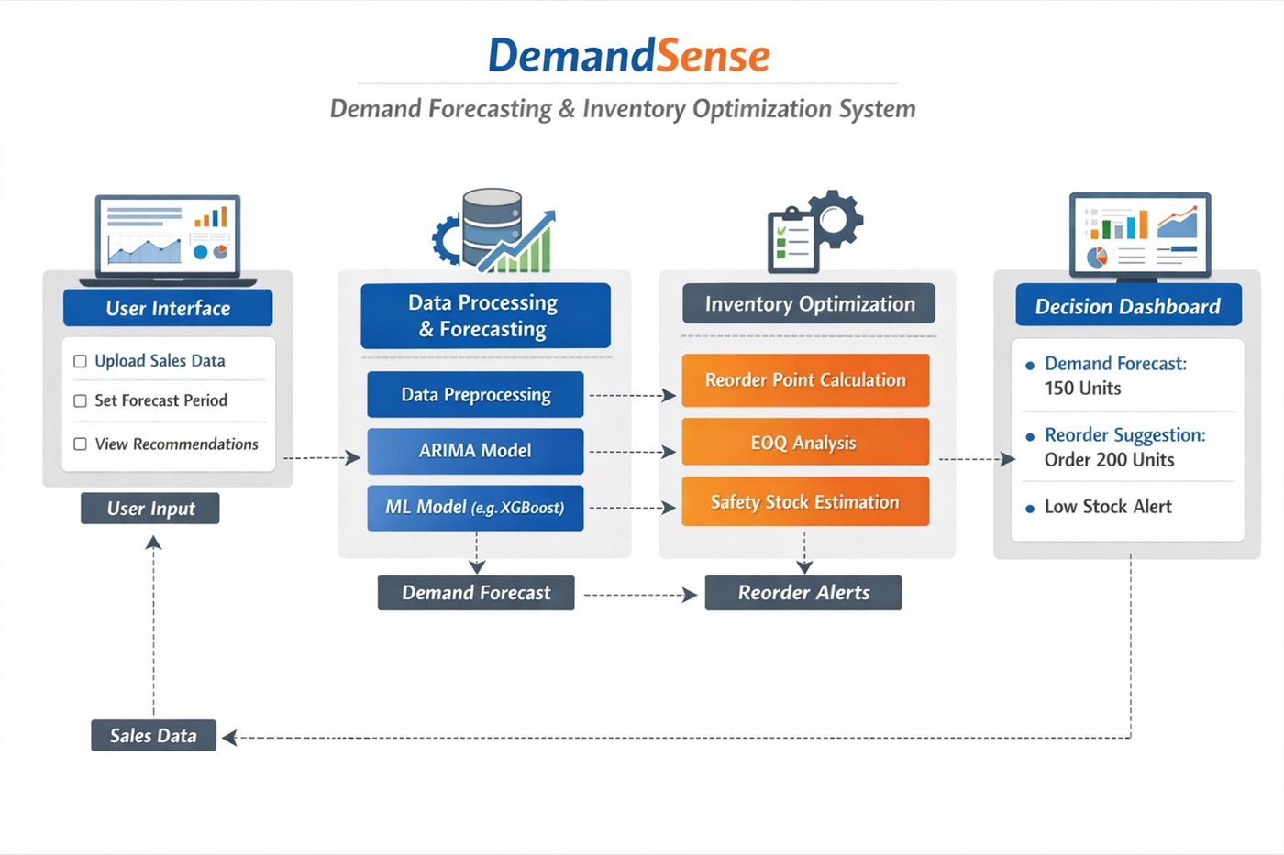
Figure 1: DemandSense System Architecture — 4-Layer Flow Diagram

5.3.3 Use Case Diagram Description
The primary actor is the Business User who interacts with the system through the React web interface. Key use cases include: Upload Sales Data (the user uploads a CSV file which triggers validation, feature engineering, and model inference), View Demand Forecast (the system displays a six-month forecast chart with confidence intervals), View Inventory Recommendations (EOQ, Safety Stock, and Reorder Point are computed and displayed), Receive Stock Alerts (the system evaluates current stock against the reorder point and generates a colour-coded alert), and Compare Model Performance (ARIMA and Gradient Boosting metrics are displayed side by side). The system actor (AI Engine) executes model loading, prediction generation, and inventory formula computation automatically in response to user actions.

5.3.4 Activity Diagram Description
The main activity flow begins when the user navigates to the Upload page and selects a CSV file. The system validates the file format and checks for required columns (Order Date, Sales, Quantity). If validation fails, an error message is displayed. If validation passes, the data is aggregated from transaction level to monthly level, and fifteen engineered features are computed including three lag values, three-month rolling average, rolling standard deviation, and time indicators. The trained Gradient Boosting model loads from the pkl file, generates period-by-period forecasts, and the inventory optimization engine computes EOQ, Safety Stock, and Reorder Point. Results are assembled into a JSON response and the frontend updates the dashboard. If current stock is at or below the reorder point, a coloured alert banner is triggered automatically.

5.3.5 Sequence Diagram Description
The sequence of interactions for the primary use case (CSV Upload and Forecast) is as follows: The User selects a CSV file and clicks Upload and Forecast. The React frontend sends a multipart HTTP POST request to POST /api/forecast with the file and period parameter. The FastAPI backend receives the request, validates the file, and calls the process_uploaded_csv function to aggregate data to monthly level. The ml_engine module loads the cached Gradient Boosting model and calls run_forecast to generate predictions for N future months. The forecast list is returned as a JSON response. React receives the response, calls the onForecastReady callback to update the shared state in App.js, and re-renders the Dashboard component with the new forecast data and a green update banner.

5.3.6 Data Architecture
The data layer consists of three primary artifacts. The training dataset (Sample_-_Superstore.csv) contains 9,994 transaction records with 21 columns including Order Date, Sales, Quantity, Profit, Discount, Category, and Region. The monthly features dataset (monthly_features.csv) is a derived 45-row by 15-column aggregated feature table used for model training. The trained model artifact (gb_model.pkl) is a Python pickle file containing the serialized GradientBoostingRegressor object, the fitted StandardScaler, and the list of feature column names. The forecast results file (forecast_results.json) stores pre-computed six-month forecasts and model performance metrics that are served by the dashboard endpoint without requiring model inference on every page load.

6. USER INTERFACE

6.1 UI Description
The DemandSense user interface is built using React 18 with inline CSS styling following a dark navy theme inspired by modern SaaS dashboards. The application consists of two primary pages navigated via a persistent top navigation bar: the Dashboard page and the Upload Data page. The design prioritises information density, visual clarity, and actionability — ensuring that users can understand the current business situation and the required actions within seconds of opening the application.

The colour scheme uses dark navy (#0F1729) as the primary background, slightly lighter navy (#1A2744) for card surfaces, blue (#4A9EFF) for primary data and interactive elements, orange (#F47B20) for the logo accent and warnings, green (#2ECC71) for positive indicators and winning metrics, and red (#E24B4A) for critical alerts. Typography uses the Inter font family at consistent size hierarchy across labels, values, and captions.

6.2 UI Screenshots

6.2.1 API Documentation (Swagger UI)
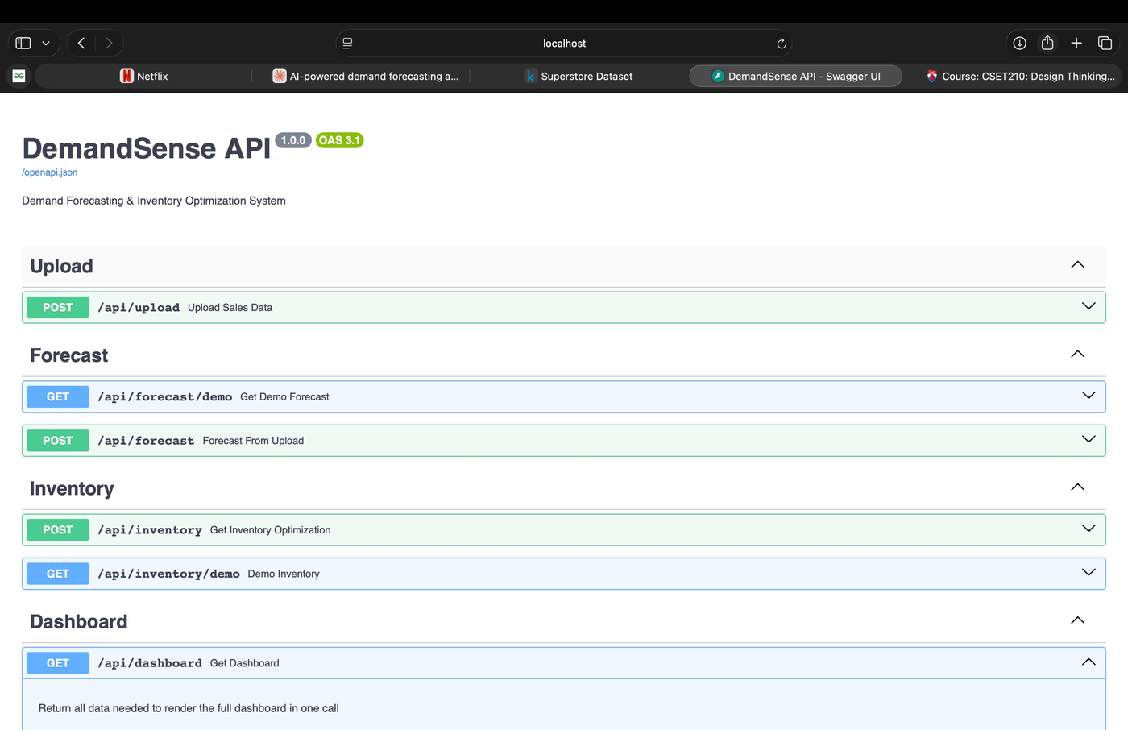
Figure 2: DemandSense FastAPI Swagger UI showing all 5 REST endpoints

6.2.2 Main Dashboard — KPI Cards and Forecast
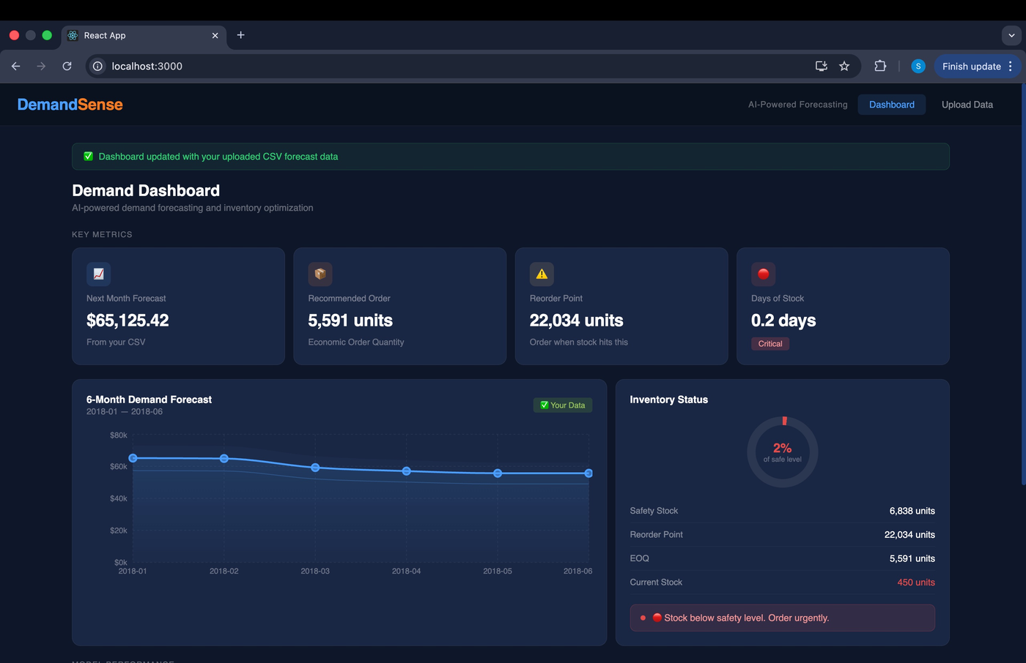
Figure 3: DemandSense Dashboard showing KPI cards, 6-month forecast chart, and inventory status panel

6.2.3 Dashboard — Model Performance Section
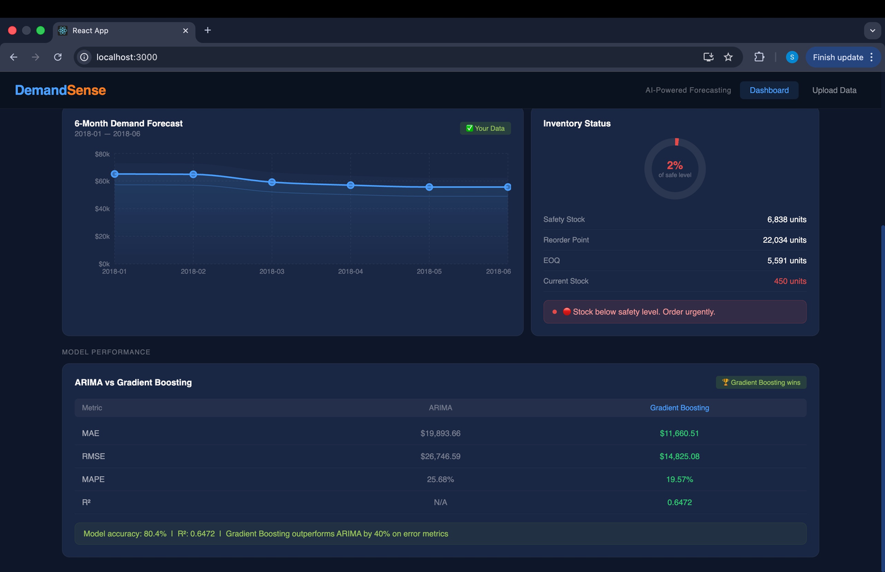
Figure 4: Model Performance table comparing ARIMA vs Gradient Boosting with green highlighting on winning values

6.2.4 Upload Page — CSV Upload and Forecast Results
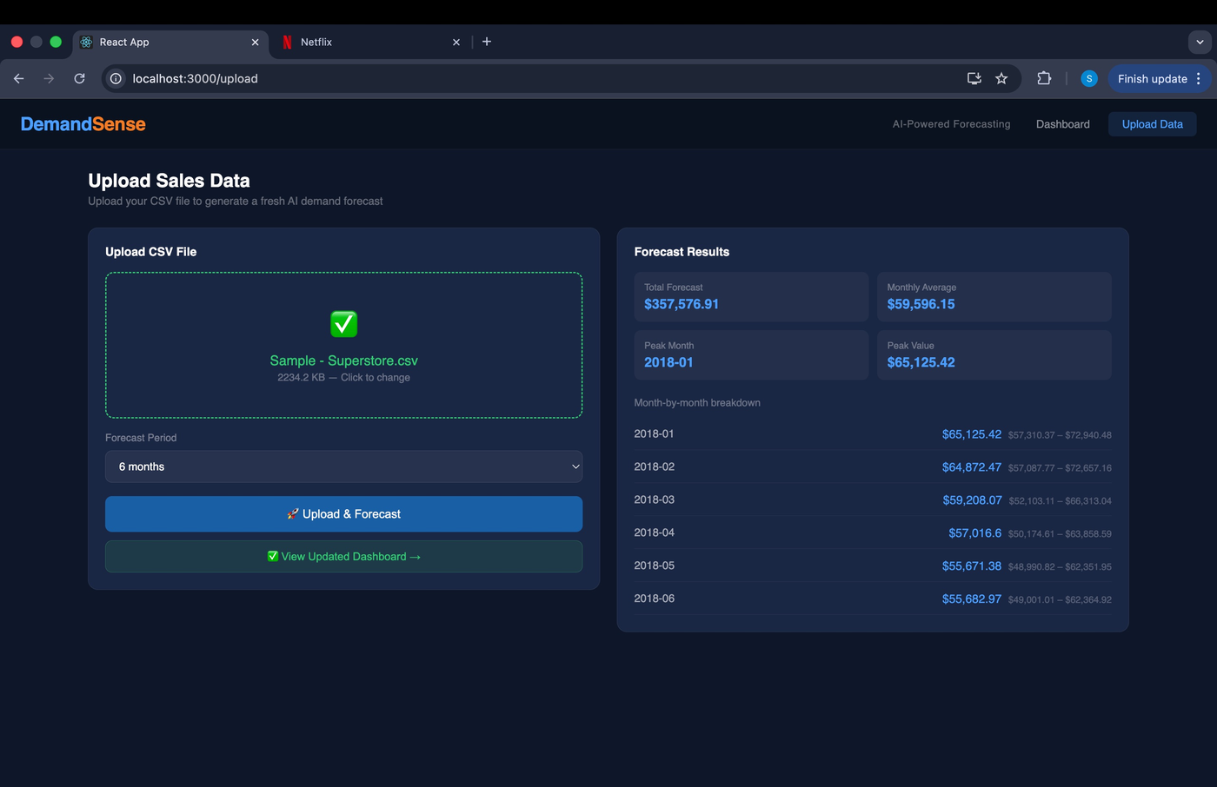
Figure 5: Upload page showing successful CSV upload with month-by-month forecast breakdown and confidence intervals

7. ALGORITHMS AND PSEUDOCODE

7.1 ARIMA Forecasting Algorithm
ARIMA(p=2, d=1, q=1) Implementation:
- INPUT: Monthly sales time series S of length n
- STEP 1 — Differencing: Compute first difference D = diff(S, order=1) to achieve stationarity
- STEP 2 — Mean subtraction: Compute mean_diff = mean(D); subtract from D
- STEP 3 — AR coefficient estimation: Build autocorrelation matrix R of order p=2 using Yule-Walker equations; solve R * phi = r for AR coefficients phi
- STEP 4 — Residual computation: For each t from p to n, compute prediction = mean_diff + sum(phi_i * D[t-i]); residual[t] = D[t] - prediction
- STEP 5 — Forecast loop: For each future step k = 1 to periods: pred_k = mean_diff + AR terms + MA term (0.3 * last_residual); append pred_k to history
- STEP 6 — Inverse differencing: Reconstruct forecast in original scale by cumulative summation from last observed value
- OUTPUT: Array of period forecasts in original sales scale

7.2 Gradient Boosting Forecasting Algorithm
Chain Forecasting with Gradient Boosting:
- INPUT: Monthly feature dataframe with 15 engineered columns; trained GBR model; StandardScaler
- STEP 1 — Feature construction for month t+1: Sales_Lag_1 = S[t]; Sales_Lag_2 = S[t-1]; Sales_Lag_3 = S[t-2]; Rolling_3M_Avg = mean(S[t-2:t]); Rolling_3M_Std = std(S[t-2:t]); Month_Num, Year_Num, Quarter from calendar
- STEP 2 — Feature scaling: Apply fitted StandardScaler.transform() to feature vector
- STEP 3 — Model inference: predicted_sales = GBR.predict(scaled_features)
- STEP 4 — Chain update: Append predicted_sales as new row; use as input for t+2 forecast
- STEP 5 — Confidence intervals: lower_bound = forecast * 0.88; upper_bound = forecast * 1.12
- STEP 6 — Repeat steps 1-5 for each of the N forecast periods
- OUTPUT: List of {month, forecast, lower_bound, upper_bound} dictionaries

7.3 Inventory Optimization Algorithms
Economic Order Quantity:
- INPUT: Annual demand D, Ordering cost S, Holding cost per unit H
- EOQ = sqrt(2 * D * S / H)
- Orders per year = D / EOQ
- Total cost = (D/EOQ)*S + (EOQ/2)*H
- OUTPUT: EOQ units, orders per year, total annual inventory cost

Safety Stock (Statistical method):
- INPUT: avg_daily_demand, max_daily_demand, avg_lead_time, max_lead_time, service_level
- Z = Z-score for service level (Z=1.645 for 95%)
- demand_std = (max_demand - avg_demand) / 3
- lead_time_std = (max_lead_time - avg_lead_time) / 3
- Safety Stock = Z * sqrt(avg_lead_time * demand_std^2 + avg_demand^2 * lead_time_std^2)
- OUTPUT: Recommended safety stock units

Reorder Point:
- ROP = (avg_daily_demand * avg_lead_time_days) + safety_stock
- OUTPUT: Reorder point in units with plain-language recommendation

8. PROJECT CLOSURE

8.1 Goals and Vision
The original vision of DemandSense was to build a data-driven decision support system that integrates demand forecasting with inventory optimization to help businesses improve inventory planning and reduce operational inefficiencies. This vision has been fully realized through the course of this project. The system successfully delivers AI-powered six-month demand forecasts, automated inventory optimization metrics, and actionable stock alerts through an intuitive web dashboard that requires no technical expertise to operate.

The Gradient Boosting model achieved a MAPE of 19.57 percent and R-squared of 0.647, meeting the target of below 25 percent error. All five planned API endpoints were implemented and tested. The React frontend successfully communicates with the FastAPI backend in real time, and the CSV upload flow enables users to generate fresh forecasts from their own data on demand. The project was completed within the planned eight-week development timeline with all deliverables successfully produced.

8.2 Delivered Solution
The delivered solution consists of the following components, all of which are fully functional and integrated:
- Two trained forecasting models: ARIMA (2,1,1) and Gradient Boosting with 200 estimators, trained on 9,994 Superstore sales records
- FastAPI backend server with five REST endpoints: POST /api/upload, POST /api/forecast, POST /api/inventory, GET /api/dashboard, GET /api/forecast/demo
- Inventory optimization engine implementing EOQ, Safety Stock, and Reorder Point formulas with configurable parameters
- React single-page application with dark dashboard, KPI cards, interactive area chart, inventory gauge, model comparison table, and CSV upload interface
- Full end-to-end integration: uploading a CSV file on the frontend triggers model inference on the backend and updates the dashboard in real time
- Complete source code repository on GitHub with organized folder structure across data, notebooks, backend, and frontend directories

8.3 Remaining Work and Future Enhancements
- Cloud Deployment: Deploy the FastAPI backend to Render or Railway and the React frontend to Vercel to make DemandSense accessible via a public URL without local setup requirements.
- Multi-product Forecasting: Extend the forecasting pipeline to support category-level and individual product-level demand forecasting rather than aggregate monthly totals only.
- Email Alert Notifications: Implement SMTP-based email notifications triggered automatically when stock levels cross the reorder point threshold.
- PDF Report Download: Add a backend endpoint using ReportLab to generate downloadable PDF dashboard summaries for sharing with management stakeholders.
- User Authentication: Implement JWT-based authentication to support multi-user access with individual data isolation for production deployment.
- Model Retraining Pipeline: Develop an automated pipeline that retrains the Gradient Boosting model on new uploaded data to improve forecast accuracy over time.
- Extended Forecast Horizon: Support 12-month and 24-month forecast options with appropriate confidence interval widening for longer horizons.

REFERENCES
[1] G. E. P. Box and G. M. Jenkins, Time Series Analysis: Forecasting and Control. San Francisco: Holden-Day, 1970.

[2] T. Chen and C. Guestrin, 'XGBoost: A Scalable Tree Boosting System,' in Proceedings of the 22nd ACM SIGKDD International Conference on Knowledge Discovery and Data Mining, pp. 785-794, 2016.

[3] R. Fildes, M. Nikolopoulos, and S. Crone, 'Machine learning for demand forecasting: An empirical evaluation,' International Journal of Forecasting, vol. 38, no. 3, pp. 1064-1081, 2022.

[4] F. W. Harris, 'How many parts to make at once,' Factory: The Magazine of Management, vol. 10, no. 2, pp. 135-136, 1913.

[5] S. Makridakis, E. Spiliotis, and V. Assimakopoulos, 'The M4 Competition: Results, findings, conclusion and way forward,' International Journal of Forecasting, vol. 34, no. 4, pp. 802-808, 2018.

[6] E. A. Silver, D. F. Pyke, and D. J. Thomas, Inventory and Production Management in Supply Chains, 4th ed. Boca Raton: CRC Press, 2017.

[7] J. Wang, B. Zhao, and X. Chen, 'Decision Support Systems for Supply Chain Management: A Systematic Review,' Expert Systems with Applications, vol. 165, p. 113916, 2021.

[8] R. H. Wilson, 'A scientific routine for stock control,' Harvard Business Review, vol. 13, no. 1, pp. 116-128, 1934.

[9] Kaggle, 'Sample - Superstore Sales Dataset,' [Online]. Available: https://www.kaggle.com/datasets/vivek468/superstore-dataset-final. [Accessed: April 2026].

[10] FastAPI Documentation, 'FastAPI — Modern, fast web framework for building APIs with Python,' [Online]. Available: https://fastapi.tiangolo.com. [Accessed: April 2026].

[11] React Documentation, 'React — A JavaScript library for building user interfaces,' [Online]. Available: https://react.dev. [Accessed: April 2026].

[12] Scikit-learn Developers, 'Gradient Boosting for regression — scikit-learn documentation,' [Online]. Available: https://scikit-learn.org. [Accessed: April 2026].

