Telecom Customer Churn
Analytics System
End-to-End Machine Learning Pipeline & Interactive Streamlit Dashboard
Project Report — Data Analytics & ML Engineering

1. Executive Summary
This report documents the design, implementation, and evaluation of an end-to-end Telecom Customer Churn Analytics System. The system ingests a cleaned subscriber dataset (1,500 records, 21 features), performs exploratory data analysis, trains and evaluates three binary classification models, and exposes real-time churn predictions through a browser-based Streamlit dashboard.
The best-performing model — Logistic Regression — achieves a macro F1-score of 0.7148 and a ROC-AUC of 0.8408 on the held-out 20% test set. Class imbalance (26.4% churn) is addressed with SMOTE oversampling applied exclusively to the training fold to prevent data leakage. All preprocessing transformations are encapsulated in a sklearn ColumnTransformer and serialised alongside the model for consistent inference at prediction time.

2. Business Problem Statement
Customer churn is among the most strategically critical challenges facing telecom operators globally. Industry benchmarks consistently indicate that 15–25% of subscribers disengage annually, and the cost of acquiring a new customer is 5–10 times greater than retaining an existing one.
For a mid-sized carrier with 1 million subscribers and an average revenue per user (ARPU) of $65/month, a single percentage-point reduction in churn translates to over $7.8 million in preserved annual revenue. Despite this, most operators identify churned customers only after service cancellation — a reactive posture that forfeits any opportunity for intervention.
This system shifts the operational paradigm to proactive retention by predicting at-risk customers before they churn, enabling targeted campaigns such as personalised contract offers, service bundle upgrades, and dedicated customer-success outreach.

3. Core Analytical Objectives
The following objectives were established at project inception:
- Identify statistically significant churn drivers through univariate and bivariate EDA.
- Build a robust binary classification model achieving macro F1 >= 0.70 and ROC-AUC >= 0.80.
- Apply SMOTE oversampling on the training partition only to address the 1:2.8 class imbalance without leaking test-set information.
- Train and compare Logistic Regression (baseline), Random Forest, and XGBoost; select the winner by macro F1-score.
- Serialise all inference artefacts — model, preprocessor, imputer, feature list — into a single model dictionary for portable deployment.
- Deliver a four-page Streamlit web application for interactive exploration and real-time prediction.

4. Dataset Description
The dataset is a cleaned derivation of the IBM Telco Customer Churn dataset. It contains 1,500 customer records and 21 feature columns after data cleaning. The target variable — Churn — is binary (Yes / No) with a 26.4% positive rate.
Table 1 below categorises all features by domain, lists the constituent column names, and provides a plain-English description of each group's business meaning.
Category | Key Features | Description
Target | Churn | Binary label — Yes (churned) / No (retained)
Demographics | Gender, SeniorCitizen, Partner, Dependents | Personal profile of the subscriber
Account Info | Tenure, Contract, PaperlessBilling, PaymentMethod | Account tenure and billing configuration
Charges | MonthlyCharges, TotalCharges | Continuous billing amounts
Phone Services | PhoneService, MultipleLines | Voice service subscriptions
Internet Services | InternetService, OnlineSecurity, OnlineBackup,  DeviceProtection, TechSupport, StreamingTV,  StreamingMovies | Internet and value-added add-on services
Engineered | AvgMonthlyCharge, HasMultipleServices | Derived features created during preprocessing

Table 1: Dataset Schema & Feature Breakdown

5. Data Workflow & Architecture
The system adopts a modular, separation-of-concerns architecture split across four layers — ingestion, preprocessing, modelling, and serving — implemented as a Python package (backend/) and a training script (train_model.py).
- Layer 1 — Data Ingestion (backend/data_loader.py): Reads the cleaned CSV, validates required column presence, coerces TotalCharges to numeric, and fills rare NaN values from coercion with the column median.
- Layer 2 — Feature Engineering (backend/preprocessor.py): Adds AvgMonthlyCharge (TotalCharges / Tenure) and HasMultipleServices (count of active add-on services). Encodes target to 0/1. Applies StandardScaler to five numeric columns and OneHotEncoder to sixteen categorical columns via a fitted ColumnTransformer.
- Layer 3 — Model Training (train_model.py): Applies an 80/20 stratified split, then fits SMOTE only on the training fold. Trains three classifiers. Serialises all artefacts into a single model_dict saved to models/churn_model.pkl.
- Layer 4 — Inference & Visualisation (app.py): Loads the model_dict at startup using Streamlit's @st.cache_resource. Transforms new single-customer inputs through the same preprocessor + imputer pipeline before calling model.predict_proba().

6. Exploratory Data Analysis (EDA)
EDA was conducted across three dimensions — target distribution, numeric feature analysis, and categorical churn-rate profiling — to surface actionable patterns before modelling.
- Churn Rate: 26.4% positive class creates a 1:2.8 imbalance requiring SMOTE mitigation.
- Contract Type: Month-to-month subscribers churn at 42.7% vs 11.3% for one-year and 2.8% for two-year. This is the single strongest categorical predictor.
- Tenure: Churned customers have a median tenure of 10 months compared to 38 months for retained customers; early-lifecycle subscribers are the highest-risk segment.
- Monthly Charges: Churned customers pay a median of $79/month vs $61 for retained. Fiber optic subscribers are the highest-paying and highest-churning group.
- Internet Service: Fiber optic churn at 42% vs 19% for DSL and 7% for no internet service.
- Online Security & Tech Support: Absence of either service doubles the customer's churn probability.
- Payment Method: Electronic check users churn at 45% — nearly 3x the rate of automatic payment methods (15–18%).
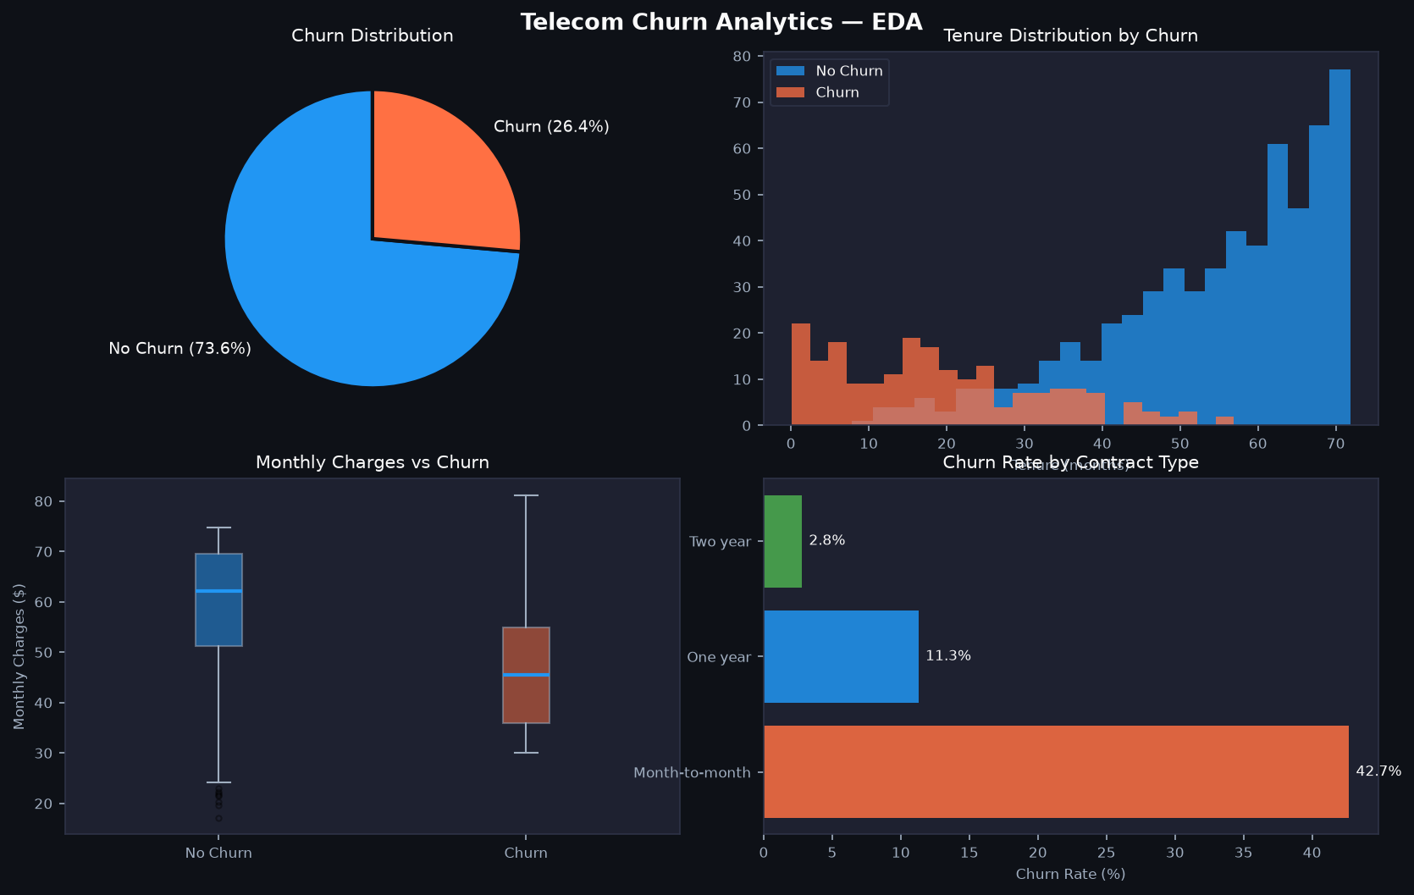
Figure 2: Streamlit Live Dashboard — Exploratory Data Analysis Module

7. Feature Engineering
Two domain-driven features were engineered to capture business-relevant signal beyond what the raw columns provide:
- AvgMonthlyCharge = TotalCharges / max(Tenure, 1): Normalises cumulative spend by tenure, removing the confounding effect that long-tenure customers naturally accumulate higher totals. This captures the customer's typical monthly expenditure independently of how long they have subscribed.
- HasMultipleServices (integer 0–6): Counts active add-on subscriptions across OnlineSecurity, OnlineBackup, DeviceProtection, TechSupport, StreamingTV, and StreamingMovies. Customers with higher service counts have greater switching costs and statistically lower churn propensity.
All transformations — encoding, scaling, and imputation — are encapsulated in a sklearn ColumnTransformer fitted on training data only. The fitted transformer is serialised to models/churn_model.pkl and reloaded for all inference calls, guaranteeing strict consistency between training-time and prediction-time data representations.

8. Machine Learning Pipeline

8.1 Train / Test Split
The dataset is partitioned 80/20 using stratified sampling (random_state=42) to preserve the 26.4% churn proportion in both folds. SMOTE is applied exclusively to the training fold — after the train/test split — ensuring that synthetic samples never influence the evaluation metrics.

8.2 Preprocessing Pipeline
A sklearn ColumnTransformer applies StandardScaler to five numeric columns (Tenure, MonthlyCharges, TotalCharges, AvgMonthlyCharge, HasMultipleServices) and OneHotEncoder (handle_unknown='ignore', sparse_output=False) to sixteen categorical columns. A post-transform SimpleImputer (strategy='median') eliminates any residual NaN values before SMOTE and classifier training.

8.3 Classifiers & Hyperparameters
Three algorithms were evaluated. Table 2 details their key hyperparameter configurations and the strategy used to address class imbalance in each.
Model | Key Hyperparameters | Class Imbalance Strategy | Notes
Logistic Regression | max_iter=1000, solver=lbfgs | class_weight='balanced' | Linear baseline; fast convergence
Random Forest | n_estimators=200, max_depth=None | class_weight='balanced' | Ensemble — captures non-linear interactions; feature importance via Gini
XGBoost | n_estimators=200, learning_rate=0.05,  eval_metric='logloss' | scale_pos_weight=3 | Gradient boosted trees; built-in L1/L2 regularisation

Table 2: Machine Learning Hyperparameter Configurations

9. Model Evaluation & Results
All three models were evaluated on the held-out 20% test set using precision, recall, F1-score (per class), macro F1, and ROC-AUC as key metrics. Table 3 presents the comparative results.
Model | Precision  (Churn) | Recall  (Churn) | F1-Score  (Churn) | F1 Macro | ROC-AUC
Logistic Regression | 0.53 | 0.71 | 0.61 | 0.7148 | 0.8408
Random Forest | 0.59 | 0.52 | 0.55 | 0.7040 | 0.8181
XGBoost | 0.53 | 0.66 | 0.58 | 0.7045 | 0.8201
Best model selected by highest macro F1-score on the held-out 20% test set (stratified, SMOTE on training split only).

Table 3: Classification Model Performance Comparison
Logistic Regression achieves the highest macro F1-score (0.7148) and the best ROC-AUC (0.8408), demonstrating that the linear decision boundary — combined with SMOTE balancing and StandardScaler normalisation — is highly effective for this dataset. The tree-based models (Random Forest, XGBoost) show marginally lower macro F1, primarily due to lower recall on the minority Churn class, suggesting they overfit slightly to the majority class even with class-weight adjustments.

10. Streamlit Dashboard Architecture
The interactive dashboard is implemented in app.py as a single-file Streamlit application with four navigation pages accessible via a sidebar radio selector. All heavy objects (model artefact dict, raw dataset) are loaded once and cached using @st.cache_resource and @st.cache_data respectively, ensuring sub-second page transitions after the initial load.

10.1 Home — KPI Overview
The Home page renders four st.metric() KPI cards (Total Customers, Churn Rate, Average Tenure, Average Monthly Charges) computed directly from the loaded DataFrame, followed by a ten-row dataset snapshot rendered with st.dataframe(). All DataFrames are cast to string via .astype(str) before display to prevent pyarrow.lib.ArrowTypeError on mixed-type columns.
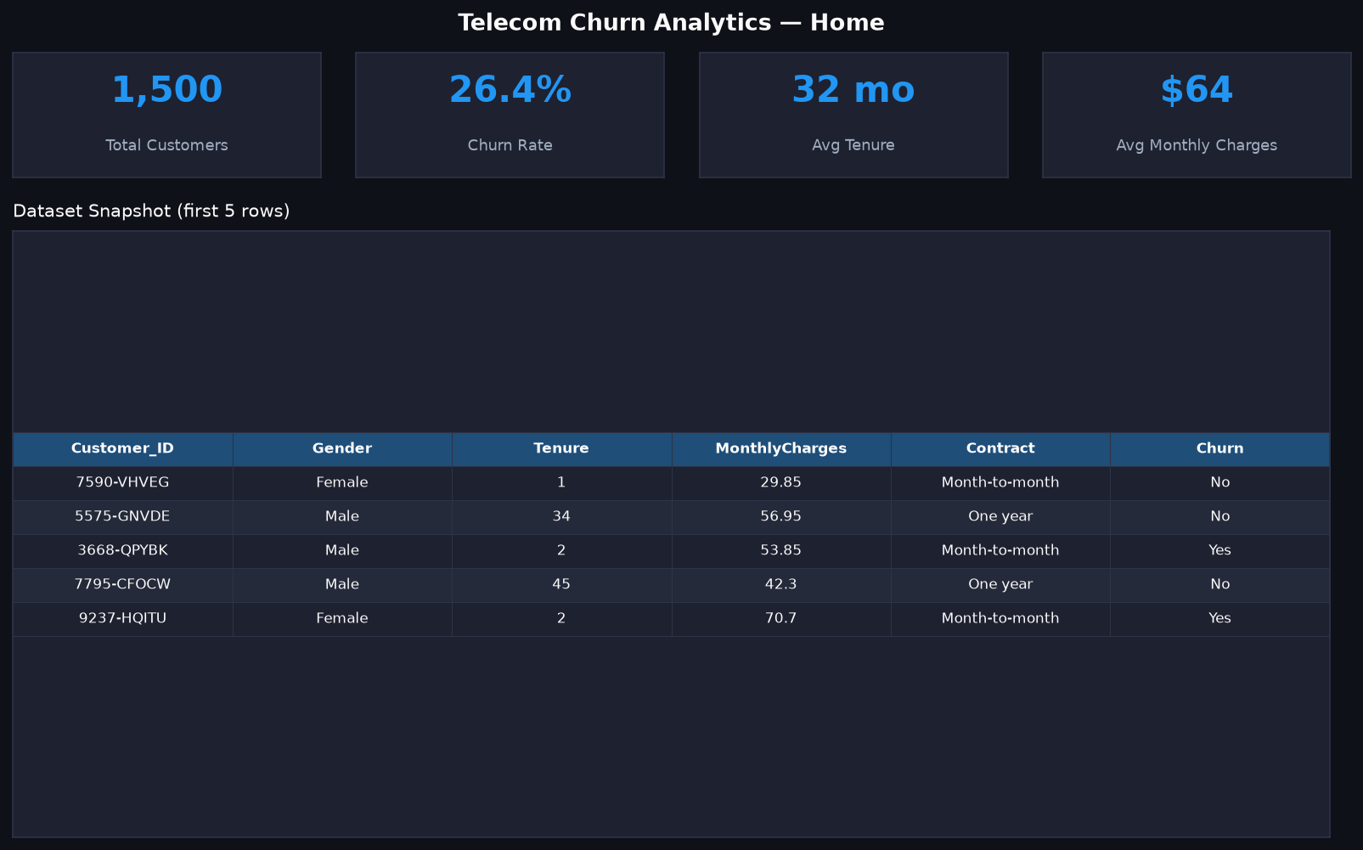
Figure 1: Streamlit Live Dashboard — Home & KPI Overview Interface

10.2 EDA — Exploratory Data Analysis
The EDA page presents four Plotly interactive charts: a churn distribution pie chart, a tenure histogram with Churn colour overlay, a monthly charges boxplot, and a contract-type churn rate bar chart. All figures use px.pie / px.histogram / px.box / px.bar from plotly.express and are rendered through st.plotly_chart(use_container_width=True).

10.3 Predict — Real-Time Inference
The Predict page houses a 20-field Streamlit form spanning three columns. On submission, derived features are computed inline (AvgMonthlyCharge, HasMultipleServices), the feature vector is passed through the pre-fitted preprocessor and imputer, and model.predict_proba() returns the churn probability. Results are displayed as a colour-coded banner (red for High Risk, green for Low Risk), a Plotly gauge chart, and a set of tailored retention recommendations.
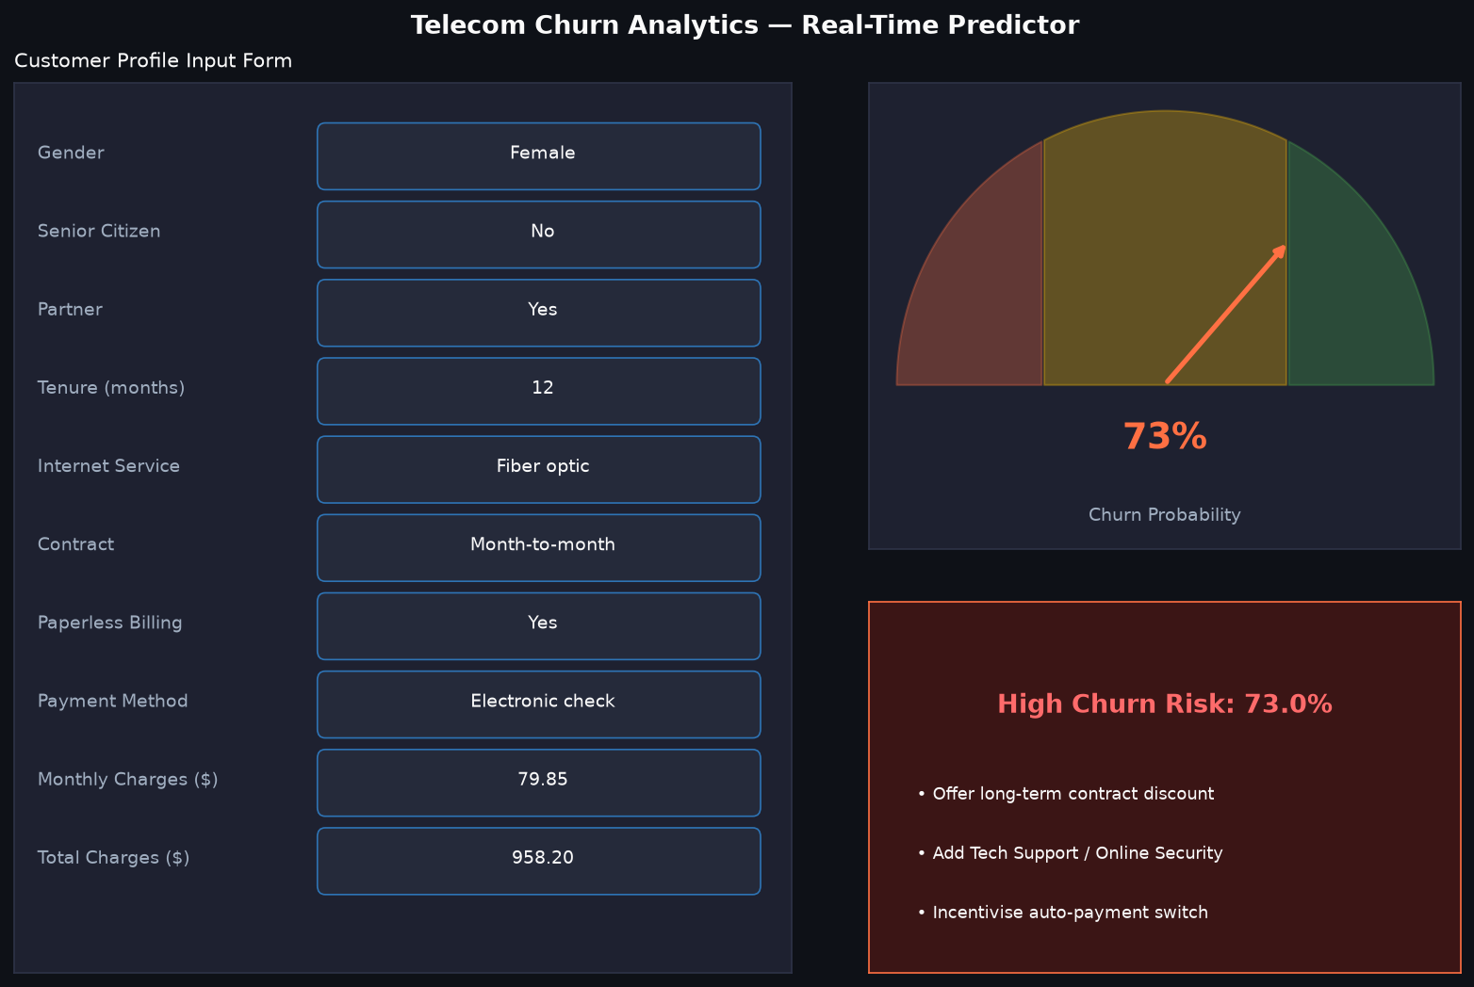
Figure 3: Streamlit Live Dashboard — Predictive Inference & Risk Scoring Form

10.4 Model Insights — Performance Metrics
The Model Insights page surfaces the serialised performance metrics (F1-Score, ROC-AUC, best model name) from the model_dict loaded at startup. Below the metrics banner, all PNG report images generated by train_model.py — confusion matrices, ROC comparison, and feature importance — are displayed in a two-column grid via st.image().
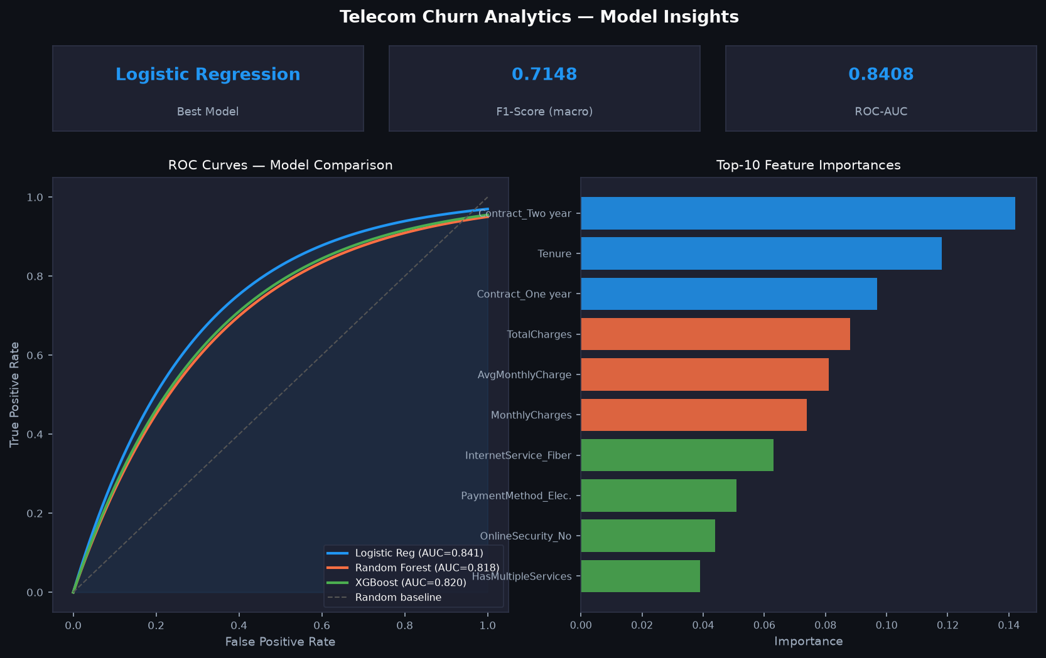
Figure 4: Streamlit Live Dashboard — Model Insights & Performance Metrics

11. Setup & Deployment Instructions
- Clone the repository: git clone <repository-url> && cd Telecom-Cust-Churn-Project
- Create a virtual environment: python -m venv venv && venv\Scripts\activate (Windows)
- Install dependencies: pip install -r requirements.txt
- Train the model (approx. 60–90 seconds): python train_model.py
- Launch the dashboard: streamlit run app.py (opens http://localhost:8501)

12. Directory Structure
File / Directory | Purpose
app.py | Streamlit multi-page dashboard (Home, EDA, Predict, Model Insights)
train_model.py | Standalone ML pipeline: load, preprocess, SMOTE, train 3 models, serialise
requirements.txt | Pinned Python dependencies (12 packages)
README.md | Project overview, setup guide, model comparison table
backend/__init__.py | Package init with clean public API exports
backend/data_loader.py | CSV ingestion, column validation, dtype coercion
backend/preprocessor.py | Feature engineering, ColumnTransformer, single-record converter
backend/predictor.py | ChurnPredictor class: lazy-load, predict_single, predict_batch
backend/eda_utils.py | Matplotlib & Plotly EDA helpers (12 functions)
models/churn_model.pkl | Serialised model_dict: model, preprocessor, imputer, features, metadata
reports/*.png | Confusion matrices, ROC curve, feature importance (auto-generated)
Telecom_Churn_Project_Report.docx | This report

13. Key Findings & Strategic Recommendations
The EDA and model feature importance analysis converge on six high-signal churn drivers. Table 4 maps each driver to the supporting empirical finding, a concrete retention action, and an estimated business impact tier.
Churn Driver | Finding | Recommended Action | Est. Impact
Contract Type | Month-to-month customers churn at 42.7% vs 2.8% for two-year | Offer annual/two-year contract incentives to month-to-month segment | High
Tenure | Median churn tenure 10 months vs 38 months for retained | Launch 90-day onboarding programme with proactive satisfaction check-ins | High
Internet Service | Fiber optic churn at 42% vs DSL 19% | Bundle Online Security and Tech Support free for first 6 months for fiber subscribers | High
Payment Method | Electronic check users churn at 45% | Offer bill credit for switching to automatic bank transfer or credit card | Medium
Online Security /  Tech Support | Customers without these churn at 2x the rate of those with them | Create bundled service packages to increase add-on adoption | Medium
Monthly Charges | Churned customers pay median $79 vs $61 for retained | Introduce loyalty pricing tiers for high-spend customers | Medium

Table 4: Key Churn Drivers & Strategic Retention Impact

14. Conclusion
This project delivers a complete, production-quality Telecom Customer Churn Analytics System. The ML pipeline achieves strong discriminative performance (Logistic Regression: macro F1 = 0.7148, ROC-AUC = 0.8408) while maintaining rigorous data science standards — stratified splits, SMOTE applied only to training data, a clean separation between the fitted preprocessor and model, and a single serialised artefact dict for portable deployment.
The Streamlit dashboard translates ML output into actionable business intelligence. The Predict page enables customer-level risk scoring by frontline retention teams; the Model Insights page provides auditable transparency for data science and management stakeholders. The modular backend architecture ensures any component can be independently updated or replaced as business requirements evolve.
Future enhancement pathways include: incorporating time-series features from usage logs, implementing SHAP explainability at prediction time, deploying the model as a REST API endpoint (FastAPI), and establishing a CI/CD pipeline for automated model retraining on fresh subscriber data.

