**PBJ Documentation**

**Objective:** This document aims at explaining all the required steps that one needs to follow in order to successfully prepare a peanut butter and jam (or jelly) sandwich.

**Scope of the document:** The steps involved in making a peanut butter jam sandwich are elucidated in such a way that anyone with little/no prior experience can easily follow it.

**Materials Required:** The following materials will be required for a peanut butter jam (or) jelly sandwich.

* ***Cutlery*** - butter knife, jam spreader knife, bread knife cutting board and plate
* ***Edible Items***- A loaf of bread (or bread slices), a jar of peanut butter, a jar of jam (or jelly) of any flavor.

**Procedure:** Steps to make a peanut butter jam sandwich are as follows.

* ***Preparing the bread slices.***

1. Take an unsliced loaf of bread and place it on a cutting board such that one of the flat surfaces of the loaf is resting on the cutting board
2. Gently grip the loaf of bread as shown in figure1

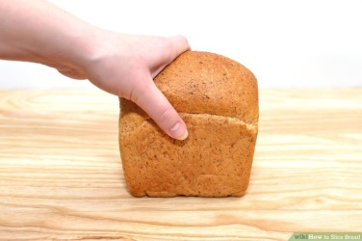

Figure 1: How to grip a loaf of bread *(“How to slice bread,” n.d.)*

1. Hold a bread knife securely, cut into the crust at a slight angle. Saw the bread knife downwards through the loaf after the crust of the bread gets pierced.
2. After the first cut through the loaf you get one bread slice. Repeat the above mentioned steps in order to get the second bread slice. One can make the slices as thick or thin according to requirements. However a ½ -1 inch of thickness is usually considered apt as shown in figure 2.

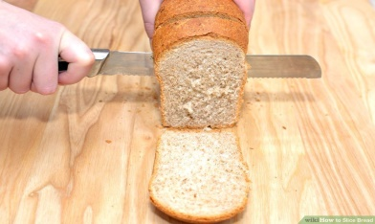

Figure 2: Cutting slices from a loaf of bread *(“How to slice bread,” n.d.)*

1. Step 1 to step 4 are required if an unsliced loaf of bread is used for peanut butter jam sandwich. However these steps are not required if pre sliced bread slices are used. In that case just take two bread slices and place them on the cutting board side by side as shown in figure 3.

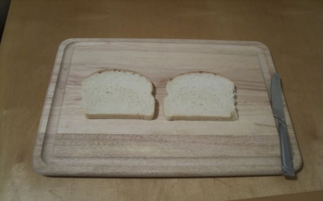

Figure 3: Placing two bread slices side by side *(kzavoral, n.d.)*

* ***Applying Peanut Butter***

1. Open the peanut butter jam and then using butter knife scoop out a dollop of peanut butter (according to desired taste and requirement) and spread it evenly on top of each bread slices one by one as shown in the figure 4. (only one side of each bread slice will be applied with peanut butter)This step can be repeated as long as the entire bread surface is not evenly covered with peanut butter.

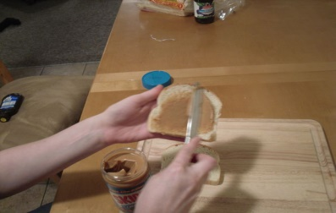

Figure 4: Applying peanut butter on bread *(kzavoral, n.d.)*

* ***Applying Jam***

1. After both the bread slices are ready with a layer of peanut butter spread over them, pick one of the bread slice and apply jam on it by using a jam spreader.
2. Open the jam jar and scoop out a big dollop of jam and spread it evenly on the bread slice as shown in figure 5

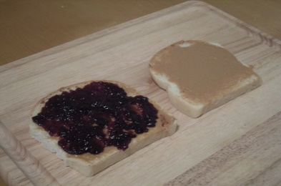

Figure 5: Applying jam on bread *(kzavoral, n.d.)*

* ***Final Steps***

1. Combine both the bread slices. Pick the bread slice with only peanut butter on it and put it on top of the bread slice with peanut butter and jam on it. While putting the bread slice (with only peanut butter) make sure that the peanut butter side of the bread faces down towards the jam smeared face of the second bread as shown in figure6 .

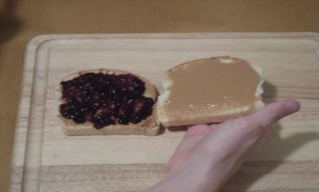

Figure 6: Combining bread pieces *(kzavoral, n.d.)*

1. After putting the peanut butter side of the bread on the jam and peanut butter smeared bread, cut it diagonally as shown in figure7.

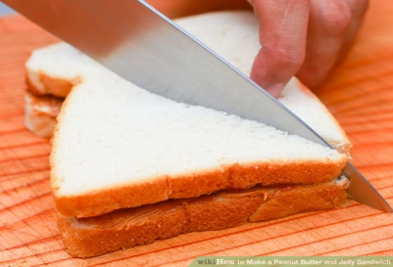

Figure 7: Cutting bread pieces *(“How to make a peanut butter and jelly sandwich,” n.d.)*

1. Thus after following the above steps we get the peanut butter jam sandwich with peanut butter on top and bottom and with jam (jelly) in between. Refer figure 8.

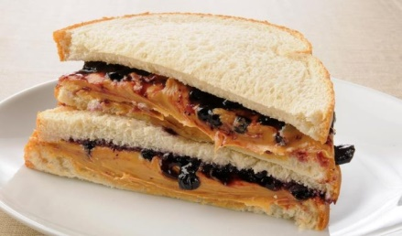

Figure 8: Peanut Butter and Jam Sandwich *(Samuels, 2015)*

**Reference:**

* How to slice bread. Retrieved October 24, 2016, from wikihow, http://www.wikihow.com/Slice-Bread#/Image:Slice-Bread-Step-2.jpg
* How to slice bread. Retrieved October 24, 2016, from wikihow, http://www.wikihow.com/Slice-Bread#/Image:Slice-Bread-Step-3.jpg
* (Kzavoral, n.d.) How to make the perfect peanut butter and jelly sandwich. Retrieved October 24, 2016, from http://www.instructables.com/id/How-To-Make-a-Perfect-Peanut-Butter-and-Jelly-Sand/
* (Kzavoral, n.d.) How to make the perfect peanut butter and jelly sandwich. Retrieved October 24, 2016, from http://www.instructables.com/id/How-To-Make-a-Perfect-Peanut-Butter-and-Jelly-Sand/step3/Apply-Peanut-Butter/
* (Kzavoral, n.d.) How to make the perfect peanut butter and jelly sandwich. Retrieved October 24, 2016from http://www.instructables.com/id/How-To-Make-a-Perfect-Peanut-Butter-and-Jelly-Sand/step4/Apply-Jelly/
* (Kzavoral, n.d.) How to make the perfect peanut butter and jelly sandwich. Retrieved October 24, 2016, from http://www.instructables.com/id/How-To-Make-a-Perfect-Peanut-Butter-and-Jelly-Sand/step5/Combine-Both-Slices-of-Bread/
* How to make a peanut butter and jelly sandwich. Retrieved October 24, 2016, from wikihow, http://www.wikihow.com/Make-a-Peanut-Butter-and-Jelly-Sandwich#/Image:Make-a-Peanut-Butter-and-Jelly-Sandwich-Step-5.jpg
* Samuels, M. (2015, November 6). The Carbohydrates in a peanut butter & jelly sandwich. Retrieved October 24, 2016, from Livestrong, http://www.livestrong.com/article/254515-the-carbohydrates-in-a-peanut-butter-jelly-sandwich/

**[Word Count: 659]**