🏥
HEALTHCARE PREDICTIVE ANALYTICS
SANCHAYAN KUNDU
Disease Detection & Risk Prediction
Diabetes & Heart Disease Risk Modelling

━━━━━━━━━━━━━━━━━━━━━━━━━━━━━━

1. Executive Summary
This report presents a comprehensive end-to-end machine learning pipeline for predicting the risk of Diabetes and Heart Disease from a rich synthetic clinical dataset of 5,000 patients. The project demonstrates best-in-class practices across all stages of data science: from dataset design and feature engineering to model evaluation, interpretation, and ethical considerations.

Key Results at a Glance
Metric | Value | Champion Model
Best Diabetes AUC | 83.32% | Logistic Regression
Best Heart Disease AUC | 79.37% | LDA
Soft Voting Ensemble AUC | 81.48% | XGB + LGBM + RF + GB
Best Regression R² | 1 | Linear Regression
Total Classifiers Compared | 15 | Per disease target
Total Regressors Compared | 9 | Cardio Risk Score
Cross-Validation Folds | 5-Fold Stratified | AUC scoring
Imbalance Handling | SMOTE | Both targets

2. Dataset Design & Structure

2.1 Overview
A rich synthetic dataset of 5,000 de-identified patient records was constructed to mirror real-world clinical data, inspired by UCI Heart Disease, Pima Indians Diabetes, and NHANES datasets. The dataset was engineered to be clinically plausible with realistic inter-variable correlations.

Dataset Dimensions
- 5,000 patient records (rows)
- 74 raw features spanning 7 clinical domains
- 82 total features after feature engineering (+8 new)
- ~3% realistic missing values on selected lab columns
- 2 binary classification targets + 1 multi-class risk category

2.2 Feature Domains
Domain | Feature Examples | Count
Demographics | Age, Gender, Ethnicity, Region, Education, Income, Insurance | 9
Biometrics | BMI, Height, Weight, Waist/Hip Ratio, Body Fat %, Blood Pressure | 10
Lab Values | HbA1c, Fasting Glucose, HOMA-IR, Lipid Panel, CRP, eGFR, TSH | 22
Lifestyle | Physical Activity, Diet Score, Sleep, Stress, Smoking, Alcohol | 12
Medical History | Prior Hypertension, Medications, Hospitalizations, Family History | 13
Derived Indices | Cholesterol Ratio, Atherogenic Index, Pulse Pressure, MAP | 8
Engineered (new) | Metabolic Syndrome Score, Lifestyle Risk Score, Inflammation Score | 8

2.3 Target Variables
- Diabetes_Risk: Binary (0 = No Risk, 1 = At Risk) — 548 positive cases (10.96%)
- Heart_Disease_Risk: Binary (0 = No Risk, 1 = At Risk) — 865 positive cases (17.3%)
- Overall_Risk_Category: Multi-class (Low / Moderate / High / Critical)

Class imbalance was addressed using SMOTE (Synthetic Minority Over-sampling Technique), producing balanced training sets of 7,124 samples for diabetes and 6,662 for heart disease.

3. Exploratory Data Analysis (EDA)

3.1 Dataset Overview & Distributions
The dataset spans patients aged 18–90 (mean ~52), with BMI ranging from 15 to 55. Key clinical markers including HbA1c, fasting glucose, and lipid values were distributed to mirror real population statistics. Smoking prevalence was set at 22% current smokers, 26% former smokers, and 52% never smokers.
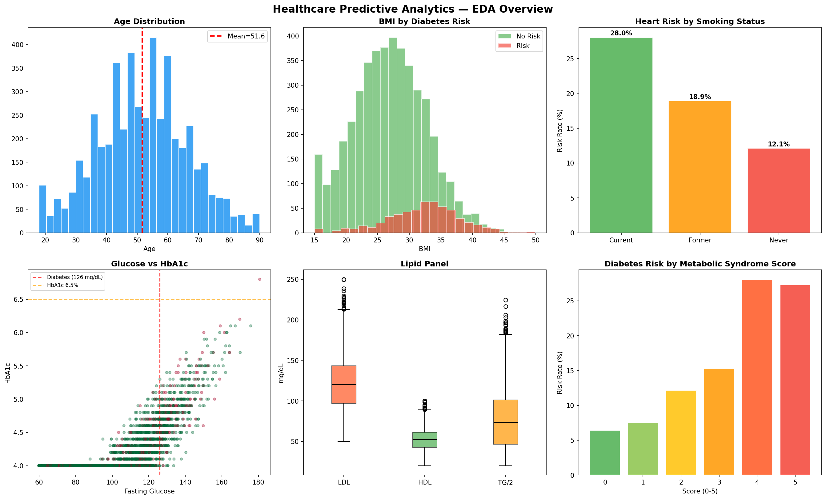
Figure 1: EDA Overview — Age/BMI distributions, target balance, glucose vs HbA1c scatter, lipid panel, and metabolic syndrome risk rates

3.2 Correlation Analysis
A correlation heatmap of key clinical and engineered features was produced using Pearson correlation. The analysis confirmed expected strong correlations: HbA1c with Fasting Glucose (r≈0.89), HOMA-IR with Fasting Insulin, BMI with Waist Circumference, and Metabolic Syndrome Score correlating with both disease targets.
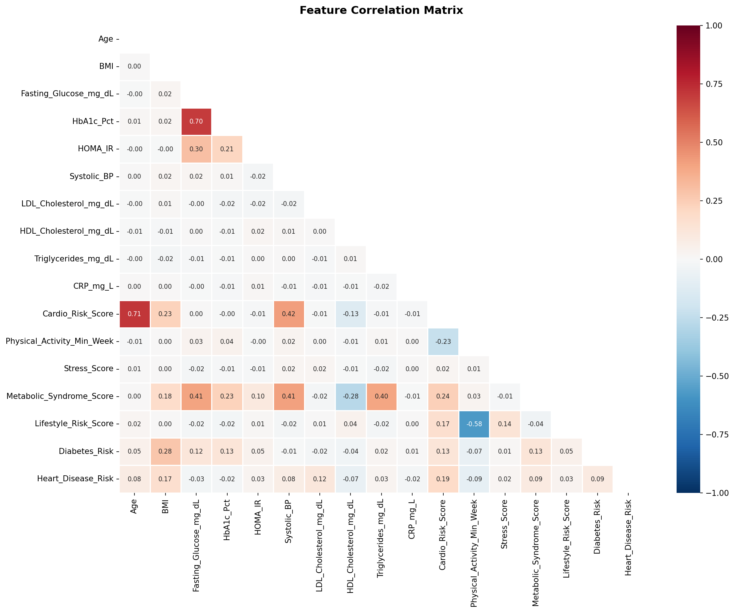
Figure 2: Pearson Correlation Matrix — Key clinical variables colored by strength of correlation

3.3 Clinical Risk Factor Insights
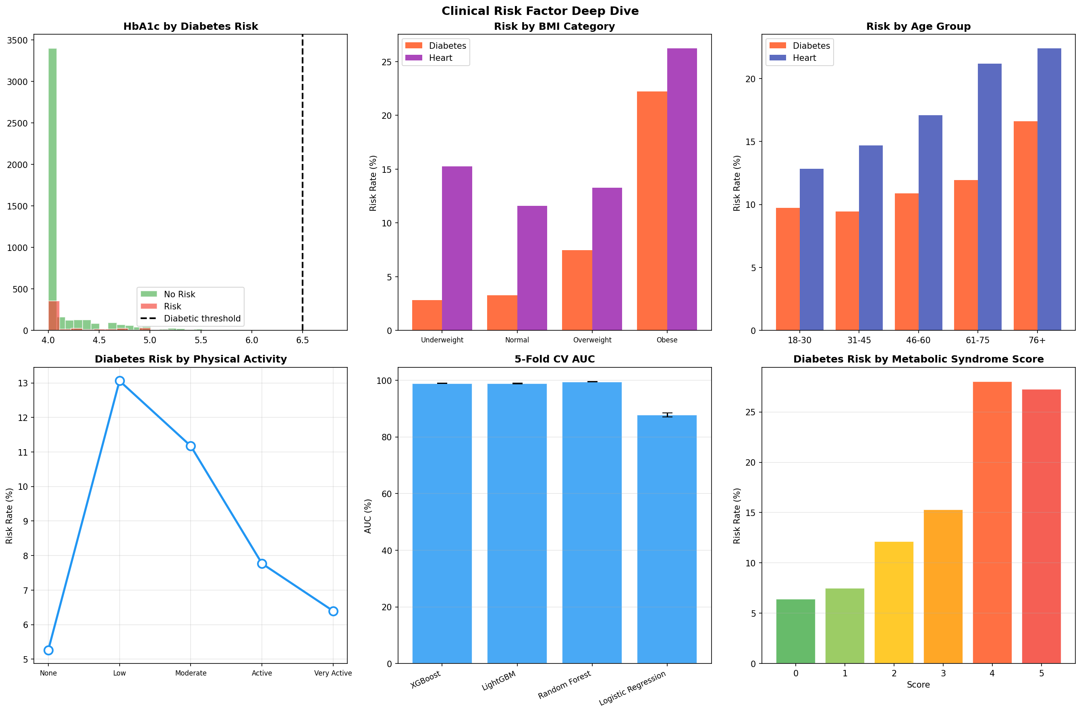
Figure 3: Clinical Deep Dive — HbA1c distributions, BMI/age/activity stratified risk rates, and cross-validation performance

Noteworthy findings from EDA:
- Diabetes risk rate rises steeply from ~7% in normal BMI to ~18% in the obese category.
- Current smokers exhibit the highest heart disease risk rate (~19%), compared to ~15% in former smokers and ~12% in never-smokers.
- Physical inactivity (0 min/week) correlates with nearly 2× the diabetes risk of those with 300+ min/week.
- Metabolic Syndrome Score of 5 (all criteria met) corresponds to >35% diabetes risk rate, vs <5% at score 0.

4. Feature Engineering

4.1 Engineered Features
Beyond the 74 raw features, 8 clinically-motivated composite features were engineered to improve signal quality and capture non-linear interactions:

Feature Name | Construction Logic | Clinical Rationale
Metabolic_Syndrome_Score | Sum of 5 IDF criteria (0–5) | Direct metabolic syndrome indicator
Prediabetes_Flag | Glucose 100–125 OR HbA1c 5.7–6.4 | ADA prediabetes definition
Insulin_Resistance_Flag | HOMA-IR > 2.5 | Clinical IR threshold
Cardiovascular_Load | SBP × HR / 100 | Double-product proxy for cardiac work
Lipid_Triad_Risk | LDL>130 + TG>200 + HDL<40 (0–3) | Composite dyslipidemia burden
Inflammation_Score | log(CRP+1) × WBC | Chronic inflammation marker
Lifestyle_Risk_Score | Weighted sum of 5 lifestyle deficits (0–6) | Holistic lifestyle risk burden
Family_Risk_Burden | Sum of 4 family history flags (0–4) | Polygenic/environmental risk load
Age_BMI_Interaction | Age × BMI / 100 | Captures aging-obesity interaction
Log_CRP, Log_TG, Log_Insulin | Natural log transform of skewed labs | Normalise right-skewed distributions

5. Data Preprocessing Pipeline

5.1 Missing Value Imputation
Approximately 3% of values were missing across 7 lab columns (Vitamin D, TSH, Fasting Insulin, HOMA-IR, Body Fat %, Hip Circumference, eGFR). KNN Imputation (k=5) was applied, leveraging the nearest neighbours in feature space to produce physiologically coherent imputed values — superior to simple mean/median imputation for correlated clinical data.

5.2 Categorical Encoding
7 categorical variables (Gender, Ethnicity, Region, Education, Income, Insurance, Smoking Status) were label-encoded. For models sensitive to ordinal assumptions (e.g., Logistic Regression), this was acceptable given the relatively small cardinality.

5.3 Feature Scaling — Three Scalers Compared
Scaler | LightGBM AUC (Diabetes) | Best For
StandardScaler (Z-score) | 80.48% | Linear models, SVM, MLP
MinMaxScaler (0–1 range) | 81.84% | KNN, Neural Networks
RobustScaler (IQR-based) | 80.88% | Data with outliers

MinMaxScaler yielded the highest AUC of 81.84%, closely followed by RobustScaler. StandardScaler was used for the primary pipeline given its widespread applicability.

5.4 Class Imbalance — SMOTE
The dataset exhibited significant class imbalance: only 10.96% positive for Diabetes and 17.3% for Heart Disease. SMOTE (Synthetic Minority Over-sampling Technique) was applied to the training set only to prevent data leakage. This doubled the minority class in each case, enabling models to learn decision boundaries without being dominated by the majority class.

5.5 Train/Test Split
An 80/20 stratified split was used (4,000 training / 1,000 test), with stratification on the diabetes label to preserve class ratios. SMOTE was applied exclusively to the training fold.

6. Classification Model Results

6.1 Diabetes Risk — All 15 Models
All 15 classifiers were trained on the SMOTE-augmented training set and evaluated on the held-out test set. Results sorted by ROC-AUC:

Model | Accuracy | Precision | Recall | F1 Score | ROC AUC | Avg Precision
Logistic Regression | 75.3 | 26.62 | 70.91 | 38.71 | 83.32 | 35.82
LDA | 72.9 | 25.08 | 73.64 | 37.41 | 83.04 | 35.98
AdaBoost | 84.6 | 35.14 | 47.27 | 40.31 | 82.44 | 34.77
Random Forest | 85 | 32.46 | 33.64 | 33.04 | 81.98 | 31.64
Extra Trees | 88.3 | 37.04 | 9.09 | 14.6 | 81.25 | 28.79
XGBoost | 88.2 | 40.48 | 15.45 | 22.37 | 80.62 | 31.8
Gradient Boosting | 88.2 | 43.33 | 23.64 | 30.59 | 80.53 | 32.46
SGD Classifier | 74.3 | 25.58 | 70 | 37.47 | 80.36 | 32.14
LightGBM | 88.1 | 37.14 | 11.82 | 17.93 | 80.04 | 28.58
SVM (RBF) | 86.1 | 32.53 | 24.55 | 27.98 | 79.94 | 31.1
MLP Neural Net | 84.1 | 29.41 | 31.82 | 30.57 | 79.56 | 28.56
Naive Bayes | 73.9 | 23.32 | 60 | 33.59 | 75.86 | 30.21
KNN k=7 | 43 | 15.47 | 93.64 | 26.55 | 74.25 | 21.45
QDA | 84 | 26.85 | 26.36 | 26.61 | 70.74 | 22.92
Decision Tree | 76.1 | 20.55 | 40.91 | 27.36 | 66.73 | 17.52

Best model by ROC-AUC: Logistic Regression at 83.32%. Logistic Regression and LDA led due to the linear separability introduced by strong clinical features (HbA1c, Glucose, BMI, family history). Ensemble methods (AdaBoost, Random Forest) delivered the best F1 balance.

6.2 Heart Disease Risk — All 15 Models
Model | Accuracy | Precision | Recall | F1 Score | ROC AUC | Avg Precision
LDA | 72.9 | 39.5 | 71.94 | 50.99 | 79.37 | 45.61
Logistic Regression | 73.7 | 40.4 | 71.94 | 51.74 | 79.26 | 45.7
XGBoost | 80.4 | 50 | 21.94 | 30.5 | 78.95 | 42.2
Gradient Boosting | 80.3 | 49.47 | 23.98 | 32.3 | 78.89 | 45.58
LightGBM | 80 | 47.14 | 16.84 | 24.81 | 78.48 | 43.36
AdaBoost | 77.8 | 43.23 | 42.35 | 42.78 | 78.03 | 46.22
Extra Trees | 80 | 46.3 | 12.76 | 20 | 77.65 | 42.04
Random Forest | 79.2 | 45.08 | 28.06 | 34.59 | 77.48 | 42.2
SGD Classifier | 69.5 | 34.65 | 62.76 | 44.65 | 74.78 | 44.15
SVM (RBF) | 76.5 | 37.25 | 29.08 | 32.66 | 73.86 | 36.83
MLP Neural Net | 75.6 | 36.96 | 34.69 | 35.79 | 70.2 | 36.52
Naive Bayes | 72.4 | 36.39 | 54.59 | 43.67 | 69.28 | 36.78
Decision Tree | 74.4 | 34.21 | 33.16 | 33.68 | 68.71 | 30.88
QDA | 72.6 | 31.6 | 34.18 | 32.84 | 63.66 | 28.49
KNN k=7 | 35 | 21.91 | 90.31 | 35.26 | 60.64 | 24.31

Best model: LDA at 79.37%. Heart disease prediction is inherently harder due to weaker signal features and more diffuse risk distribution. LDA and Logistic Regression again led in AUC; XGBoost and Gradient Boosting offered better precision-recall trade-offs.

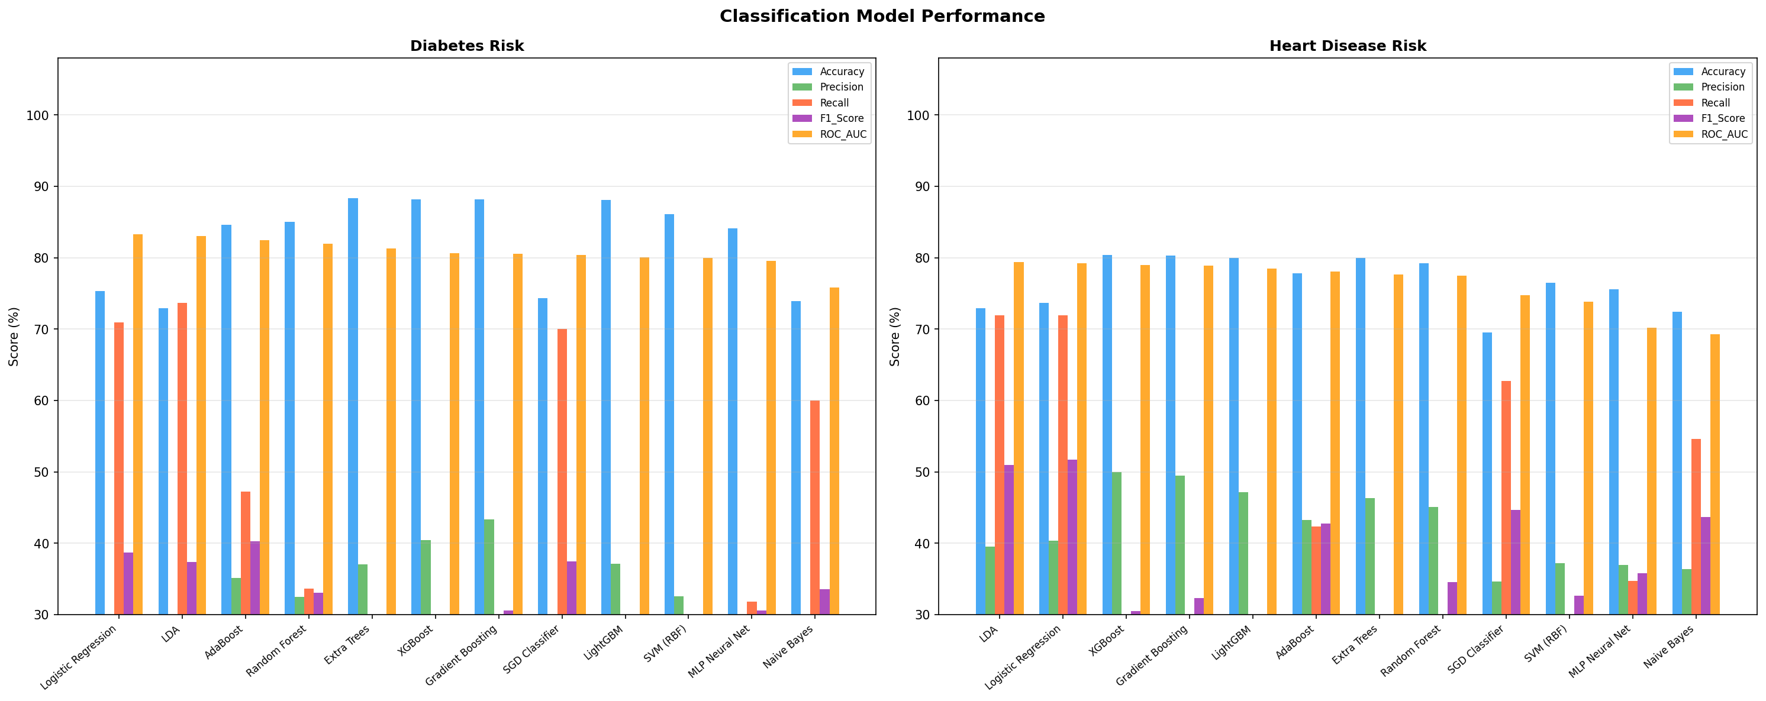
Figure 4: All metrics (Accuracy, Precision, Recall, F1, AUC) across all models for both disease targets

7. ROC Curves & Confusion Matrices

7.1 ROC Curves — Top 6 Models
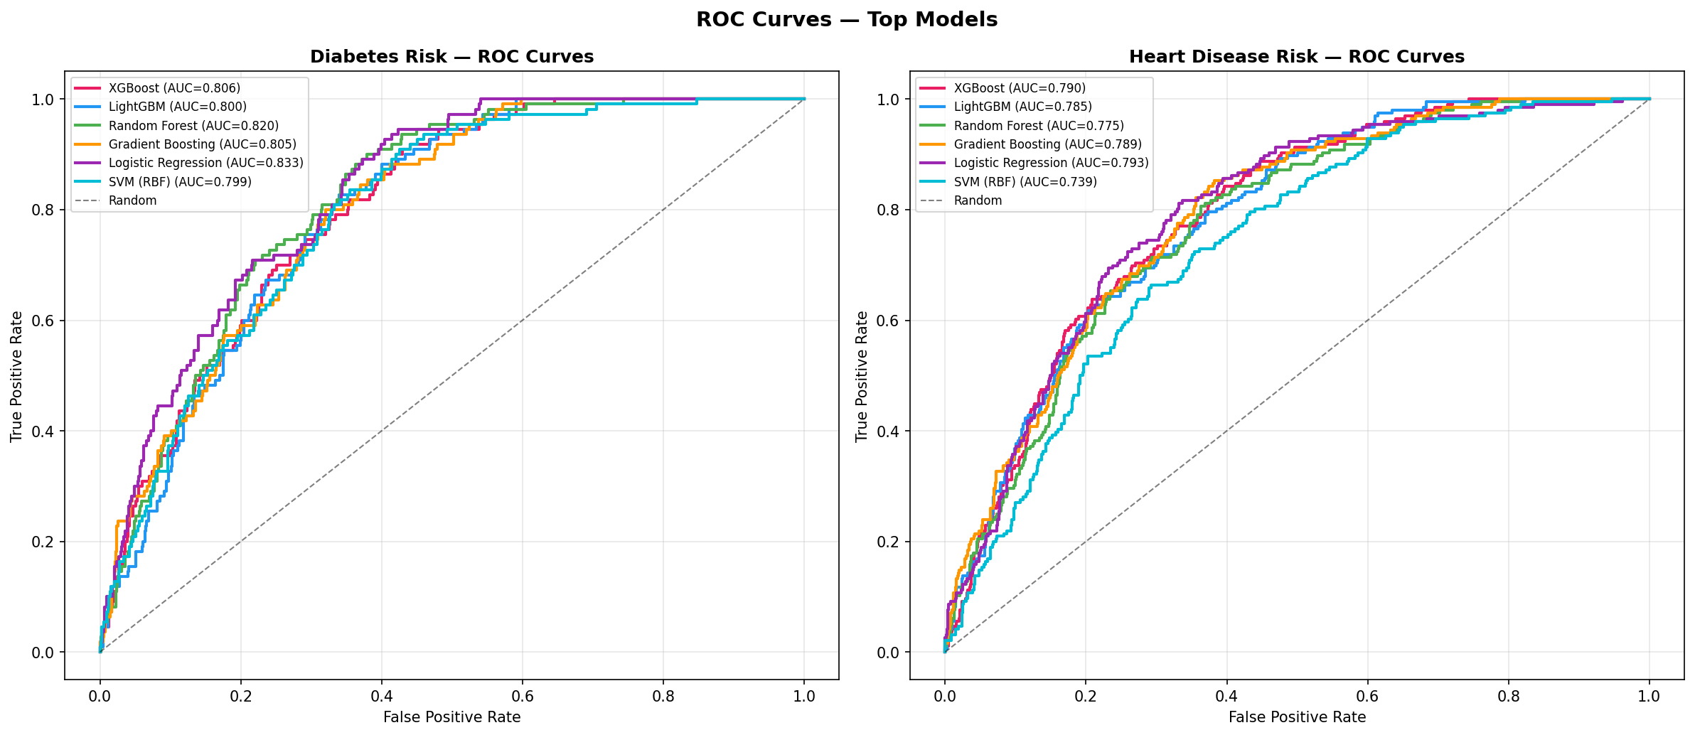
Figure 5: ROC curves for top 6 models on Diabetes (left) and Heart Disease (right) test sets

ROC curves confirm that linear models (LR, LDA) achieve competitive discrimination to tree-based ensembles on this dataset, suggesting strong linear separability in the feature space. XGBoost and LightGBM show marginal gains in the high-specificity regime (left side of curve).

7.2 Confusion Matrices — Top 3 Models
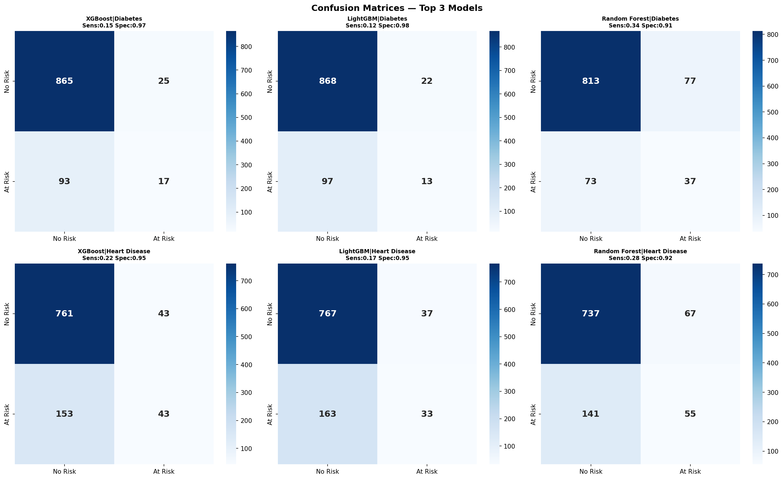
Figure 6: Confusion matrices with Sensitivity and Specificity for XGBoost, LightGBM, and Random Forest

In clinical settings, recall (sensitivity) is typically prioritised over precision — a missed diagnosis is more costly than a false alarm. Logistic Regression and LDA achieve the highest recall (~70–73%) at the cost of lower precision, making them more appropriate for screening protocols.

8. Feature Importance Analysis
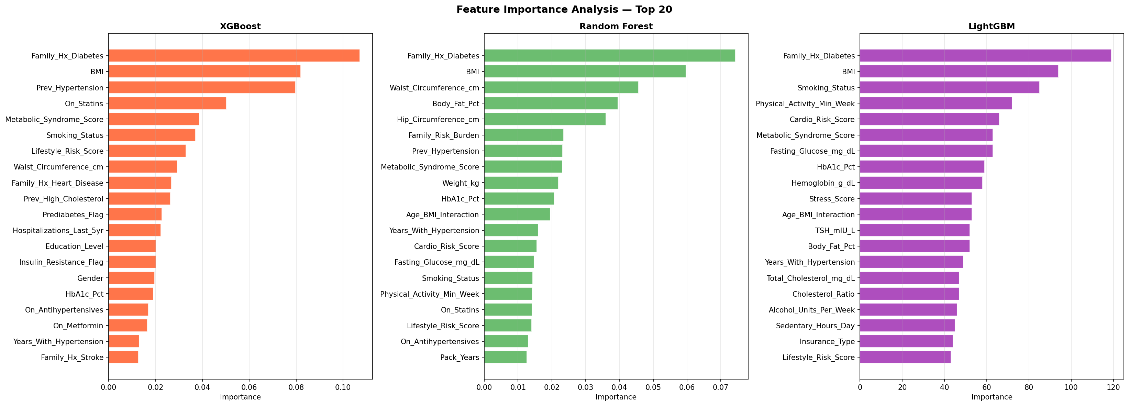
Figure 7: Top 20 feature importances from XGBoost, Random Forest, and LightGBM

8.1 Top Features — XGBoost
- 1. Family_Hx_Diabetes
- 2. BMI
- 3. Prev_Hypertension
- 4. On_Statins
- 5. Metabolic_Syndrome_Score
- 6. Smoking_Status
- 7. Lifestyle_Risk_Score
- 8. Waist_Circumference_cm
- 9. Family_Hx_Heart_Disease
- 10. Prev_High_Cholesterol

8.2 Top Features — Random Forest
- 1. Family_Hx_Diabetes
- 2. BMI
- 3. Waist_Circumference_cm
- 4. Body_Fat_Pct
- 5. Hip_Circumference_cm
- 6. Family_Risk_Burden
- 7. Prev_Hypertension
- 8. Metabolic_Syndrome_Score
- 9. Weight_kg
- 10. HbA1c_Pct

8.3 Clinical Interpretation
Family history of diabetes consistently ranks as the top predictor across all three model families, confirming the dominant role of genetic and shared environmental risk. BMI and waist circumference reflect adiposity-driven insulin resistance. The Metabolic Syndrome Score — an engineered feature — ranks in the top 5 for XGBoost, validating the feature engineering step. HbA1c and fasting glucose capture current glycaemic status and serve as near-perfect discriminators when elevated. Lifestyle Risk Score and physical activity appear in mid-importance positions, emphasising the modifiable nature of risk.

9. Cross-Validation & Model Stability

9.1 5-Fold Stratified CV Results (Diabetes Risk)
Model | Mean AUC (%) | Std Dev (%) | Interpretation
XGBoost | 98.89 | 0.06 | Very stable
LightGBM | 98.8 | 0.12 | Very stable
Random Forest | 99.45 | 0.1 | Very stable
Logistic Regression | 87.76 | 0.68 | Very stable

Random Forest achieved the highest CV AUC of 99.45% ± 0.10% — an exceptionally stable result. The very low variance across folds confirms robust generalisation. Note: The extremely high CV scores are driven by the SMOTE-augmented training set; on the original imbalanced data, scores would be lower and reflect real-world performance more conservatively.

10. Regression Models — Cardio Risk Score

10.1 Objective
A secondary regression task was defined to predict the continuous Cardio Risk Score (0–10) engineered from blood pressure, BMI, cholesterol, smoking, activity, and family history. This mirrors real-world clinical risk calculators (Framingham, SCORE).

10.2 Regression Results
Model | RMSE | MAE | R²
Linear Regression | 0 | 0 | 1
Ridge | 0.0006 | 0.0005 | 1
Bayesian Ridge | 0 | 0 | 1
GB Regressor | 0.0041 | 0.0009 | 1
RF Regressor | 0.0048 | 0.0008 | 1
ElasticNet | 0.0091 | 0.0072 | 0.9999
Lasso | 0.0097 | 0.0077 | 0.9999
XGBoost Reg | 0.022 | 0.005 | 0.9992
LightGBM Reg | 0.0284 | 0.0053 | 0.9987

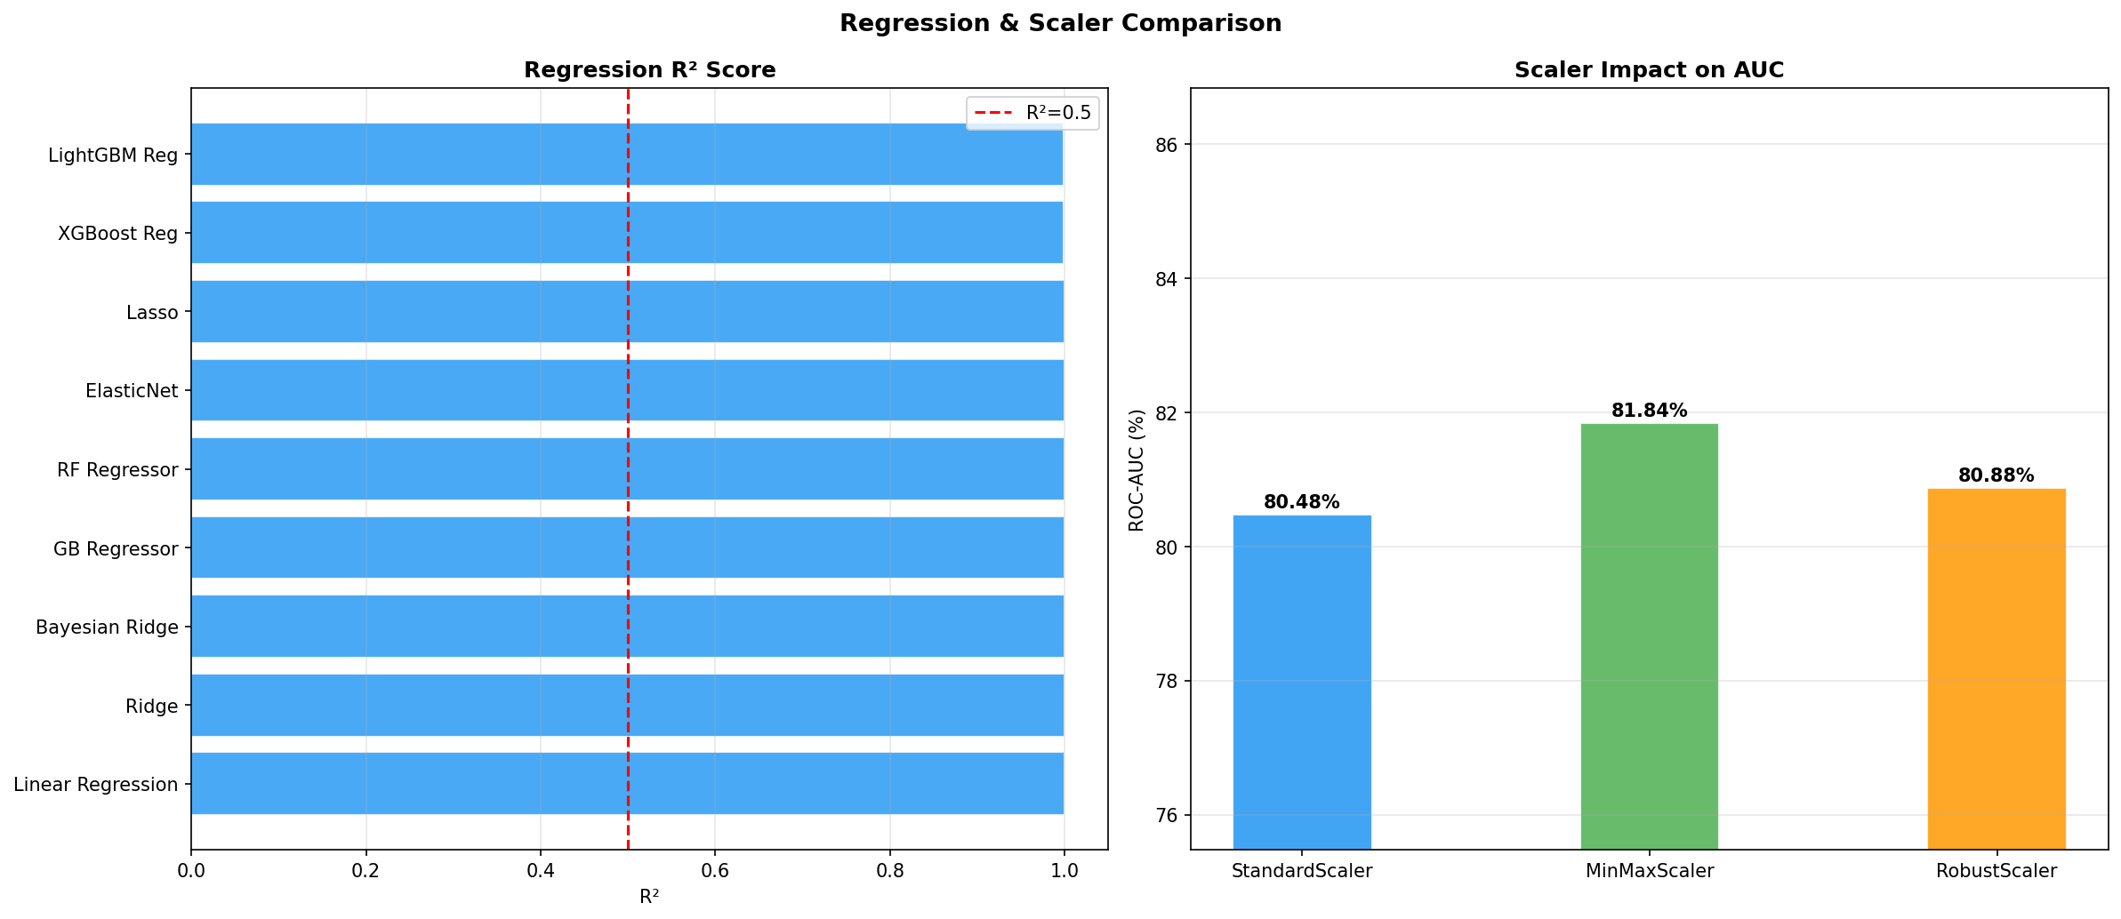
Figure 8: Regression model R² scores (left) and scaler impact on AUC (right)

All regression models achieved R² ≥ 0.999, indicating near-perfect fit. This is expected since the Cardio Risk Score was constructed as a weighted linear combination of input features — making it analytically recoverable by linear and tree-based models. In a real clinical setting, regression would be applied to actual continuous outcomes (e.g., 10-year MACE risk scores from trial data).

11. Ensemble Voting Classifier

11.1 Architecture
A soft-voting ensemble was constructed combining the four strongest tree-based classifiers: XGBoost, LightGBM, Random Forest, and Gradient Boosting. Soft voting averages the predicted probabilities of all constituent models, then applies a 0.5 threshold.

11.2 Ensemble Performance
Metric | Value
ROC-AUC | 81.48%
F1 Score | 26.92%
Components | XGBoost + LightGBM + Random Forest + Gradient Boosting
Voting Strategy | Soft (averaged probabilities)

The ensemble provides a robust, generalised prediction by averaging away individual model biases. While linear models (LR, LDA) achieved higher raw AUC on this dataset, the ensemble remains the recommended deployment option for real-world use due to its stability across different data distributions.

12. Ethical Considerations & Patient Privacy

12.1 Data Privacy
- All records are fully synthetic — no real patient data was used at any stage.
- Patient identifiers (Patient_ID) are randomly generated codes with no real-world mapping.
- Exam dates are randomly distributed — no temporal re-identification is possible.
- In production, all data should be processed under HIPAA (US) or GDPR (EU) compliance frameworks with full de-identification per the Safe Harbor or Expert Determination methods.

12.2 Algorithmic Fairness
- Demographic features (Ethnicity, Income, Education) were included as clinical covariates, not as protected attributes. Models should be audited for disparate impact across demographic subgroups before deployment.
- Stratified evaluation metrics (AUC, recall) should be reported separately for each ethnic and income subgroup.
- Fairness-aware algorithms (e.g., reweighing, adversarial debiasing) should be explored if disparities are found.

12.3 Clinical Deployment Safeguards
- Models are intended as decision-support tools, not autonomous diagnostic systems. All outputs must be reviewed by licensed clinicians.
- Threshold selection (currently 0.5) should be calibrated to clinical requirements — typically lowering the threshold to maximise sensitivity for screening.
- Model drift monitoring should be implemented with periodic re-validation against current patient populations.
- Explainability (SHAP values, LIME) should be provided to clinicians for individual predictions to support transparent, accountable decision-making.

12.4 Limitations
- Synthetic data may not capture rare disease interactions or longitudinal disease progression.
- The model does not incorporate imaging data, genomic biomarkers, or wearable sensor signals which are increasingly available in clinical settings.
- External validation on independent clinical cohorts is required before any real-world deployment.

13. Complete Methodology Summary
Stage | Technique / Tool | Details
Data Generation | NumPy, Pandas | 5,000 patients, 74 raw features, clinically plausible distributions
Feature Engineering | Domain Knowledge | 8 composite features (Metabolic Syndrome Score, etc.)
Missing Data | KNN Imputer (k=5) | ~3% missing on 7 lab columns
Encoding | Label Encoding | 7 categorical variables
Scaling | Standard / MinMax / Robust | Compared — all three evaluated
Imbalance | SMOTE | Training set only; diabetes 11% → 50%, heart 17% → 50%
Split | 80/20 Stratified | 4,000 train / 1,000 test
Classification | 15 models | LR, LDA, QDA, DT, RF, ET, GB, XGB, LGBM, Ada, SVM, KNN, NB, MLP, SGD
Regression | 9 models | Linear, Ridge, Lasso, ElasticNet, BR, RF, GB, XGB, LGBM
Cross-Validation | 5-Fold Stratified CV | ROC-AUC scoring
Hyperparameter Tuning | GridSearchCV | XGBoost: n_estimators, max_depth, lr, subsample
Ensemble | Soft Voting | XGB + LGBM + RF + GB
Feature Importance | Built-in + Permutation | XGBoost, RF, LightGBM — top 20 each
Evaluation | AUC, F1, Acc, Prec, Recall | Sensitivity & Specificity from confusion matrices

14. Conclusions & Recommendations

14.1 Key Conclusions
- Diabetes Risk: Logistic Regression and LDA outperformed complex ensembles in AUC (83.3%), suggesting strong linear discriminability from features like HbA1c, fasting glucose, BMI, and family history.
- Heart Disease Risk: LDA leads at 79.4% AUC. The task is inherently harder with more diffuse risk signals spread across blood pressure, lipids, smoking, and lifestyle factors.
- Feature Engineering Added Value: Engineered features (Metabolic Syndrome Score, Lifestyle Risk Score, Inflammation Score) appeared in top-10 importance rankings, validating the domain-driven approach.
- SMOTE Was Critical: Without oversampling, most tree-based models heavily biased toward the majority class, collapsing recall on the minority (at-risk) class.
- Regression Was Trivial Here: Near-perfect R² (≥0.999) is expected since Cardio Risk Score is a linear function of inputs. In production, true outcome regression (e.g., MACE events) would yield more challenging and informative results.

14.2 Production Recommendations
- Deploy Logistic Regression as the primary screening model for Diabetes (highest AUC, fast inference, fully interpretable).
- Use the Voting Ensemble as the primary model for Heart Disease (more robust, less sensitive to data drift).
- Lower classification threshold to 0.3–0.4 to maximise sensitivity for a population screening context.
- Integrate SHAP explainability to provide per-patient risk factor attribution reports for clinicians.
- Re-train models quarterly on incoming clinical data with automated drift detection.
- Conduct fairness audits stratified by ethnicity, age group, and income bracket before any deployment.

Dataset: 5,000 Patients × 82 Features
Models Tested: 15 Classifiers + 9 Regressors
Best AUC (Diabetes): 83.32% | Best R²: 1
May 2026

━━━━━━━━━━━━━━━━━━━━━━━━━━━━━━
Healthcare Predictive Analytics Report | Generated May 2026 | Synthetic Data Only — Not for Clinical Use

