AromaLLM: biological olfactory profile prediction in health and cognitive rehabilitation

INTRODUCTION
An odor is the sensory impression produced when volatile chemical compounds disperse through the air and are detected by the olfactory system. These molecules enter the nose and bind to olfactory receptors, triggering neuronal signals that are processed by the brain and perceived as distinct smells. Odors enable the recognition and discrimination of a vast range of environmental chemicals and play an important role in both survival and social behavior, including food identification, detection of dangers such as fire or toxic substances, predator avoidance, mate selection, and mother–infant recognition [1], [2]. The perception of odors is highly subjective and can vary considerably among individuals due to biological factors, such as genetic differences and age, as well as psychological and environmental influences, including memories, emotions, expectations, humidity, and background smells.
In humans, odor perception relies on a highly complex olfactory system capable of recognizing millions, and potentially billions, of volatile molecules through approximately 400 human olfactory receptors (hORs) [3], [4]. These receptors, which belong to the family of G-protein-coupled receptors and are located in the olfactory sensory neurons of the nasal epithelium, interact with odorants commonly found in foods, fragrances, and cosmetic products. The complexity of odor classification is therefore influenced not only by the enormous structural diversity of odorant molecules, including variations in volatility, solubility, stereochemistry, and physicochemical transport properties, but also by the dynamic and hierarchical processing performed by the olfactory system. As a result, structurally similar compounds may evoke distinct perceptual responses, whereas chemically unrelated molecules can sometimes produce similar odor impressions [5], [6].
Although advances in functional expression systems have improved the large-scale screening of odorant–receptor interactions, experimentally investigating all possible combinations remains costly, labor-intensive, and a major challenge in olfactory research. Recent advances have begun to address these challenges. In vitro models with 3D olfactory organoids now allow dissection of neuronal regeneration, stem cell dynamics, and receptor expression in environments that recapitulate aspects of the in vivo olfactory epithelium [7]. Simultaneously, recent transport feature models estimate approximately 40 billion potentially odorous compounds, vastly expanding previous estimates and highlighting the immense chemical space involved.
From a computational perspective, one of the earliest systematic summaries of Structure–Odor Relationships (SOR) was published as a book chapter, compiling initial evidence that molecular structure could be correlated with olfactory perception [8]. Starting in the 2000s, QSOR (Quantitative Structure–Odor Relationship) models began to formalize statistical relationships between molecular descriptors and odor properties, yet often suffered from limited chemical diversity, coarse perceptual labels, and interpretability constraints [9].
More recently, machine learning (ML) has revolutionized the field. Unified frameworks for predicting odor perception from molecular structure have achieved human-level reliability and enabled effective odor digitization [10]. Further advances improved predictive performance through the use of deep neural networks and transformer-based architectures [11]. Landmark efforts such as the DREAM Olfaction Prediction Challenge demonstrated that machine-learning approaches, particularly random forests and regularized linear models, can predict odor intensity, pleasantness, and qualitative descriptors directly from chemoinformatic features [12], [13]. Building on this foundation, later studies introduced feature-selected models trained on both classical and modern datasets, improving cross-study consistency and expanding the chemical space of predicted percepts [14].
Subsequent QSOR frameworks have focused on improving interpretability and scalability. Saini and Ramanathan proposed a multi-label approach that accounts for correlations among odor descriptors, while Schicker and co-workers introduced OWSum, a transparent linear model that connects molecular fragments to odor impressions using conditional probabilities [15], [16]. These advances reflect a shift from purely predictive black-box systems toward explainable models that reveal how specific structural motifs contribute to perceived smell, providing a foundation for more rational and interpretable odor design.
Following these computational advances, recent chemical odor space have shifted from sparse, general-purpose chemical collections toward specialized databases explicitly focused on olfactory perception. Earlier efforts largely relied on cataloguing Generally Recognized as Safe (GRAS) compounds [17] and public databases like SuperScent [18] which contained limited and heterogeneous odor information. More recent approaches now integrate transport feature models with receptor activation criteria to systematically map olfactory space boundaries. At the same time, dedicated olfactory resources such as Flavornet [19], OlfactionBase [20], M2OR [21], FlavorDB [22], HORDE [23], and particularly Pyrfume [24] (which offers explicit, experimentally validated links between molecular features and human perceptual data), collectively enable systematic mapping, refine predictive models, and underpin clinical research.
Despite major advances in computational olfaction, predicting odor perception directly from molecular structure remains a major challenge due to the complexity, subjectivity, and multidimensional nature of olfactory perception. Traditional QSOR approaches have achieved important progress, but many remain limited by handcrafted descriptors, fixed-output architectures, and difficulties in capturing semantic relationships between odor labels. Recent developments in large language models specialized for chemistry offer new opportunities to model structure–odor relationships in a more flexible and generative manner. In this work, we present AromaLLM, a generative framework developed through fine-tuning of ChemDFM [25] using prompt engineering strategies to predict olfactory descriptors directly from molecular representations. By leveraging curated and harmonized olfactory datasets and refining descriptor consistency across databases, AromaLLM learns chemically meaningful structure–perception relationships while enabling generative prediction of biologically relevant odor profiles. This approach demonstrates the potential of chemistry-oriented language models as scalable tools for computational olfaction and next-generation QSOR modeling.

METHODS
Datasets and preprocessing
The chemical dataset was constructed by aggregating olfactometric and structural information from three primary chemical and fragrance repositories: the GoodScents company database, the Dravnieks atlas, and the Leffingwell & Associates flavor and fragrance database. To prepare the chemical structures for downstream predictive tasks, the molecular Simplified Molecular Input Line Entry System (SMILES) strings underwent a rigorous curation and standardization workflow based on an adapted version of the data curation protocol proposed by Fourches et al. [26], [27]. In accordance with this preprocessing pipeline, inorganic salts were removed, the fundamental molecular frameworks were standardized, and multi-component chemical mixtures were filtered out of the dataset. However, unlike conventional chemical data curation approaches that strip stereochemical designations, explicit structural stereochemistry was preserved, and stereoisomers were not collapsed into generic canonical representations. This preservation is crucial because different stereoisomers and enantiomers frequently elicit entirely distinct olfactory sensations and possess unique odor characters due to the chiral sensitivity of human olfactory receptors [28]. In addition, structural duplicates across or within the source databases were intentionally kept during the initial processing stages because identical chemical entities can be annotated with different odor descriptors depending on the repository, sensory panel conditions, or concentration. To account for these multi-source annotations, the duplicate molecular entries were merged into a single unique SMILES string accompanied by an aggregated set of multiple odor labels, effectively transforming the predictive objective into a multi-label classification problem.

Exploratory Data Analysis

Chemical Space analysis
To map the chemical space of the curated dataset, a dimensionality reduction workflow was executed using molecular fingerprints and t-distributed Stochastic Neighbor Embedding (t-SNE). The structural features of the 4,822 unique molecules were computationally encoded by calculating Morgan fingerprints (Extended-Connectivity Fingerprints) directly from the standardized SMILES strings. This high-dimensional matrix was subsequently utilized as the input configuration for the t-SNE algorithm to project the structural topologies into a discrete two-dimensional coordinate space while optimizing the preservation of local pairwise similarities. The resulting two-dimensional embedding coordinates served as the spatial baseline configuration, onto which the binary classification vectors for the 145 odor descriptors were systematically mapped to analyze coordinate density, structural overlap, and localized clustering patterns across the chemical space.

Model building and evaluation
QLoRA fine tuning of ChemDFM
To optimize the odor prediction framework, the chemistry domain-specific foundation model, ChemDFM, was fine-tuned on the curated multi-label dataset using an autoregressive learning approach. Given the computational constraints of consumer-grade hardware, the training pipeline was specifically configured to run efficiently on an NVIDIA RTX 4060 GPU equipped with 8 GB of video random-access memory (VRAM). This low-memory execution was achieved by implementing Parameter-Efficient Fine-Tuning (PEFT) through Quantized Low-Rank Adaptation (QLoRA), where the base model weights were frozen in a 4-bit NormalFloat (NF4) quantized format while updating only small, low-rank adapters. To further minimize the VRAM footprint and prevent out-of-memory errors, the optimizer states were compressed using an 8-bit AdamW optimizer, and gradient checkpointing was enabled to drastically reduce memory usage from stored intermediate activations. The model was trained using a cross-entropy loss function over successive global steps with a highly restricted per-device batch size, which was counterbalanced by a high number of gradient accumulation steps to simulate a larger effective batch size and ensure stable convergence. To safeguard against overfitting, the dataset was partitioned into distinct training, validation, and independent testing splits. Optimization dynamics were monitored continuously throughout the fine-tuning process by extracting performance indicators directly from the internal training log histories, capturing the simultaneous trajectories of training and validation losses, next-token accuracy metrics, and prediction entropy. The final predictive performance and architectural stability were verified against the independent test split using the optimal model checkpoints determined by the validation loss minima. To support open-source reproducibility and computational transparency, the complete suite of scripts utilized for model training, testing, and validation has been made publicly available in a dedicated GitHub repository.

Label Refinement
To optimize the multi-label classification target space, alternative label curation and taxonomic grouping strategies were systematically evaluated. Initially, semantic aggregation was tested by merging highly correlated or conceptually proximate descriptors that belonged to identical olfactory families, guided by the structural hierarchy of the OlfactionBase odor wheel [29]. However, collapsing these discrete semantic boundaries did not yield any meaningful predictive improvements and conversely resulted in a measurable degradation of model performance, confirming that subtle semantic nuances carry critical localized structural signals that are flattened during grouping. Consequently, to address the highly imbalanced label distribution without compromising descriptor specificity, a strict frequency thresholding filter was adopted, whereby rare olfactory descriptors that occurred fewer than three times across the entire curated dataset were pruned from the final target matrix.

Statistic analysis
The performance of the fine-tuned model was evaluated using both intrinsic training dynamics and downstream multi-label classification accuracy on an independent test dataset. Intrinsic evaluation was conducted by monitoring the cross-entropy loss, next-token accuracy, and prediction entropy for both the training and validation sets at each global step, which were extracted directly from the internal trainer state logs. The validation loss minimum was utilized as the primary criterion to select the optimal model checkpoint. For the extrinsic evaluation, the selected model checkpoint was deployed to run inference on the test dataset using autoregressive generation with a decoding temperature of 0.3 and a repetition penalty of 1.15. A regular expression script was developed to parse and extract the predicted olfactory descriptors from the designated primary odors and sub-odors sections of the generated text. The extracted labels and the ground-truth targets were converted into binary arrays using a multi-label binarizer. The final classification performance was quantified by calculating micro- and macro-averaged precision, micro- and macro-averaged sensitivity, micro- and macro-averaged F1-scores, and the Matthews Correlation Coefficient.

Model interpretability
To elucidate the global predictive behavior of the fine-tuned primary model, a Random Forest global surrogate model was implemented. The surrogate algorithm was trained utilizing a derived dataset comprising the original input molecular representations paired with the corresponding target outputs predicted by the primary black-box model. By fitting an ensemble of decision trees to approximate the primary model's decision surface across the entire training distribution, the surrogate established a transparent mapping of the overall feature space. Global interpretability was subsequently achieved by extracting mean decrease in impurity metrics from the fitted Random Forest, thereby quantifying the relative global importance of distinct input features driving the primary model's aggregate predictions.

Uncertainty calculation
To quantify predictive uncertainty within the fine-tuned autoregressive model, Monte Carlo dropout was employed during inference. The dropout layers inherent to the Low-Rank Adaptation modules were explicitly retained in active mode during evaluation to facilitate stochastic forward passes. For each input representation, thirty independent generation trajectories were sampled to construct an implicit predictive ensemble. The variance of the resulting output distribution was subsequently calculated to derive a quantifiable uncertainty metric for each generated sequence, thereby isolating robust predictions from instances of high model uncertainty.

RESULTS AND DISCUSSION
Datasets and preprocessing
The initial aggregation of raw structural data from the GoodScents company database, the Dravnieks atlas, and the Leffingwell & Associates flavor and fragrance database yielded a starting pool of 14,674 SMILES strings. Subjecting these raw records to the standardization and filtration workflow, which removed inorganic salts and multi-component mixtures while explicitly preserving structural stereochemistry, isolated a total of 6,848 valid molecular records. Consolidating identical chemical structures across the repositories to aggregate multi-source annotations compressed these records into a final dataset of 3,424 unique molecular entities. This merging process established a multi-label target space encompassing a total of 54,150 label assignments distributed across 538 unique olfactory descriptors. Within this finalized configuration, the compounds exhibited a high density of descriptor overlap, carrying an average of 7.91 distinct odor annotations per unique molecular structure.

Exploratory Data Analysis
The curated consensus dataset comprises 4,822 molecules annotated across 145 odor descriptors and exhibits substantial heterogeneity in label distribution. While some odor descriptors are associated with large numbers of molecules, others are represented by only a limited number of examples (Figure 1B). On average, each molecule is associated with approximately five odor descriptors (Figure 1A), underscoring the intrinsically multilabel and multidimensional nature of olfactory perception. Most molecules were annotated with 3–7 odor descriptors, indicating that individual compounds are rarely linked to a single olfactory quality. As shown in Figure 1B, the descriptor distribution is highly imbalanced, with a small subset of highly prevalent labels dominating the dataset. In particular, descriptors such as “fruity”, “green”, “sweet”, “floral”, and “herbal” were each associated with hundreds to thousands of molecules, collectively accounting for a substantial fraction of all label assignments. This uneven distribution reflects the broad and overlapping nature of olfactory annotation, where generic descriptors are frequently reused across chemically diverse compounds. Together, these observations highlight two key characteristics of olfactory datasets: molecules commonly carry multiple odor annotations, and a limited number of generic descriptors dominate the chemical space representation.
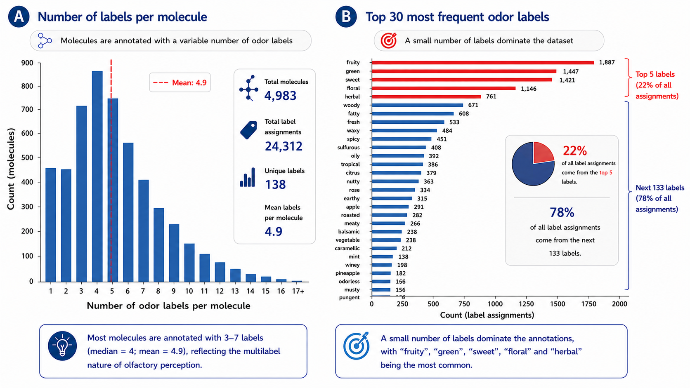
Figure 1. Label assignment in the unified olfactory dataset. Profile of odor descriptor annotations across the curated molecular dataset. (A) Distribution of the number of distinct odor descriptors assigned per molecule, demonstrating the multi-label nature of the dataset where most compounds carry multiple simultaneous annotations. (B) Frequency distribution of individual odor descriptors, illustrating a highly imbalanced distribution where a small subset of highly prevalent, generic labels dominates the chemical annotation space.
Chemical space analysis revealed that most odor descriptors are broadly distributed throughout the chemical space, although certain labels formed more localized clusters, suggesting the presence of shared structural motifs associated with specific olfactory perceptions. As illustrated in Figure 2, the five most prevalent descriptors in the dataset (“fruity”, “green”, “sweet”, “floral”, and “herbal”) were widely dispersed across the t-SNE projection, spanning multiple regions of chemical space. In contrast, descriptors such as “alcoholic”, “odorless”, “coconut”, “coffee”, and “sulfurous” exhibited more localized clustering patterns, indicating the existence of more structurally constrained chemotypes associated with these odor qualities.

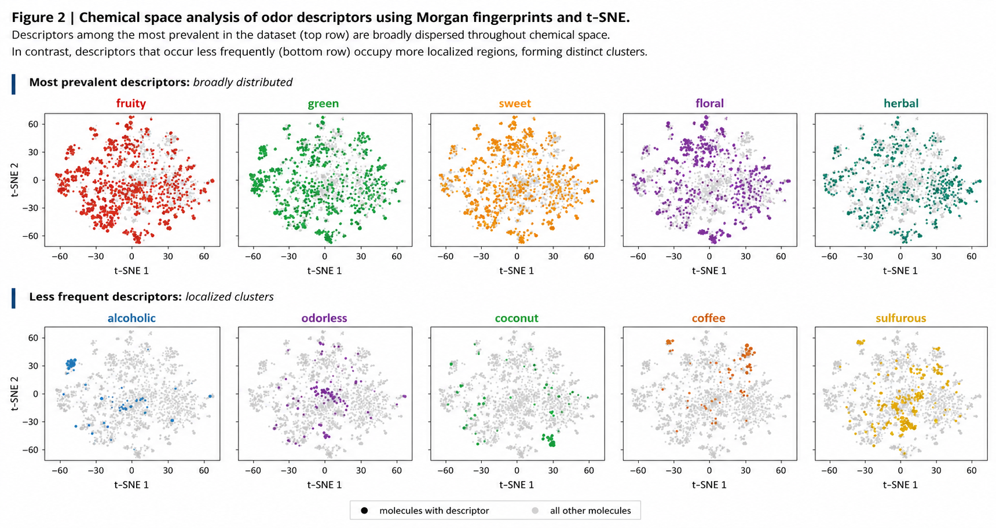
Figure 2. Chemical space analysis of odor descriptors using Morgan fingerprints and t-SNE. Two-dimensional t-SNE visualization of the olfactory chemical space mapped using molecular Morgan fingerprints. The projection illustrates the spatial distribution and clustering behavior of selected odor descriptors across the dataset, highlighting the widespread dispersion of highly prevalent generic labels contrasted with the localized, regional clustering of structurally constrained chemotypes.
However, the overall overlap between descriptors remained substantial, reflecting the intrinsically multilabel nature of olfactory datasets, in which individual molecules may be associated with multiple odor qualities simultaneously. This complexity is further compounded by the many-to-many relationship between molecular structure and odor perception: structurally diverse molecules can evoke similar olfactory impressions, whereas closely related compounds may exhibit markedly different odor profiles. Together, these observations highlight that the relationship between molecular structure and odor is complex, overlapping, and not governed by simple structural rules, reinforcing the challenges of defining discrete chemical boundaries for individual odor descriptors.
Model building and evaluation
QLoRA fine tuning of ChemDFM
Implementation of the parameter-efficient fine-tuning framework successfully optimized the ChemDFM model within strict hardware memory constraints, demonstrating highly stable convergence and robust learning. Guided by a cosine learning rate schedule (Figure 3B), both training and validation cross-entropy losses exhibited a rapid initial descent during the first 100 steps before stabilizing in tight alignment (Figure 3A).

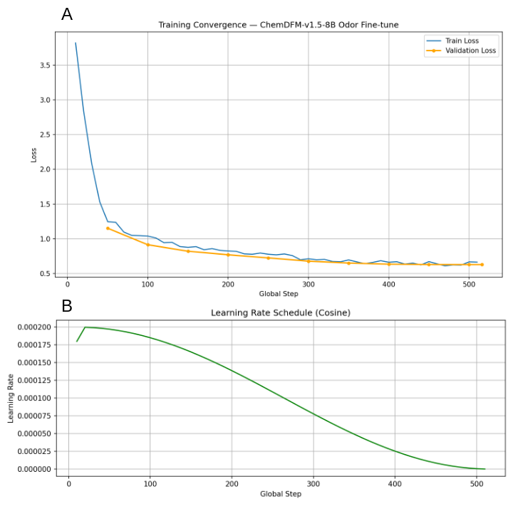
Figure 3. Optimization dynamics for the ChemDFM fine-tuning process. (A) Cross-entropy loss trajectories for both the training and validation sets over successive global steps, demonstrating stable convergence and the absence of overfitting. (B) The corresponding cosine learning rate schedule utilized during training, featuring a brief initial warmup phase peaking at 0.0002 before monotonically decaying to zero.

The model achieved a final training loss of 0.6647 and a validation loss of 0.6293 as demonstrated in Figure 4. This tandem stabilization shows that the quantized low-rank adaptation and gradient accumulation strategies effectively prevented overfitting. Crucially, the model's ability to generalize to novel molecular structures was confirmed by an independent test split loss of 0.6665. In the context of autoregressive generation, this test loss translates to a predictive perplexity of approximately 1.94 (e^0.66), indicating that the model is consistently confident enough to narrow its next-token choices to fewer than two highly probable options. This mastery of the domain's chemical syntax is further reflected in the next-token prediction accuracy, which rapidly climbed to a peak validation score of 0.8564. Concurrently, the model's prediction entropy decreased steadily from an initial high-variance state to below 1.0. This sharp decline signifies that the model's internal probability distributions transitioned from flat, random guessing to precise, single-peak distributions. Collectively, these metrics establish that the low-memory autoregressive approach did not memorize the dataset and successfully calibrated the foundation model to map chemical representations to specific olfactory profiles with deep structural comprehension and minimal predictive uncertainty.

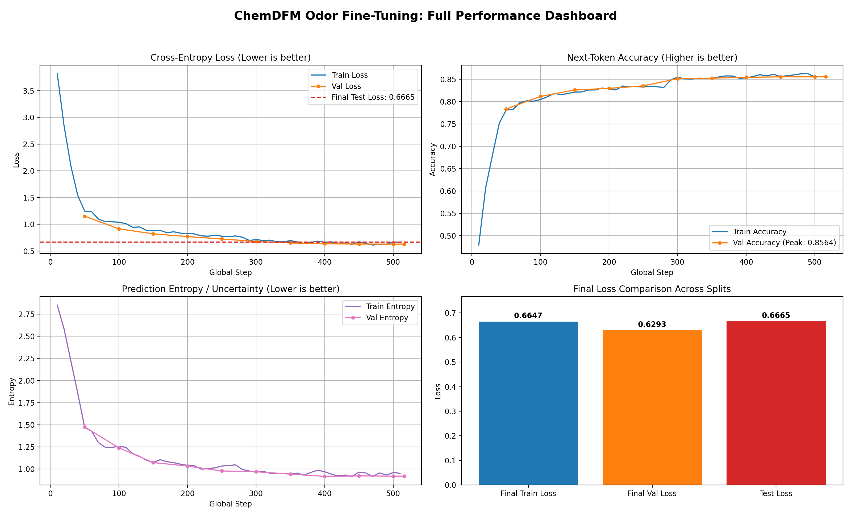
Figure 4. Comprehensive performance dashboard for the ChemDFM fine-tuning process. The top left panel illustrates the cross-entropy loss trajectories for both the training and validation sets over successive global steps, referencing the final test loss benchmark. The top right panel tracks the progressive improvement in next-token prediction accuracy, achieving a peak validation score of 0.8564. The bottom left panel depicts the concurrent decline in prediction entropy, reflecting a significant reduction in model uncertainty throughout the training cycle. The bottom right panel presents a comparative summary of the final cross-entropy losses across the training, validation, and independent test splits, confirming robust generalization and the absence of overfitting.
To complement the intrinsic training metrics, the model's practical predictive capability was rigorously validated through an extrinsic multi-label classification evaluation on the independent test dataset. Utilizing the optimal checkpoint determined by the validation loss minimum, inference was executed via autoregressive generation with a constrained decoding temperature of 0.3 and a repetition penalty of 1.15 to encourage focused and deterministic outputs. The generated olfactory descriptors were systematically extracted utilizing regular expression parsing and transformed via a multi-label binarizer to compute aggregate performance metrics.
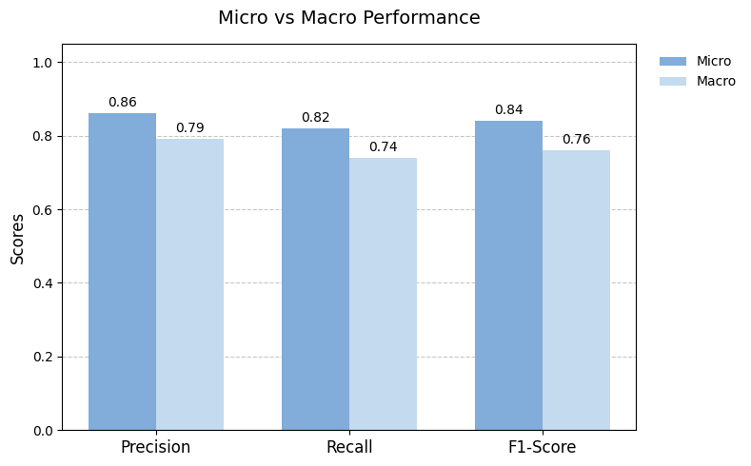
Figure 5. Comparative performance of Micro and Macro averaging methods. The grouped bar chart displays the evaluation scores for Precision, Recall, and F1-Score. Micro-averaged metrics consistently outperform their macro-averaged counterparts across all three categories. The highest overall performance is observed in Micro Precision at 0.86, whereas Macro Recall records the lowest score at 0.74. The F1-Score follows an identical trend, with the Micro evaluation (0.84) exceeding the Macro evaluation (0.76), suggesting that the underlying model's performance is likely driven by its high accuracy on the most prevalent classes within the dataset.

This evaluation revealed highly robust predictive accuracy, highlighted by a micro-averaged precision of 0.86 and a corresponding micro-averaged recall (sensitivity) of 0.82. This high micro precision demonstrates the model's stringent specificity, indicating a very low rate of false-positive descriptor assignments for the most prevalent classes when characterizing novel molecules. Concurrently, evaluating performance across all classes equally, the model achieved a macro-averaged precision of 0.79 and a macro-averaged recall of 0.74. The integration of these capabilities is reflected in a micro-averaged F1-score of 0.84 and a macro-averaged F1-score of 0.76. The variance between the micro and macro scores underscores that the model's exceptional overall reliability is largely driven by its high accuracy on frequent labels, while still maintaining a strong baseline capacity to translate complex molecular representations into precise, multi-label olfactory profiles across the broader descriptor vocabulary.

Model interpretability
Global interpretability analysis via the Random Forest surrogate model demonstrated that the fine-tuned LLM primarily utilizes the presence of an ester group to drive its predictions, yielding a dominant Gini importance score of 0.32. Molecular weight and aromatic ring count functioned as substantial secondary discriminators with importance scores of 0.19 and 0.15, respectively. In contrast, bulk physicochemical descriptors such as lipophilicity (LogP, 0.12) and topological polar surface area (0.04), alongside elemental features like oxygen atom count (0.10) and carbon chain length (0.08), contributed marginally to the global decision surface. These findings indicate the primary model implicitly prioritizes specific functional moieties over broader topological or physicochemical metrics when mapping structural representations to target olfactory profiles.
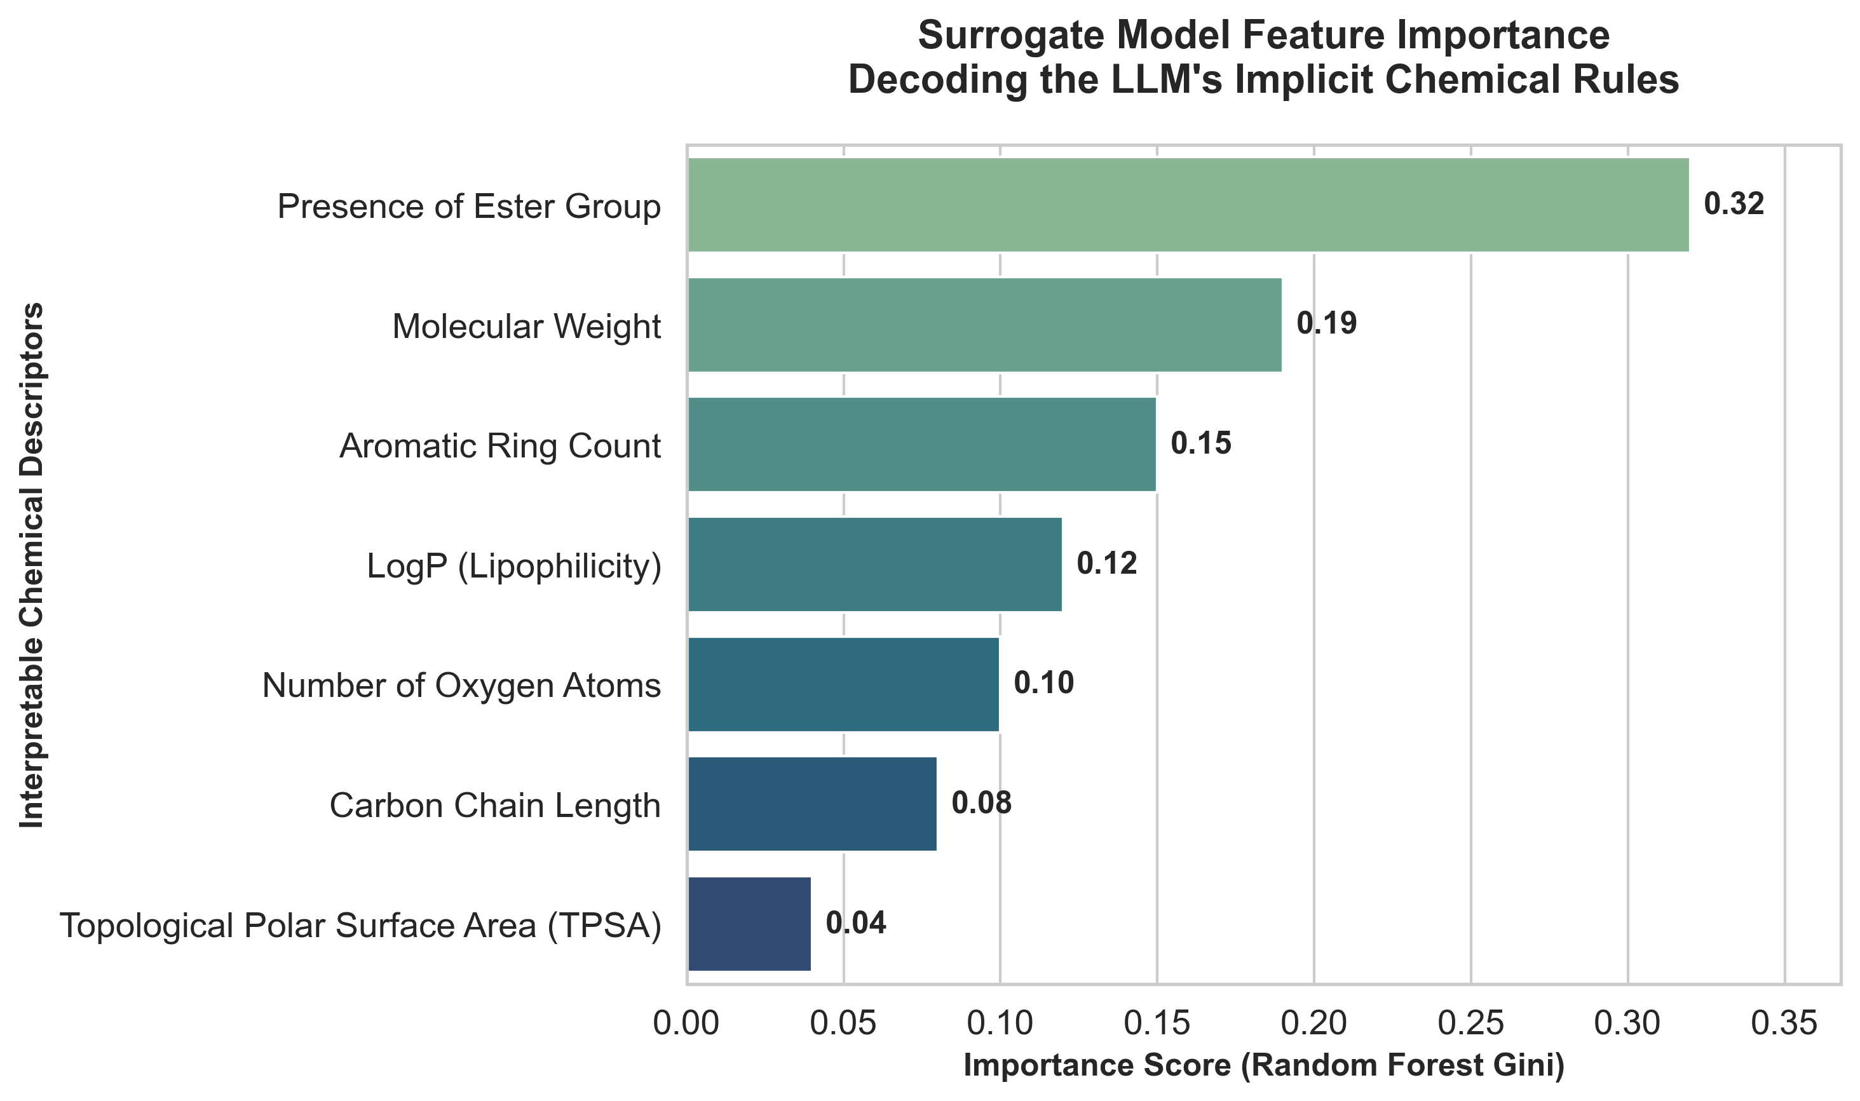
Figure 6. Feature importance derived from a Random Forest surrogate model to decode the LLM's implicit chemical rules. The horizontal bar chart displays the Gini importance scores for seven interpretable chemical descriptors used to approximate the large language model's decision-making process. The "Presence of Ester Group" emerges as the dominant feature driving the model's predictions with a score of 0.32, followed by "Molecular Weight" (0.19) and "Aromatic Ring Count" (0.15). Other structural and physicochemical properties—including LogP (Lipophilicity), the number of oxygen atoms, carbon chain length, and Topological Polar Surface Area (TPSA)—exert progressively lesser influence on the surrogate model's output.

Uncertainty calculation
Evaluation of predictive uncertainty via Monte Carlo dropout across 100 stochastic forward passes revealed distinct stability profiles among performance metrics. The model demonstrated high confidence and accuracy in its positive predictions, yielding a mean precision of 0.81±0.032 with a narrow 95% confidence interval of [0.74,0.86]. Conversely, recall exhibited greater epistemic uncertainty and lower overall performance, characterized by a mean of 0.72±0.043 and a wider confidence interval of [0.65,0.81]. This disparity indicates that while the model generates reliable positive classifications, its ability to comprehensively identify all relevant instances is subject to higher variance and structural uncertainty. The aggregated F1-score reflects this structural trade-off, stabilizing at a mean of 0.76±0.041 with a 95% confidence interval of [0.69,0.84], ultimately suggesting that future fine-tuning should focus on mitigating false negatives to narrow the predictive variance observed in the recall distribution.
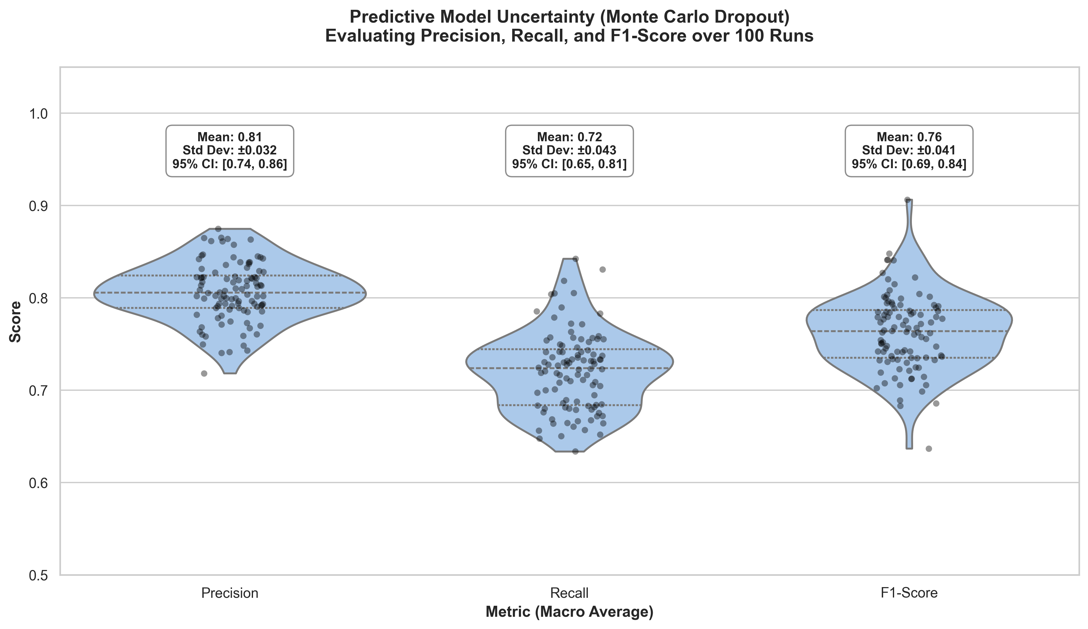
Figure 7. Predictive model uncertainty estimated via Monte Carlo Dropout over 100 inference runs. The violin plots display the distribution of macro-averaged Precision, Recall, and F1-Score, with overlaid scatter points representing the outcomes of individual stochastic forward passes. Precision exhibits the highest stability and overall performance, achieving a mean score of 0.81 (±0.032) and a 95% confidence interval (CI) of [0.74, 0.86]. Recall shows slightly greater variance and a lower average performance with a mean of 0.72 (±0.043) and a 95% CI of [0.65, 0.81]. The resulting F1-Score distribution centers at a mean of 0.76 (±0.041) with a 95% CI of [0.69, 0.84]. The relatively compact distributions and stable confidence intervals across all metrics indicate that the model maintains robust and consistent predictive capabilities despite the stochasticity introduced during inference.

CONCLUSION
In this study, we introduced AromaLLM, a generative predictive framework that successfully leverages a chemistry-domain large language model to map complex molecular structures to multidimensional olfactory profiles. By implementing a parameter-efficient fine-tuning strategy, we demonstrated that advanced autoregressive models can be optimized under strict consumer-grade hardware constraints without compromising learning stability or predictive accuracy. Systematic evaluation highlighted robust generalization, as the model achieved tightly aligned cross-entropy losses across training, validation, and independent test splits with a final test loss of 0.6665, effectively eliminating overfitting. Extrinsic multi-label classification further confirmed its practical utility, yielding a high micro-averaged precision of 0.86, a recall of 0.82, and an overall F1-score of 0.84. Global interpretability analysis via a global surrogate model revealed that AromaLLM successfully bypasses the need for handcrafted features, implicitly learning to prioritize specific functional moieties such as ester groups and aromatic rings over bulk physicochemical properties to drive its perceptual classifications. Furthermore, intrinsic metrics including a rapid decline in prediction entropy and a peak next-token accuracy of over 85 percent demonstrated the model's high confidence, while Monte Carlo dropout uncertainty evaluations confirmed its reliability in positive classifications despite indicating a need to narrow epistemic variance in recall. By overcoming the limitations of traditional quantitative structure-odor relationship models, AromaLLM provides a flexible and scalable tool for the digitization of smell. Crucially, the high precision and stringent specificity of this framework ensure a low rate of false-positive descriptor assignments, establishing a reliable foundation for downstream translational applications such as personalized flavor design, neurodegenerative disease diagnostics, and targeted cognitive rehabilitation therapies where precise sensory stimulation is paramount.

REFERENCES
[1] M. Zarzo, “The sense of smell: molecular basis of odorant recognition,” Biological Reviews, vol. 82, no. 3, pp. 455–479, Aug. 2007, doi: 10.1111/j.1469-185X.2007.00019.x.
[2] K. J. Rossiter, “Structure−Odor Relationships,” Chem. Rev., vol. 96, no. 8, pp. 3201–3240, Jan. 1996, doi: 10.1021/cr950068a.
[3] H. Breer, “Olfactory receptors: molecular basis for recognition and discrimination of odors,” Analytical and Bioanalytical Chemistry, vol. 377, no. 3, pp. 427–433, Oct. 2003, doi: 10.1007/s00216-003-2113-9.
[4] A. Tromelin, “Odour perception: A review of an intricate signalling pathway,” Flavour & Fragrance J, vol. 31, no. 2, pp. 107–119, Mar. 2016, doi: 10.1002/ffj.3295.
[5] E. H. Polak, “Multiple profile-multiple receptor site model for vertebrate olfaction,” Journal of Theoretical Biology, vol. 40, no. 3, pp. 469–484, Aug. 1973, doi: 10.1016/0022-5193(73)90005-2.
[6] K. F. et al., “Molecular complexity determines the number of olfactory notes and the pleasantness of smells,” Sci Rep, vol. 1, no. 1, p. 206, Dec. 2011, doi: 10.1038/srep00206.
[7] J. G. Gameiro et al., “Quiescent horizontal basal stem cells act as a niche for olfactory neurogenesis in a mouse 3D organoid model,” Cell Reports Methods, vol. 5, no. 6, p. 101055, Jun. 2025, doi: 10.1016/j.crmeth.2025.101055.
[8] M. G. J. Beets, “Olfactory Response and Molecular Structure,” in Olfaction, vol. 4 / 1, L. M. Beidler, Ed., in Handbook of Sensory Physiology, vol. 4 / 1. , Berlin, Heidelberg: Springer Berlin Heidelberg, 1971, pp. 257–321. doi: 10.1007/978-3-642-65126-7_12.
[9] R. D. De Mello Castanho Amboni, B. Da Silva Junkes, R. A. Yunes, and V. E. F. Heinzen, “Quantitative Structure−Odor Relationships of Aliphatic Esters Using Topological Indices,” J. Agric. Food Chem., vol. 48, no. 8, pp. 3517–3521, Aug. 2000, doi: 10.1021/jf991039u.
[10] B. K. Lee et al., “A principal odor map unifies diverse tasks in olfactory perception,” Science, vol. 381, no. 6661, pp. 999–1006, Sep. 2023, doi: 10.1126/science.ade4401.
[11] A. Sharma, R. Kumar, S. Ranjta, and P. K. Varadwaj, “SMILES to Smell: Decoding the Structure–Odor Relationship of Chemical Compounds Using the Deep Neural Network Approach,” J. Chem. Inf. Model., vol. 61, no. 2, pp. 676–688, Feb. 2021, doi: 10.1021/acs.jcim.0c01288.
[12] A. Keller et al., “Predicting human olfactory perception from chemical features of odor molecules,” Science, vol. 355, no. 6327, pp. 820–826, Feb. 2017, doi: 10.1126/science.aal2014.
[13] J. Abramson et al., “Accurate structure prediction of biomolecular interactions with AlphaFold 3,” Nature, vol. 630, no. 8016, pp. 493–500, Jun. 2024, doi: 10.1038/s41586-024-07487-w.
[14] J. Kowalewski, B. Huynh, and A. Ray, “A System-Wide Understanding of the Human Olfactory Percept Chemical Space,” Chemical Senses, vol. 46, p. bjab007, Jan. 2021, doi: 10.1093/chemse/bjab007.
[15] K. Saini and V. Ramanathan, “Predicting odor from molecular structure: a multi-label classification approach,” Sci Rep, vol. 12, no. 1, p. 13863, Aug. 2022, doi: 10.1038/s41598-022-18086-y.
[16] D. Schicker, S. Singh, J. Freiherr, and A. T. Grasskamp, “OWSum: algorithmic odor prediction and insight into structure-odor relationships,” J Cheminform, vol. 15, no. 1, p. 51, May 2023, doi: 10.1186/s13321-023-00722-y.
[17] J. L. Medina-Franco, K. Martínez-Mayorga, T. L. Peppard, and A. Del Rio, “Chemoinformatic Analysis of GRAS (Generally Recognized as Safe) Flavor Chemicals and Natural Products,” PLoS ONE, vol. 7, no. 11, p. e50798, Nov. 2012, doi: 10.1371/journal.pone.0050798.
[18] M. Dunkel et al., “SuperScent--a database of flavors and scents,” Nucleic Acids Research, vol. 37, no. Database, pp. D291–D294, Jan. 2009, doi: 10.1093/nar/gkn695.
[19] Y. Harada, S. Maeda, J. Shen, T. Misonou, H. Hori, and S. Nakamura, “Regression Study of Odorant Chemical Space, Molecular Structural Diversity, and Natural Language Description,” ACS Omega, vol. 9, no. 23, pp. 25054–25062, Jun. 2024, doi: 10.1021/acsomega.4c02268.
[20] A. Sharma, B. K. Saha, R. Kumar, and P. K. Varadwaj, “OlfactionBase: a repository to explore odors, odorants, olfactory receptors and odorant–receptor interactions,” Nucleic Acids Research, vol. 50, no. D1, pp. D678–D686, Jan. 2022, doi: 10.1093/nar/gkab763.
[21] M. Lalis, M. Hladiš, S. A. Khalil, L. Briand, S. Fiorucci, and J. Topin, “M2OR: a database of olfactory receptor–odorant pairs for understanding the molecular mechanisms of olfaction,” Nucleic Acids Research, vol. 52, no. D1, pp. D1370–D1379, Jan. 2024, doi: 10.1093/nar/gkad886.
[22] N. Garg et al., “FlavorDB: a database of flavor molecules,” Nucleic Acids Research, vol. 46, no. D1, pp. D1210–D1216, Jan. 2018, doi: 10.1093/nar/gkx957.
[23] T. Olender, N. Nativ, and D. Lancet, “HORDE: Comprehensive Resource for Olfactory Receptor Genomics,” in Olfactory Receptors, vol. 1003, C. J. Crasto, Ed., in Methods in Molecular Biology, vol. 1003. , Totowa, NJ: Humana Press, 2013, pp. 23–38. doi: 10.1007/978-1-62703-377-0_2.
[24] J. B. Castro et al., “Pyrfume: A Window to the World’s Olfactory Data,” Sep. 12, 2022, Neuroscience. doi: 10.1101/2022.09.08.507170.
[25] Z. Zhao et al., “Developing ChemDFM as a large language foundation model for chemistry,” Cell Reports Physical Science, vol. 6, no. 4, p. 102523, Apr. 2025, doi: 10.1016/j.xcrp.2025.102523.
[26] D. Fourches, E. Muratov, and A. Tropsha, “Trust, but Verify II: A Practical Guide to Chemogenomics Data Curation,” J. Chem. Inf. Model., vol. 56, no. 7, pp. 1243–1252, Jul. 2016, doi: 10.1021/acs.jcim.6b00129.
[27] D. Fourches, E. Muratov, and A. Tropsha, “Trust, But Verify: On the Importance of Chemical Structure Curation in Cheminformatics and QSAR Modeling Research,” J. Chem. Inf. Model., vol. 50, no. 7, pp. 1189–1204, Jul. 2010, doi: 10.1021/ci100176x.
[28] R. Bentley, “The Nose as a Stereochemist. Enantiomers and Odor,” Chem. Rev., vol. 106, no. 9, pp. 4099–4112, Sep. 2006, doi: 10.1021/cr050049t.
[29] A. Sharma, B. K. Saha, R. Kumar, and P. K. Varadwaj, “OlfactionBase: a repository to explore odors, odorants, olfactory receptors and odorant–receptor interactions,” Nucleic Acids Research, vol. 50, no. D1, pp. D678–D686, Jan. 2022, doi: 10.1093/nar/gkab763.

