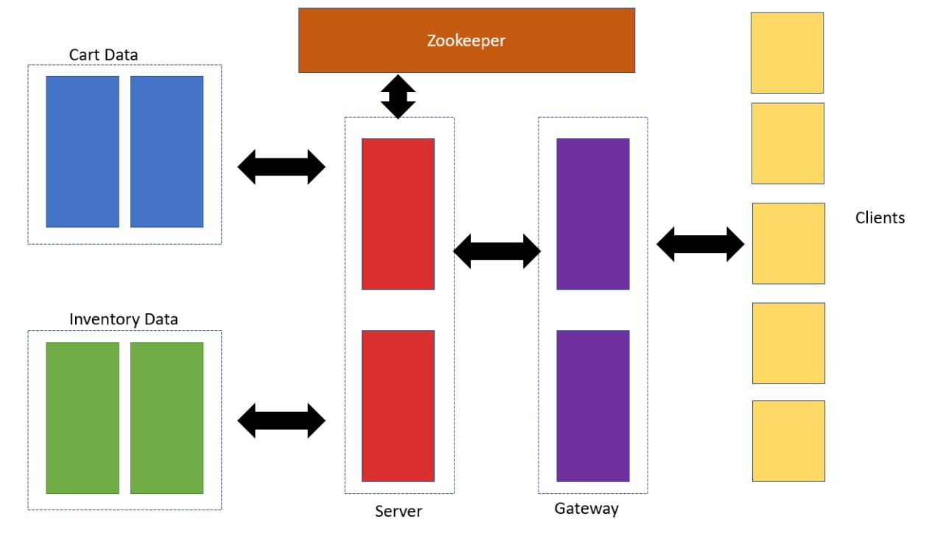

The above displays the overall design of the system. It consists of,

* Clients
  + The nodes that send requests to the gateway. In this particular case, the requests sent by clients will be to add a product to cart, display cart etc.
* Gateway
  + The gateway receives requests from clients and using CRUSH it determines which replica the data resides in. Using this information it forwards the request to the server who does the required processing. For e.g. The client may send a request to gateway1 for adding an item to his/her cart. The gateway would determine which replica of inventory data the item resides in and update it and user cart accordingly.
* Server
  + The server receives a request from the gateway and which node it would be executed on. Using this information, the request is made and response is forwarded to the gateway.
* Inventory and Cart data replicas
  + They hold the data about items in inventory and different user carts.
* Zookeeper
  + The synchronization of this whole system relies on distributed locks via zookeeper.

**The data:**

Inventory Data:

The inventory data consists of Product Name, Available Quantity and Timestamp. Using CRUSH the data is distributed across 2 replicas.

Requests:

All requests are extracted from the “requests.csv” file for simulation purpose and based on the nodes from where the requests are made the requests are sent to respective clients. Once the docker container is up, these clients would start sending these requests out.

Cart data:

The cart for a particular user would consist of items which the user would have added along with their quantities and price.