**Project Name :- Locked.java**

**Project Developer: Sanchi Srivastava**

**Project detail:**

The project shows user 6 choices by using 4 switch cases:-

1. There is choice for the Creation of directory.
2. Add the files.
3. View all files available in the directory.
4. Delete the files.
5. Search the files
6. Exit from the system.
7. I have created a project “Locked.java” for Phase 1. In this project there are 4 cases provided for above choices.
8. First of all I have taken choice of user for the path of creation of directory and mentioned the directory name.This project creates a separate directory into the system for the file operation.
9. For this project I have created directory “LockedProject” by user input and going forward I have taken it default directory.
10. User can add files as many he/she want and can view the list of all files in alphabetical ascending order.The file can only be created with .txt extension.This solves the problem of inappropriate file extensions.
11. For the deletion of file I have added case sensitivity to avoid getting deleted wrong files.
12. For the searching of file I have added case sensitivity to get right file.

**Github link**: https://github.com/Sanchiak/Project-LockedMe

**Technology used:**

* Eclipse
* Java
* Git Bash
* Git Hub

**Core Concepts used:**

* File Handling.
* Collection
* String
* Exception Handling
* Switch Case

**Sprint detail:**

**Sprint 1:**

1. Show four cases:

* Create Directory and mention path
* Load listed files in alphabetical ascending order
* All files available in the directory
* Add a new File.
* Search any file.
* Delete a File.
* Exit

1. Take user inputs for each choice
2. Create separate methods for searching/adding/deletion.

**Sprint 2:**

1. Validate the user input for each choice.
2. Show files alphabetically ascending order.
3. Created a separate directory for all the files.

**Scrum Burndown chart:**

|  |  |  |
| --- | --- | --- |
| **Task** | **Estimated Time** | **Total Time** |
| First interface development with four choices using swithc cases | 580 | 580 |
| Taken input by user input and perform methods by using switch cases | 550 | 500 |
| Taken directory path by user input | 480 | 420 |
| Taken directory name by user input | 400 | 380 |
| Created files into directory | 350 | 340 |
| Sorted files in ascending order | 300 | 280 |
| Created file by user input | 250 | 230 |
| Search file by user input | 150 | 140 |
| Delete file by user input | 100 | 90 |
| Add exception and check | 80 | 70 |
| Test | 60 | 60 |

time.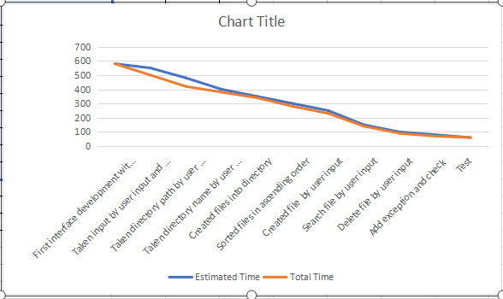

**Conclusion:**

The project created for user input and this scrum burnt down graph will be helpful for monitoring project accuracy and accurate time for completion of project.