CMake is a build system generator that acts as a universal translator between your C++ code and the specific compiler installed on a machine.
CMake is the universal standard for sharing C++ projects; developers expect to download a repository, run cmake ., and have it compile seamlessly.
CMake automatically detects the user's operating system, locates the correct system paths, and adjusts the build instructions accordingly, ensuring it works on different Linux distributions (or even macOS and Windows) without you needing to rewrite scripts.
The project requires compilation using GCC or Clang. CMake allows developers to swap between these compilers effortlessly without modifying the project files.
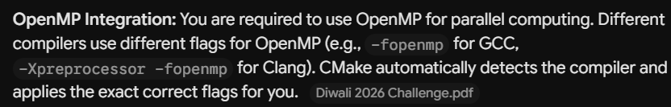
We need a specific flag to force CPU to trigger and follow the OpenMp.

The file extension for the main CMake file is .txt, and the file must be named CMakeLists.txt (case-sensitive).
CMake specifically looks for this exact filename in your repository root when you run commands like cmake ...
(FOR ANY PROJECT’S CMAKE : THIS EXACT NAME IS REQUIRED).

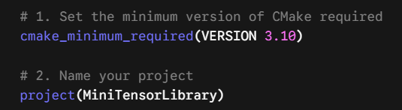
Instead of C++, CXX is used.
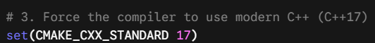
Compiler supported are GCC,CLANG. If left OFF, it lets the compiler on the machine run on any version of C++, ON enforces it.
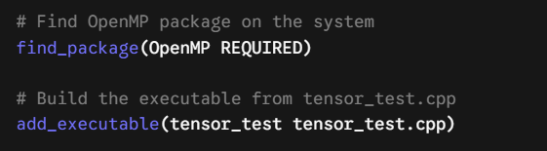
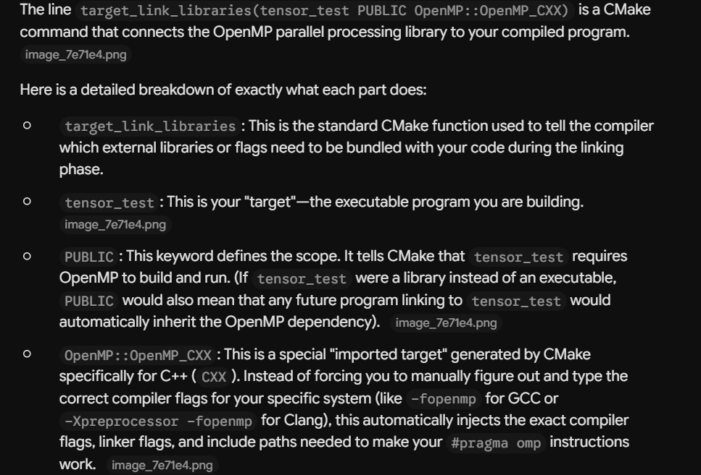
Bascially the purpose of PUBLIC:
Any future program linking to testor_test.c++ is allowed to inherit OpenMp also.

HOW TO ACTUALLY RUN ON LINUX:
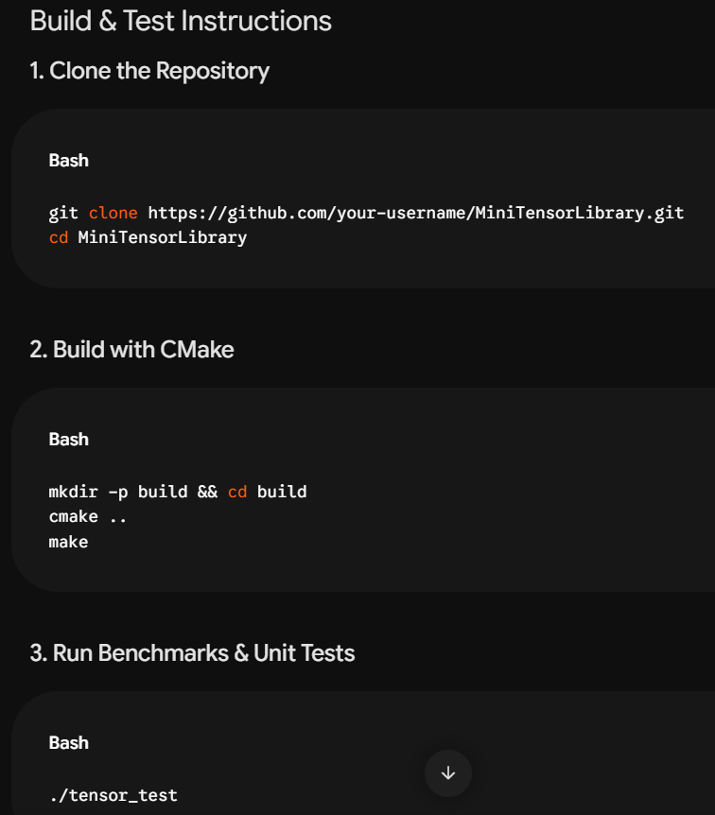
In 2nd step we make new directory build.

