We use .h or .hpp file for tensor, (its header not library file), easily portable on linux, library wasn’t.

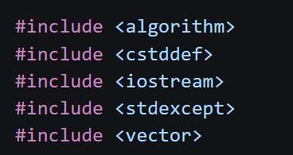
Used this instead of bits.stdc++.h and using namespace::std, because the cpp file where this header would be included, would get polluted with the header files used in this Tensor.h, and namespace std too would become active there.

Purpose of 

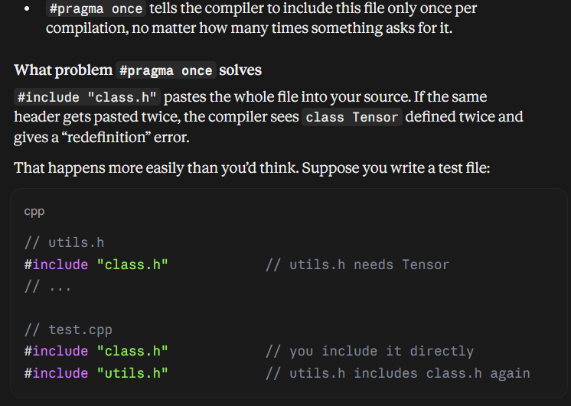

Purpose of using 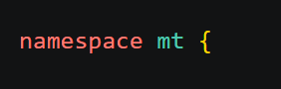
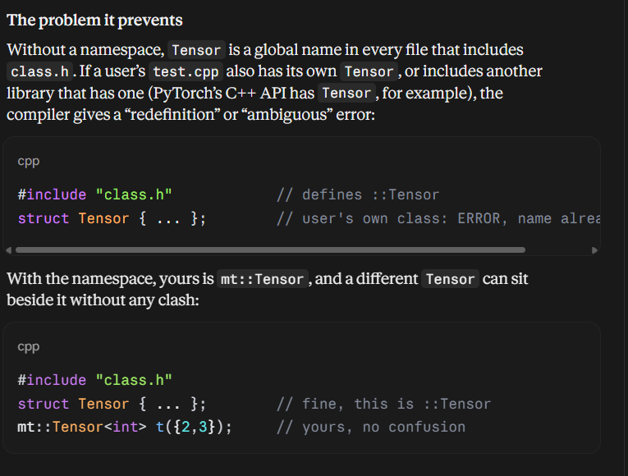

Just T is placeholder for whatever data type this Tensor holds. By default we take it to be float.

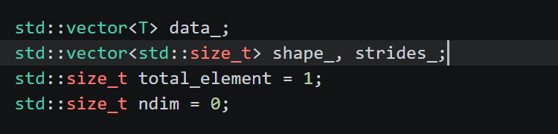
Private Data Members:
We use a 1d array data_ to store the actual datastuff, not a n arry vector, too slow and too many loops, access [][][] problems, and a vector<vector<vector>>> uses heap(dynamic or non stack)memory for each vector<> hence slow.
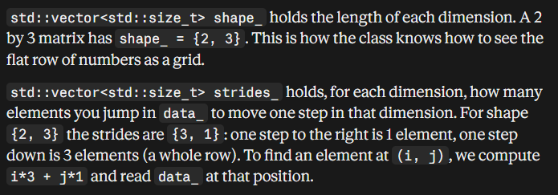
Here (i,j) or any index is 0 based (0,0,0..)based for that matter.
std::size_t total_element is how many numbers the tensor holds, which is the shape multiplied together.
std::size_t ndim is the number of dimensions, which is just the length of shape.
std::size_t: It is an unsigned type made for sizes and positions. A length or an index can never be negative, and it is the same type std::vector uses for its own size, so there are no type mismatches when we compare them.
The only thing is that size_t i=7(let us say).
So for(size_t i=7; i>=0;i--) this loop never ends, as size_t always>=0.
for(size_t i=7;i>0;i--) this also never ends. Negative i, gets overlflwon to large positive thing.
So we use rather: for(size_t i=7; i-- >0;)

In C++, std::vector::resize() changes the actual number of elements stored in a vector. It inserts or deletes elements at the end of the container to match the requested size.
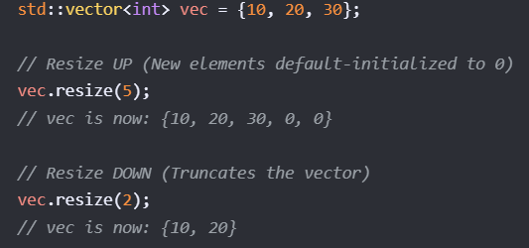
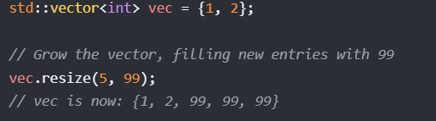

How to compute strides:
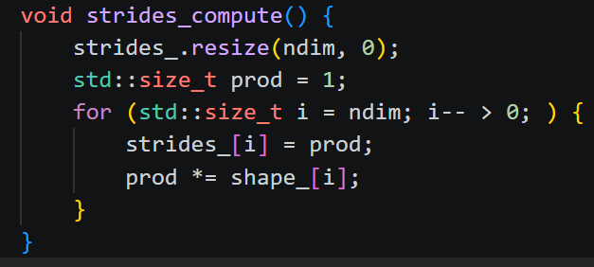
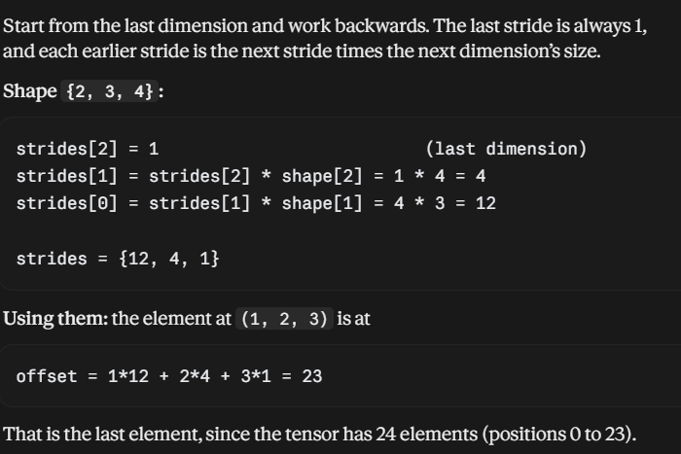
The purpose of stride: for ex how many elements to skip -to reach the next row. Or to reach the next column.
In a 3*4 matrix, to reach the next row, same column, you would have to skip 4 elements, and to reach same row,next column: only 1.

Throw invalid_argument(“”);
And other throw error statements, none carry a return statement.
When a throw statement is executed, it instantly alters the execution flow of your program. The function exits immediately, normal execution halts, and C++ begins a process called stack unwinding to search for a matching catch block. Because the code line immediately following a throw is unreachable, a return statement is completely redundant.

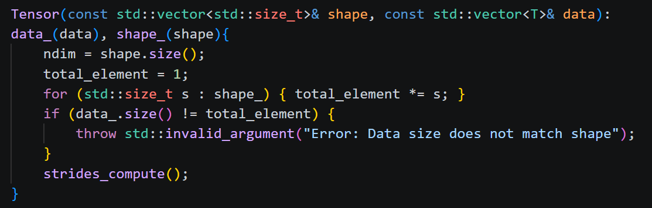
Above simply copies data_,shape_ received into the new object’s data_,shape_. Finds its number of dimensions and also checks if number of elements remain same as before. If not-then throws error.
The above constructor called by reshape() func. We are given new dimensions and the number of dimensions may also vary. We wish to create a new Tensor object-having the same data_, this new dimensions, total elements remain same, the new ndim=number of dimensions,and new strides.
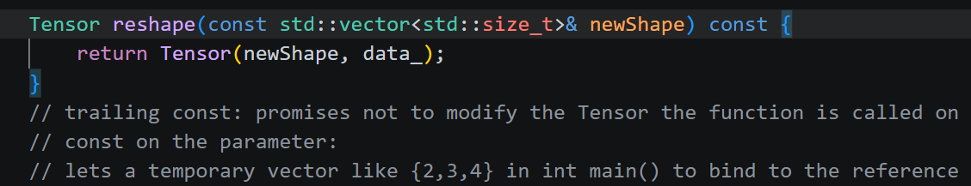
Inside int main(){ Reshape({1,2,3}) is only allowed since we use const vector<> &newShape inside reshape() argument, else without const, we can’t let a temporary vector be taken by &. A permanent vector would be vector<>me={1,2,3} and then me is passed.}
Main constructor:
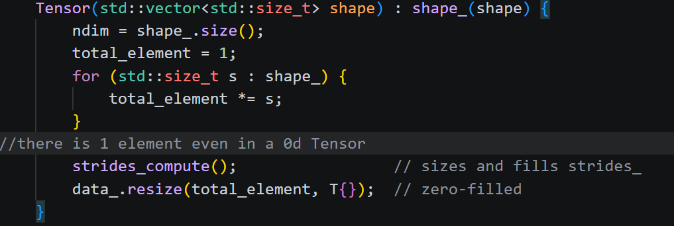
Inside it we find the number of dimensions(ndim), the total number of elements(by default=1, because 0d Tensor also holds 1 element). And then compute strides_, and resize data_ too.
Data_.resize(total element,T{});
Here T is placeholder for whatever data type the Tensor holds, and if it was int, then resize (size,0). If string then resize(size,””), similarly here we put empty/default of the data type placeholder T by using T{}.

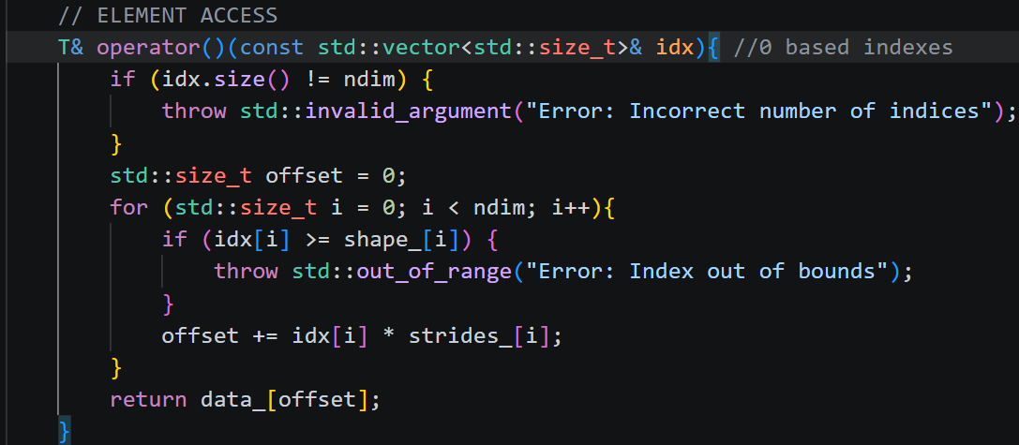
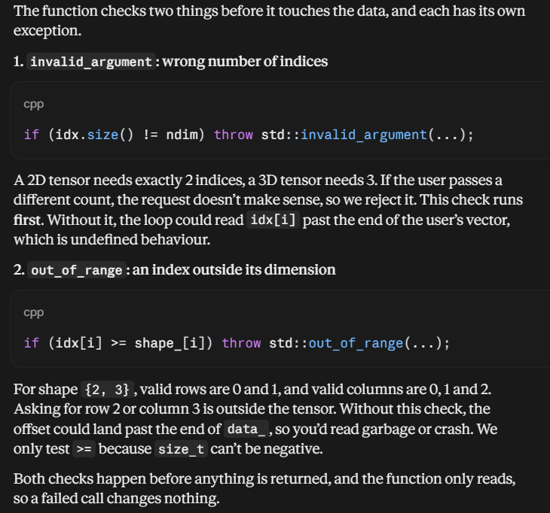
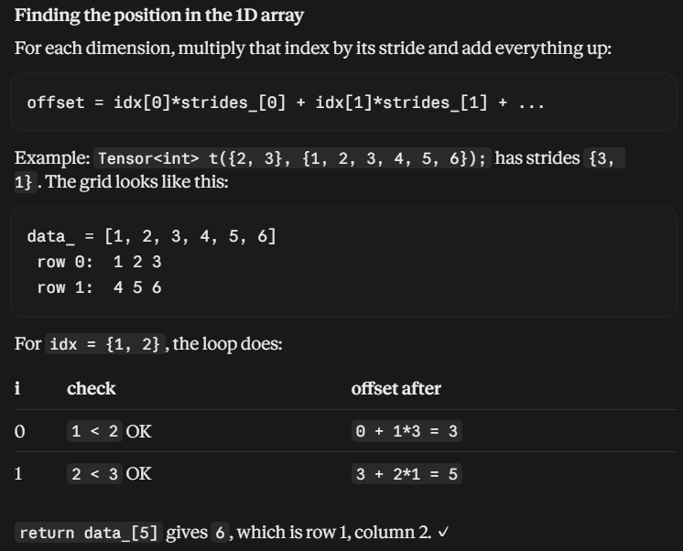
To use it inside int main. Suppose an object t of Tensor class. We wish to access (1,2,3) indexed element so t({1,2,3}). We can also modify or simply read this element,as object returns T&.

Similarly for iteration over whole Tensor:
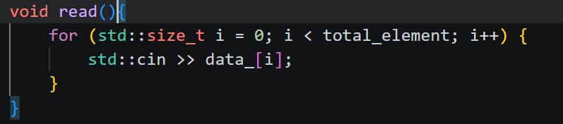

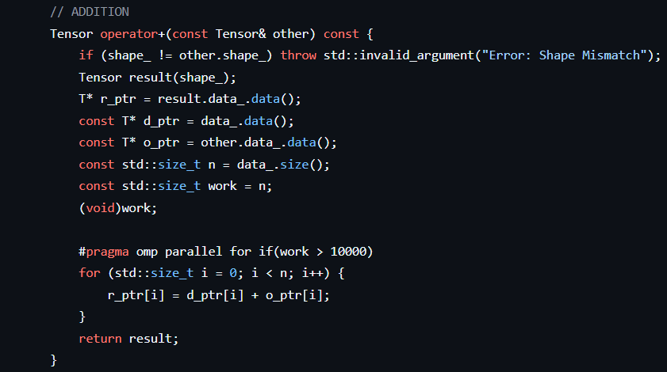
To add, similarly subtract, element wise *, first we check if number of dimensions and the actual number of elements in a row(for ex) match or not. Then we create a resulting Tensor object and return with new data.

T* ptr=vector_name.data() returns a pointer same as &vector_name[0] . unlike the later it doesn’t crash if vector empty.

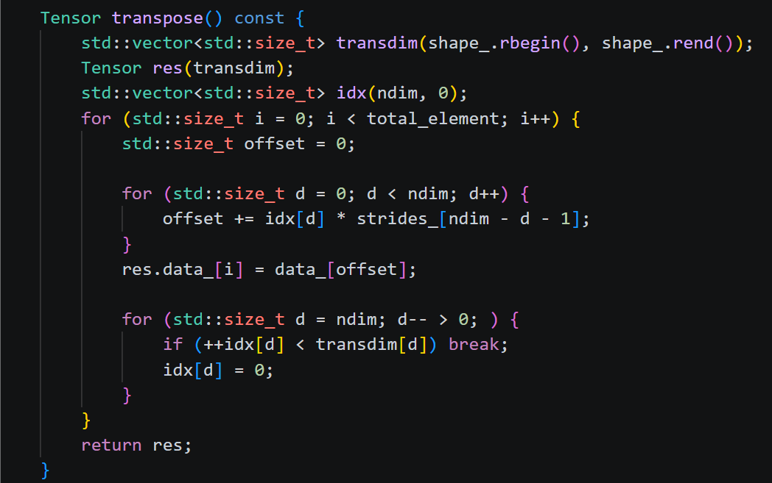

Tensor transpose:
Clearly an element at (i,j) in transpose result matrix, will be at (j,i) in original matrix. So for (i,j) of resulting transpose matrix we want to find the element from the 1d orginal array. How?
The element (j,i) of original matrix is at data_[offset]. Where offset= j*stride[0]+i*stride[1]…
So directly relating (i,j) from resulting transpose we get offset=i*stride[1] +j*stride[0]….
Or offset=i*stride[ndim-d-1] +j*strider[ndim-d-1] where d is 0,1,2…upto <ndim.
Now the other part: how do we find where (i,j) of transpose matrix be put in the 1d transpose data_ ? either we can compute its transpose_element_offset (slower). Or we do it parallely side by side-without actually computing transpose_element_offset.

For this, we maintain a vector idx and a pointer or iterator or simply variable i.
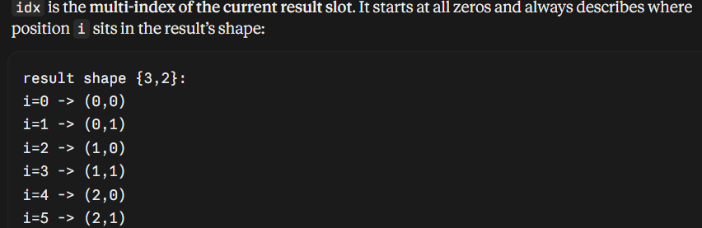
The last loop moves idx from one slot to the next: add 1 to the last index, and if it reaches its limit (transdim[d]), reset it to 0 and carry into the previous index. That is how we are able to point at some place(i) of the 1d result transpose array and also able to read the element’s corresponding (i,j,k..) of result transpose from the idx vector.
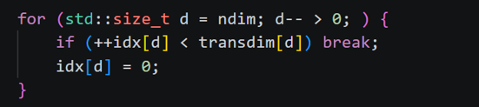
This for loop is responsible for changing elements of idx, like bits from right to left. In this loop, if an element idx[d] reaches the corresponding dimension transdim[d]
-it gets reset to zero, and we move on to the next left guy and so on. We stop for a particular element of the matrix, when some idx[d] doesn’t exceed corresponding transim[d].

Matrix Multiplication:
Firstly matrix multiplication works for only 2 tensors whose dimensions>=2 atleast.
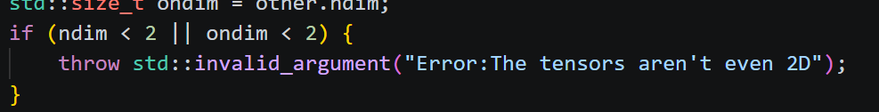
Then let A=[….,m,n] B=[…..,n,p].
A’s last dimension must match B’s second last dimension.
And After checking one more condition,we get the resulting dimension:[….,m,p].
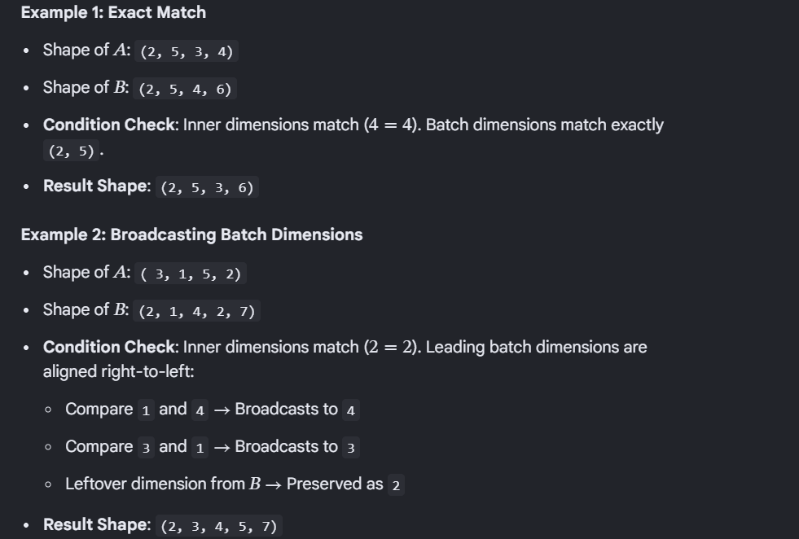

Let the other dimension before the last two be something:
So starting from right(the dimension left to second last dimension): the dimension of A,B should either match, or one of them should 1, or one of them should be missing.
So short way of writing for some dim:
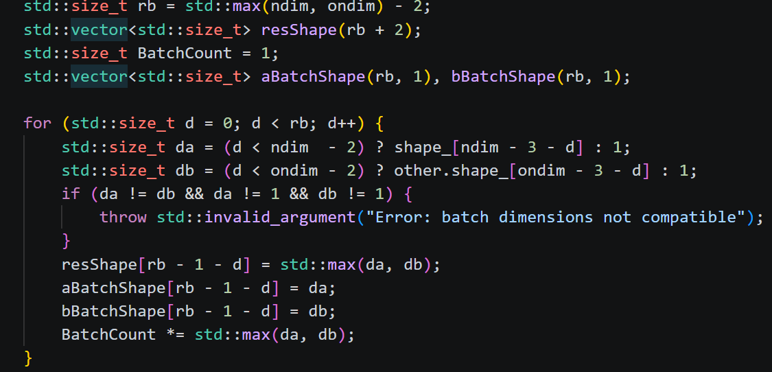

Let there be 6 dimension of A,and 5 of B. so leaving last two of both: we get rb= 4 dimensions (called batch dimensions) (4 because max of 6-2,5-2).
Now beginning from right(left guy of last two) to left: we extract the corresponding dimensions(da,db). If the dimension of A/B doesn’t exist we take it as 1.
Finally reshape gets the max of (da,db). We also calculate total batches=the product of dimension of the resultant matrix(other than last 2 dimensions) on the fly.
We also construct aBatchShape and bBatchShape on the fly. Their size is rb. 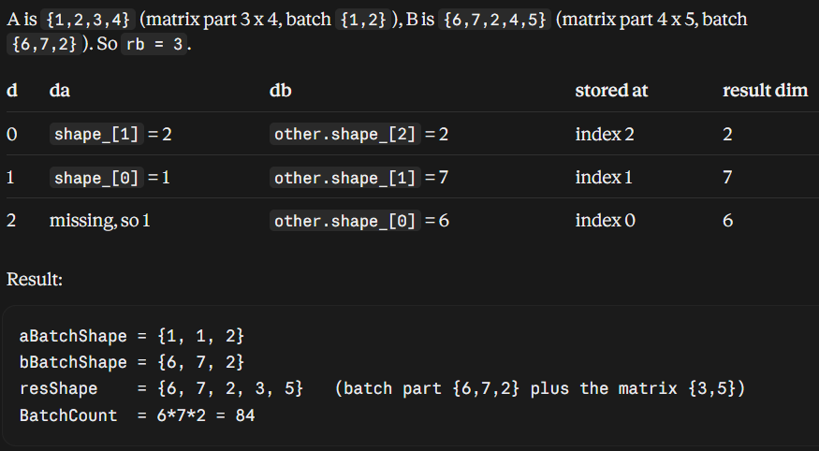

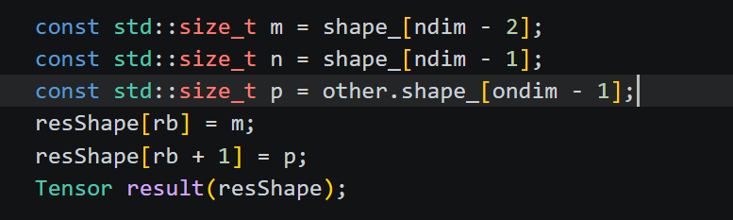
A: m*n, B:n*p.
And resulting matrix has dimensions: […., m,p]. the rb part contributes the [….].
We create the resulting tensor with reshape dimensions.
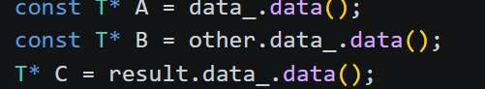
A,B,C are pointers set to the 1d flat arrays of obj on which matmul called, the passed tensor, the result tensor.
So A.data_[1] same as data_[1]
B.data_[1] same as other.data_[1].
Also A,B are const since the argument Tensor (other) passed and the func both are const, so we need const pointers. C pointer not const as we need to work on result.data_

Construct aStride,bStride both of dimensions rb.
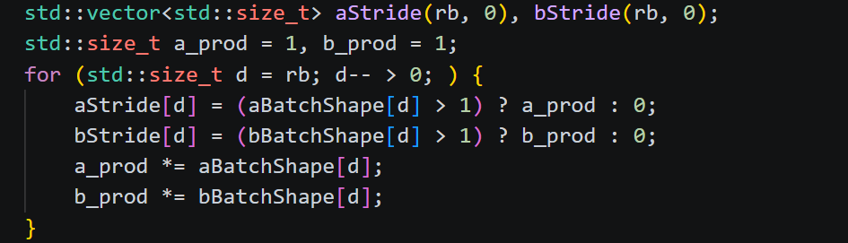
It is like making normal stride vector, but if a aBatchShape’s dimension here is 1(talking about aStride, aBatchshape here )-then nothing to skip, or say pointer keeps pointing here.
Basically in normal stride-moving across some axis(or dimension) required us to skip some moves,which we got to know from strides vector. Here we skip matrices( not only elements) at behest of aStrides.
And If aBatchShape[d] is 1== we know that 1 meant either that dimension in A is missing or is genuinely 1. So nothing to skip here and hence aStride[at that d]=0. For ex:
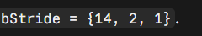
Read it like this: for B, one step along axis 1 skips 2 matrices, and one step along axis 0 skips 14 (7 x 2). For A, only the last axis moves, and the other two are 0 called Broadcast. See this example:
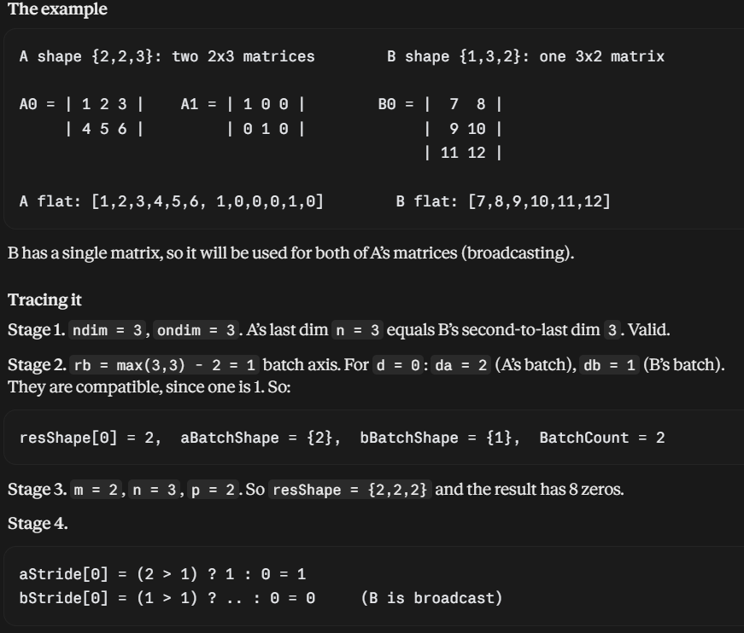
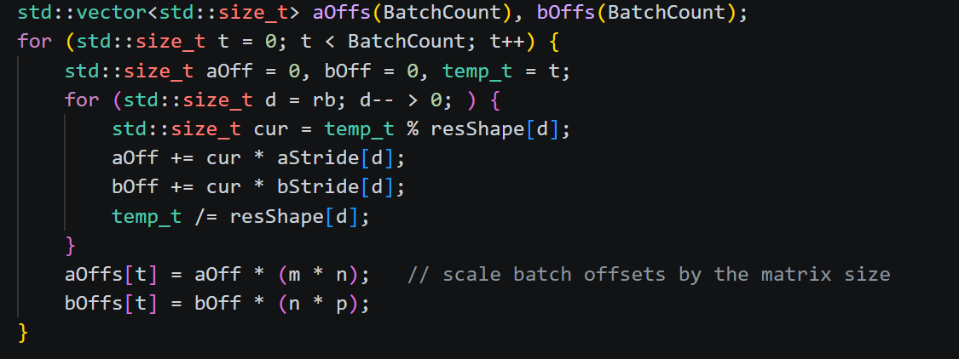
Later this helps us find aoffs,boffs both which have size=BatchCount. Basically for each batch(t=0 to t<batchcount) we storing which positon of the 1d arrays of A,B to start iterating from in the below 3 loops.

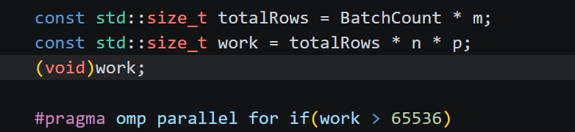
Work just finds out total number of multiplications done.
As you will see later-the total number of multiplications are totalRows*n*p.
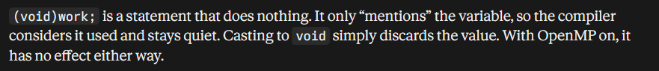
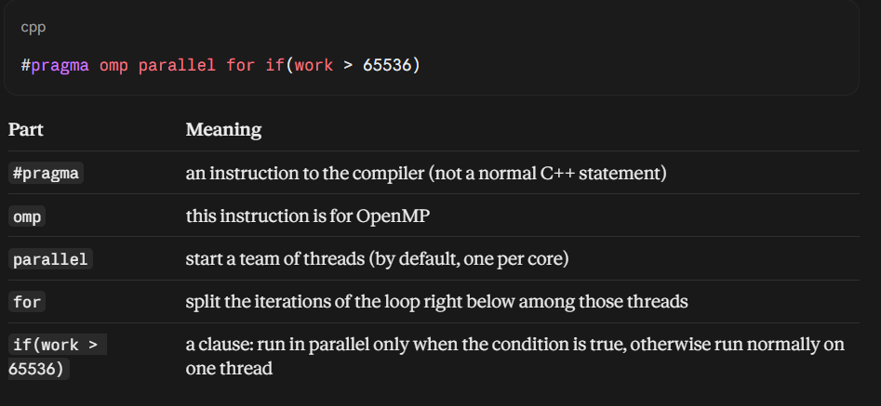
This syntax must sit directly above a for loop.
Only the r loop (one iteration per result row) runs parallelly. That’s the loop directly under the pragma. The loops k and j inside it run serially, in order, within whichever thread owns that row.
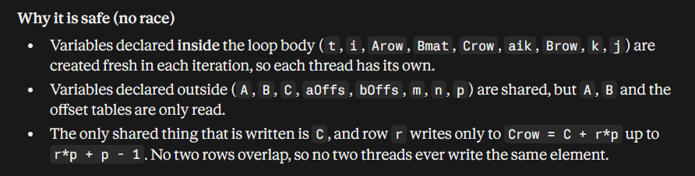
Thread0 does Crow=C+0*p ,thread1 does Crow=C+1*p.
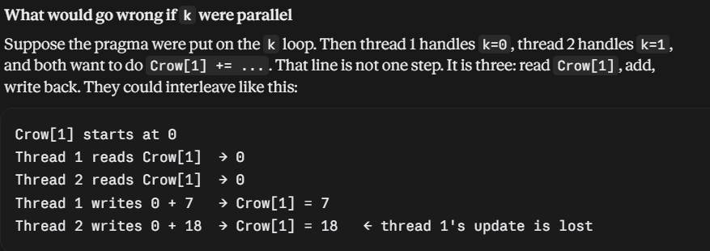
In above suppose thread0,thread1 on k=0,1 have j=0 at same time,then race would happen in Crow[j] += aik * Brow[j]; line.
(Race doesn’t happen on:
const T aik = Arow[k]; const T* Brow = Bmat + k * p; because k would be different for different threads.)
j: each iteration does one multiply-add, which is too small to be worth giving to a thread.

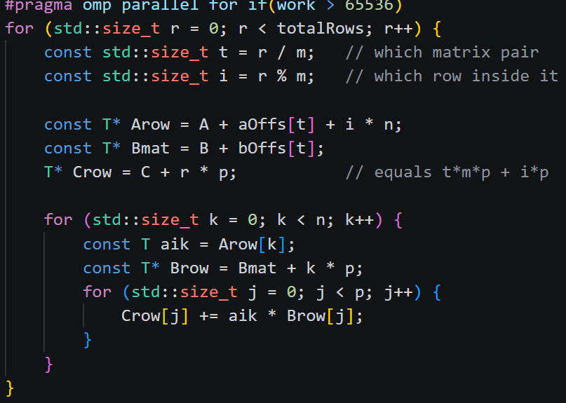

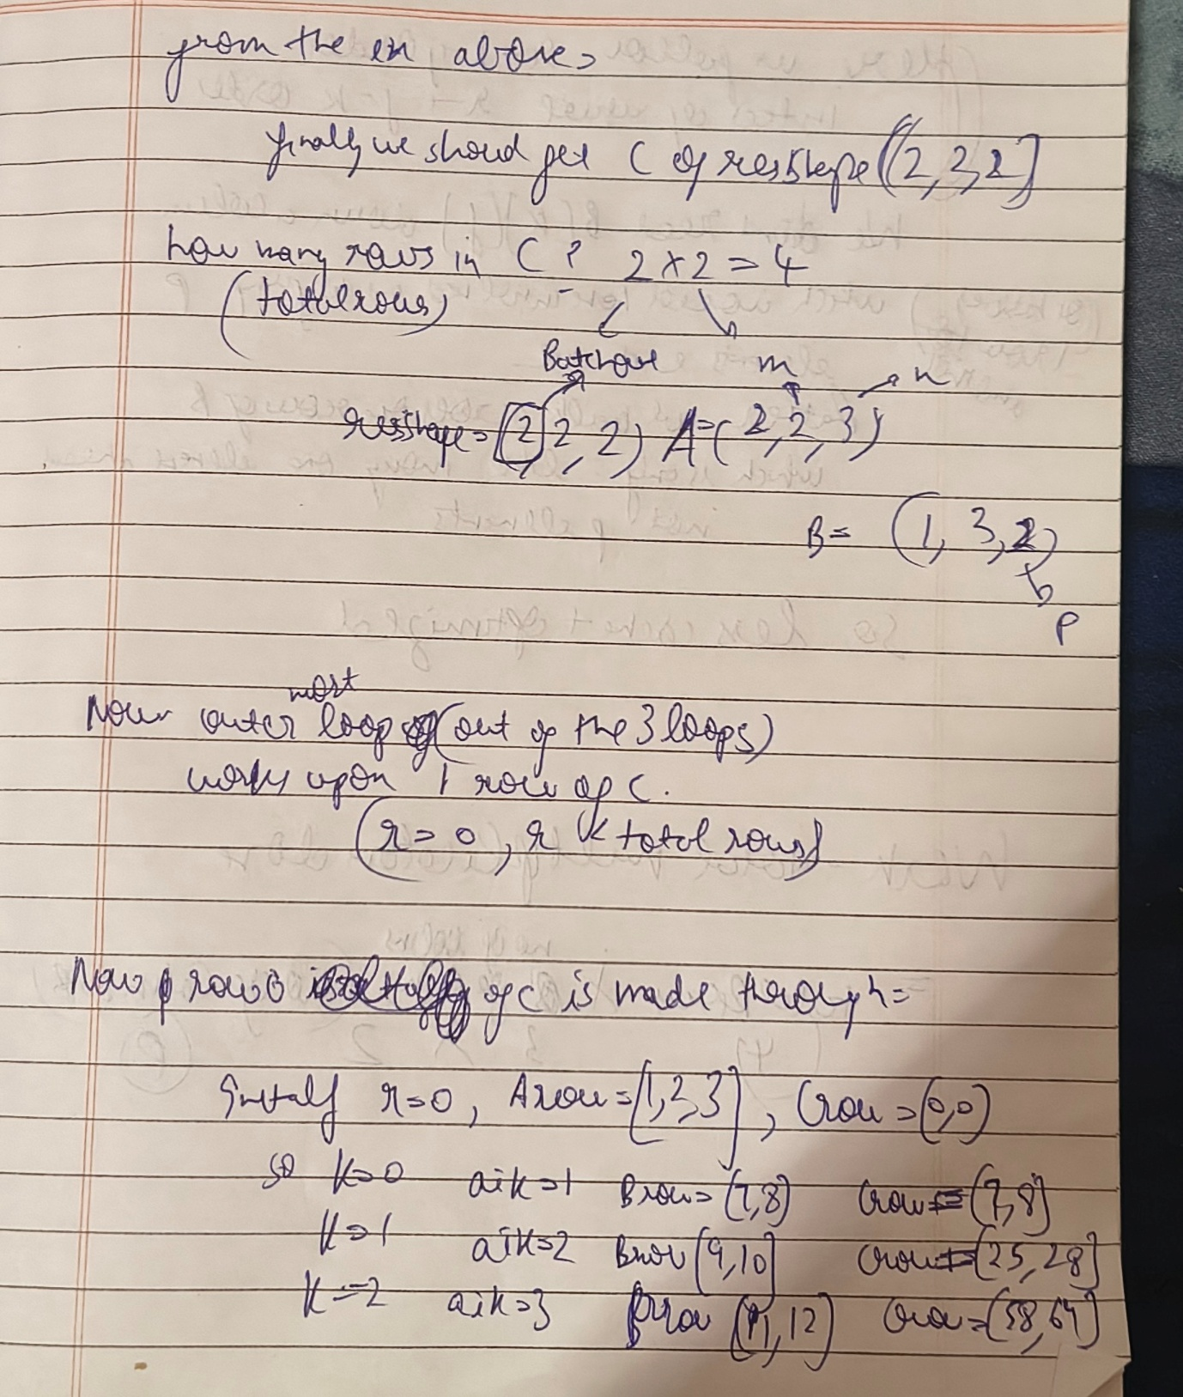

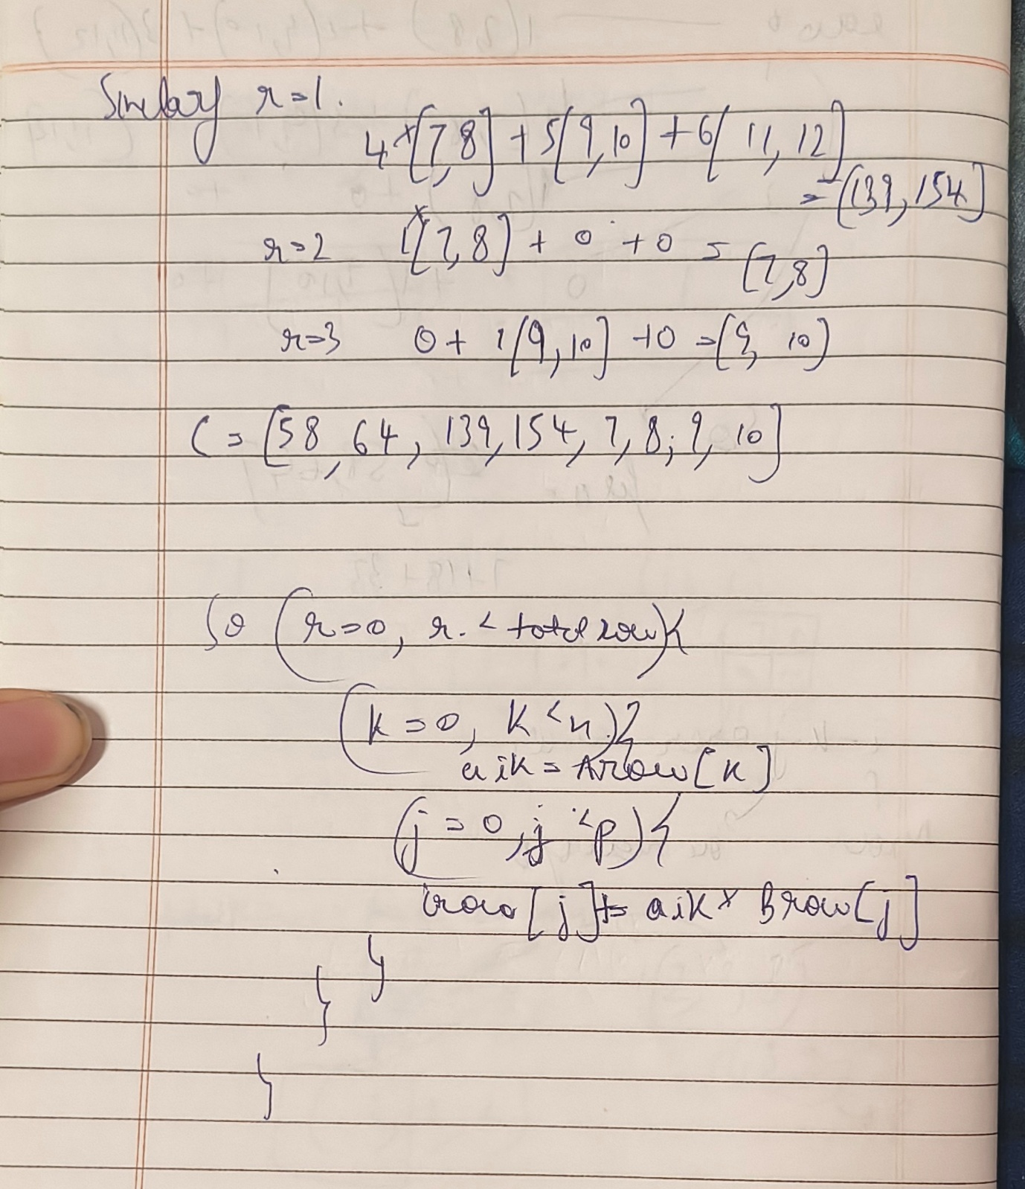

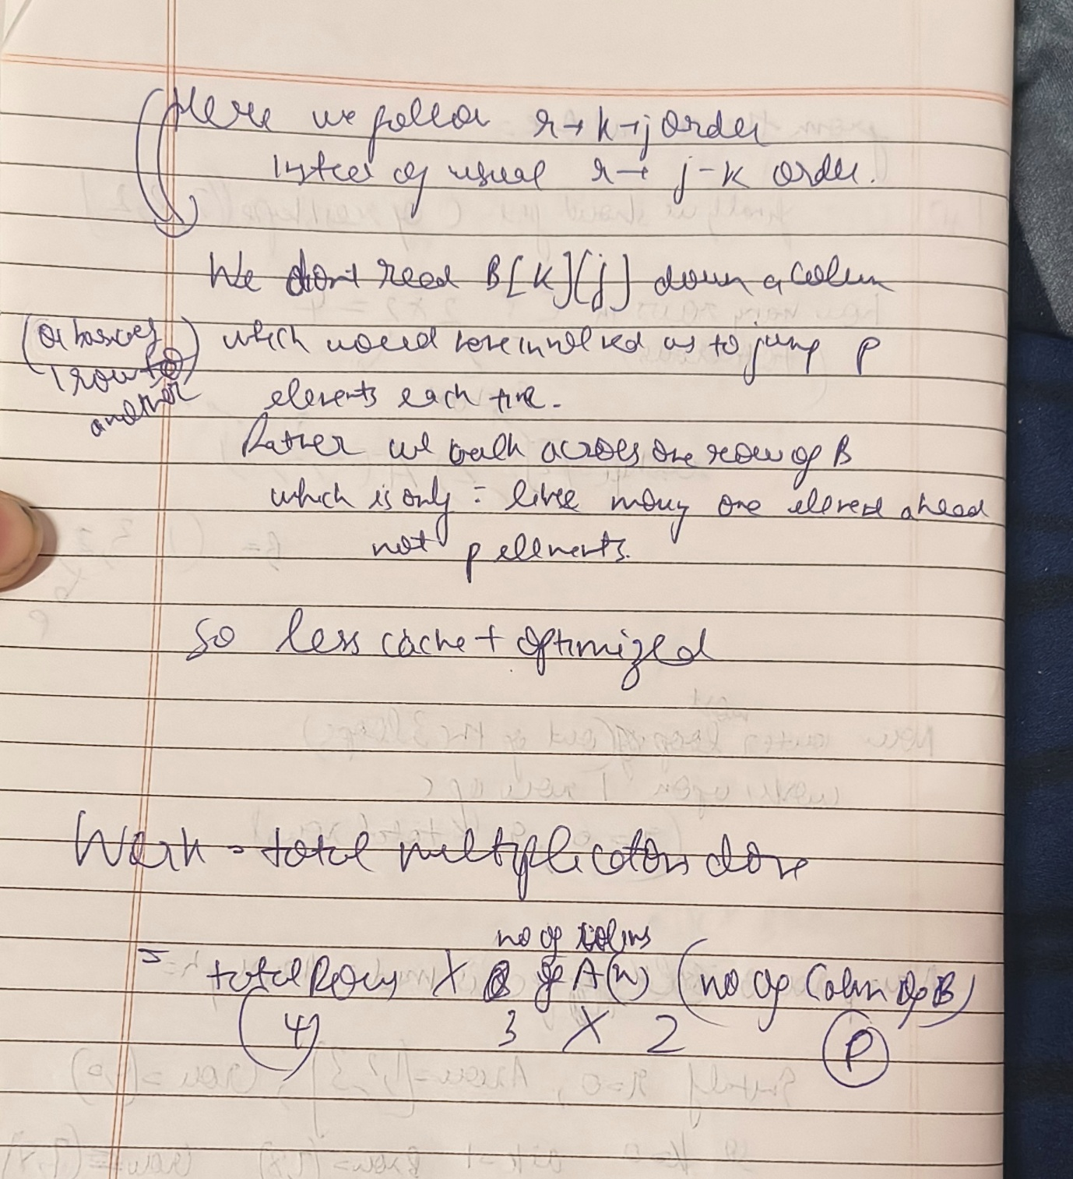

TIME COMPLEXITY:
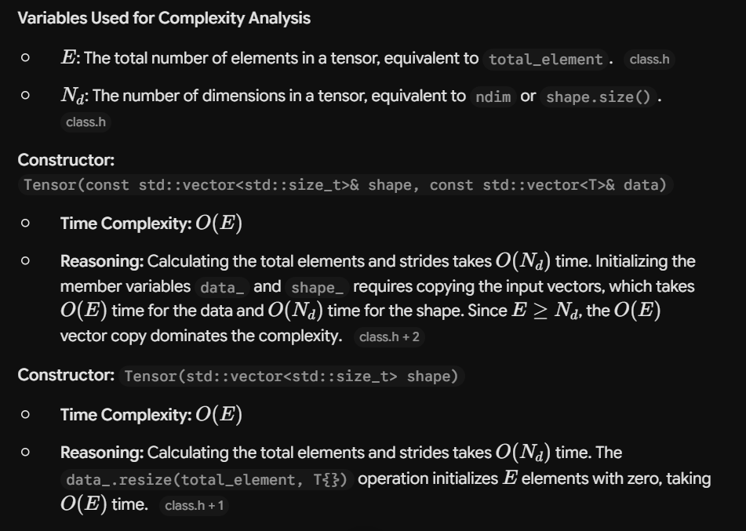
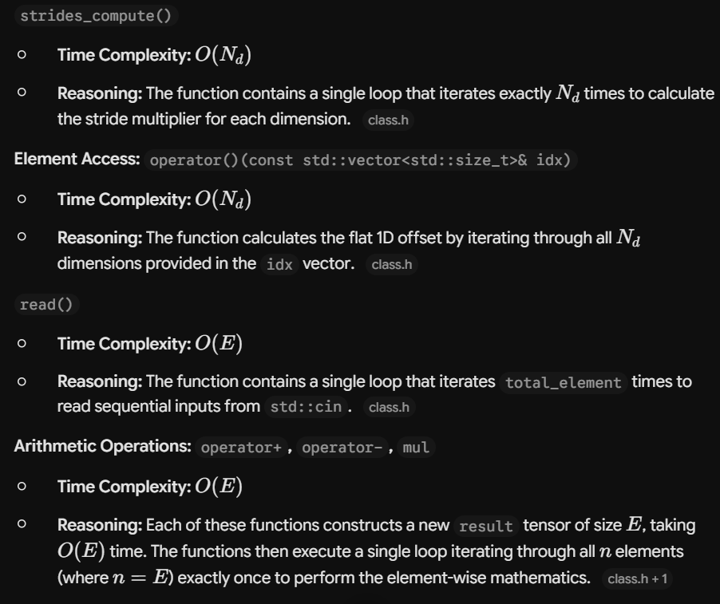

CONTINUED:


