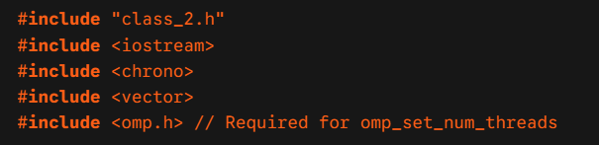
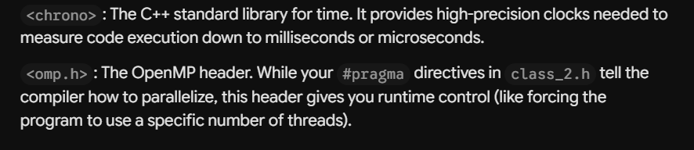
Will see later the syntax meant for controlling the number of threads.
If didn’t wish to control, no need to use this header.

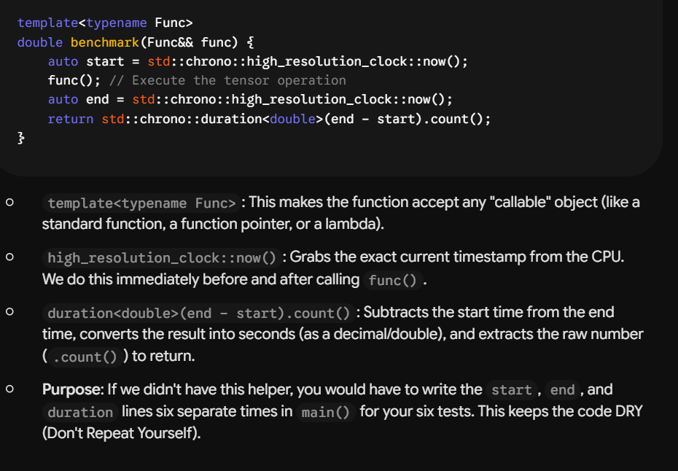
It is lambda function and also we pass the Tensor Objects A,B by reference rather than the function/operator itself.

The above 2 override default OpenMp behaviour. Now will execute on 1/max_threads. If it works on 1, then it behaves sequentially like any other normal for loop.

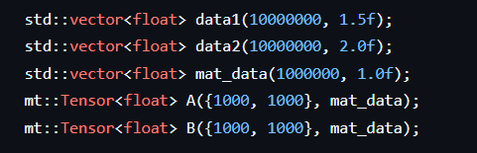
Preparing 2 tensor objects A,B and passing data1,data2 into it and their dimensions are {100,100}, and we have kept the number of elements enough to trigger thread creation in #pragma omp parallel for (by ensuring work is greater than the conditions in all three operators +,-,* and matmul).

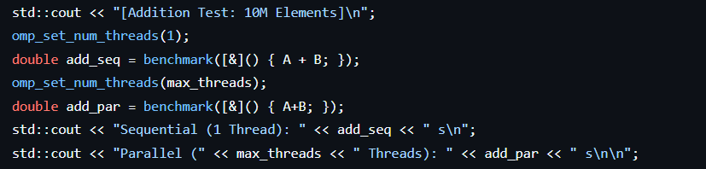
We set threads to 1, and measure time for the + operator in add_seq, and then set threads to max and then measure the time for the same operator in add_par. Surely add_par must be taking less execution time than add_seq.
Also we pass A,B by reference &, so that copy doesn’t happen.

