### **1st Page: Introduction**

**Name:** Sanchit Gupta
**Roll No.:** 23M1114
**Branch:** Electronic System (EE5)
**Project Title:** Design and Implementation of Hardware Communication Protocols

#### **1. Introduction**

Communication protocols are essential for enabling data exchange between hardware components in various digital systems. Among the most commonly used hardware communication protocols are Universal Asynchronous Receiver-Transmitter (UART) and Serial Peripheral Interface (SPI). These protocols facilitate reliable and efficient data transfer, playing a critical role in embedded systems, microcontrollers, and integrated circuits.

This project focuses on the design and implementation of UART and SPI communication protocols using Verilog HDL. The primary objective was to create robust and efficient hardware modules that adhere to protocol standards, ensuring compatibility and reliability in communication.

#### **2. Design Methodology**

##### **2.1 Universal Asynchronous Receiver-Transmitter (UART)**
UART is a serial communication protocol that allows full-duplex communication between two devices. It transmits data bit by bit asynchronously without needing a clock signal between the transmitter and receiver.

**Key Features:**
- Asynchronous communication.
- Full-duplex transmission.
- Variable baud rate.

**Design Implementation:**
The UART module was designed in Verilog, incorporating a transmitter and receiver. The transmitter converts parallel data into serial form, while the receiver converts serial data back into parallel. The design also includes baud rate generation and error detection mechanisms to ensure reliable communication.

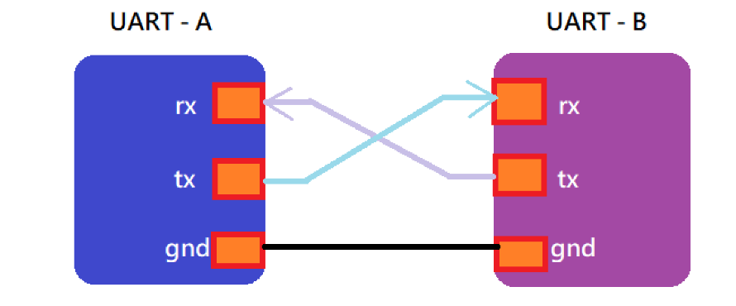

##### **2.2 Serial Peripheral Interface (SPI)**
SPI is a synchronous serial communication protocol that enables communication between a master device and one or more slave devices. It is widely used in systems where speed is critical, as it supports high data rates.

**Key Features:**
- Synchronous communication with a clock signal.
- Supports multiple slave devices.
- High-speed data transfer.

**Design Implementation:**
The SPI module was implemented in Verilog with a master-slave configuration. The master generates the clock signal and controls the data exchange, while the slave responds accordingly. The design ensures that data is correctly synchronized with the clock signal to maintain integrity.

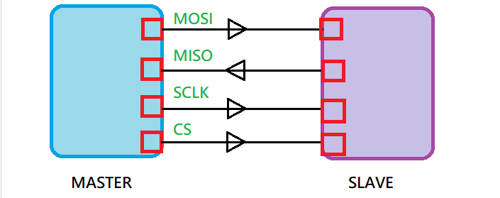

#### **3. Validation and Testing**

Validation and testing were crucial steps in confirming that the designed UART and SPI modules comply with protocol specifications. Simulation tests were conducted using Verilog testbenches to verify the functionality of each module.

**Testing Results:**
- The UART module was tested at various baud rates, and data integrity was maintained throughout the transmission.
- The SPI module was tested with different clock frequencies and successfully communicated with multiple slave devices.

#### **4. Conclusion**

The project successfully achieved the design and implementation of UART and SPI communication protocols in Verilog. The hardware modules were validated and tested, confirming their compliance with protocol standards. These modules can be integrated into various digital systems, providing reliable and efficient communication.

### **5th Page: References**

1. Replica455. "VLSI-Protocol." GitHub Repository. [https://github.com/replica455/VLSI-Protocol](https://github.com/replica455/VLSI-Protocol).
2. Ashwin-Rajesh. "Verilog_comm." GitHub Repository. [https://github.com/Ashwin-Rajesh/Verilog_comm/tree/main/spi](https://github.com/Ashwin-Rajesh/Verilog_comm/tree/main/spi).

---

You can format this content in a word processor to create a polished report. Ensure that you add relevant diagrams and simulation waveforms for a comprehensive presentation. Let me know if you need further assistance with this!

