
BHARATIYA VIDYA BHAVAN’S SARDAR PATEL INSTITUTE OF TECHNOLOGY
Bhavan’s Campus, Munshi Nagar, Andheri (West), Mumbai – 400058-India
Department of Computer Science and Engineering

Rozo File System

Distributed Computing Case Study

under,
Prof. Mayuri More

by,
Mayur Raonang (2023800093)

1

TABLE OF CONTENT

INTRODUCTION..........................................................................................................3 ARCHITECTURE DESIGN..........................................................................................4 High Level Components........................................................................................... 4 Component Interactions............................................................................................5 Core Design Principles............................................................................................. 5 FILE -NAMING & ACCESS.........................................................................................7 File Naming.............................................................................................................. 7 File Access Mechanism............................................................................................ 7 Consistency Model................................................................................................... 7 HIERARCHICAL STRUCTURE..................................................................................8 Namespace Organization.......................................................................................... 9 Metadata Management..............................................................................................9 Locking & Concurrency........................................................................................... 9 Advantages of the Hierarchical Model..................................................................... 9 IMPLEMENTATION...................................................................................................10 Programming Language & Platform.......................................................................10 Replication & Fault Tolerance................................................................................ 10 Consistency & Concurrency Control...................................................................... 11 Security Considerations.......................................................................................... 11 REAL-WORLD APPLICATION.................................................................................12 Cloud Providers ……...........................................................................................12 Media & Entertainment Industry .......................................................................12 Scientific Research & High-Performance Computing (HPC).........................12 Enterprises & Big Data Analytics...................................................................... 13 Government & Archival Institutions................................................................. 13 ADVANTAGES & LIMITATIONS............................................................................14 Advantages..............................................................................................................14 Limitations.............................................................................................................. 15 CONCLUSION............................................................................................................ 16 REFERENCES………………………………….........................................................17

2

1. INTRODUCTION

The digital era has brought with it an explosion in data creation, processing, and storage requirements. Every click on social media, every transaction on e-commerce platforms, and every scientific experiment in large-scale research contributes to the vast ocean of data being produced globally. To cope with these massive data volumes, Distributed File Systems (DFS) have emerged as critical building blocks of modern computing infrastructure.
Traditional file systems, built for single-machine use, cannot handle the scale, redundancy, and fault tolerance required today. Systems like the Hadoop Distributed File System (HDFS) introduced the idea of replication to achieve reliability: each file block is stored in multiple copies across different nodes. While effective, replication has an inherent drawback—high storage overhead. Maintaining three replicas of every file consumes vast amounts of disk space, which quickly becomes inefficient at the petabyte scale.
Here’s what makes Rozo FS stand out:
● Scalability: It’s built to handle clusters of thousands of servers, managing petabytes of data and supporting countless users at once.
● Fault tolerance: Instead of breaking down when hardware fails, GFS automatically detects, recovers, and keeps things running.
● Performance: It’s optimized for handling huge files and heavy workloads, something that fits perfectly with Google’s data-hungry applications.
RozoFS, an open-source distributed file system, offers an alternative. Instead of replication, RozoFS leverages erasure coding a mathematical technique that adds redundancy by encoding data into fragments that can be reconstructed even if some fragments are lost. This dramatically reduces storage overhead while maintaining fault tolerance. RozoFS is object-based, POSIX-compliant, and built for scalability, making it suitable for industries where cost efficiency and reliability are equally important.
This case study provides an in-depth analysis of RozoFS, following a structured approach: architecture design, file naming and access, hierarchical structure, implementation, real-world applications, advantages and limitations, and a concluding evaluation. It also contrasts RozoFS with replication-based DFSs like HDFS, highlighting how erasure coding shifts the design paradigm of distributed storage.

3

2. ARCHITECTURE DESIGN

i. High Level Components

RozoFS is structured around three fundamental components:

1. Metadata Servers (MDS):
• Responsible for managing file system metadata.
• Stores directory hierarchy, permissions, and file-to-object mappings. • Ensures consistency and coordinates access.
2. Storage Nodes (OIO Servers):
• Store the actual data fragments after erasure coding. • Distribute fragments across nodes for fault tolerance.
• Support parallel read/write operations for higher throughput. 3. Clients:
• Applications or users interacting with the system.
• Communicate with metadata servers for namespace resolution. • Directly read/write data from/to storage nodes after metadata
resolution.
This separation of metadata management and data storage ensures that metadata servers do not become bottlenecks while allowing storage nodes to scale horizontally.

ii. Component Interactions

The flow of operations in RozoFS involves several interactions:

• File Operation Initiation:

Clients request metadata from the Metadata Server when performing file operations like open, read, or write.
• Metadata Lookup:

The MDS provides file-to-object mappings and storage node addresses. • Direct Data Access:
Clients bypass the metadata server and interact directly with storage

4

nodes for actual I/O operations.

• Erasure Coding Handling:

For write operations, data is encoded into fragments, distributed across storage nodes, and acknowledged.
For reads, clients fetch fragments and decode them if necessary (especially when nodes are missing)

This design prevents the metadata server from being overloaded and achieves high scalability.

iii. Core Design Principles

RozoFS follows several guiding principles:

• Erasure Coding for Efficiency: Instead of creating three replicas of each block, RozoFS stores encoded fragments, significantly lowering storage overhead.
• Fault Tolerance: Can tolerate multiple node failures without data loss. • POSIX Compliance: Provides familiar file operations like open, read,
write, and close, enabling easy application integration.

• Separation of Metadata and Data Paths: Reduces bottlenecks by isolating metadata handling from bulk data transfer.
• Commodity Hardware: Designed to run on standard Linux servers, ensuring cost-effective scalability.

5

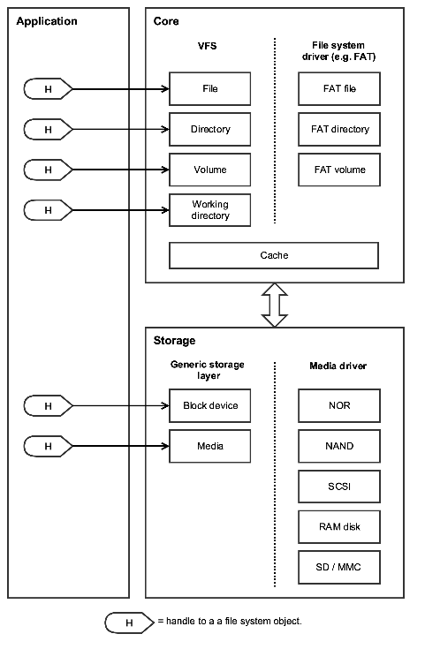
6

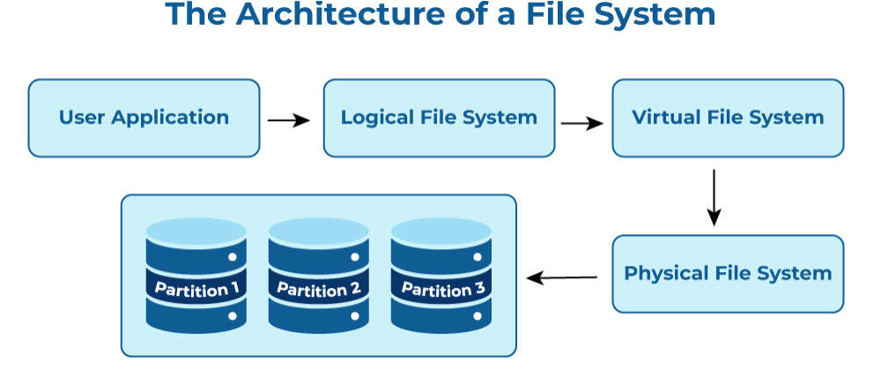
3. File Naming & Access

i. File Naming
RozoFS employs a hierarchical namespace similar to traditional file systems. Files and directories are identified by full pathnames such as: /project/data/experiment1/results.txt

The metadata server maintains mappings between these pathnames and the underlying object identifiers. This organization is intuitive for users and applications, while internally, the mapping allows efficient lookup and retrieval.

ii. File Access Mechanism The access flow is as follows:
1. Client contacts MDS: When a client needs to access a file, it queries the metadata server for metadata and chunk mappings.
2. MDS responds: The metadata server provides information about the file’s storage fragments and their locations.
3. Client interacts with storage nodes: The client directly reads from or writes to storage nodes.
4. Parallelization: Multiple fragments can be read or written in parallel, improving performance.
This model ensures scalability and prevents the MDS from becoming a performance bottleneck.

iii Consistency Model
RozoFS offers strong consistency at the file level:
• File operations such as create, delete, and rename are atomic.
• Concurrent access is controlled using distributed locking mechanisms. • Data reconstruction from erasure coding ensures that clients always
observe a consistent view, even during node failures.

7

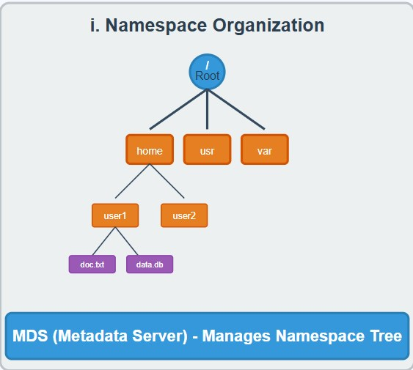
4.Hirerarchical Structure

i. Namespace Origanization

RozoFS organizes its namespace as a directory tree, much like Unix-based file systems. The MDS is responsible for managing this namespace, ensuring that operations such as create, delete, or rename are carried out consistently.

8

ii. Metadata Management

Metadata in RozoFS includes:
• File-to-fragment mappings. • Directory hierarchy.
• Permissions and access control.
• Erasure coding parameters (number of fragments, redundancy).

Metadata is stored persistently with periodic checkpoints, allowing fast recovery in case of failures.

iii. Locking $ Concurrency

Concurrency in RozoFS is handled through distributed locks:
• Read locks: Allow multiple clients to read simultaneously. • Write locks: Ensure exclusive access during modifications.
• Operations are performed atomically, avoiding inconsistencies in multi-client environments.

iv. Advantages of the Hierarchical Model
• Familiar tree-structured namespace for users.
• Centralized metadata management ensures consistency. • Scales well with billions of files.
• Simplifies application integration by mimicking traditional file systems

9

5. Implementation

i. Programming Language & Platform
• Implemented primarily in C and C++ for performance. • Runs on Linux servers built from commodity hardware.
• Designed for clusters where nodes can be added or removed dynamically.

ii. Erasure Coding & Fault Tolerance

This is the core differentiator of RozoFS compared to replication-based DFSs: • Data is split into fragments.
• Additional redundant fragments are generated using erasure coding algorithms.
• Fragments are distributed across multiple storage nodes.
• If some fragments are lost due to node failure, the system reconstructs the original data from remaining fragments.

Example Comparison with HDFS:
• HDFS with 3x replication: 300% storage overhead.
• RozoFS with erasure coding: ~125–150% storage overhead (depending on parameters).

This efficiency makes RozoFS more cost-effective at scale.

10

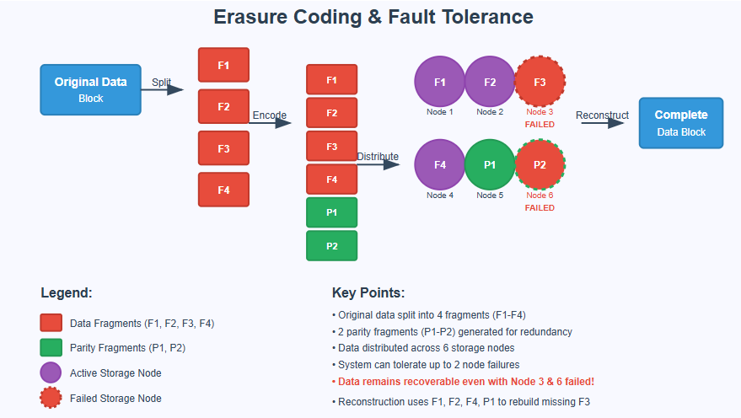
iii. Consistency & Concurrency Control
• Writes: Coordinated through metadata servers to ensure order and atomicity. • Reads: Parallel and fault-tolerant, reconstructing data if fragments are
missing.
• Concurrency: Managed using locks and versioning to avoid conflicts.

iv. Security Considerations

• Integrates with Linux authentication and permissions.
• Supports encryption-at-rest and TLS encryption-in-transit.
• Ensures compliance with enterprise-level security requirements.

11

6. Real-world Applications

RozoFS is particularly valuable in industries where data growth is exponential and cost-efficient fault tolerance is essential. Its erasure coding– based design makes it attractive across several domains:

1. Cloud Providers
Cloud service providers are under constant pressure to deliver affordable storage while maintaining high reliability. Traditional replication-based DFSs (like HDFS with 3x replication) significantly inflate storage costs.

• RozoFS allows providers to cut storage costs by up to 50% compared to replication.
• It provides elastic scalability, meaning storage nodes can be added or removed without major downtime.
• Cloud environments often experience hardware churn; RozoFS’s fault tolerance ensures uninterrupted service even during node failures.

2. Media & Entertainment Industry
The entertainment sector generates enormous multimedia content, including movies, series, and high-resolution streaming files. These datasets are not only large but also require long-term archiving.

• RozoFS is ideal for video-on-demand services, broadcast archives, and post-production pipelines.
• Its high throughput supports large sequential reads and writes, which are common in video workflows.
• Compared to replication, erasure coding ensures that storage usage remains sustainable over decades of media retention.

3. Scientific Research & High-Performance Computing (HPC)
Fields like genomics, climate modeling, and astrophysics produce petabytes of experimental and simulation data. Losing even a fraction of this data could be catastrophic.

• RozoFS ensures fault-tolerant long-term storage while reducing the storage overhead common in HPC clusters.

12

• Parallel read/write capability enables researchers to process large datasets faster, improving productivity.
• For example, in astronomy, where telescopes generate terabytes daily, RozoFS can provide both speed and reliability.

4. Enterprises & Big Data Analytics
Enterprises increasingly rely on data-driven decision-making powered by big data pipelines. While many have adopted HDFS, the rising storage costs of replication are unsustainable.

• RozoFS serves as an alternative to HDFS for analytics workloads.
• Integration with Hadoop and Spark enables enterprises to run big data jobs seamlessly on erasure-coded storage.
• Lower infrastructure costs make it appealing for startups and mid-sized businesses adopting big data analytics.

5. Government & Archival Institutions
National libraries, government agencies, and archival bodies manage digital records, census data, and historical archives. These organizations value data integrity and longevity over performance alone.

• RozoFS guarantees durability while reducing the long-term cost of storing billions of files.
• Its compliance with POSIX standards ensures smooth integration with archival systems.

13

7. Advantages & Limitations

Advantages:

1. Reduced Storage Overhead
• Unlike HDFS, which typically requires 3x replication (300% storage usage), RozoFS relies on erasure coding, reducing storage overhead to around 125–150% depending on parameters
• This allows organizations to store more data on the same hardware footprint, lowering infrastructure costs.
2. High Fault Tolerance
• With erasure coding, RozoFS can tolerate the loss of multiple storage nodes while still reconstructing data successfully.
• This level of reliability is often higher than replication, where losing a majority of replicas could lead to data loss.
3. POSIX Compliance
• Provides standard file system interfaces (open, read, write, close), which means existing applications can integrate without significant changes.
• This compliance simplifies migration from traditional file systems. 4. Scalable Architecture
• Designed for horizontal scaling: additional storage nodes can be added without major reconfiguration.
• Runs on commodity hardware, avoiding the need for specialized and expensive servers.
5. Optimized for Large Datasets
• RozoFS excels in workloads involving large sequential reads and writes, such as video streaming, backup, and scientific datasets.
• Erasure coding works particularly well when data blocks are large and workloads are throughput-oriented.
6. Efficient Metadata Management
• Metadata servers manage namespace and mappings, which makes file lookups efficient even in large-scale deployments.
7. Better Economics for Cloud and Enterprise Storage
• Due to lower storage overhead, cloud providers and enterprises

14

achieve lower cost-per-terabyte, making it more sustainable for petabyte-scale storage.

Limitations:

1. Computational Overhead from Erasure Coding
• Encoding and decoding fragments require additional CPU cycles.
• This overhead may reduce performance for write-intensive workloads compared to replication.
2. Metadata Server Bottleneck
• Since the metadata server is central to namespace management, it may become a bottleneck in extremely large deployments unless sharding or federation is introduced.
3. Not Optimized for Small Files
• Erasure coding is efficient for large blocks but inefficient for storing many small files due to overhead in encoding and fragment management.
• Systems like CephFS or Lustre may handle small-file workloads better.
4. Increased Complexity in Configuration and Tuning
• Setting up erasure coding parameters (number of data and parity fragments) requires careful planning.
• Compared to replication (which is simpler to configure), erasure coding adds administrative complexity.
5. Latency in Rebuild Operations
• In case of node failure, reconstructing data from erasure-coded fragments can be slower than simply copying replicas, especially in large clusters.
6. Limited Ecosystem Support Compared to HDFS
• While HDFS has strong integration with big data frameworks (Hadoop, Spark, Hive), RozoFS adoption is relatively niche.
• Enterprises may need to build custom connectors for certain workloads.
7.

15

8. Conclusion

RozoFS stands as a clear example of how distributed storage systems are evolving to meet the ever-growing demands of the digital era. Traditional replication-based systems like HDFS laid the groundwork for reliable distributed storage, but they come with significant storage overhead. RozoFS challenges this model by adopting erasure coding, achieving similar or even higher fault tolerance while consuming substantially less storage space. This shift highlights a broader industry trend towards coding-based resilience rather than simple replication.

The system’s architecture—built on the separation of metadata management and data access, coupled with its POSIX compliance—ensures that it is both scalable and user-friendly. It integrates seamlessly into existing infrastructures while allowing organizations to scale horizontally using cost-effective commodity hardware. These design choices make RozoFS highly relevant for industries ranging from cloud providers and enterprises to research institutions and media companies.

Admittedly, erasure coding introduces computational overhead for encoding and decoding, and workloads involving small files are not its strongest area. However, the trade-off between computation and storage savings is usually favorable, particularly in environments where storage cost dominates infrastructure budgets. With the rise of large-scale datasets across industries, the benefits of RozoFS far outweigh these challenges.

In many ways, RozoFS represents not just an alternative but an evolution in distributed file system design. It shows how the industry is moving from replication-heavy strategies towards more sophisticated, efficient techniques that balance cost, performance, and reliability. As data continues to grow at an unprecedented pace, such innovations will shape the future of distributed storage.

16

9. References

• RozoFS Official Website and Documentation https://rozofs.org
• RozoFS: A Scalable, Fault-Tolerant and Efficient Distributed File System (Research Paper, ACM/IEEE)
https://hal.archives-ouvertes.fr/hal-00917411/document

• Comparative Analysis of Erasure Coding vs Replication in Distributed File Systems (Research Publication, IEEE Xplore) https://ieeexplore.ieee.org/document/7076972
• Google File System vs Hadoop HDFS vs RozoFS: Storage Strategies (Whitepaper) https://www.usenix.org/system/files/conference/atc13/atc13-bronson.pdf
• GeeksforGeeks – Distributed File Systems Overview https://www.geeksforgeeks.org/distributed-file-system/
• TutorialsPoint – Distributed File System Concepts https://www.tutorialspoint.com/distributed_file_system/
• Introduction to Distributed Storage Systems (Lecture Notes, Stanford University)
https://web.stanford.edu/class/cs240/

• HDFS vs RozoFS Performance Benchmarking (Industry Whitepaper) https://www.hpcwire.com/2016/04/07/erasure-coding-vs-replication/

17

