What are input features and what is target variable?
According to chatgpt causal diagram makes sense, (price and sugar are mediators) but not final output.
So, two approaches
- One in which influence of price and sugar is considered
- One in which influence of price and sugar is not considered

Selecting features, hypothesis testing.. (chi scores)

Final recommendation

Use GPR to quantify uncertainty – (There will be safer and riskier bets).

TanPFN (Foundation model for tabular data).
Add notes (- could have used RFE for feature selection and Permutation feature importance)
What are they looking for ?
How can you help in making business decision? (Find the optimum and show the insights on
design space comparing insights from data)
Can we try a new composition? (This type of things have not been tried enough, differentiator)
Basic DS should be correct.

Simple Analysis of the Candy Power Ranking Dataset
Top linear correlations
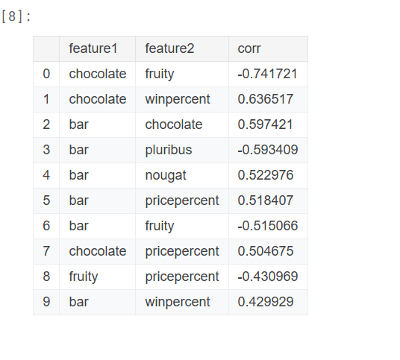
The groupby technique to get an idea of how many data points are there with that feature combination is good.

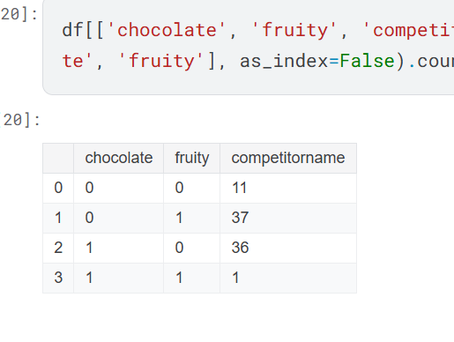
P values for hypothesis testing
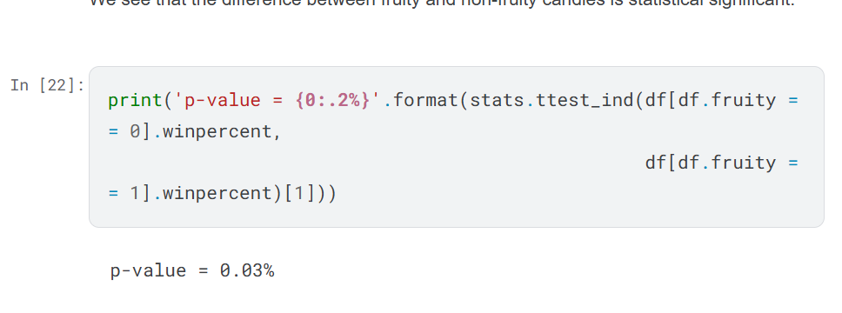

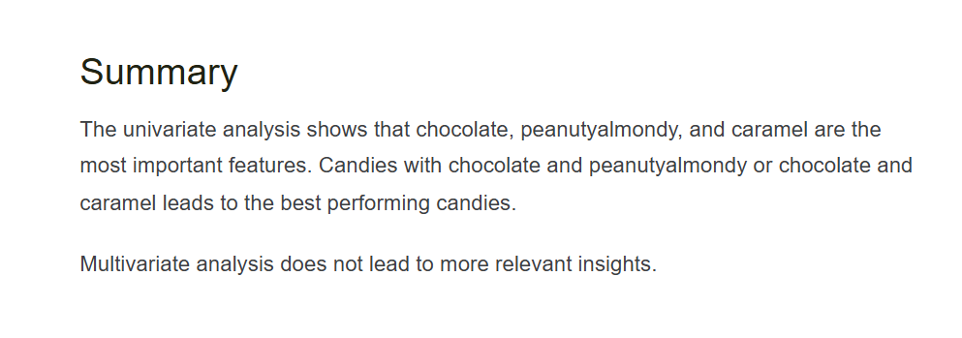
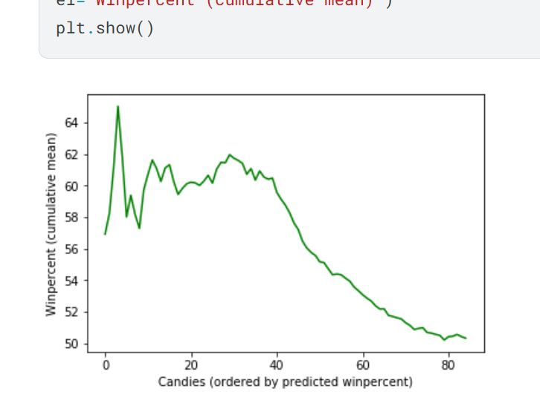

Analyzing Candy Data to Develop a New Product
This notebook is actually answering the same questions as the case study, developed for the same case study.
Does Monte carlo simulation and Recursive Feature Elimination for Feature selection.
The Ultimate Halloween Frankencandy Generator
Finds the spearman coefficient between the rank of the candies
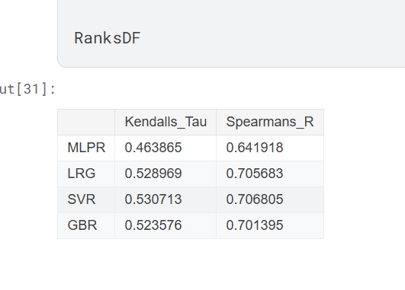
It also generates the design space and predicts it with all the models and compares the ranking –
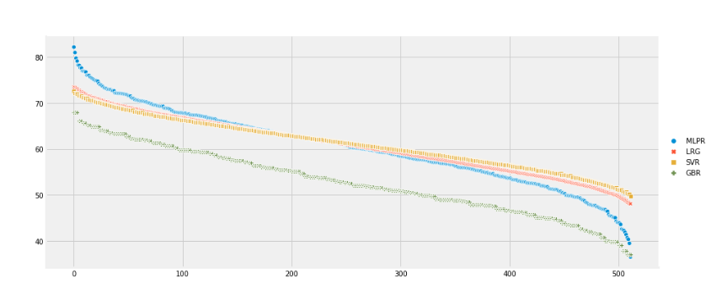
Case Study: Expanding Candy brand
PCA visualisation
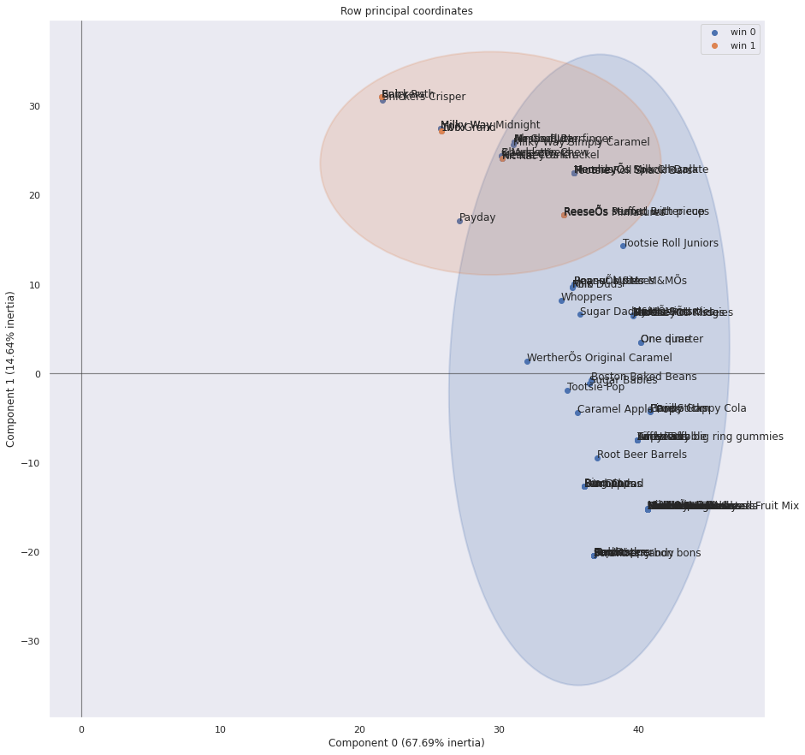

Creating the Ultimate Sweet | D-Lab
Uses GLS (that gives P values and T values for features)
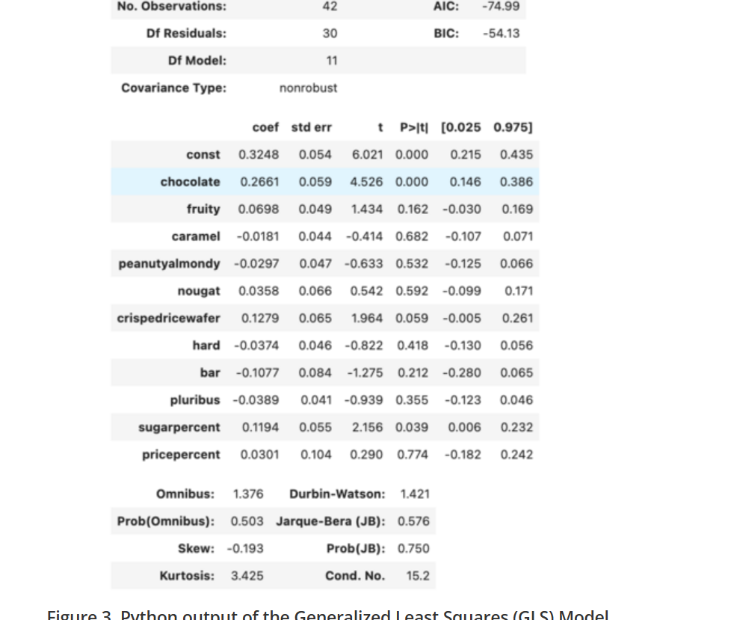
Get 0.6 R2 on training set and 0.2 on test set.
Creates design space and optimises the performance
Talks about high correlation between input features.. and how to mitigate it in discussion section.

Links with analysis
Presentation = szapp/CandyAnalysis: Case study: Analyze the candy power ranking to identify and recommend popular candy characteristics
Cluster analysis - EricPostMaster/Halloween-Candy-Power-Ranking-Cluster-Analysis: This analysis uses Principal Components Analysis and k-Means clustering to identify useful subgroups within FiveThirtyEight's Ultimate Halloween Candy Power Ranking dataset. It also used hypothesis tests to assess whether differences exist between popular and unpopular candies.
Compares each boolean feature (chocolate, caramel) with sugar, price and win percent using 2-d plot with bubble size as third dimension - Analysis of Candy Ranking using Python
T-test and P-value for chocolate and fruity - The Sweet Challenge: Analyzing Halloween Candy Preferences | by Henry Chukwunwike Morgan-Dibie | Medium
Used it to get swarm plots and distribution plots for EDA - EDA: Candy Characteristics

Data Considerations –
Sparse dataset
Possible pairs- data was generated by asking participants which candy the prefered?
269,000 responses. 8,371 different IP Addresses
Max diff, best diff could be a better way to conduct eperiment.

There will be some trends which are quite main stream now-
Chocalte is good, bar is good, peanutalmondy is good..
Univariate feature analysis is easier with this small dataset…
Build a LR model, linear coefficients - but do talk about the correlation between features itself, and how in cases where there is not enough data to remove the effect of other feature to see the trend for one feature (f1 is correlated is with f2 and there is not enough data where f1 is Flase so only f2’s effect on win percent could be seen).
For boolean feature analysis we don’t correlation analysis, bar/ box plots should be used…

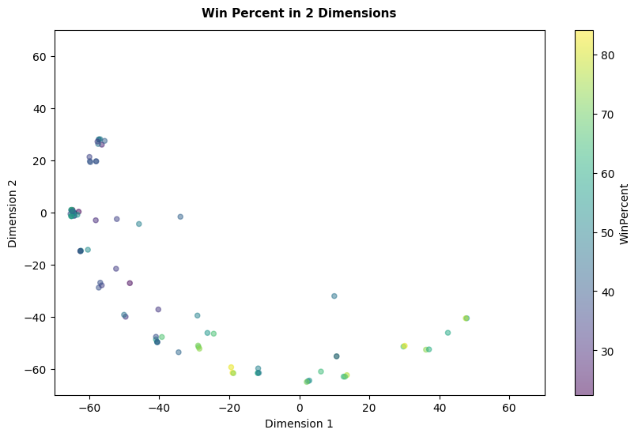
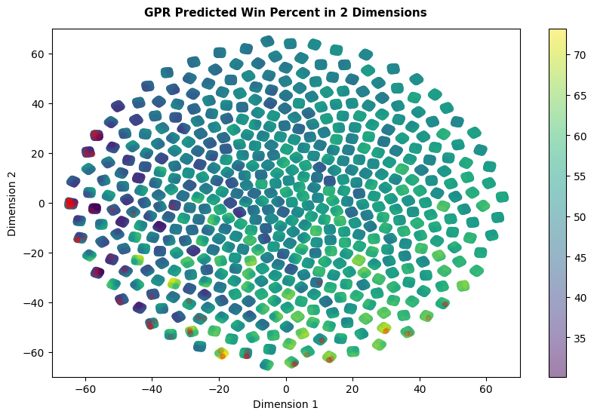

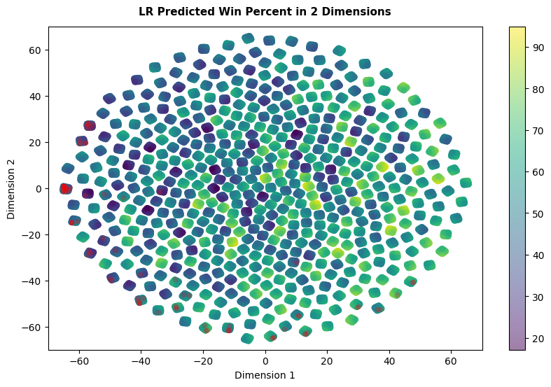
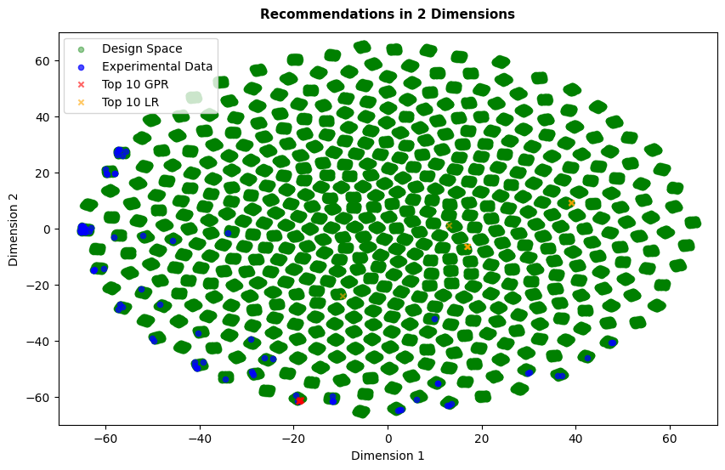

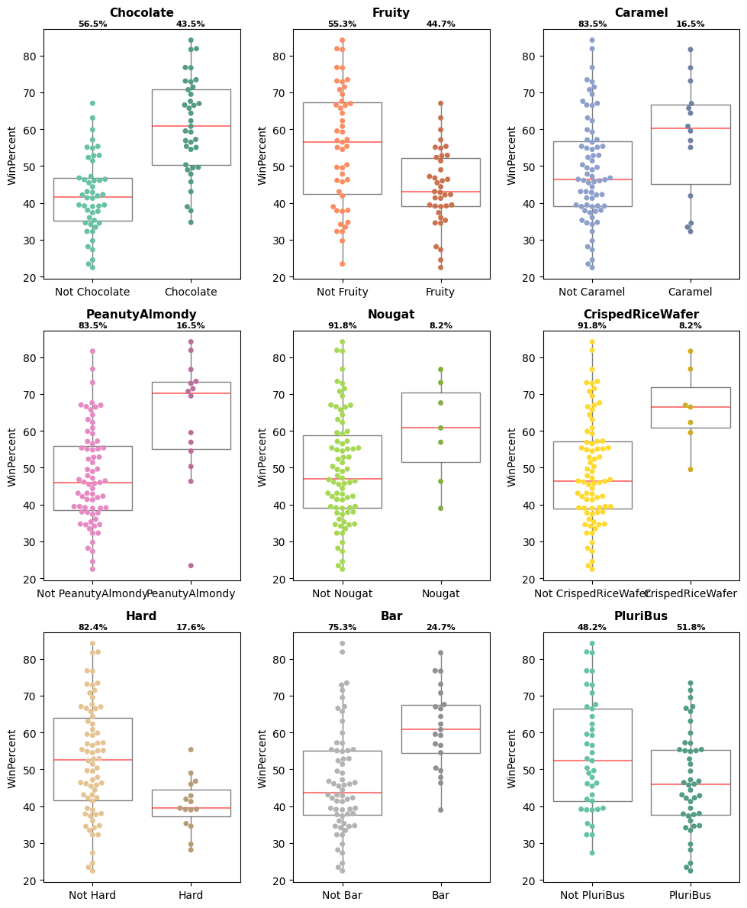
(Go for chocolate and not Fruity)

