Experiment No: 4

|  |  |
| --- | --- |
| **Experiment No 4**  **Aim: To create an interactive Form using form widget** | |
| **ROLL NO** | **38** |
| **NAME** | Sanchit Mhatre |
| **CLASS** | **D15-B** |
| **SUBJECT** | **MAD & PWA Lab** |
| **LO-MAPPE**  **D** |  |

**Aim: To create an interactive Form using form widget**

**Theory:**

* Form Widget:

The Form widget in Flutter acts as a container for multiple FormField widgets. It tracks the form's global state, facilitating scenarios like form validation, resetting, and saving of form data. The Form widget is essential for grouping related form fields together, making collective operations on these fields more manageable.

* GlobalKey<FormState>:

To interact with the form, such as validating fields or resetting the form, a GlobalKey<FormState> is used. This key provides access to the FormState, which is where the logic for these operations resides. By associating a GlobalKey<FormState> with a Form, you gain the ability to programmatically control the form's state from other parts of your widget tree.

* TextFormField:

TextFormField is a specialized FormField widget for text input. It integrates seamlessly with the Form widget, supporting features like validation, auto-validation, and saving. Each TextFormField can have its own validation logic, defined through its validator property, which can enforce specific rules (e.g., required fields, email format) and provide user feedback.

* Validation Logic:

Validation is a critical aspect of handling forms. The validator function within FormField widgets allows you to define validation logic for each input. This function is called for each form field when attempting to validate the form. If the input is valid, the validator should return null; otherwise, it returns a string with an error message. Validation can be triggered programmatically (e.g., when a button is pressed) or automatically based on user interaction, depending on the form's configuration.

* Managing Form Input:

Upon validation, the form's data needs to be processed or stored. This can involve sending the data to a backend service, saving it locally, or using it within the app. TextEditingController instances associated with TextFormField widgets can be used to access the current value of form fields.

* Implementing Submission Logic:

Form submission typically involves validating the form fields and, if validation passes, processing the data. Submission is usually triggered by a button press. Flutter's ElevatedButton (or other button widgets) can be used to execute submission logic, which includes calling the form's validate method through its FormState.

**Code:**

import 'package:flutter/material.dart'; void main() => runApp(const MyApp());

class MyApp extends StatelessWidget {

const MyApp({super.key});

@override

Widget build(BuildContext context) { return MaterialApp(

home: Scaffold(

appBar: AppBar(title: const Text('Form')), body: const MyCustomForm(),

),

);

}

}

class MyCustomForm extends StatefulWidget {

const MyCustomForm({super.key});

@override

_MyCustomFormState createState() => _MyCustomFormState();

}

class _MyCustomFormState extends State<MyCustomForm> {

final _formKey = GlobalKey<FormState>(); final TextEditingController _nameController = TextEditingController(); final TextEditingController _emailController = TextEditingController(); final TextEditingController _phoneController = TextEditingController(); final TextEditingController _rollNoController = TextEditingController(); final TextEditingController _classController = TextEditingController(); final TextEditingController _branchController = TextEditingController(); String? _selectedGender; final List<String> _genderOptions = ['Male', 'Female', 'Other'];

@override

Widget build(BuildContext context) { return Form(

key: _formKey, child: SingleChildScrollView(

padding: const EdgeInsets.symmetric(horizontal: 16.0), child: Column(

crossAxisAlignment: CrossAxisAlignment.start, children: <Widget>[

TextFormField( controller: _nameController, decoration: const InputDecoration(labelText: 'Name'), validator: (value) {

if (value == null || value.isEmpty) {

return 'Please enter your name';

}

return null;

},

),

TextFormField( controller: _emailController, decoration: const InputDecoration(labelText: 'Email'), validator: (value) {

if (value == null || value.isEmpty || !value.contains('@')) {

return 'Please enter a valid email';

}

return null;

},

),

TextFormField( controller: _phoneController, decoration: const InputDecoration(labelText: 'Phone Number'), keyboardType: TextInputType.phone, validator: (value) {

if (value == null || value.isEmpty || value.length != 10) {

return 'Please enter a valid phone number';

}

return null;

},

),

TextFormField( controller: _rollNoController, decoration: const InputDecoration(labelText: 'Roll Number'), validator: (value) {

if (value == null || value.isEmpty) {

return 'Please enter your roll number';

}

return null;

},

),

TextFormField( controller: _classController, decoration: const InputDecoration(labelText: 'Class'), validator: (value) {

if (value == null || value.isEmpty) {

return 'Please enter your class';

}

return null;

},

),

TextFormField( controller: _branchController, decoration: const InputDecoration(labelText: 'Branch'), validator: (value) {

if (value == null || value.isEmpty) {

return 'Please enter your branch';

}

return null;

},

),

DropdownButtonFormField<String>( value: _selectedGender, decoration: const InputDecoration(labelText: 'Gender'), items: _genderOptions

.map((gender) => DropdownMenuItem<String>( value: gender, child: Text(gender),

))

.toList(),

onChanged: (value) {

setState(() {

_selectedGender = value!;

});

},

validator: (value) {

if (value == null || value.isEmpty) {

return 'Please select your gender';

}

return null;

},

),

Padding( padding: const EdgeInsets.symmetric(vertical: 16.0), child: ElevatedButton(

onPressed: () {

if (_formKey.currentState?.validate() ?? false) {

ScaffoldMessenger.of(context).showSnackBar( const SnackBar(content: Text('Processing Data')),

);

}

},

child: const Text('Submit'),

),

),

],

),

),

);

}}

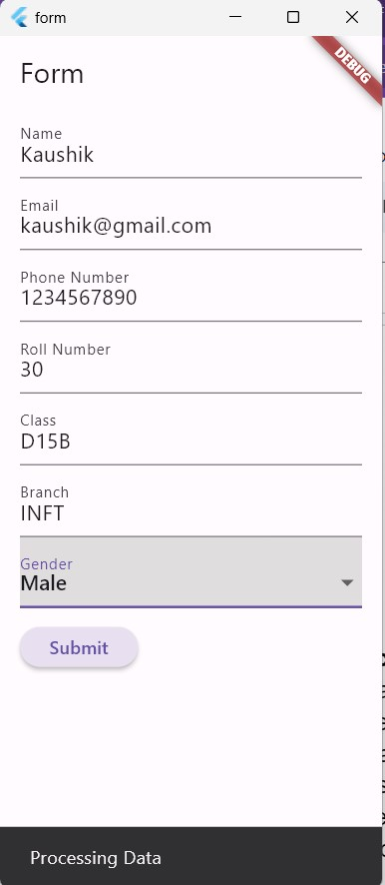

**Conclusion:**

Interactive forms are essential for user input in mobile apps. Flutter offers a robust suite of widgets and tools for form creation, validation, and management, enabling developers to build complex forms with ease. Mastering these tools is crucial for designing intuitive and efficient forms in Flutter apps.