

DevOps

Version Control Assignment 1

Name: Sanchit Sen

SapId: 500102068

Roll No.: R2142220163

Program: B.Tech[CSE] Submission to:

Batch: CCVT -B2 Prof: Prateek Raj Gautam

Introduction:

Version Control Systems (VCS) are essential for managing code changes in software

development. They help teams collaborate efficiently by tracking modifications, managing different versions, and ensuring data integrity. This assignment focuses on two popular

version control systems: **Subversion (SVN)** and **Mercurial (Hg)**.

**Subversion (SVN)** is a **centralized version control system** (CVCS) where all changes are

tracked in a single central repository. It is widely used for enterprise projects that require a structured workflow and controlled access.

**Mercurial (Hg)** is a **distributed version control system** (DVCS) that allows every user to have a complete copy of the repository. It is known for its simplicity, speed, and efficiency in managing large-scale projects.

This assignment provides a hands-on demonstration of **installing, setting up, and using SVN and Mercurial** on Windows, covering essential commands, workflows, and a comparison

between both systems.

1. Installing Subversion and Mercurial

Before using SVN and Mercurial, you need to install them on your system.

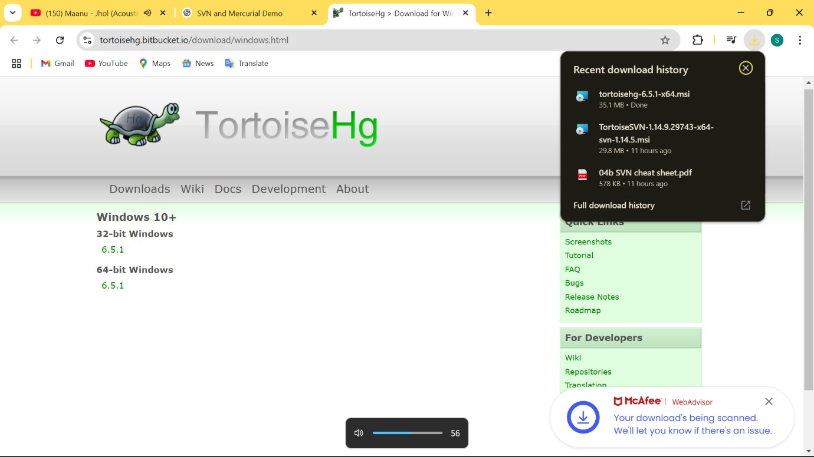

After installation, verify them by running:

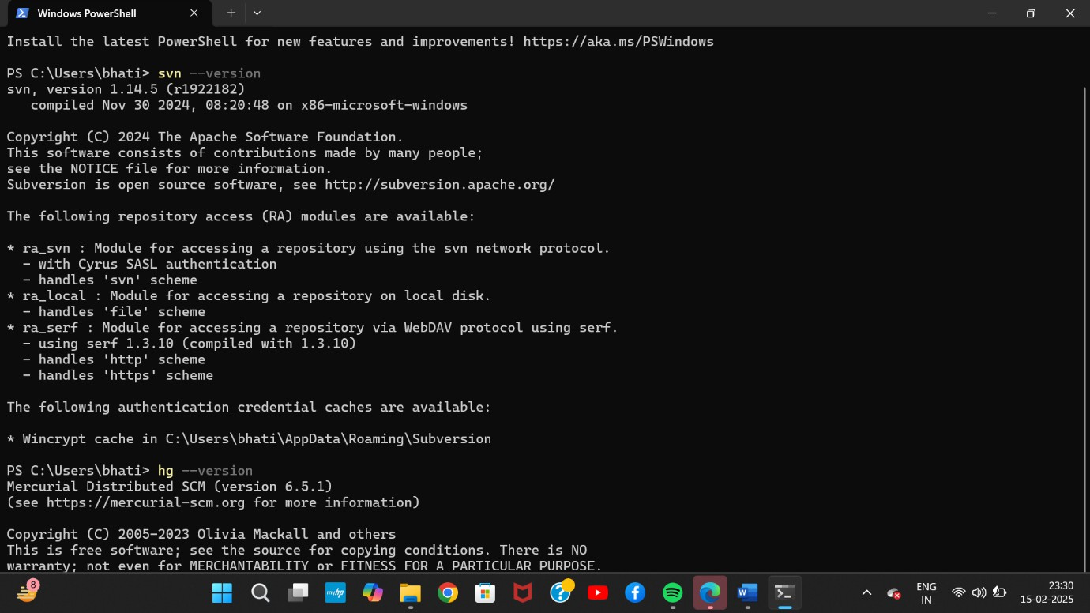

Step 2: Setting Up SVN

-Create a New Repository

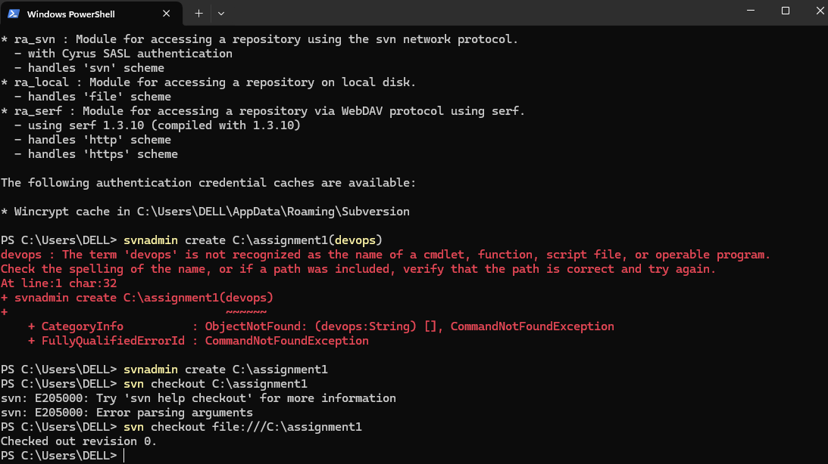

-Basic SVN Workflow

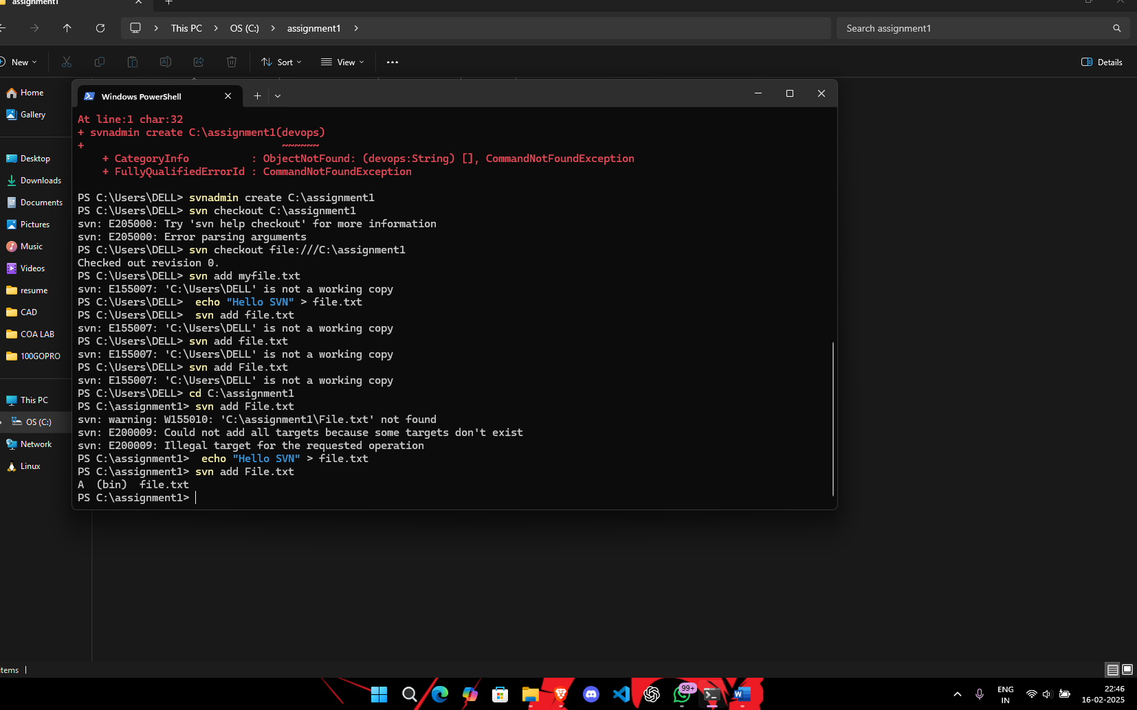

Step 3: Setting Up Mercurial

-Initialize a Mercurial Repository

-Add and Commit Files

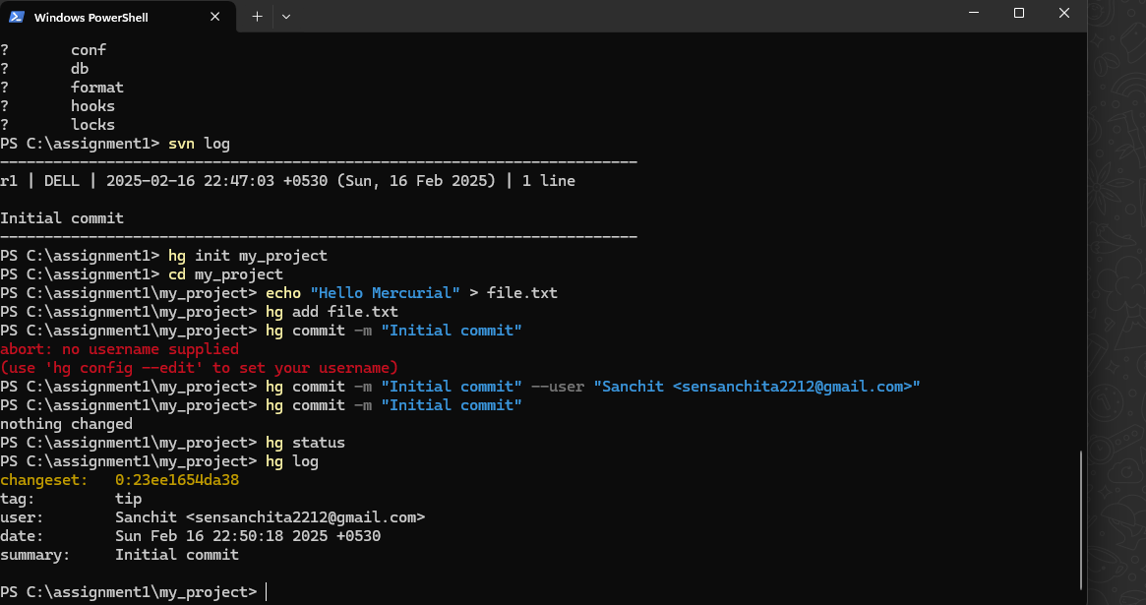

Creating a GitHub Repo & Hosting on GitHub Pages

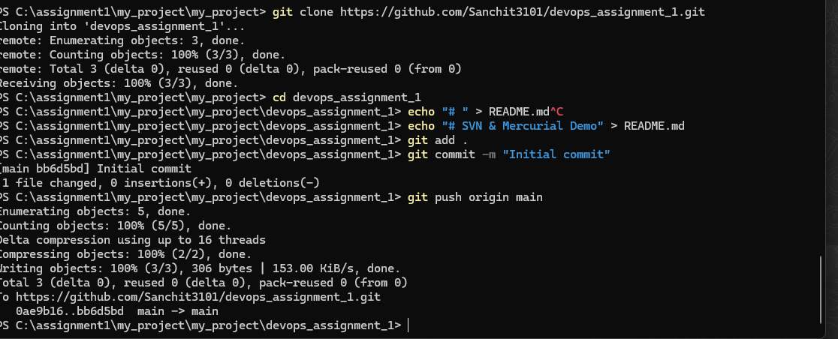

**Step 3: Enable GitHub Pages**

* + Go to **Repo → Settings → Pages**
  + Set the source to **main** branch and save.
  + 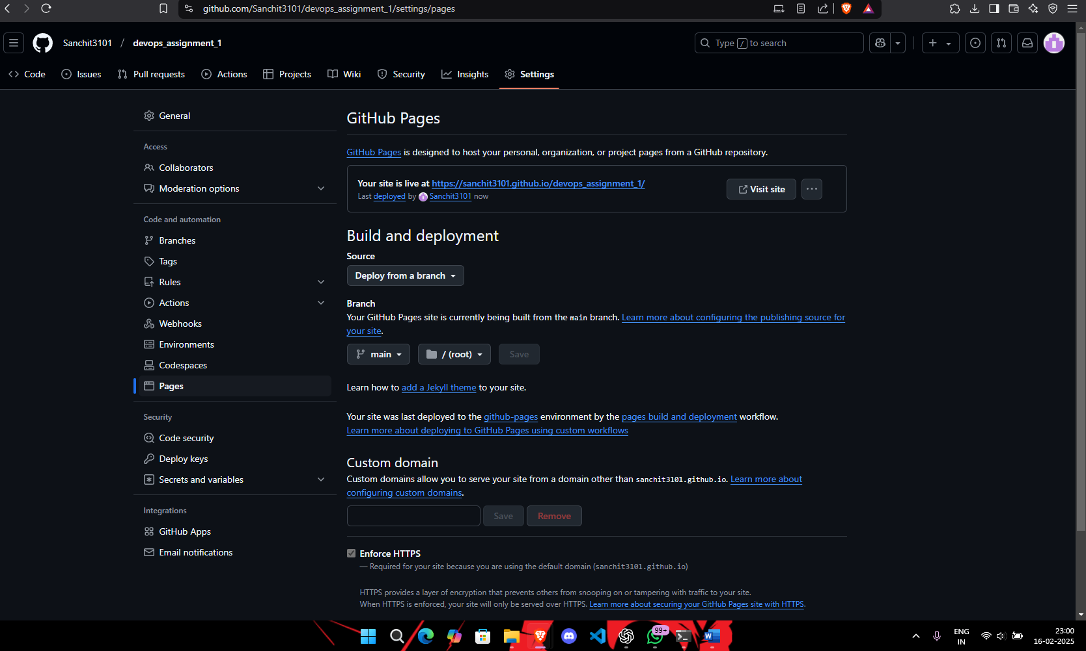

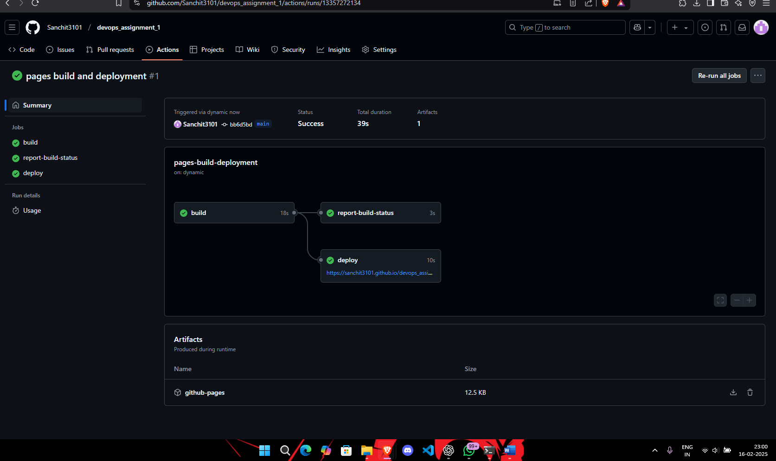

Copy the URL shown there. https://sanchit3101.github.io/devops_assignment_1/

Your GitHub Pages site will be available at:

