Worksheet -1.1

Student Name: SANCHIT KATOCH UID: 25MCA20059
Branch: MCA Section/Group: 25MCA-1-A
Semester:2nd Date of Performance: 13/01/2026 Subject Name: TECHNICAL TRAINING I Subject Code: 25CAP-652

- Aim/Overview of the practical:

To implement and analyze SQL SELECT queries using filtering, sorting, grouping, and aggregation

concepts in PostgreSQL for efficient data retrieval and analytical reporting.

- Objective:

• To retrieve specific data using filtering conditions ,
• To sort query results using single and multiple attributes ,
• To perform aggregation using grouping techniques ,
• To apply conditions on aggregated data.

S/W Requirement:

→ Oracle Database Express Edition
→ postgreSQL.

Procedure:

Step 1: Database and Table Preparation

• Start the PostgreSQL server.
• Open the PostgreSQL client tool.
• Create a database for the experiment.
• Prepare a sample table representing customer orders containing details such as customer name, product, quantity, price, and order date.
• Insert sufficient sample records to allow meaningful analysis.

Step 2: Filtering Data Using Conditions

• Execute data retrieval operations to display only those records that satisfy specific conditions, such as higher-priced orders.
• Observe how filtering limits the number of rows returned.

Step 3: Sorting Query Results

• Retrieve selected columns from the table and arrange the output based on numerical values such as price.
• Perform sorting using both ascending and descending order.
• Apply sorting on more than one attribute to understand priority-based ordering.

Step 4: Grouping Data for Aggregation

• Group records based on a common attribute such as product.
• Calculate aggregate values like total sales for each group.
• Analyze how multiple rows are combined into summarized results.

Step 5: Applying Conditions on Aggregated Data

• Apply conditions on grouped results to retrieve only those groups that satisfy specific aggregate criteria.
• Compare the difference between row-level filtering and group-level filtering.

Step 6: Conceptual Understanding of Filtering vs Aggregation Conditions
• Analyze scenarios where conditions are incorrectly applied before grouping.
• Correctly apply conditions after grouping to avoid logical errors.

Code:

CREATE TABLE customer_orders(
order_id INT PRIMARY KEY ,
customer_name VARCHAR(50),
product VARCHAR(50),
quantity INT,
price INT,
order_date DATE
);
INSERT INTO customer_orders (order_id,customer_name,product,quantity,price,order_date)VALUES
(1,'Sanchit Katoch','Laptop',1,85000,'2025-01-10'),
(2,'Roshan Kumar Singh','Mouse',2,1780,'2025-01-11'),
(3,'Anindita Dhar','Laptop',1,52250,'2025-01-12'),
(4,'Ashi Gupta','Keyboard',1,2575,'2025-01-12'),
(5,'Pratham','Mouse',3,1800,'2025-01-13'),
(6,'Swayam','Laptop',2,120000,'2025-01-14');
--step 2
SELECT * FROM customer_orders WHERE price>40000;
--step3
--asc
SELECT customer_name,product,price FROM customer_orders ORDER BY price ASC;
--desc
SELECT customer_name,product,price FROM customer_orders ORDER BY price DESC;
--mul col
SELECT customer_name,product,price FROM customer_orders ORDER BY product ASC, price DESC;
--step4
SELECT product, SUM(price) AS total_sales FROM customer_orders GROUP BY product;
--step5
SELECT product, SUM(price) AS total_sales FROM customer_orders GROUP BY product HAVING SUM(price)>50000;
--step6
SELECT product, SUM(price) FROM customer_orders GROUP BY product HAVING SUM(price)>50000;

- Output:

step 2 output :-

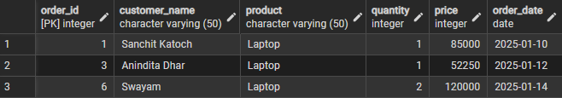

step 3 outputs (ascending, descending, mul_cols respectively) :-
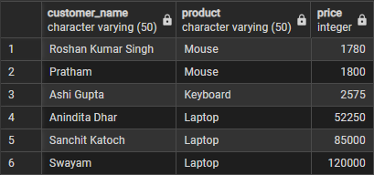

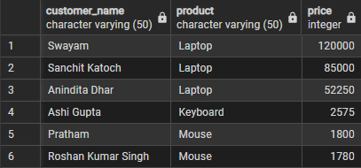
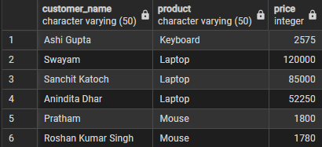

step 4 output :-

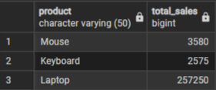

step 5 output :-

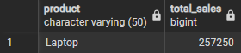

step 6 output :-

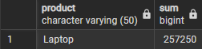

- Learning Outcome:

• Understood how data can be filtered to retrieve only relevant records from a database.
• Learnt how sorting improves readability and usefulness of query results in reports.
• Gained the ability to group data for analytical purposes.
• Clearly able to differentiate between row-level conditions and group-level conditions.

