Experiment No. 7

Student Name: Sanchit Katoch UID: 25MCA20059
Branch: MCA(GEN) Section/Group: 25MCA-1_A
Semester: 2nd Dateof Performance: 31/03/26
Subject Name: Technical Training-1 Subject Code: 25CAP-652

Aim:

To study and implement different types of SQL JOIN operations (INNER JOIN, LEFT JOIN, RIGHT JOIN, CROSS JOIN, and SELF/MULTIPLE JOIN) for retrieving and analyzing related data from multiple tables.

Objective:
- To implement INNER JOIN to fetch matching records from multiple tables.
- To use LEFT JOIN to identify unmatched records (e.g., students not enrolled).
- To apply RIGHT JOIN to display all records from the right table with matching data.
- To demonstrate CROSS JOIN for generating all possible combinations.
- To use MULTIPLE JOIN / SELF JOIN concepts to retrieve hierarchical or related data (e.g., student–department).

Tools Used:

PostgreSQL
Procedure:

Step 1: Create Students, Courses, and Enrollments tables with appropriate attributes and primary keys.

Step 2: Insert sample records into all tables ensuring meaningful relationships between students and courses.

Step 3: Execute INNER and LEFT JOIN queries to retrieve matching and unmatched student data.

Step 4: Apply RIGHT JOIN and MULTIPLE JOIN to display courses and department information.

Step 5: Use CROSS JOIN and verify outputs to understand all possible combinations clearly.

Code:

CREATE TABLE Departments (
dept_id INT PRIMARY KEY,
dept_name VARCHAR(50)
);

CREATE TABLE Students (
student_id INT PRIMARY KEY,
name VARCHAR(50),
dept_id INT,
FOREIGN KEY (dept_id) REFERENCES Departments(dept_id)
);

CREATE TABLE Courses (
course_id INT PRIMARY KEY,
course_name VARCHAR(50)
);

CREATE TABLE Enrollments (
student_id INT,
course_id INT,
FOREIGN KEY (student_id) REFERENCES Students(student_id),
FOREIGN KEY (course_id) REFERENCES Courses(course_id)
);

INSERT INTO Departments VALUES (1, 'Computer Science');
INSERT INTO Departments VALUES (2, 'Electronics');
INSERT INTO Departments VALUES (3, 'Mechanical');

INSERT INTO Students VALUES (101, 'Amit', 1);
INSERT INTO Students VALUES (102, 'Neha', 2);
INSERT INTO Students VALUES (103, 'Ravi', 1);
INSERT INTO Students VALUES (104, 'Priya', 3);
INSERT INTO Students VALUES (105, 'Karan', NULL);

INSERT INTO Courses VALUES (201, 'DBMS');
INSERT INTO Courses VALUES (202, 'Operating Systems');
INSERT INTO Courses VALUES (203, 'Networks');

INSERT INTO Enrollments VALUES (101, 201);
INSERT INTO Enrollments VALUES (101, 202);
INSERT INTO Enrollments VALUES (102, 201);
INSERT INTO Enrollments VALUES (103, 203);

-- 1. INNER JOIN (Students with enrolled courses)
SELECT s.name AS student_name, c.course_name
FROM Students s
INNER JOIN Enrollments e ON s.student_id = e.student_id
INNER JOIN Courses c ON e.course_id = c.course_id;

-- 2. LEFT JOIN (Students not enrolled in any course)
SELECT s.name
FROM Students s
LEFT JOIN Enrollments e ON s.student_id = e.student_id
WHERE e.student_id IS NULL;

-- 3. RIGHT JOIN (All courses with or without students)
SELECT c.course_name, s.name AS student_name
FROM Enrollments e
RIGHT JOIN Courses c ON e.course_id = c.course_id
LEFT JOIN Students s ON e.student_id = s.student_id;

-- 4. Multiple JOIN (Students with department info)
SELECT s.name AS student_name, d.dept_name
FROM Students s
JOIN Departments d ON s.dept_id = d.dept_id;

-- 5. CROSS JOIN (All possible student-course combinations)
SELECT s.name AS student_name, c.course_name
FROM Students s
CROSS JOIN Courses c;

Output:

INNER JOIN

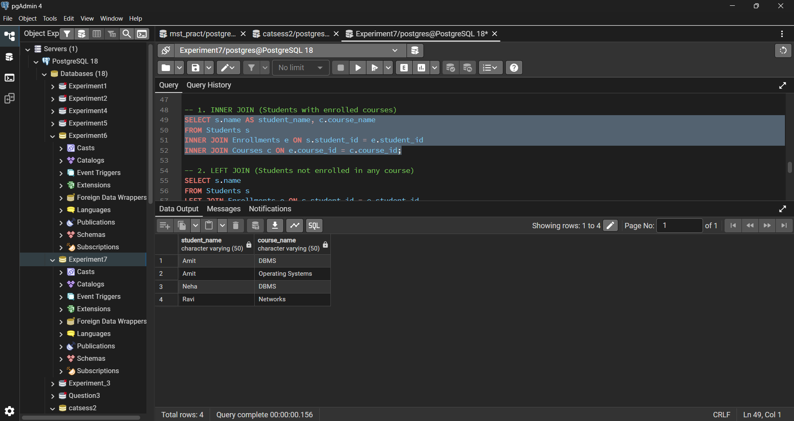

LEFT JOIN

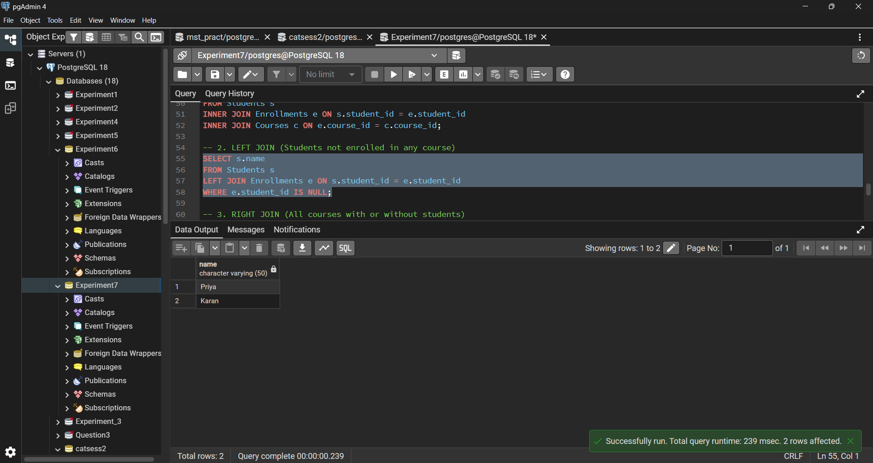

RIGHT JOIN

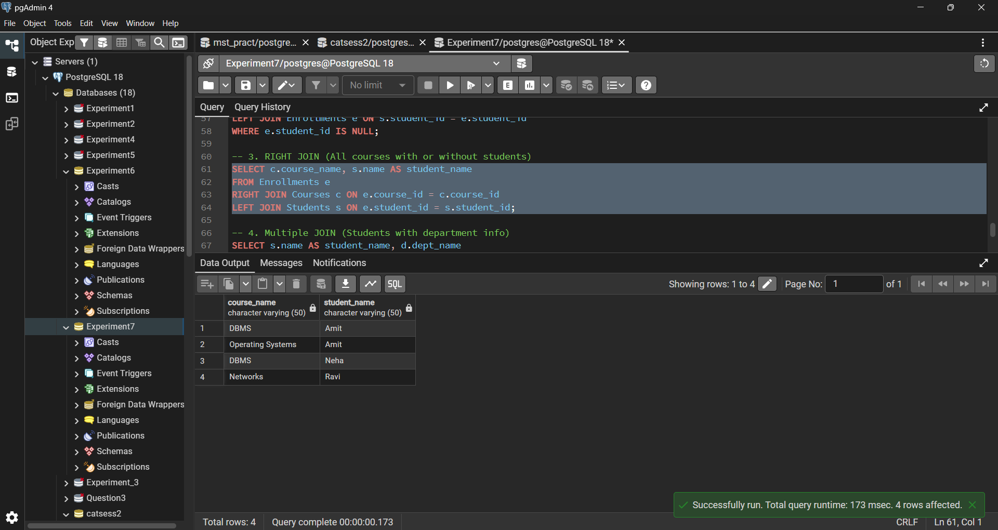

MULTIPLE JOIN

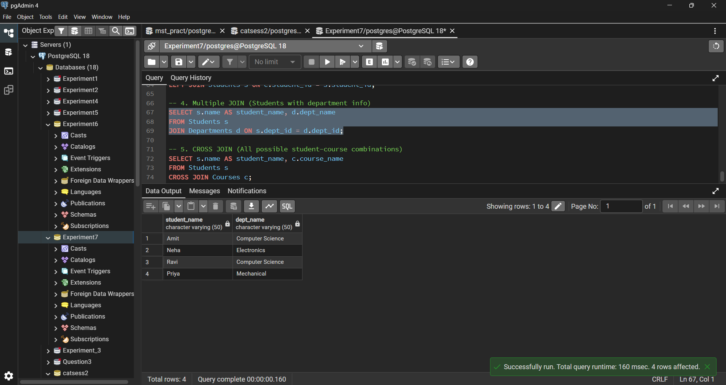

CROSS JOIN

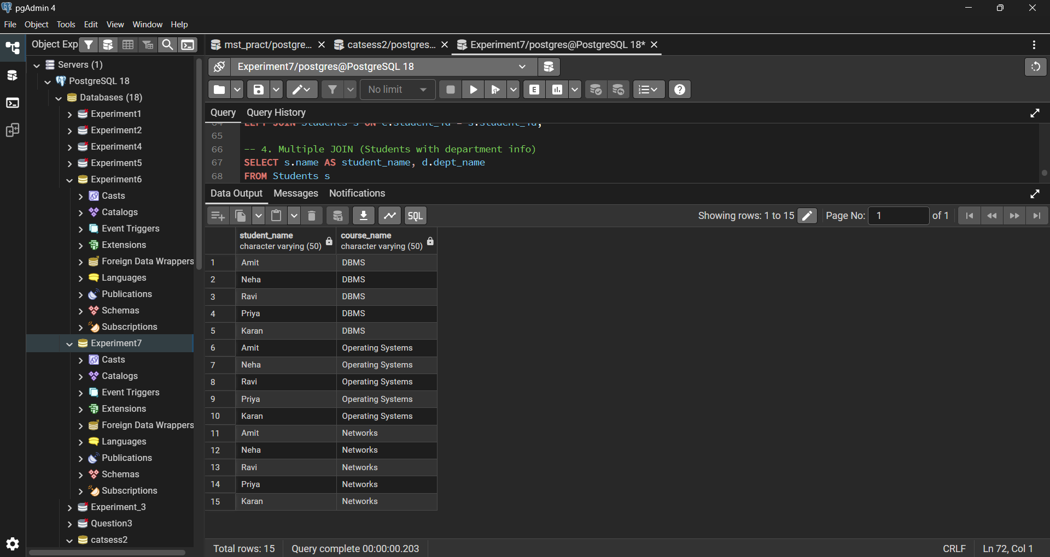

Learning Outcomes:

- Differentiate between INNER, LEFT, RIGHT, and CROSS JOIN operations.
- Write SQL queries to retrieve data from multiple related tables efficiently.
- Identify and handle matched and unmatched records using different JOIN types.
- Apply SQL JOINs to solve real-world problems like student-course enrollment.
- Gain hands-on experience in designing and querying relational database structures.

