Worksheet -3

Student Name: SANCHIT KATOCH UID: 25MCA20059
Branch: MCA Section/Group: 25MCA-1-A
Semester:2nd Date of Performance: 27/01/2026 Subject Name: TECHNICAL TRAINING I Subject Code: 25CAP-652

- Aim/Overview of the practical:

To implement conditional decision-making logic in PostgreSQL using IF-ELSE constructs and

CASE expressions for classification, validation, and rule-based data processing.

- Objective:

• To understand conditional execution in SQL
• To implement decision-making logic using CASE expressions
• To simulate real-world rule validation scenarios
• To classify data based on multiple conditions
• To strengthen SQL logic skills required in interviews and back-end systems.

S/W Requirement:

→ Oracle Database Express Edition
→ pgAdmin.

Procedure:

Start PostgreSQL Environment

Prerequisite Understanding

First create a table that stores:
• A unique identifier

• A schema or entity name

• A numeric count representing violations or issues

Populate the table with multiple records having different violation counts.

Step 1: Classifying Data Using CASE Expression

• Retrieve schema names and their violation counts.
• Use conditional logic to classify each schema into categories such as:

◦ No Violation
◦ Minor Violation
◦ Moderate Violation
◦ Critical Violation

Step 2: Applying CASE Logic in Data Updates

• Add a new column to store approval status.
• Update this column based on violation count using conditional rules such as:
◦ Approved
◦ Needs Review
◦ Rejected

Step 3: Implementing IF–ELSE Logic Using PL/pgSQL

• Use a procedural block instead of a SELECT statement.
• Declare a variable representing violation count.
• Display different messages based on the value of the variable using IF–ELSE logic.

Step 4: Real-World Classification Scenario (Grading System)

• Create a table to store student names and marks.
• Classify students into grades based on their marks using conditional logic.

Step 5: Using CASE for Custom Sorting

• Retrieve schema details.
• Apply conditional priority while sorting records based on violation severity.

4.Code:

CREATE TABLE schema_violations (
schema_id INT PRIMARY KEY,
schema_name VARCHAR(30),
violation_count INT
);

INSERT INTO schema_violations VALUES
(1,'Sanchit', 0),
(2,'Mandeep', 2),
(3,'Digam', 4),
(4,'Vanshaj', 7),
(5,'Divanshu', 8);

-- step1
SELECT
schema_name,
violation_count,
CASE
WHEN violation_count = 0 THEN 'No Violation'
WHEN violation_count BETWEEN 1 AND 3 THEN 'Minor Violation'
WHEN violation_count BETWEEN 4 AND 7 THEN 'Moderate Violation' ELSE 'Critical Violation' END AS violation_status
FROM schema_violations;

-- step2

ALTER TABLE schema_violations
ADD COLUMN approval_status VARCHAR(20);

UPDATE schema_violations
SET approval_status = CASE WHEN violation_count = 0 THEN 'Approved' WHEN violation_count <= 5 THEN 'Needs Review' ELSE 'Rejected' END;

SELECT * FROM schema_violations;

--step 3

DO $$
DECLARE
v_count INT := 6;
BEGIN
IF v_count = 0 THEN
RAISE NOTICE 'No violations detected';
ELSIF v_count <= 5 THEN
RAISE NOTICE 'Minor violations review required';
ELSE
RAISE NOTICE 'Critical violations access denied';
END IF;
END $$;

--step 4
CREATE TABLE students (
student_id INT PRIMARY KEY,
student_name VARCHAR(30),
marks INT
);

INSERT INTO students VALUES
(1,'Sanchit', 88),
(2,'Mandeep', 80),
(3,'Digam', 72),
(4,'Vanshaj',45),
(5,'Divanshu', 30);

SELECT student_name,marks,
CASE
WHEN marks >= 80 THEN 'A'
WHEN marks >= 70 THEN 'B'
WHEN marks >= 60 THEN 'C'
WHEN marks >= 40 THEN 'D'
ELSE 'F'
END AS grade
FROM students;

--step 5

SELECT schema_name,violation_count FROM schema_violations
ORDER BY CASE
WHEN violation_count = 0 THEN 1
WHEN violation_count <= 3 THEN 2
WHEN violation_count <= 7 THEN 3
ELSE 4
END;

5.Output:

Prerequisite table creation
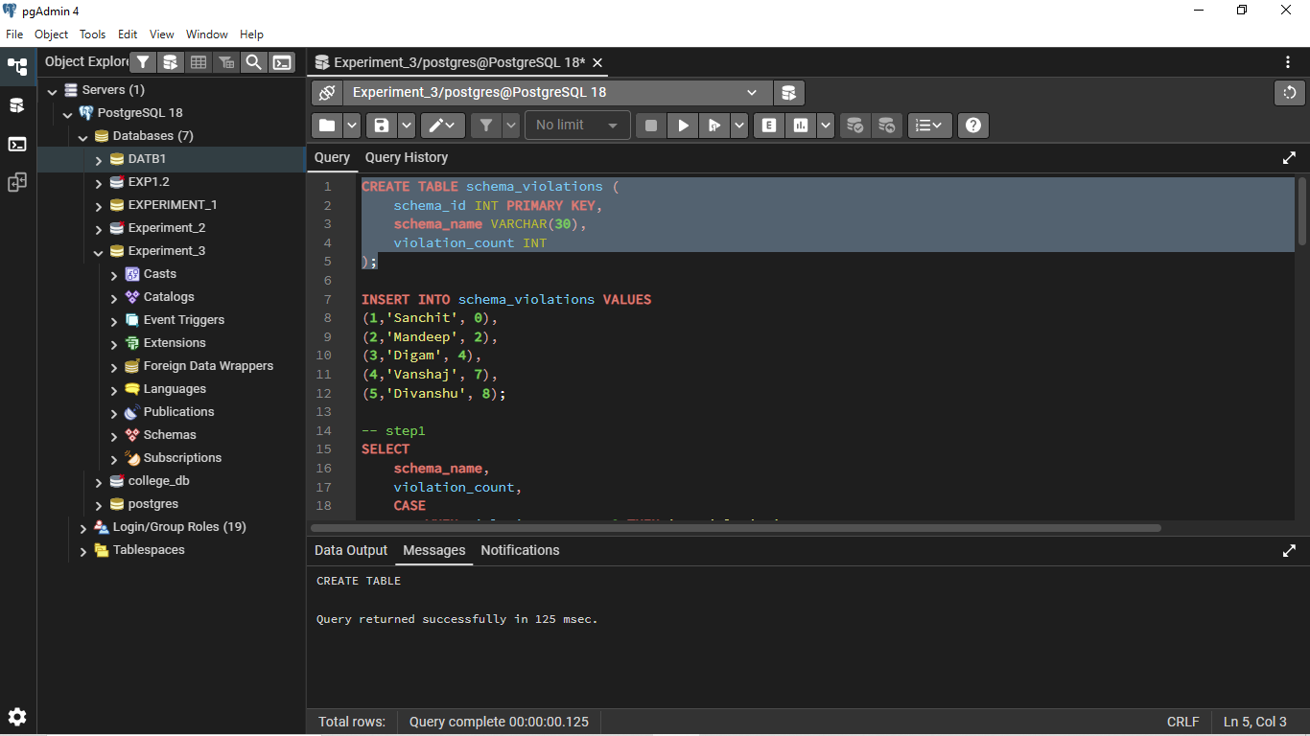

Step1
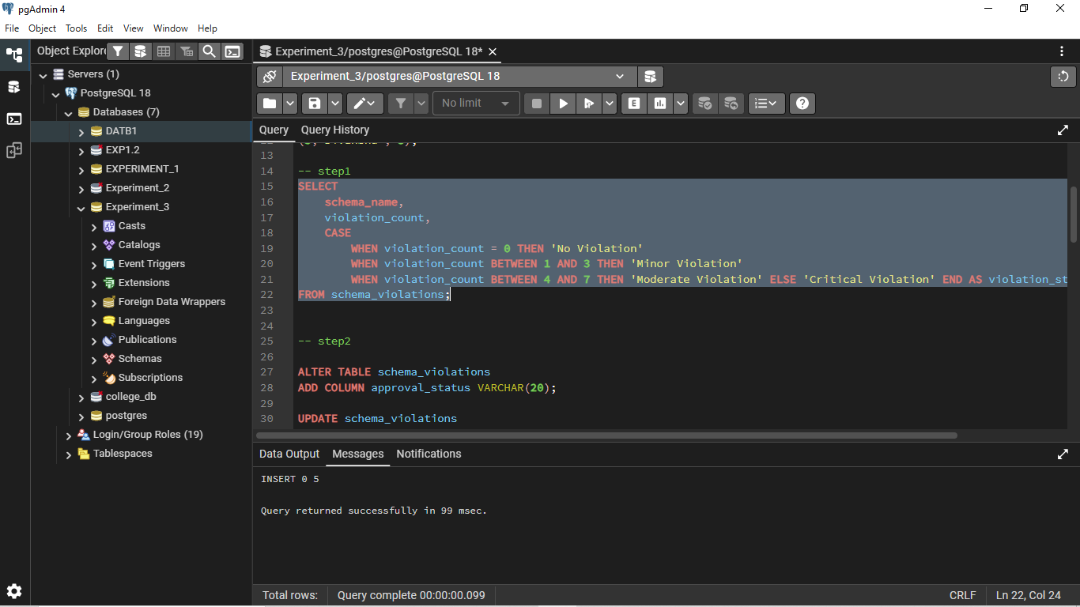

Step2 add – update - alter column

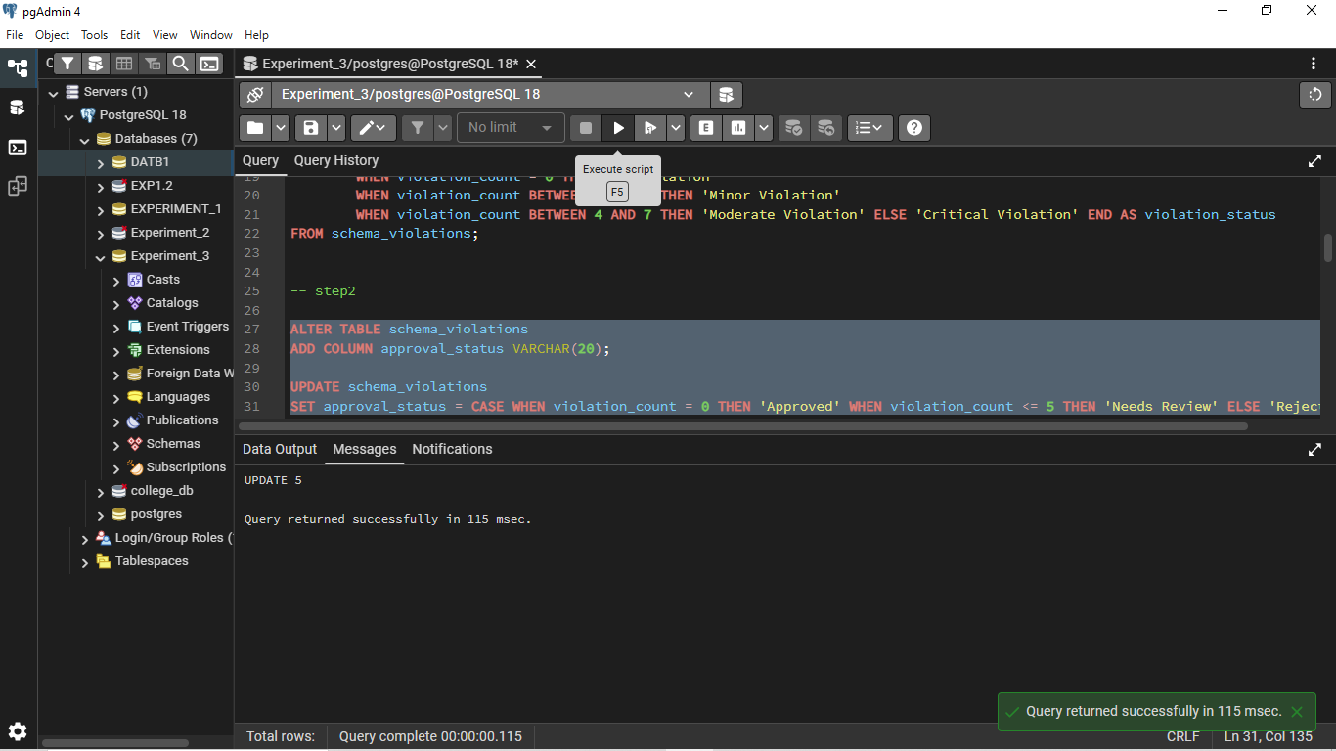

Step3

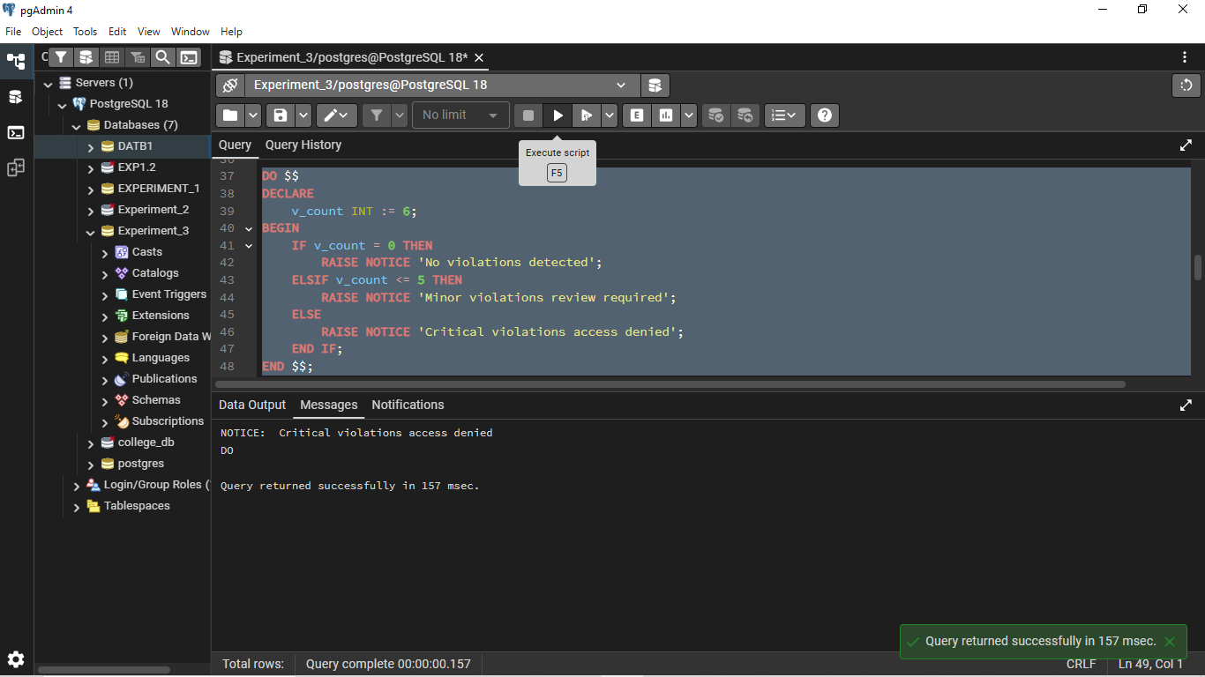

Step4
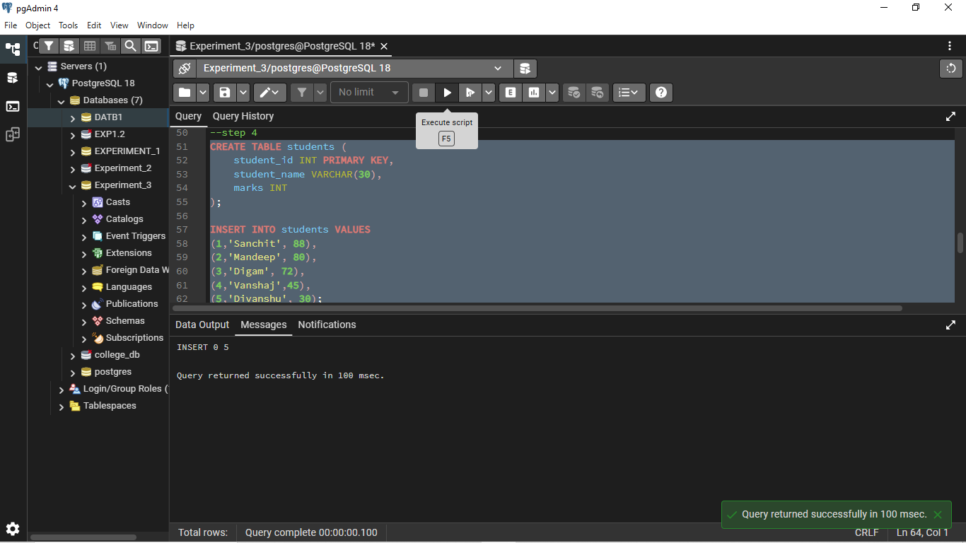

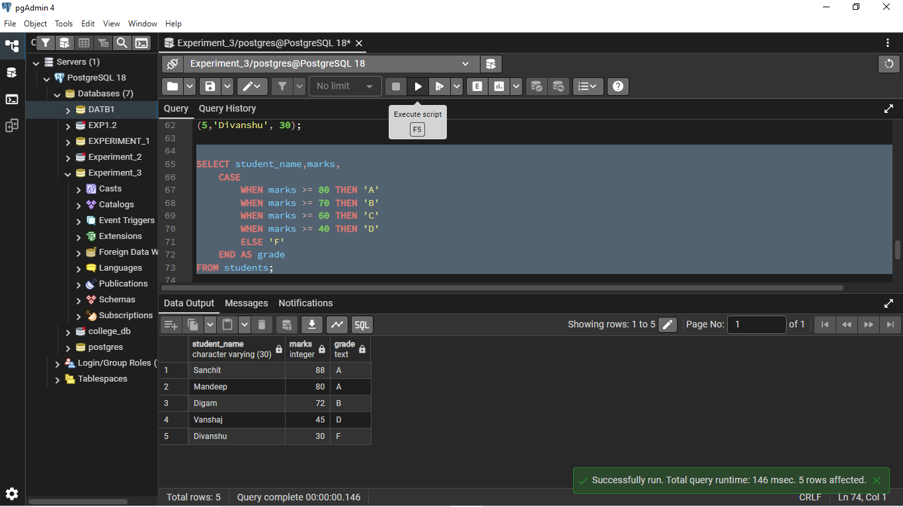

Step5
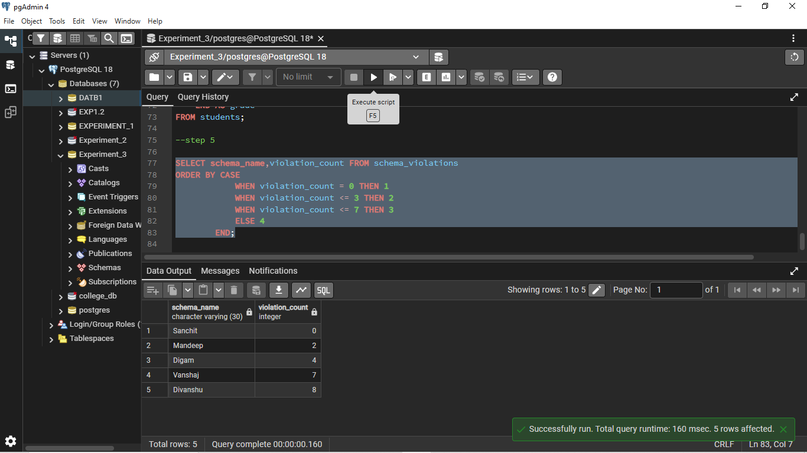

6.Learning Outcomes:

* Understood how conditional logic is implemented in PostgreSql and using CASE expressions and IF-ELSE constructs.
* Learnt how rule-based SQL logic helps in data classification and validation.
* Gained the ability to apply conditional statements
* Clearly able to use CASE-based logic for analytics and compliance reporting scenarios.

