**JsonPowerDB**

**"This project is all about basics of JsonPowerDB (JPDB) and how to use JPDB for CRUD operations."**

**About JsonPowerDB:**

* JsonPowerDB is a Real-time, High Performance, Lightweight and Simple to Use, Rest API based Multi-mode DBMS. JsonPowerDB has ready to use API for Json document DB, RDBMS, Key-value DB, GeoSpatial DB and Time Series DB functionality. JPDB supports and advocates for true serverless and pluggable API development.

**Benefits of using JsonPowerDB**

* Simplest way to retrieve data in a JSON format.
* Schema-free, Simple to use, Nimble and In-Memory database.
* It is built on top of one of the fastest and real-time data indexing engine - PowerIndeX.
* It is low level (raw) form of data and is also human readable.
* It helps developers in faster coding, in-turn reduces development cost.

**Screenshots:**

[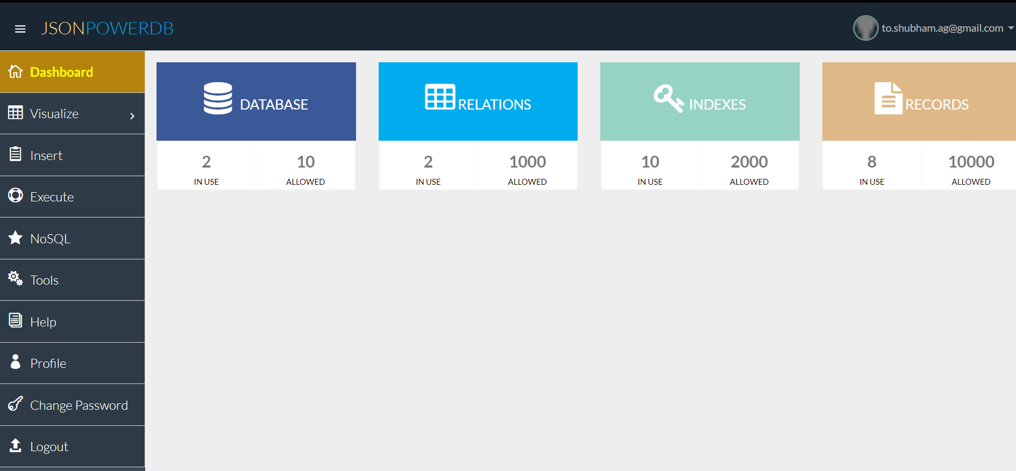](https://github.com/BeAgarwal/JsonPowerDB/blob/master/Assets/Screenshots/Dashboard.PNG)

[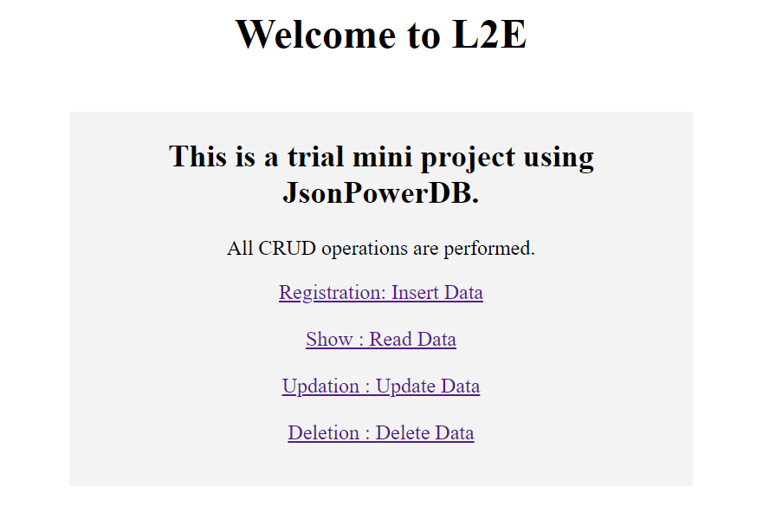](https://github.com/BeAgarwal/JsonPowerDB/blob/master/Assets/Screenshots/Index.PNG)

[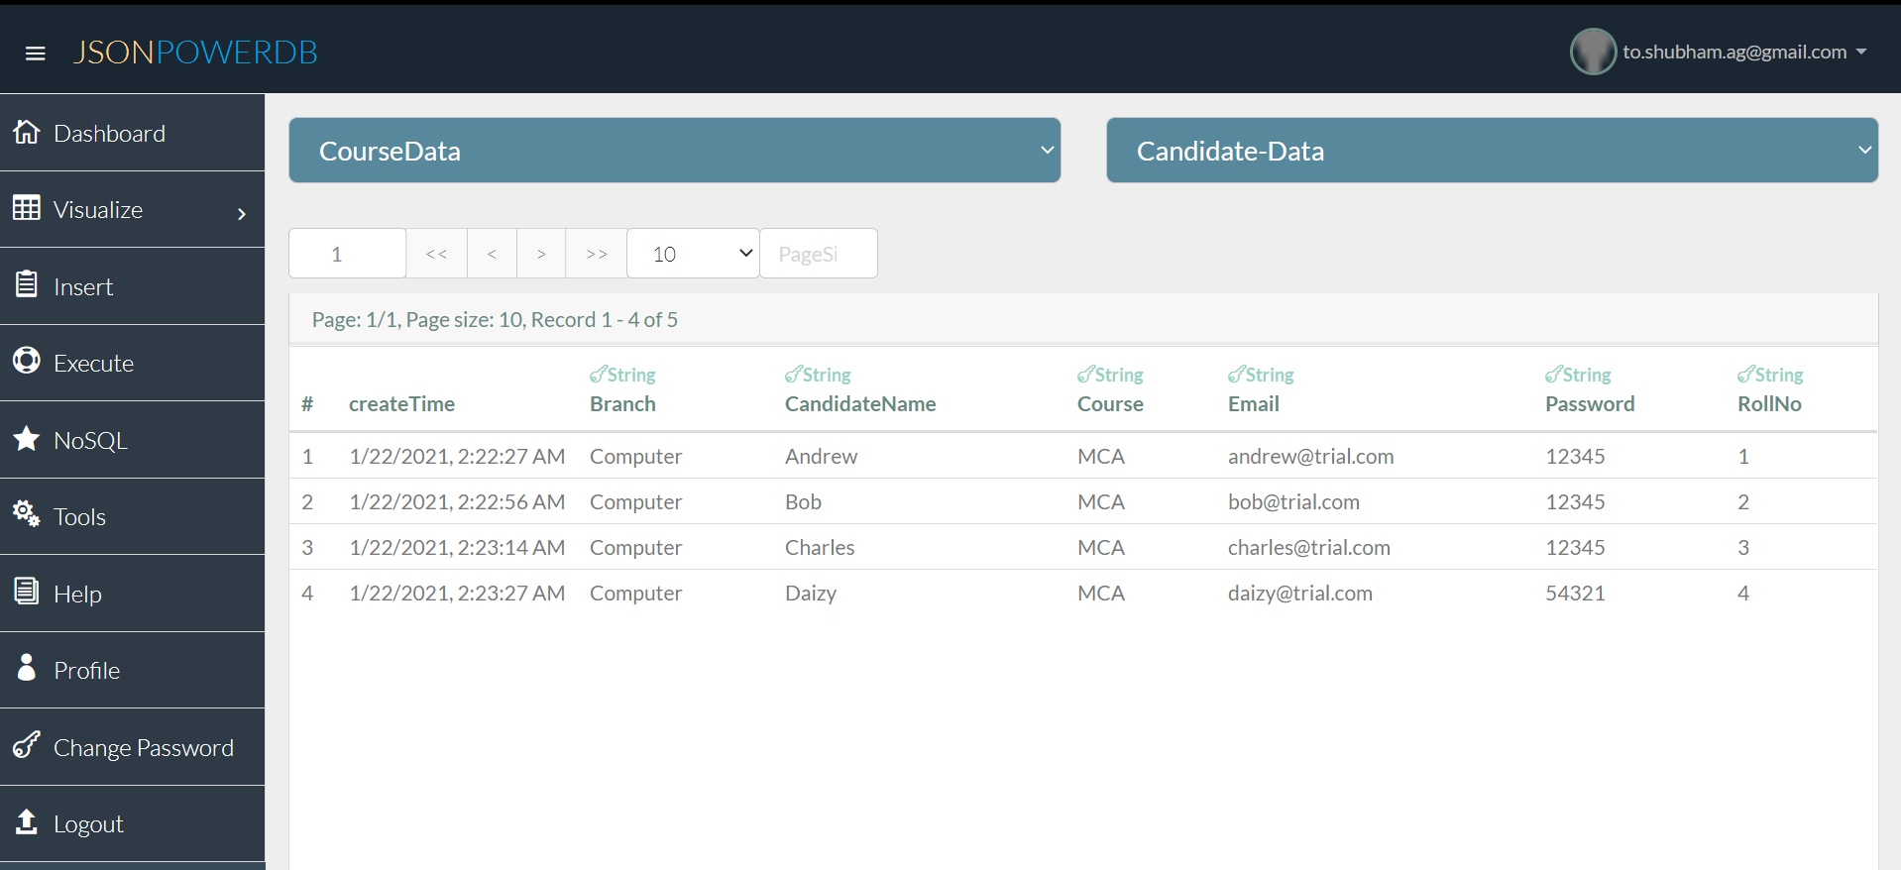](https://github.com/BeAgarwal/JsonPowerDB/blob/master/Assets/Screenshots/Server.PNG)