1. Check given year is leap year or not

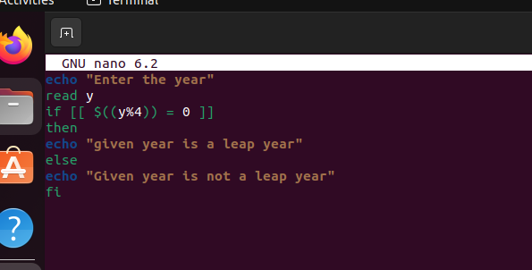

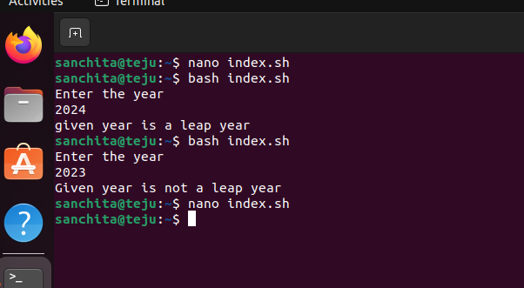

echo “enter a year”

read y

If [[ if$((y%4)) = 0 ]]

then

echo “its s leap year”

else

echo “its not a leap year”

fi

2) fibonacci series

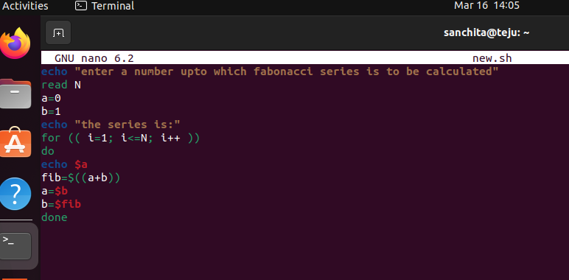

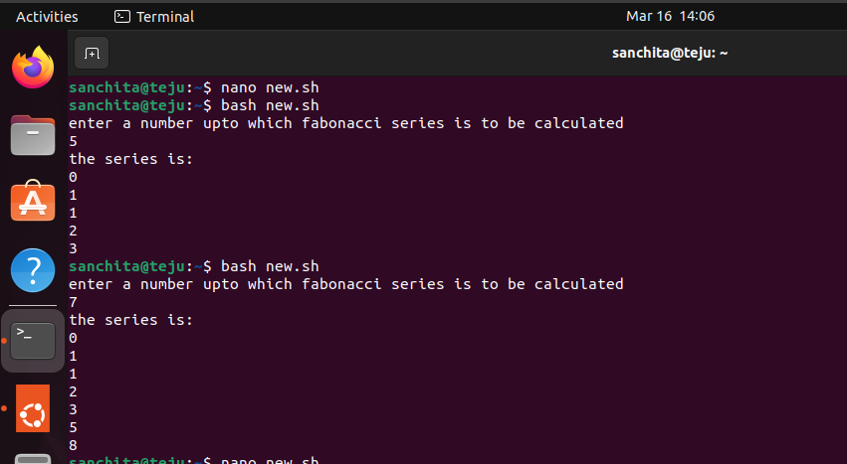

echo “enter number for fibonacci”

read N

a=0

b=1

echo “the series is”

for ((i=1;i<=N;i++))

do

echo $a

fib=$((a+b))

a=$b

b=$fib

done

3)

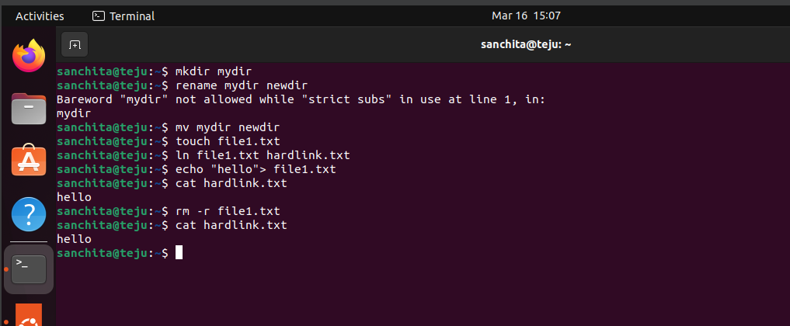

4) first launch instance

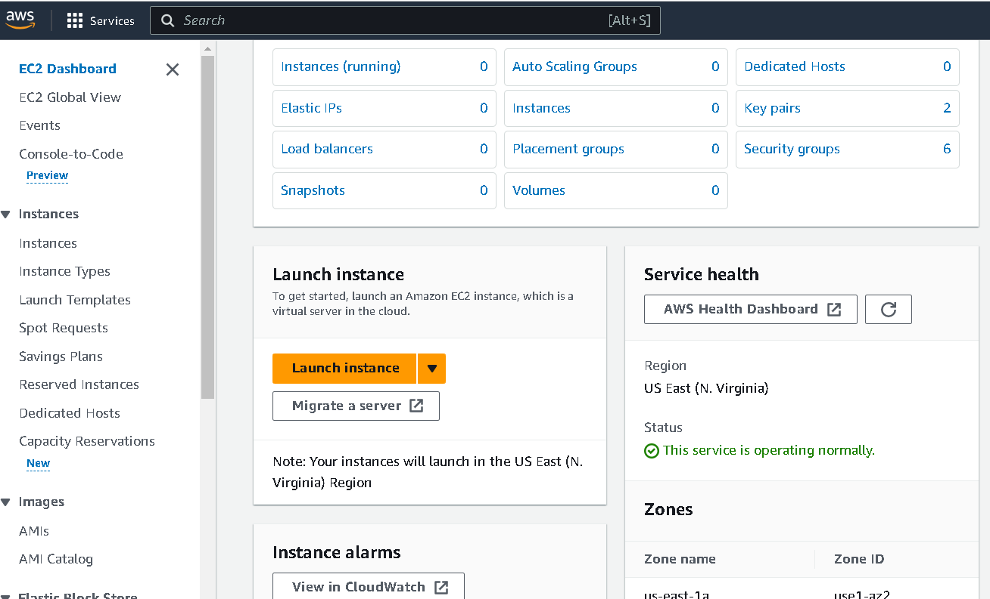

Give name to new instance

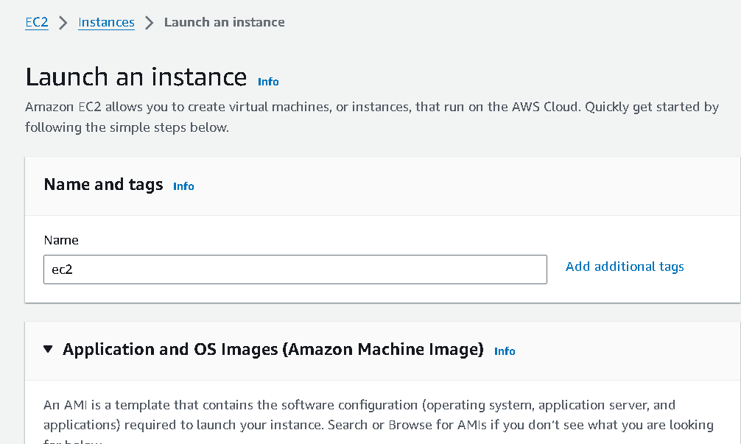

Create new kekypair

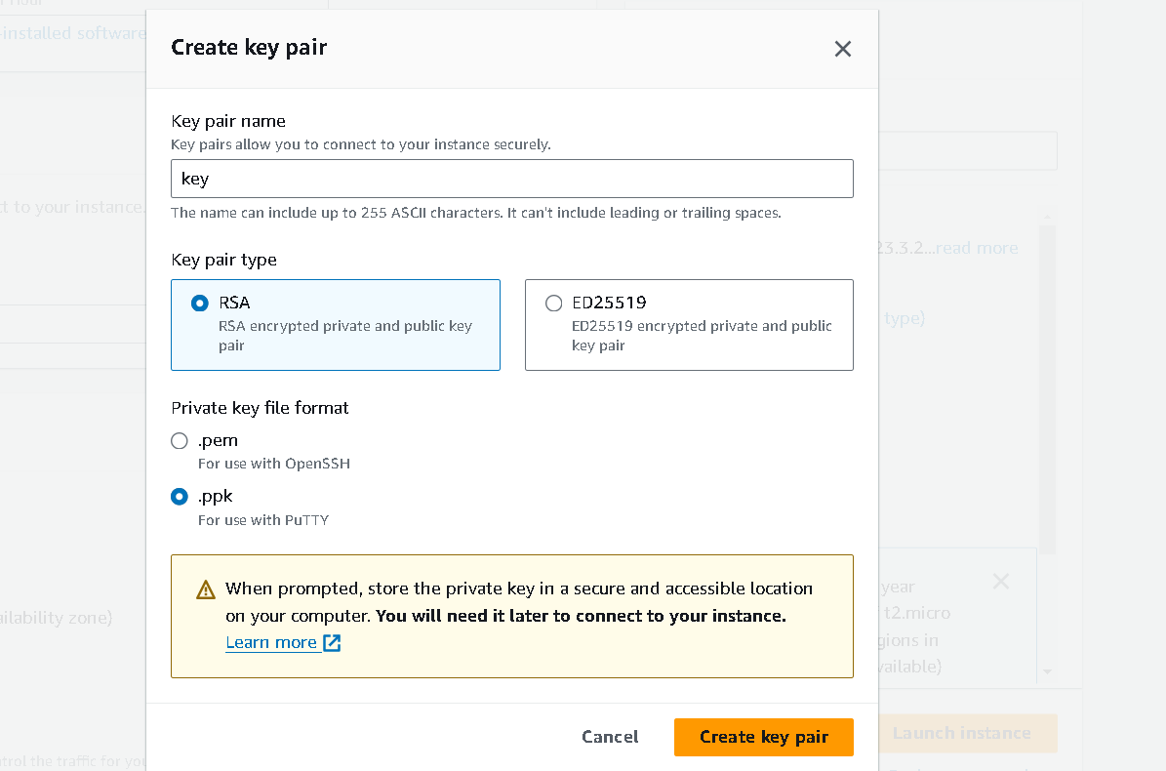

Instance is created , wait until it show running

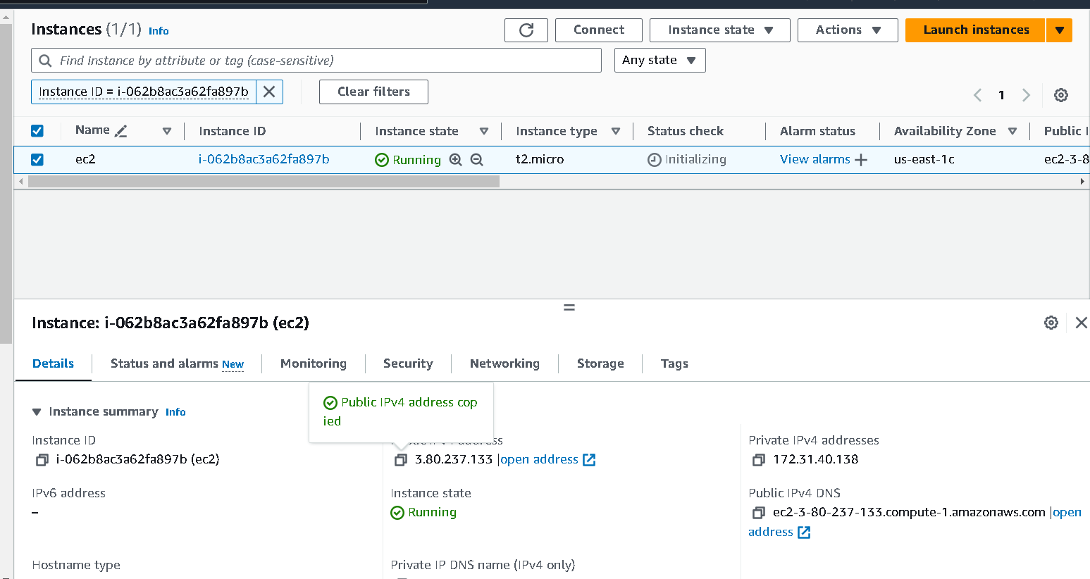

Now open putty

Give host name as we mentioned,go to ssh then auth and then to credential and oprn it

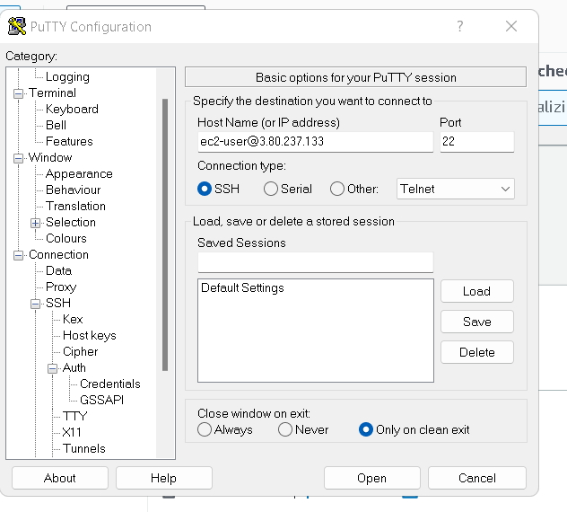

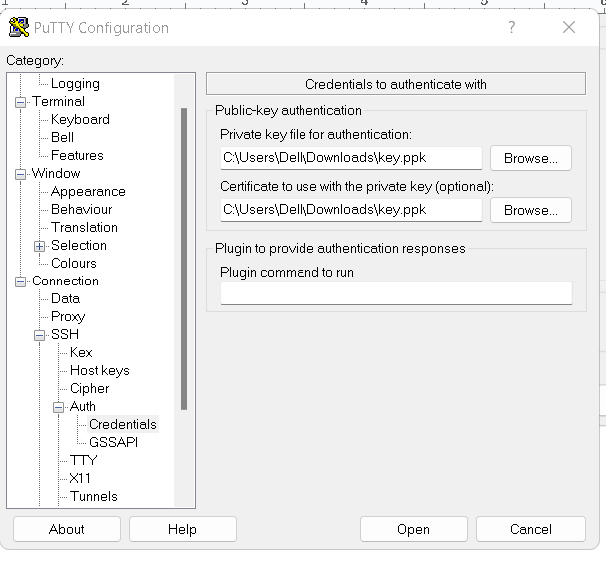

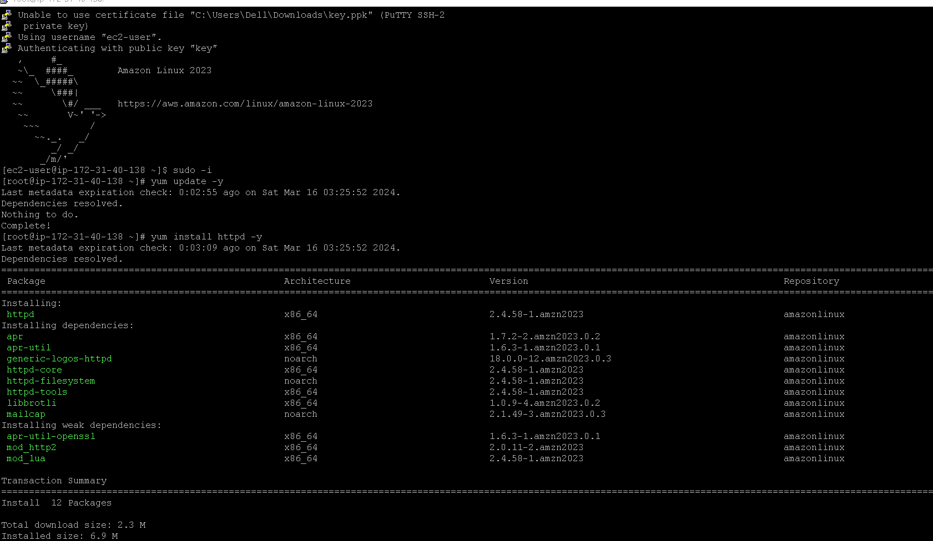

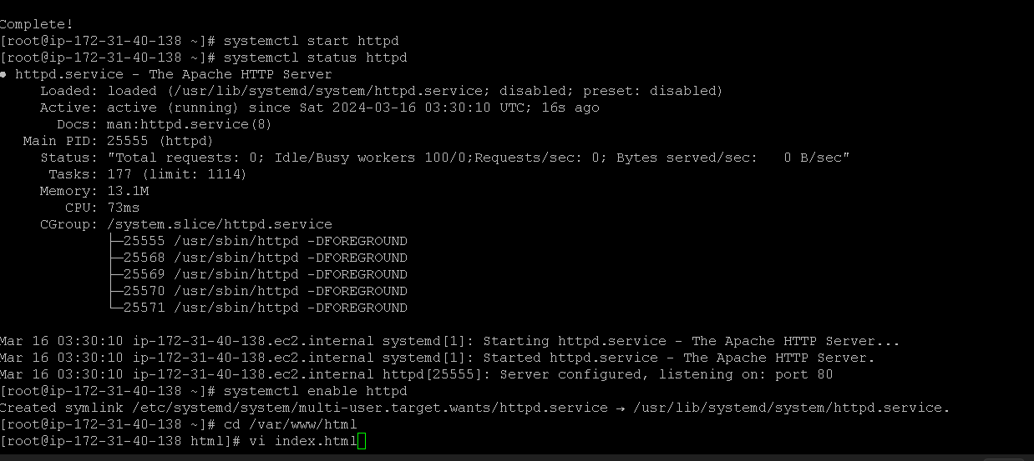

Commands are

sudo -i

yum update -y

yum install httpd -y

systemctl start httpd

systemctl status httpd

systemctl enable httpd

Cd /var/www/html

Vi index.html

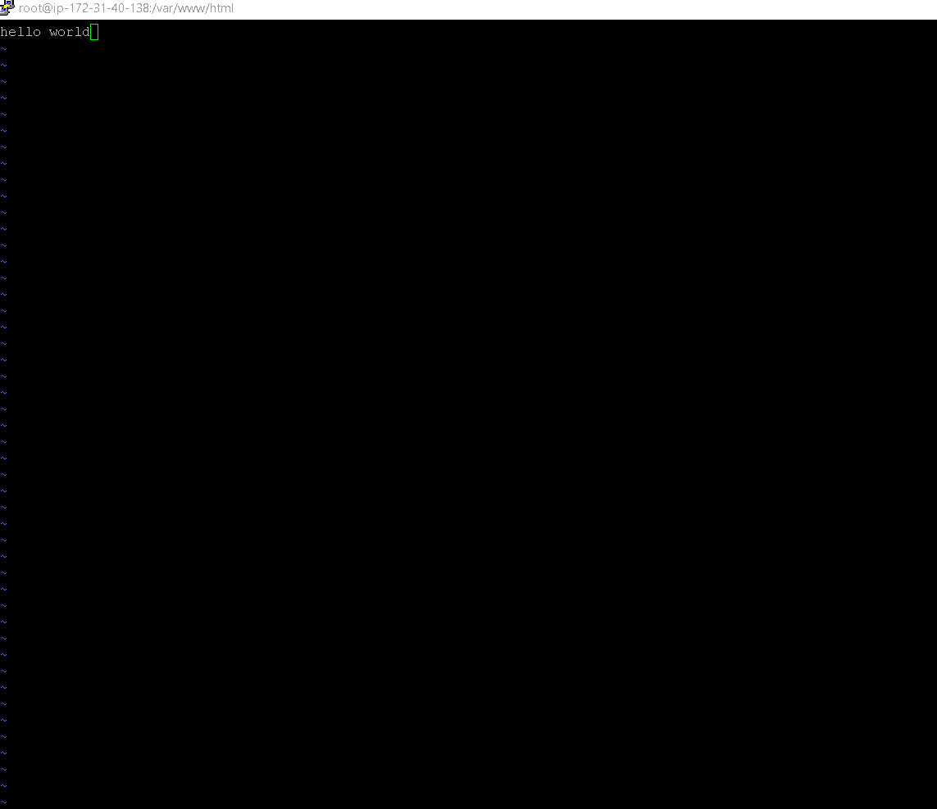

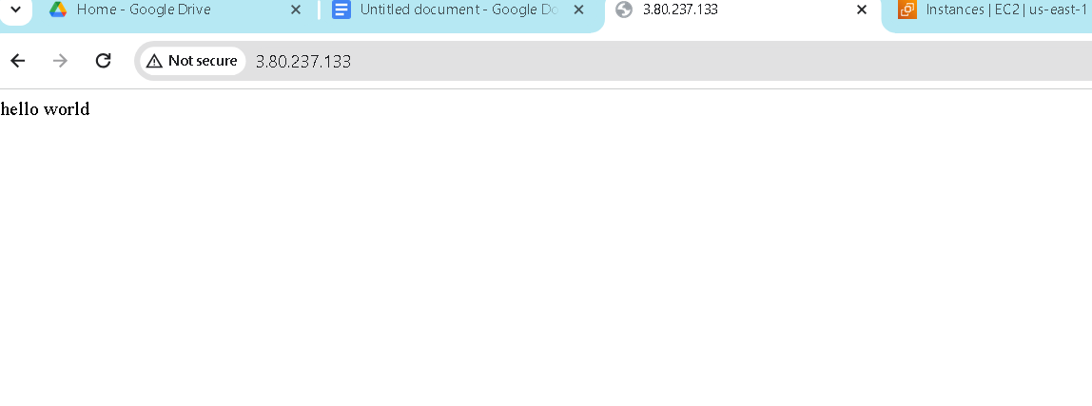

Vpc

