Submitted by: Sanchita Nagulwar

**MongoDB -Aggregation Exercises**

Import the zips.json file into your MongoDB. Database name is "population" and collection name is "zipcodes".

**mongoimport --db population --collection zipcodes --file zips.json**

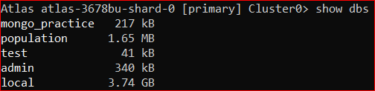

**Atlanta Population**

1. **use db.zipcodes.find() to filter results to only the results where city is ATLANTA and state is GA.**



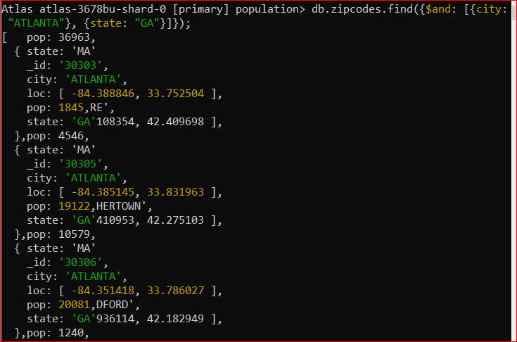

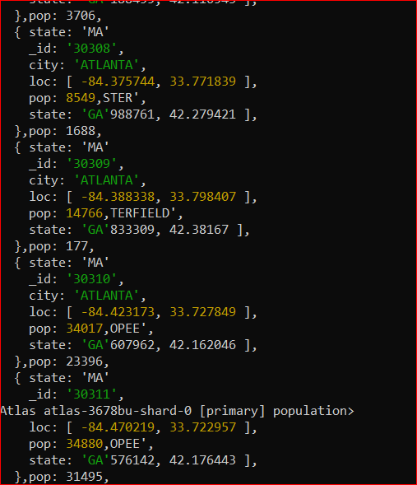

1. **use db.zipcodes.aggregate with $match to do the same as above.**

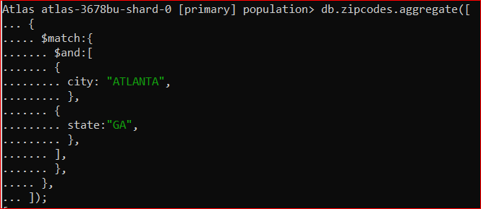

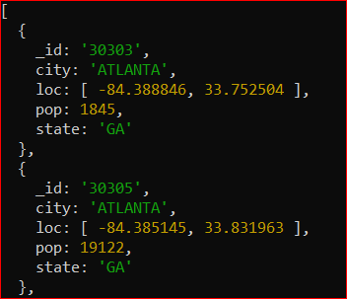

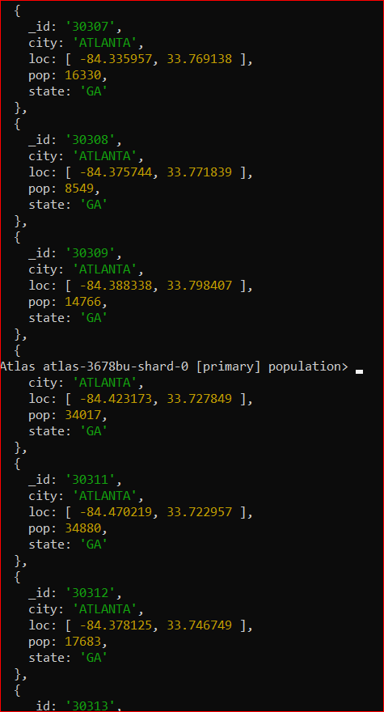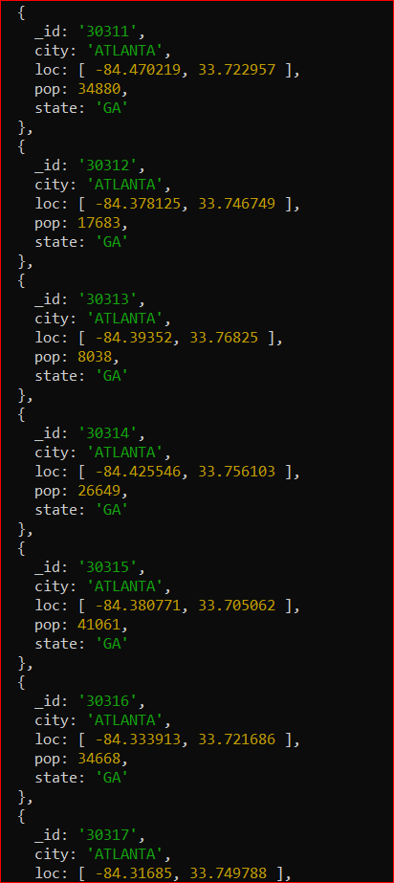

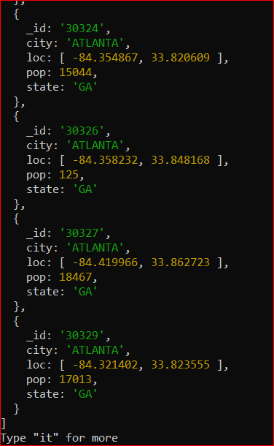

1. **use $group to count the number of zip codes in Atlanta.**

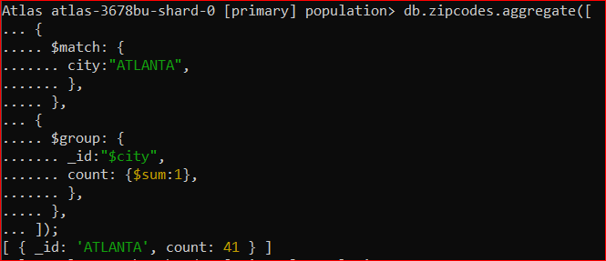

1. **use $group to find the total population in Atlanta.**

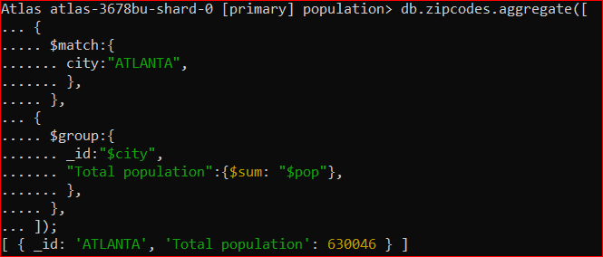

**Populations By State**

1. **use aggregate to calculate the total population for each state**

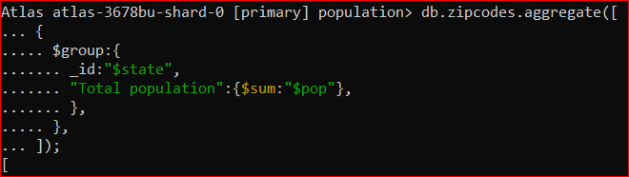

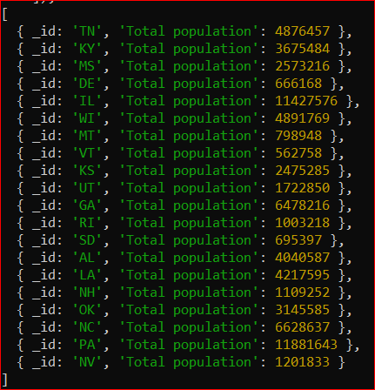

1. **sort the results by population, highest first**

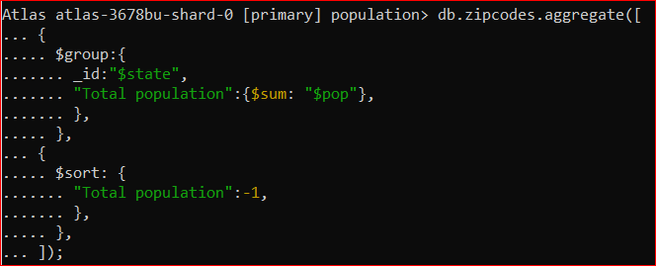

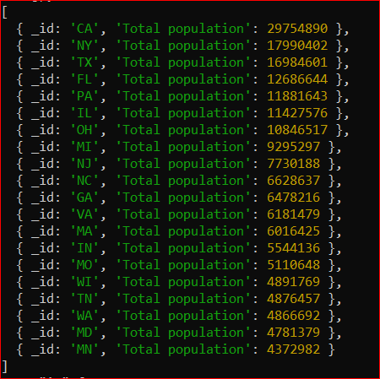

1. **limit the results to just the first 3 results. What are the top 3 states in population?**

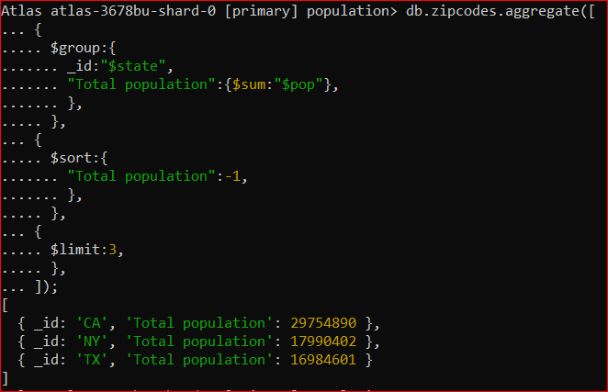

**Populations by City**

1. **use aggregate to calculate the total population for each city (you have to use city/state combination). You can use a combination for the _id of the $group: { city: '$city', state: '$state' }**

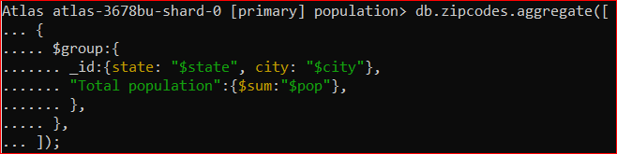

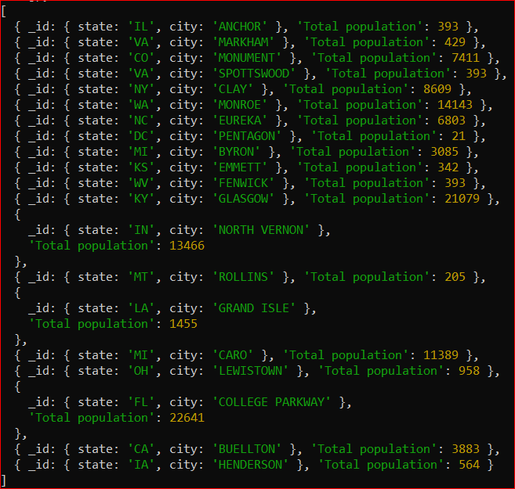

1. **sort the results by population, highest first**

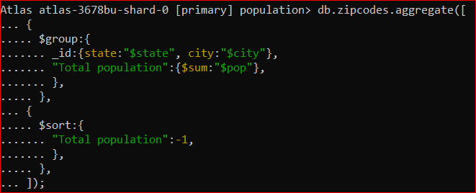

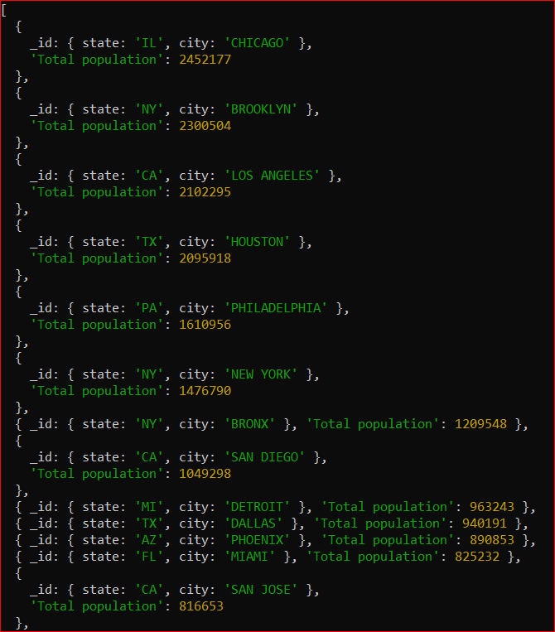

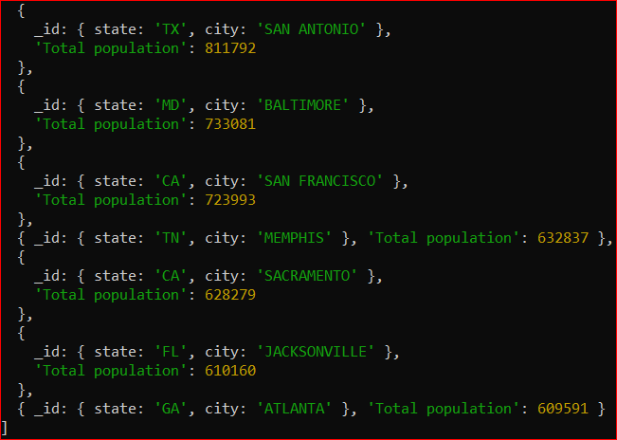

1. **limit the results to just the first 3 results. What are the top 3 cities in population?**

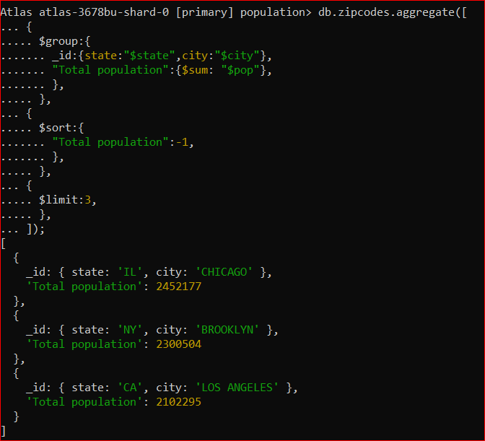

1. **What are the top 3 cities in population in Texas?**

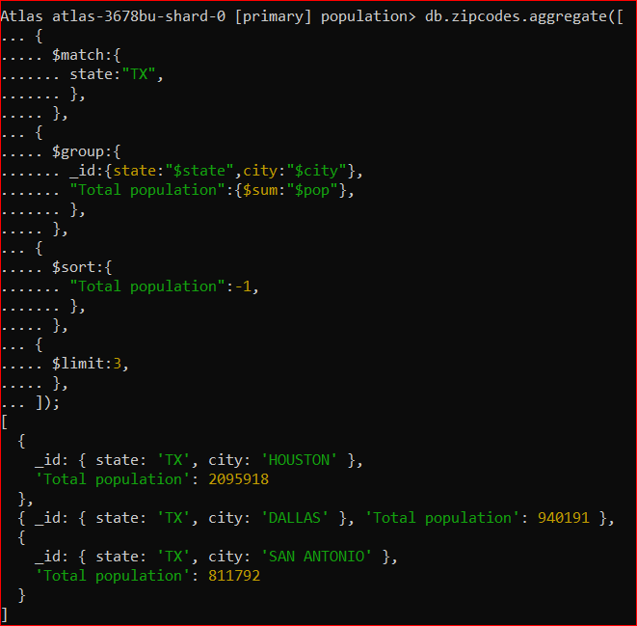

**Bonus**

1. **Write a query to get the average city population for each state.**

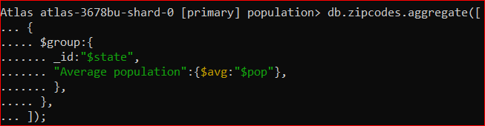

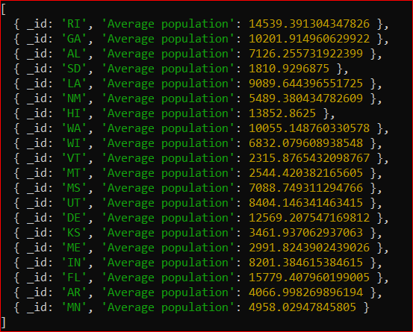

1. **What are the top 3 states in terms of average city population?**

