ICT272 Web Design and Development
Tutorial 4
Topic: Introduction to web developments and ASP.NET MVC5
Submission: Submit to Moodle link (Week4)
Exercise 1 – Answer the following questions:
- Explain what is Model-View-Controller?
Ans: A software architecture pattern called Model-View-Controller (MVC) divides the data, user interface, and control logic into three separate parts. This division facilitates the management of intricate programs, enhances maintainability, and facilitates the testing and scaling of the code.
- Mention what does Model-View-Controller represent in an MVC application?
Ans: The data and business logic are represented by the Model in an MVC application. It performs calculations, communicates with databases, maintains the application's state, and alerts the view when data changes. The presentation layer is represented by the View. Through web pages, GUI windows, or charts, it presents data from the model to the user in an understandable and intuitive manner. The control logic is represented by the controller. It decides which view should be shown, manages user inputs, processes them, and updates the model as necessary. The controller essentially manages how the model and the view interact.
- Explain the role of components Presentation, Abstraction and Control in MVC?
Ans: The view is in line with the presentation component. It oversees providing the user with information and making sure the business logic and user interface are kept apart. The model is equivalent to the abstraction component. It conceals internal implementation details while encapsulating the application's data and business processes and offering an intuitive interface for data access and modification The controller is the corresponding component. It manages user interactions, exchanges data between the model and the view, updates the model in response to user input, and chooses which view to show.
Exercise 2: Create ASP.NET MVC application
- Start your visual studio 2019
- Click on Create a new project
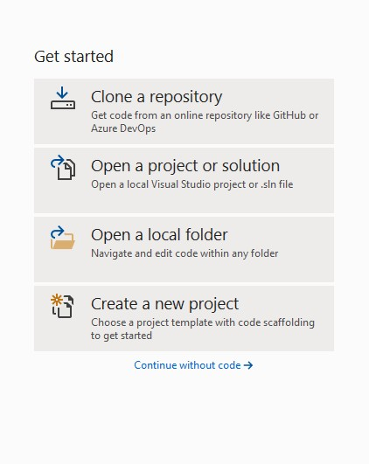
- Search for “Web Application” in search box and select “ASP.NET Web Application (.NET Framework)” with C# and then click Next.
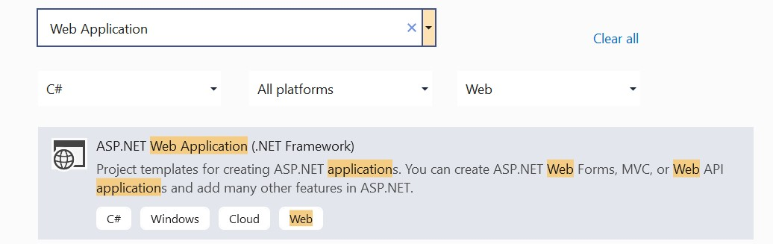
- Name your project “Tutorial5Ex2” and untick “Place solution and project in the same directory”. Then click Create.
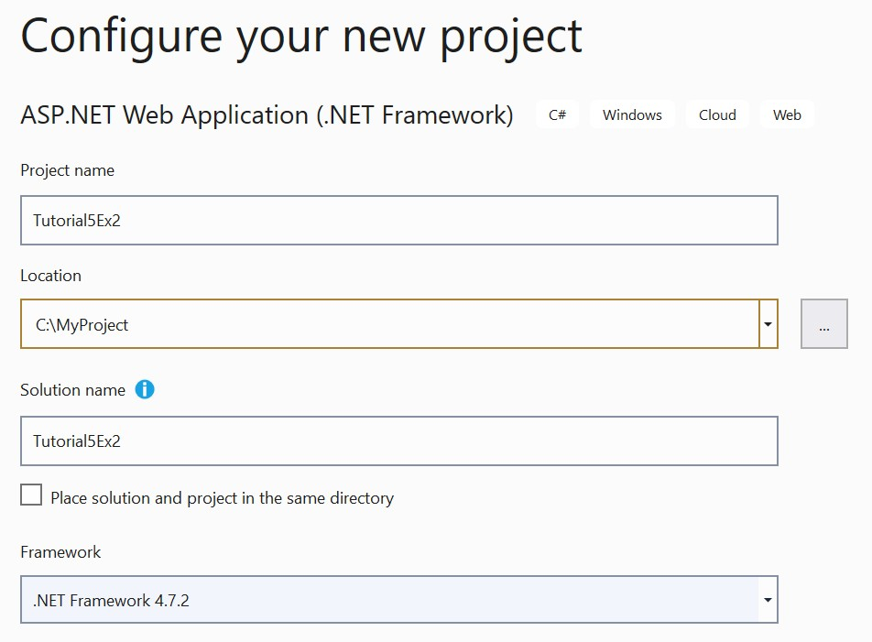
- Choose MVC and then click Create.
- Now build and run the solution by navigating to https://localhost:44332/Home/Index. The output is shown below.
What to submit:
- Screen shot of the output by navigating to https://localhost/Home/Index
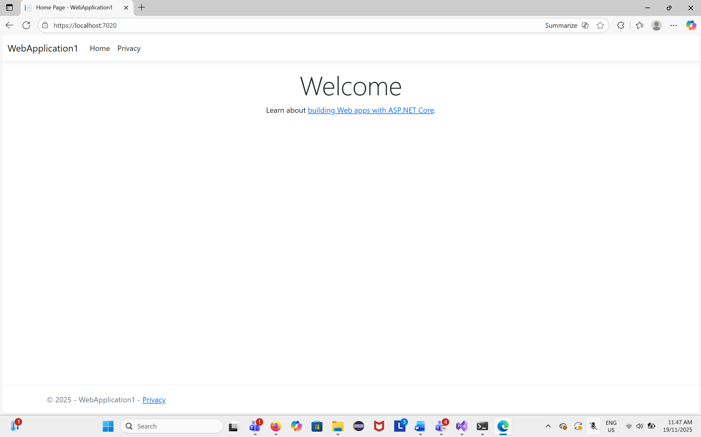
- Screen shot of the output by navigating to https://localhost/Home/ Privacy
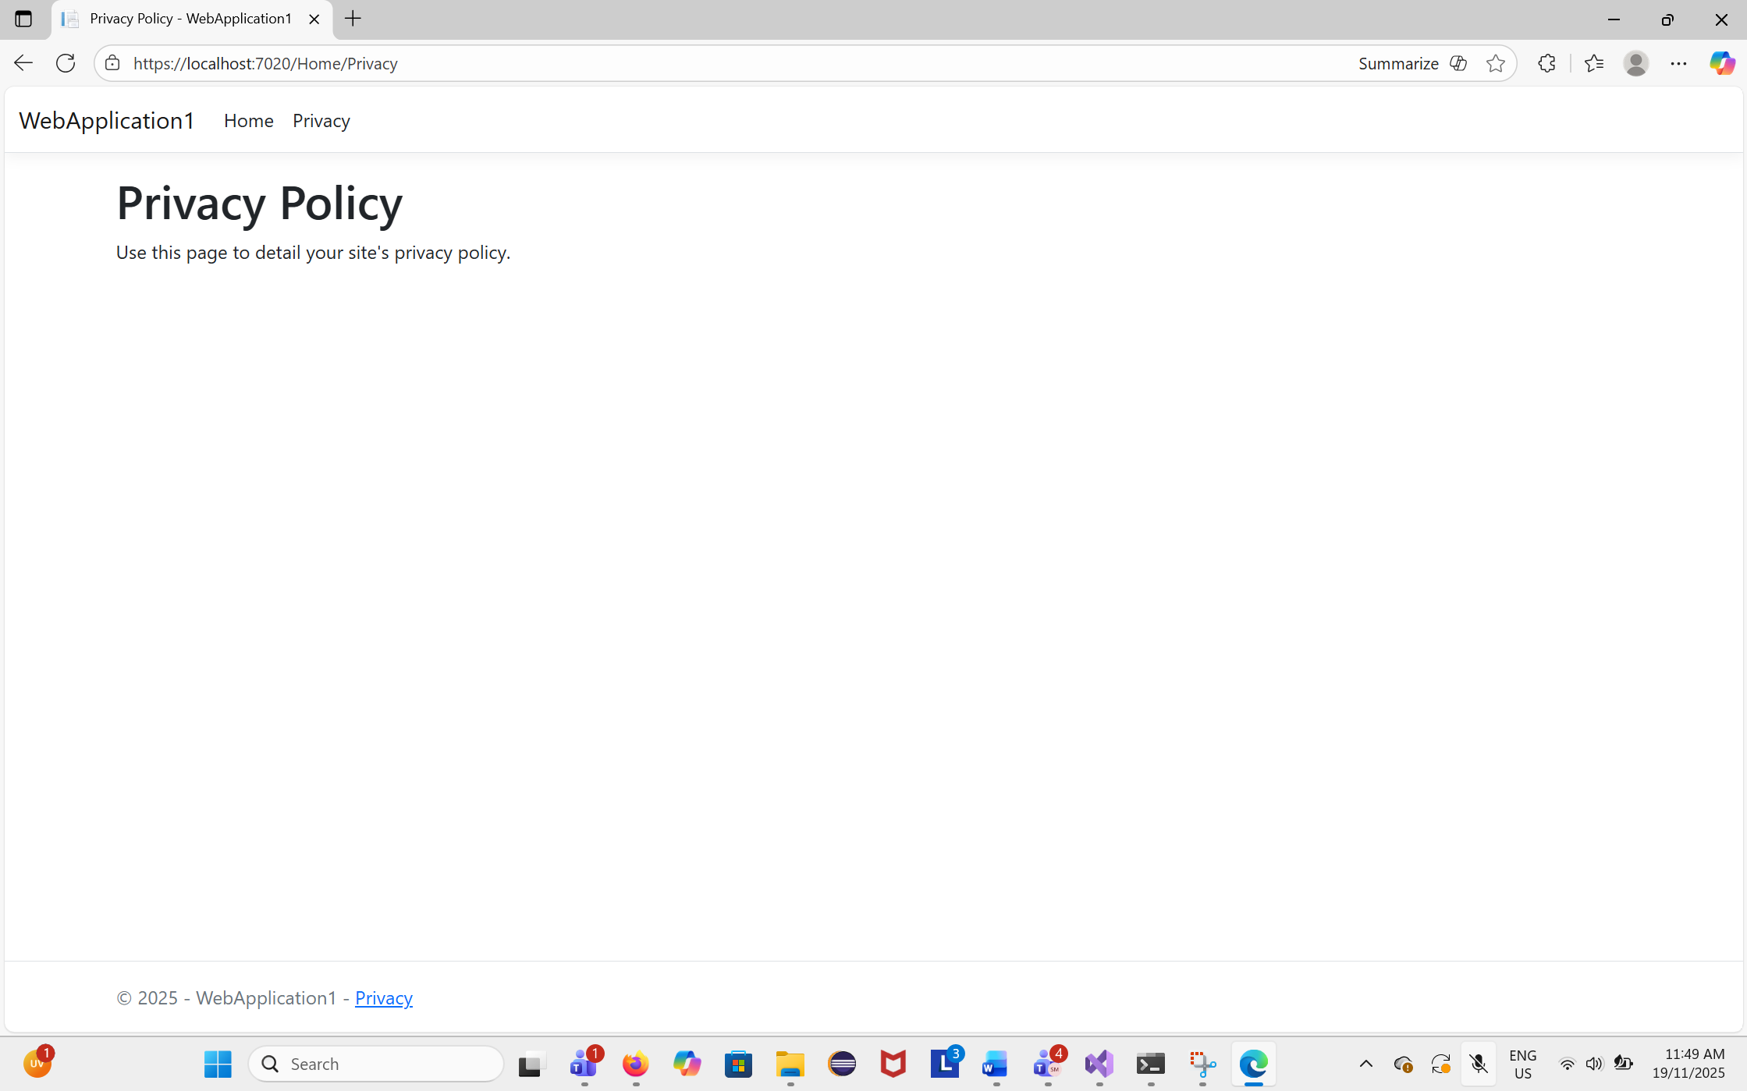
- Screen shot of the output by navigating to https://localhost/Home/Contact
Exercise 3: Change the view page
Using the same project from exercise 2, go to View->Home->Index.cshtml
Delete all the page content
Add a new HTML code to describe yourself by creating a table and add your name, studentid, major, and nationality.
What to submit:
- HTML code
@{
ViewData["Title"] = "Home Page";
}

<h2>About Me</h2>

<table border="1" cellpadding="10" cellspacing="0">
<tr>
<th>Name</th>
<td>Sanchita</td>
</tr>
<tr>
<th>Student ID</th>
<td>20028271</td>
</tr>
<tr>
<th>Major</th>
<td>Information Technology</td>
</tr>
<tr>
<th>Nationality</th>
<td>Nepali</td>
</tr>
</table>

- Screen shot of the output of https://localhost/Home/Index
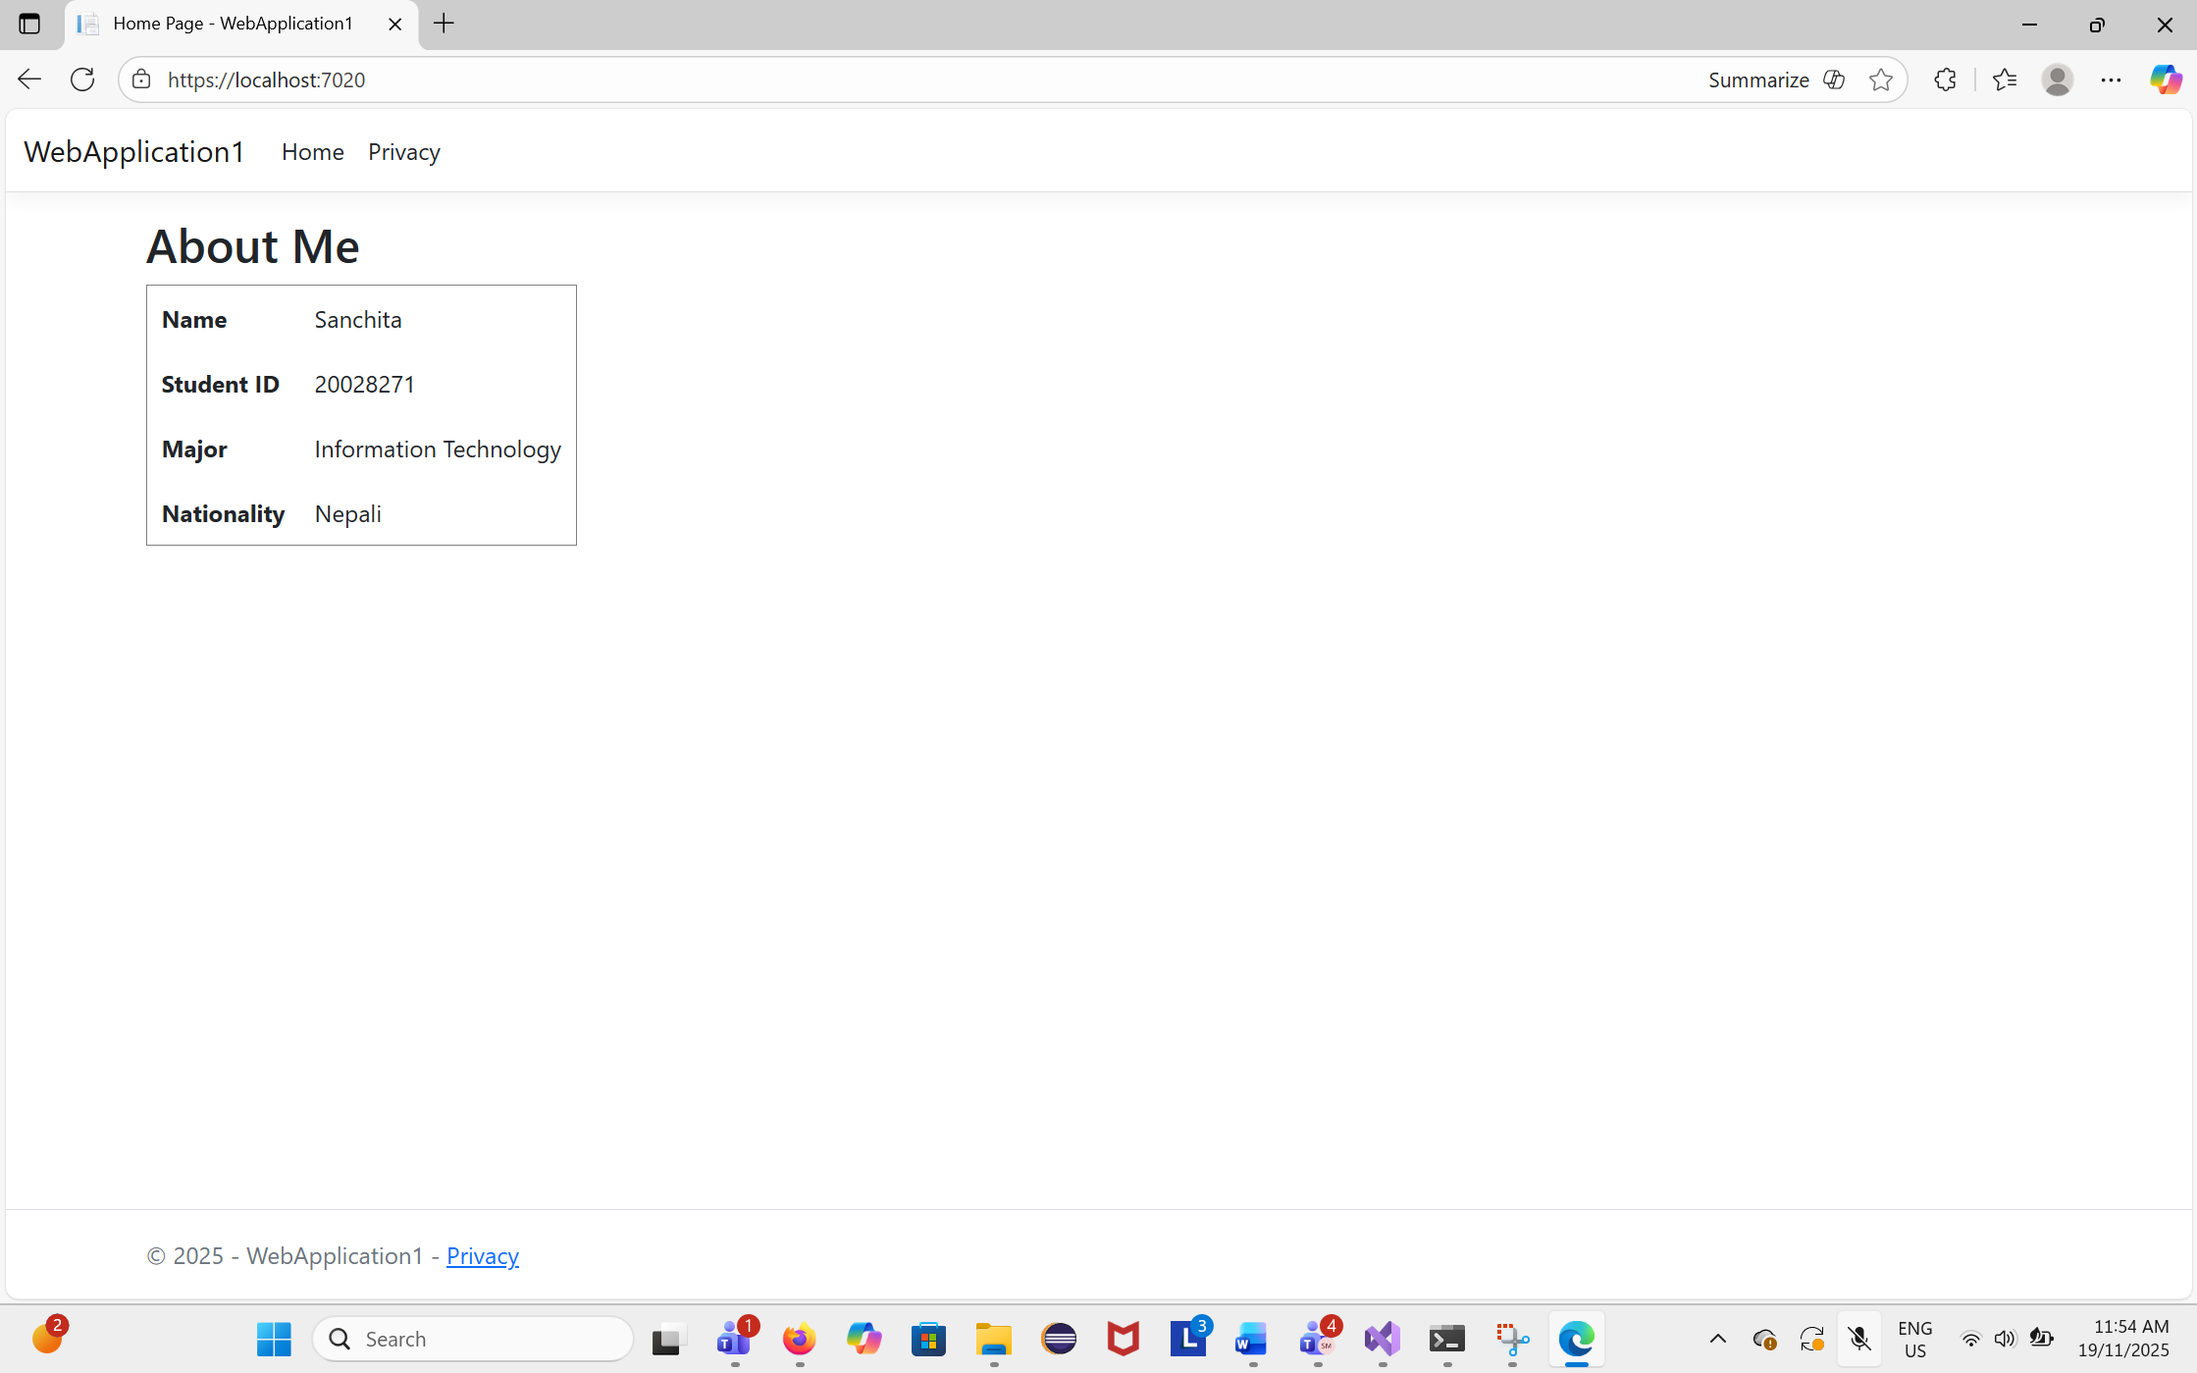
Exercise 4: Work on the biweekly activity 4
END of Tutorial

