**Experiment-6**

**Soft Computing**

**Fuzzy K-Means**

**Source Code:**

from __future__ import division, print_function

import numpy as np

import matplotlib.pyplot as plt

import skfuzzy as fuzz

colors = ['b', 'orange', 'g', 'r', 'c', 'm', 'y', 'k', 'Brown', 'ForestGreen']

# Define three cluster centers

centers = [[4, 2],

           [1, 7],

           [5, 6]]

# Define three cluster sigmas in x and y, respectively

sigmas = [[0.8, 0.3],

          [0.3, 0.5],

          [1.1, 0.7]]

# Generate test data

np.random.seed(42)  # Set seed for reproducibility

xpts = np.zeros(1)

ypts = np.zeros(1)

labels = np.zeros(1)

for i, ((xmu, ymu), (xsigma, ysigma)) in enumerate(zip(centers, sigmas)):

    xpts = np.hstack((xpts, np.random.standard_normal(200) * xsigma + xmu))

    ypts = np.hstack((ypts, np.random.standard_normal(200) * ysigma + ymu))

    labels = np.hstack((labels, np.ones(200) * i))

# Visualize the test data

fig0, ax0 = plt.subplots()

for label in range(3):

    ax0.plot(xpts[labels == label], ypts[labels == label], '.',

             color=colors[label])

ax0.set_title('Test data: 200 points x3 clusters.')

**Output:**

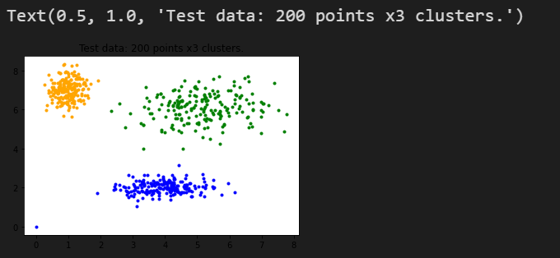

**Source Code:**

# Set up the loop and plot

fig1, axes1 = plt.subplots(3, 3, figsize=(8, 8))

alldata = np.vstack((xpts, ypts))

fpcs = []

for ncenters, ax in enumerate(axes1.reshape(-1), 2):

    cntr, u, u0, d, jm, p, fpc = fuzz.cluster.cmeans(

        alldata, ncenters, 2, error=0.005, maxiter=1000, init=None)

    # Store fpc values for later

    fpcs.append(fpc)

    # Plot assigned clusters, for each data point in training set

    cluster_membership = np.argmax(u, axis=0)

    for j in range(ncenters):

        ax.plot(xpts[cluster_membership == j],

                ypts[cluster_membership == j], '.', color=colors[j])

    # Mark the center of each fuzzy cluster

    for pt in cntr:

        ax.plot(pt[0], pt[1], 'rs')

    ax.set_title('Centers = {0}; FPC = {1:.2f}'.format(ncenters, fpc))

    ax.axis('off')

fig1.tight_layout()

**Output:**

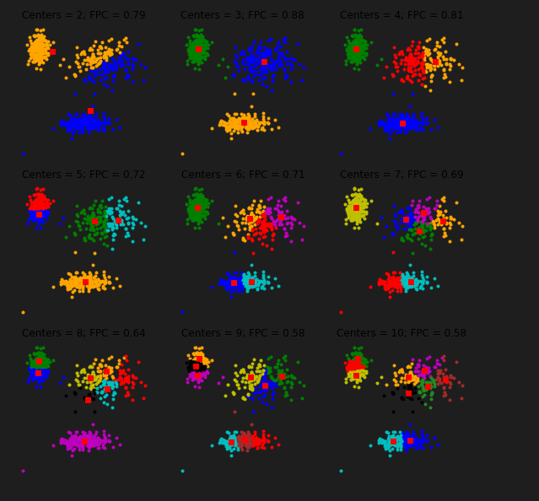

**Source Code:**

fig2, ax2 = plt.subplots()

ax2.plot(np.r_[2:11], fpcs)

ax2.set_xlabel("Number of centers")

ax2.set_ylabel("Fuzzy partition coefficient")

**Output:**

