

**University of Petroleum and Energy Studies**

**DBMS Mini-Project**

**Course: MCA**

**School Of Computer Science**

**Submitted To:**

Dr. Mitali Chugh

Assistant Professor

Senior Scale School of Computer Science

**CONTENTS**

* INTRODUCTION
* ABSTRACT
* PROJECT DESCRIPTION
* SCOPE
* FEATURES
* LIMITATIONS
* ENTITIES
* ATTRIBUTES
* ER DIAGRAM
* DATA FLOW DIAGRAM (DFD)
* INITIAL DATABASE SCHEMA
* OBSERVATIONS
* CREATE & INSERT SQL QUERY
* CONLUSION

**INTRODUCTION**

THE SYSTEM IS BASICALLY CONCERNED WITH ONLINE RESERVATION OF RAILWAY TICKETS TO THE PASSENGERS.IN THIS PROJECT WE TRY TO EDUCATE VIEWERS ON HOW A RESERVATION IS DONE.STORE AND RETRIEVE INFORMATION ABOUT THE VARIOUS TRANSACTIONS RELATED TO RAIL TRAVEL.KEEP TRACK OF ALL ITS PASSENGERS AND THUS SCHEDULE THEIR JOURNEY ACCORDINGLY.MAINTAINS RECORDS OF PASSWNGERS TRAVELLING IN THE DIFFERENT TRANIS ON DIFFERENTS DATES REACHING DIFFERENTS DESTINATIONS.

**ABSTRACT**

THE RAILWAY RESERVATION SYSTEM FACILITATES THE PASSENGERS TO ENQUIRE ABOUT THE TRAINS AVAILABLE ON THE BASIS OF SOURCE AND DESTINATION, BOOKING AND CANCELLATION OF TICKETS, ENQUIRE ABOUT THE STATUS OF THE BOOKED TICKET, ETC. THE AIM OF CASE STUDY IS TO DESIGN AND DEVELOP A DATABASE MAINTAINING THE RECORDS OF DIFFERENT TRAINS, TRAIN STATUS, AND PASSENGERS. THIS PROJECT CONTAINS INTRODUCTION TO THE RAILWAYS RESERVATION SYSTEM. IT 1S THE COMPUTERIZED SYSTEM OF RESERVING THE SEATS OF TRAIN SEATS IN ADVANCED. IT IS MAINLY USED FOR LONG ROUTE. ON-LINE RESERVATION HAS MADE THE PROCESS FOR THE RESERVATION OF SEATS VERY MUCH EASIER THAN EVER BEFORE. IN OUR COUNTRY INDIA, THERE ARE NUMBER OF COUNTERS FOR THE RESERVATION OF THE SEATS AND ONE CAN EASILY MAKE RESERVATIONS AND GET TICKETS. THEN THIS PROJECT CONTAINS ENTITY RELATIONSHIP MODEL DIAGRAM BASED ON RAILWAY RESERVATION SYSTEM AND INTRODUCTION TO RELATION MODEL. THERE IS ALSO DESIGN OF THE DATABASE OF THE RAILWAY RESERVATION SYSTEM BASED ON RELATION MODEL. EXAMPLE OF SOME SQL QUERIES TO RETRIEVES DATA FROM RAIL MANAGEMENT DATABASE.

**PROJECT DESCRIPTION**

THIS PROJECT IS ABOUT CREATING THE DATABASE ABOUT RAILWAY RESERVATION SYSTEM.THE RAILWAY RESERVATION SYSTEM FACILITATES THE PASSENGERS TO ENQUIRE ABOUT THE TRAINS AVAILABLE ON THE BASIS OF SOURCE AND DESTINATION, BOOKING AND CANCELLATION OF TICKETS, ENQUIRE ABOUT THE STATUS OF THE BOOKED TICKET, ETC. THE AIM OF CASE STUDY IS TO DESIGN AND DEVELOP A DATABASE MAINTAINING THE RECORDS OF DIFFERENT TRAINS, TRAIN STATUS, AND PASSENGERS. THE RECORD OF TRAIN INCLUDES ITS NUMBER, NAME, SOURCE, DESTINATION, AND DAYS ON WHICH IT IS AVAILABLE, WHEREAS RECORD OF TRAIN STATUS INCLUDES DATES FOR WHICH TICKETS CAN BE BOOKED, TOTAL NUMBER OF SEATS AVAILABLE, AND NUMBER OF SEATS ALREADY BOOKED. PASSENGERS CAN BOOK THEIR TICKETS FOR THE TRAIN IN WHICH SEATS ARE AVAILABLE.FOR THIS, PASSENGER HAS TO PROVIDE THE DESIRED TRAIN NUMBER AND THE DATE FOR WHICH TICKET IS TO BE BOOKED. BEFORE BOOKING A TICKET FOR A PASSENGER, THE VALIDITY OF TRAIN NUMBER AND BOOKING DATE ARE CHECKED. ONCE THE TRAIN NUMBER AND BOOKING DATE ARE VALIDATED, IT IS CHECKED WHETHER THE SEAT IS AVAILABLE. IF YES, THE TICKET IS BOOKED WITH CONFIRM STATUS AND CORRESPONDING TICKET ID IS GENERATED WHICH IS STORED ALONG WITH OTHER DETAILS OF THE PASSENGER. THE TICKET ONCE BOOKED CAN BE CANCELLED AT ANYTIME. FOR THIS, THE PASSENGER HAS TO PROVIDE THE TICKET ID (THE UNIQUE KEY). THE TICKET ID IS SEARCHED AND THE CORRESPONDING RECORD IS DELETED. WITH THIS, THE FIRST TICKET WITH WAITING STATUS ALSO GETS CONFIRMED. LIST OF ASSUMPTION SINCE THE RESERVATION SYSTEM IS VERY LARGE IN REALITY, IT IS NOT FEASIBLE TO DEVELOP THE CASE STUDY TO THAT EXTENT AND PREPARE DOCUMENTATION AT THAT LEVEL. THEREFORE, A SMALL SAMPLE CASE STUDY HAS BEEN CREATED TO DEMONSTRATE THE WORKING OF THE RESERVATION SYSTEM. TO IMPLEMENT THIS SAMPLE CASE STUDY, SOME ASSUMPTIONS HAVE BEEN MADE, WHICH ARE AS FOLLOWS:

1. THE NUMBER OF TRAINS HAS BEEN RESTRICTED TO 5.

2. THE BOOKING IS OPEN ONLY FOR NEXT SEVEN DAYS FROM THE CURRENT DATE.

3. ONLY TWO CATEGORIES OF TICKETS CAN BE BOOKED, NAMELY, AC AND GENERAL.

4. THE TOTAL NUMBER OF TICKETS THAT CAN BE BOOKED IN EACH CATEGORY (AC AND GENERAL) IS 10.

5. THE TOTAL NUMBER OF TICKETS THAT CAN BE GIVEN THE STATUS OF WAITING IS 2.

6. THE IN- BETWEEN STOPPAGE STATIONS AND THEIR BOOKINGS ARE NOT CONSIDERED.

LIST OF TRAINS HAS TO BE MAINTAINED. DETAILED PASSENGER INFORMATION IS TO BE

MAINTAINED IN THE BOOKING PROCEDURE, THE TRAIN NUMBER, TRAIN DATE, AND CATEGORY ARE

READ FROM THE PASSENGER. ON THE BASIS OF THE VALUES PROVIDED BY THE PASSENGER,

CORRESPONDING RECORD IS RETRIEVED FROM THE TRAIN_STATUS. IF THE DESIRED CATEGORY IS

AC. THEN TOTAL NUMBER OF AC SEATS AND NUMBER OF BOOKED AC SEATS ARE COMPARED

IN ORDER TO FIND WHETHER TICKET CAN BE BOOKED OR NOT. SIMILARLY, IT CAN BE CHECKED

FOR THE GENERAL CATEGORY. IF TICKET CAN BE BOOKED, THEN PASSENGER DETAILS ARE READ

AND STORED IN THE PASSENGER TABLE. IN THE CANCELLATION PROCEDURE, TICKET ID IS READ

FROM THE PASSENGER AND CORRESPONDING RECORD IS SEARCHED IN THE PASSENGER. IF THE

RECORD EXISTS, IT IS DELETED. AFTER DELETING THE RECORD (IF IT IS CONFIRMED), FIRST RECORD

WITH WAITING STATUS FOR THE SAME TRAIN AND SAME CATEGORY ARE SEARCHED FROM THE

PASSENGER TABLE AND ITS STATUS IS CHANGED TO CONFIRM.

**SCOPE**

ALL THE MANUAL WORK SHOULD BE CONBERTED AND COMPUTERIZED SO THAT THE MANUAL WORK FOR THE EMPLOYEES WILL BE REDUCED THE DATABASE SHOULD BE STORED IN COMPUTER THAN STORNG ALL THE RECORDS MANUALLY INTRODUCTION A NEW ONLINE RAILWAY SYSTEM IS NOT ONLY TECHNOLOGICAL INNOVATION. BUT ALSO, WILL IMPROVE THE RAILWAY SERVICES TO A CERTAIN EXTENT SOLVE THE DIFFICULT PROBLEM OF RAILWAY TICKETING.

**FEATURES**

SURFING OF DATA IS EASY.THE WAIT TIME OF THE PASSWNGER WILL BE REDUCED.ACCURACY OF THE INFORMATION.IT IS A FAST PROCESS.DATA IS EFFICIENT.

**LIMITATIONS**

DATA REDUNDANCY. DIFFICULTY IN ACCESSING DATA .

**ENTITIES**

THESE ARE THE FOLLOWING ENTITIES THAT ARE RELATED TO RESERVATION.

1. EMPLOYEE.
2. PASSENGERS.
3. STATION.
4. TRAINS.
5. TICKET.
6. FARE.
7. CLASS.
8. TIME.
9. ROUTE.
10. USER.

**EMPLOYEE AND ITS ATTRIBUTES**

IN THIS PART WE ARE COVERING ON HOW THW EMPLOYEES ARE WORKING IN RESERVATIONS SECTION OF RAILWAYS.

THE ATTRIBUTES OF EMPLOYEE:

1. E_ID (P.k)
2. E_NAME
3. ADDRESS
4. GENDER
5. PH_NUMBER
6. DOJ
7. SALARY

**PASSENGER & ITS ATTRIBUTES**

WE ARE COVERING THE DETAILS RELATED TO PASSENGERS REQUIRED FOR RESERVATIONS.

1. P_ID (P.k)
2. P_NAME
3. SEAR_N0
4. GENDER
5. PH_NUMBER
6. E_ID (F.K)
7. RES_STATUS

**STATIONS & IT’S ATTRIBUTES**

ALL THE DETAILS OF THE STATION ARE COVERED.

ATTRIBUTES:

1. STATION_ID
2. STATON_NAME
3. N0_OF_LINES
4. N0_OF_PLATFORMS

**TRAIN & IT’S ATTRIBUTES**

ALL THE DETAILS RELATED TO TRAINS ARE COVERED IN THIS ENTITY.

ATTRIBUTES:

1. TRAIN_ID
2. STATION_ID
3. TRN_NAME
4. STATION_ID

**TICKET & IT’S ATTRIBUTES**

THE DETAILS OF THE TICKET ARE COVERED IN THIS ENTITY.

ATTRIBUTE:

1. TICKETT_NO
2. SOURCE
3. DESTINATION
4. CLASS_ID
5. FARE
6. TRAIN_ID

**FARE & IT’S ATTRIBUTES**

FARE IS THE CHARGE SPENT BY THE PASSENGER. FARE IS DECIDED ACCORDING TO THE TRAIN WHICH IS SELECTED BY THE CUSTOMER.

THE DETAILS INCLUDE:

1. RECIPT_NC
2. TRAIN_ID
3. SOURCE
4. DESTINATION
5. CLASS
6. FARE
7. TICKET_NO

**CLASS & IT’S ATTRIBUTES**

* IN THIS WE ARE COVERING DIFFERENT TYPES OF CLASSES LIKE.
* 1ST CLASS.
* BUSINESS CLASS.
* GENERAL CLASS AND VARIOUS OTHER CLASS AVAILABLE FOR THE TRAIN ARE DISCUSSED.
* THE PRICE DEPENDS UPON THE CLASS THE CUSTOMER SELECTS

ATTRIBUTES:

1. CLASS
2. JOURNEY_DATE
3. NO_OF_SEATS
4. TRAIN_ID

**TIME & IT’S ATTRIBUTES**

ALL THE DETAILS RELATED TO THE TIME ARE COVERED.

ATTRIBUTES:

1. REF_NO
2. DEP_TIME
3. ARR_TIME
4. TRAIN_ID
5. STATION_ID

**ROUTE & IT’S ATTRIBUTES**

ALL THE DETAILS RELATED TO THE ROUTE ARE COVERED

ATTRIBUTES :

1. ARR_TIME
2. DEP_TIME
3. STOP_NO

**USER & IT’S ATTRIBUTES**

ALL THE DETAILS RELATED TO THE USER ARE COVERED

ATTRIBUTES :

1. PASSENGER_ID
2. PASSENGER_PASSWORD
3. PHONE_NUMBER
4. GENDER

**ER DIAGRAM**

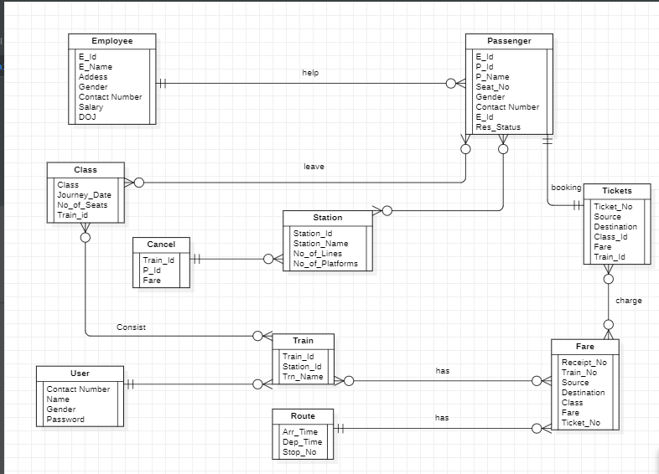

**DATA FLOW DIAGRAM (DFD)**

**0 LEVEL**

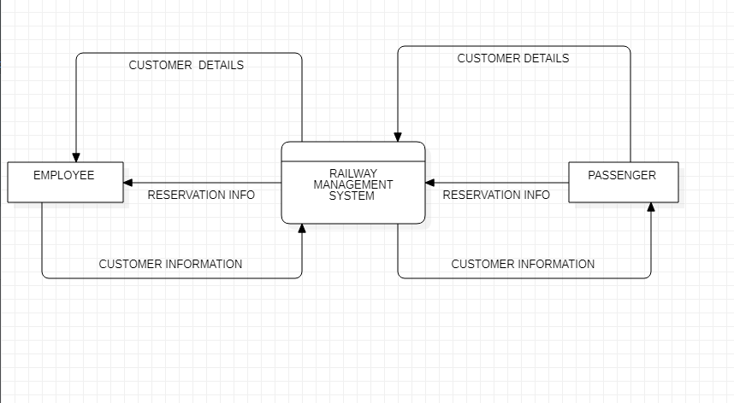

**1 LEVEL**

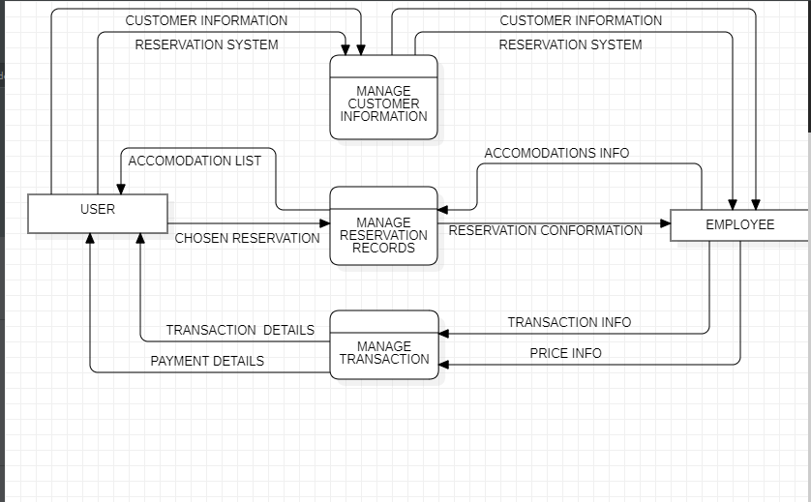

**2 LEVEL**

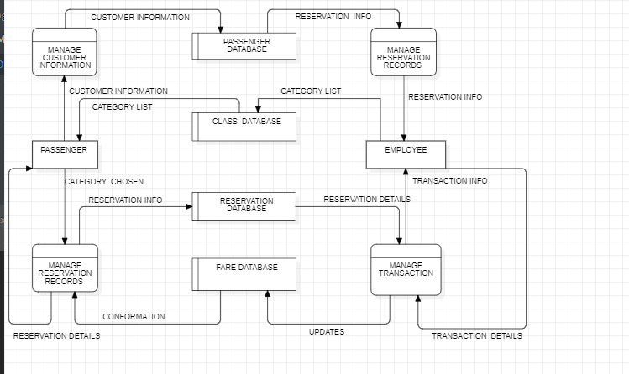

**INITIAL DATABASE SCHEMA**

EMPLOYEE:

|  |  |  |  |  |  |  |
| --- | --- | --- | --- | --- | --- | --- |
| E_ID | E_NAME | ADDRESS | GENDER | PH_NUMBER | DOJ | SALARY |

PASSENGER:

|  |  |  |  |  |  |  |
| --- | --- | --- | --- | --- | --- | --- |
| P_ID | P_NAME | SEAT_NO | GENDER | PH_NUMBER | E_ID | RES_STATUS |

FARE:

|  |  |  |  |  |  |  |
| --- | --- | --- | --- | --- | --- | --- |
| RECIPT_NO | TRAIN_NO | SOURCE | DESTINATION | CLASS | FARE | TICKET_NO |

ROUTE:

|  |  |  |
| --- | --- | --- |
| ARR_TIME | DEP_TIME | STOP_NO |

STATION:

|  |  |  |  |
| --- | --- | --- | --- |
| STATION_ID | STATION_NAME | NO_OF_LINES | NO_OF_PLATFORMS |

TRAIN:

|  |  |  |
| --- | --- | --- |
| TRAIN_ID | STATION_ID | TRN_NAME |

CLASS:

|  |  |  |  |
| --- | --- | --- | --- |
| CLASS | JOURNEY_DATE | NO_OF_SEATS | TRAIN_ID |

TICKET:

|  |  |  |  |  |  |
| --- | --- | --- | --- | --- | --- |
| TICKET_NO | SOURCE | DESTINATION | CLASS_ID | FARE | TRAIN_ID |

TIME:

|  |  |  |  |  |
| --- | --- | --- | --- | --- |
| REF_NO | DEP_TIME | ARR_TIME | TRAIN_ID | STATION_ID |

**OBSERVATIONS**

OVERALL, THE MAIN PURPOSE OF MAINTAINING THIS SATABASE FOR THE RAILWAY RESERVATION SYSTEM IS TO REDUCE THE ERRORS INVOLVED IN THE BOOKING AND CANCELLING OF TICKETS AND MAKE IT CONVENIENT FOR THE CUSTOMER AND TO MAINTAIN THE DATA ABOUT THE CUSTOMERS AND ABOUT THE SEATS AVAILABLE.BY MAKING AN ONLINE APPLICATION MANYBLOOPHOLES THAT EXIST IN THE MANUAL MAINTENANCE OF THE RECORDS CAN BE REMOVED. THE SPEED OF OBTAINING DATA WILL BE FAST. TO OVERCOME ALL THE PROBLEMS OF MANUAL RESERVATION SYATEM WE HAVE DESIGNED A DATABASE WHICH INCLUDES CUSTOMER DETAILS, AVAILABILITY OF SEATS IN TRAINS, NO OF TRAINS AND THEIR DETAILS.

**CREATE & INSERT SQL QUERY**

CREATE TABLE TRAIN

(

TRAIN_ID INT NOT NULL PRIMARY KEY ,

TRN_NAME VARCHAR(300) ,

FOREIGN KEY (STATION_ID ) REFERENCES STATION (STATION_ID )

);

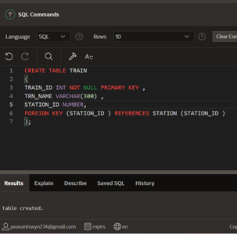

CREATE TABLE EMPLOYEE

(

E_ID INT NOT NULL PRIMARY KEY ,

E_NAME VARCHAR(255) NOT NULL ,

ADDRESS VARCHAR(255),

GENDER VARCHAR (100),

PH_NUMBER NUMBER ,

DOJ VARCHAR(200),

SALARY NUMBER

);

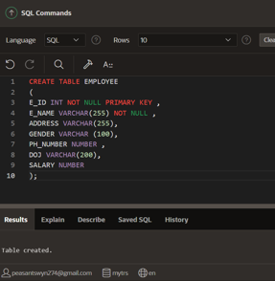

CREATE TABLE PASSENGER

(

P_ID INT NOT NULL PRIMARY KEY ,

P_NAME VARCHAR(300),

SEAT_NO NUMBER ,

GENDER VARCHAR(300),

PH_NUMBER VARCHAR(300) ,

RES_STATUS VARCHAR(300)

);

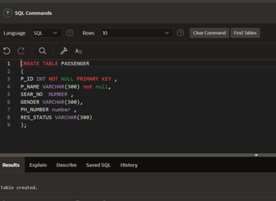

CREATE TABLE STATION

(

STATION_ID INT NOT NULL PRIMARY KEY ,

STATION_NAME VARCHAR(300),

NO_OF_LINES VARCHAR(300),

NO_OF_PLATFORMS NUMBER

);

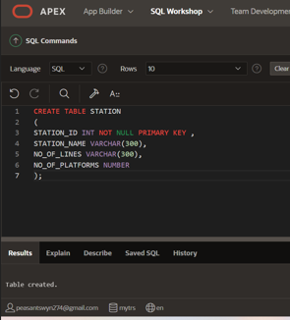

CREATE TABLE FARE

(

RECIPT_NO INT NOT NULL PRIMARY KEY ,

SOURCE VARCHAR(300),

DESTINATION VARCHAR(300),

CLASS VARCHAR(300),

FARE VARCHAR(300),

TICKET_NO NUMBER ,

FOREIGN KEY (TRAIN_NO) REFERENCES TRAIN (TRAIN_NO )

);

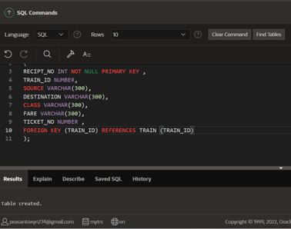

CREATE TABLE CLASS

(

CLASS VARCHAR(300),

JOURNEY_DATE VARCHAR(300),

NO_OF_SEATS NUMBER,

FOREIGN KEY (TRAIN_ID) REFERENCES TRAIN (TRAIN_ID)

);

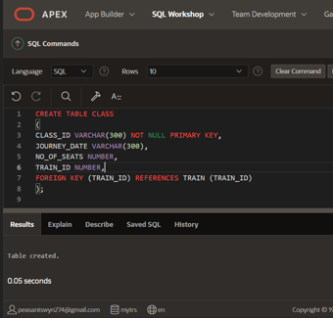

CREATE TABLE ROUTE

(

ARR_TIME VARCHAR(300),

DEP_TIME VARCHAR(300),

STOP_NO VARCHAR(300)

);

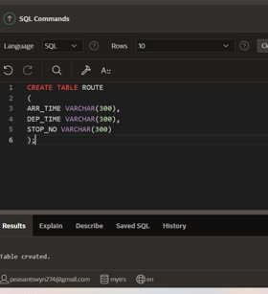

CREATE TABLE TICKETS

(

TICKET_NO INT NOT NULL PRIMERY KEY,

SOURCE VARCHAR(300),

DESTINATION VARCHAR(300),

FOREIGN KEY (CLASS_ID) REFERENCES CLASS (CLASS_ID ),

FARE VARCHAR(300) ,

FOREIGN KEY (TRAIN_ID) REFERENCES TRAIN (TRAIN_ID )

);

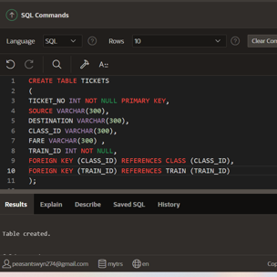

CREATE TABLE TIME

(

REF_NO INT NOT NULL PRIMERY KEY ,

DEP_TIME VARCHAR(300),

ARR_TIME VARCHAR(300),

FOREIGN KEY (TRAIN_ID) REFERENCES TRAIN (TRAIN_ID ),

FOREIGN KEY (STATION_ID) REFERENCES STATION (STATION_ID )

);

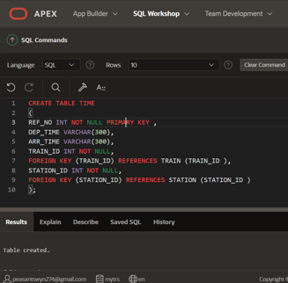

**CONLUSION**

IN OUR PROJECT RAILWAY RESERVATION SYSTEM, WE HAVE STORED ALL THE INFORMATION ABOUT THE TRAINS SCHEDULED AND THE USERS’ BOOKING TICKETS AND EVEN STATUS OF TRAINS, SEATS ETC. THIS DATA BASE IS HELPFUL FOR THE APPLICATIONS WHICH FACILITATE PASSENGERS TO BOOK THE TRAIN TICKETS AND CHECK THE DETAILS OF TRAINS AND THEIR STATUS FROM THEIR PLACE ITSELF IT AVOIDS INCONVINIENCES OF GOING TO RAILWAY STATION FOR EACH AND EVERY QUERY THEY GET.WE HAD CONSIDERED THE MOST IMPORTANT. REGURMENTS ONIV. MANV MORE FEATURES AND DETAUS CAND BE ADDED TO OUR PROLECT MORDER TO OBTAM. EVEN MORE USER FRIENDLV APPLICATIONS. THESE APPLICATIONS ARE ALREADY IN PROGRESS AND IN FUTURE. THE CAN BE UPGRADED AND MAV BECOME PART OF AMAZING TECHNOLOGV.