## ****Configure static website hosting using Azure Portal****

**Step1: Create storage account.**

There are 2 ways you can create azure storage account for hosting static website.

**1:**Create storage account using azure portal.

* In azure portal search **storage account** and click on **create.**
* Give specifications and create storage account.

**2:**Create storage account using visual studio code

* Open the **Visual Studio Code** from your Computer. Next step is, click on the **Extensions**.
* Now search for the **Azure Storage** click on the **Install**button.

## ****Step2: Configure static website hosting using Azure Portal.****

**1:** Login to**Azure Portal** **(https://portal.azure.com/)**

**2:**Navigate to the **storage account** that you have created above.

**3:**Now click on the **Static website** link from the left navigation.

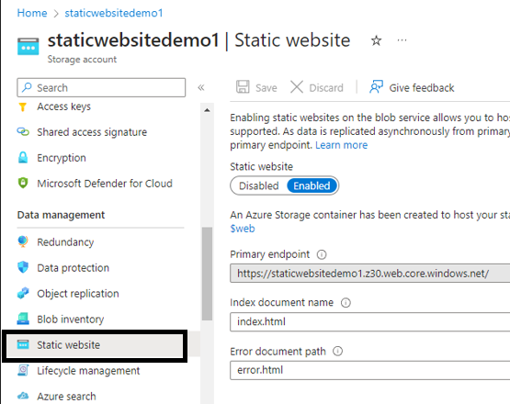

**Step-4:**Click on the **Enabled** option for the **Static website** option. Provide the value for the option **Index document name** as**index.html** and **Error document path** as**404.html**. Then click on the **Save**button to save the changes.

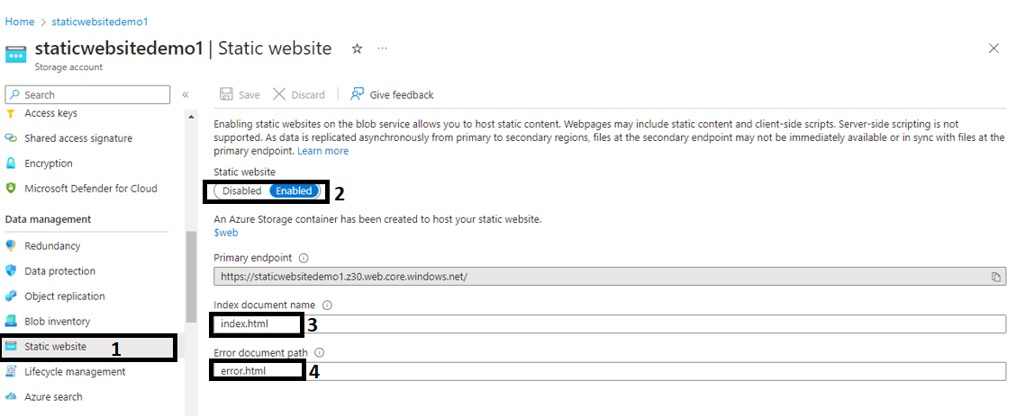

## Step3: ****Deploy a static website in Azure.****

## ****1] Deploy website using visual studio code****

## ****Step-1**:** Create a **folder** in your local system and then give a **name** to the folder.

**Step-2:** Open the **Visual Studio Code**and click on the **Explorer**icon. Now click on the **Open Folder**  to open the folder that you have created above.

**Step-3:** After opening the folder, click on the **new file** button to create 2 new files index.html and error.html .

**Step-4:**Open the**index.html** file and paste the below line of code.

<h1>This is my static test website</h1>

**Step-5:**Create another file and name it as **404.html** and paste the below code in the **404.html** file.

<h1>404 error</h1>

**Step-6:** **Right-click** on the down to the **folder** you have created and then click on the **Deploy to Static Website.**

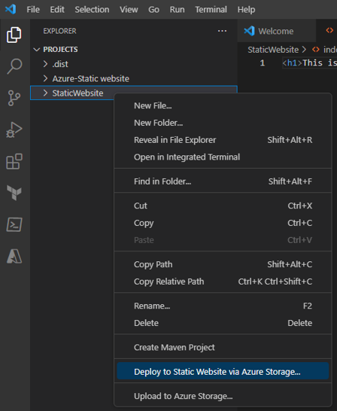

**Step-7:**Now click on the **Sign into Azure…** button to sign in. Enter the Azure credential to login.

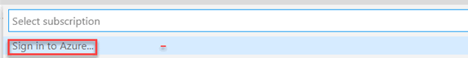

**Step-8:** Now you have logged in to the Portal successfully. It will prompt for **select the storage account**, click on the **storage account** .

**Step-9:** In the same **Visual studio code**screen, you can see down the pop up saying that Deployment complete. Click on the **Browse to website** to browse the static site.

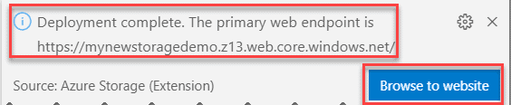

Reference: [How To Host A Website On Azure - Azure Lessons](https://azurelessons.com/how-to-host-a-website-on-azure/)