R-26.5 Solve the linear program of Exercise R-26.4, for α = 1, using the simplex method. Show the result of each pivot.

Solution: maximize: z = αx1 + x2

subject to: 3x1 + 5x2 ≤ 77

7x1 + 2x2 ≤ 56

x1,x2 ≥0.

For α = 1

z = x1 + x2

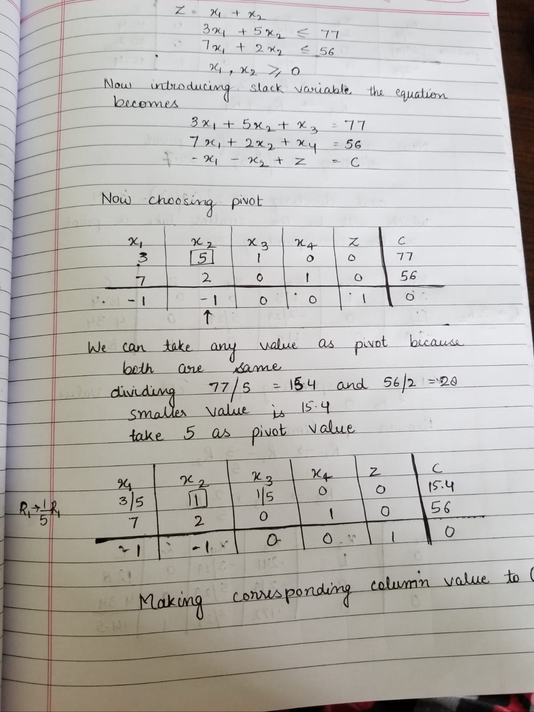

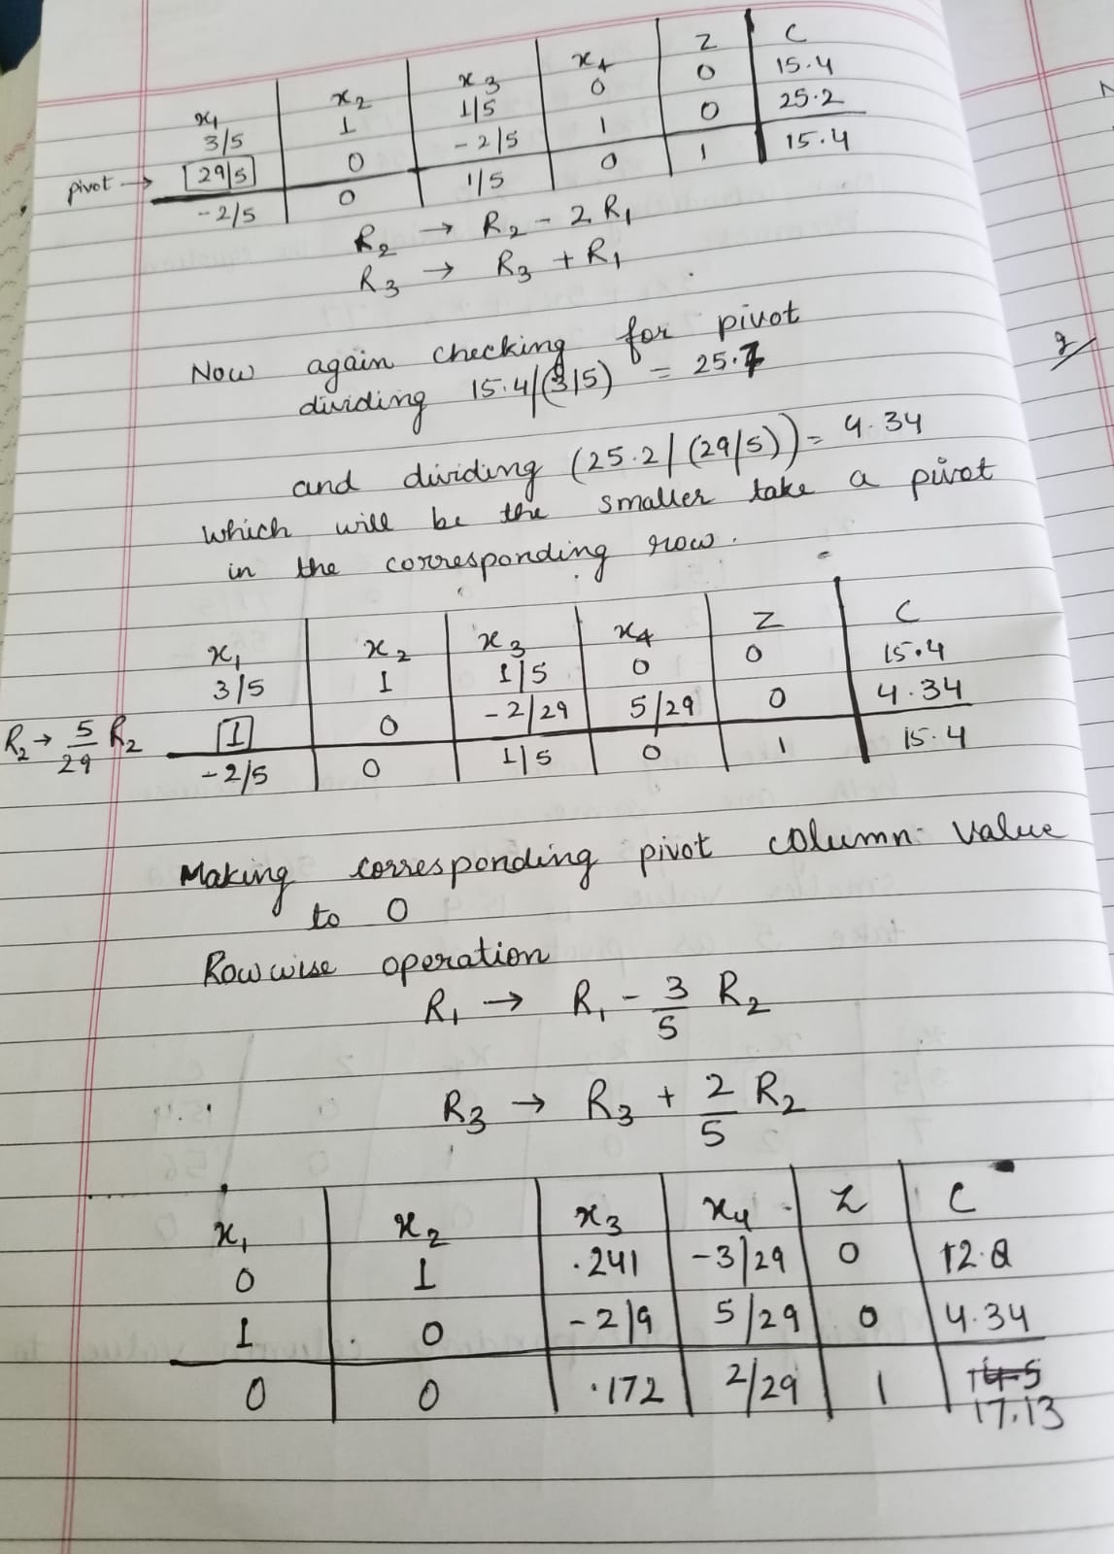

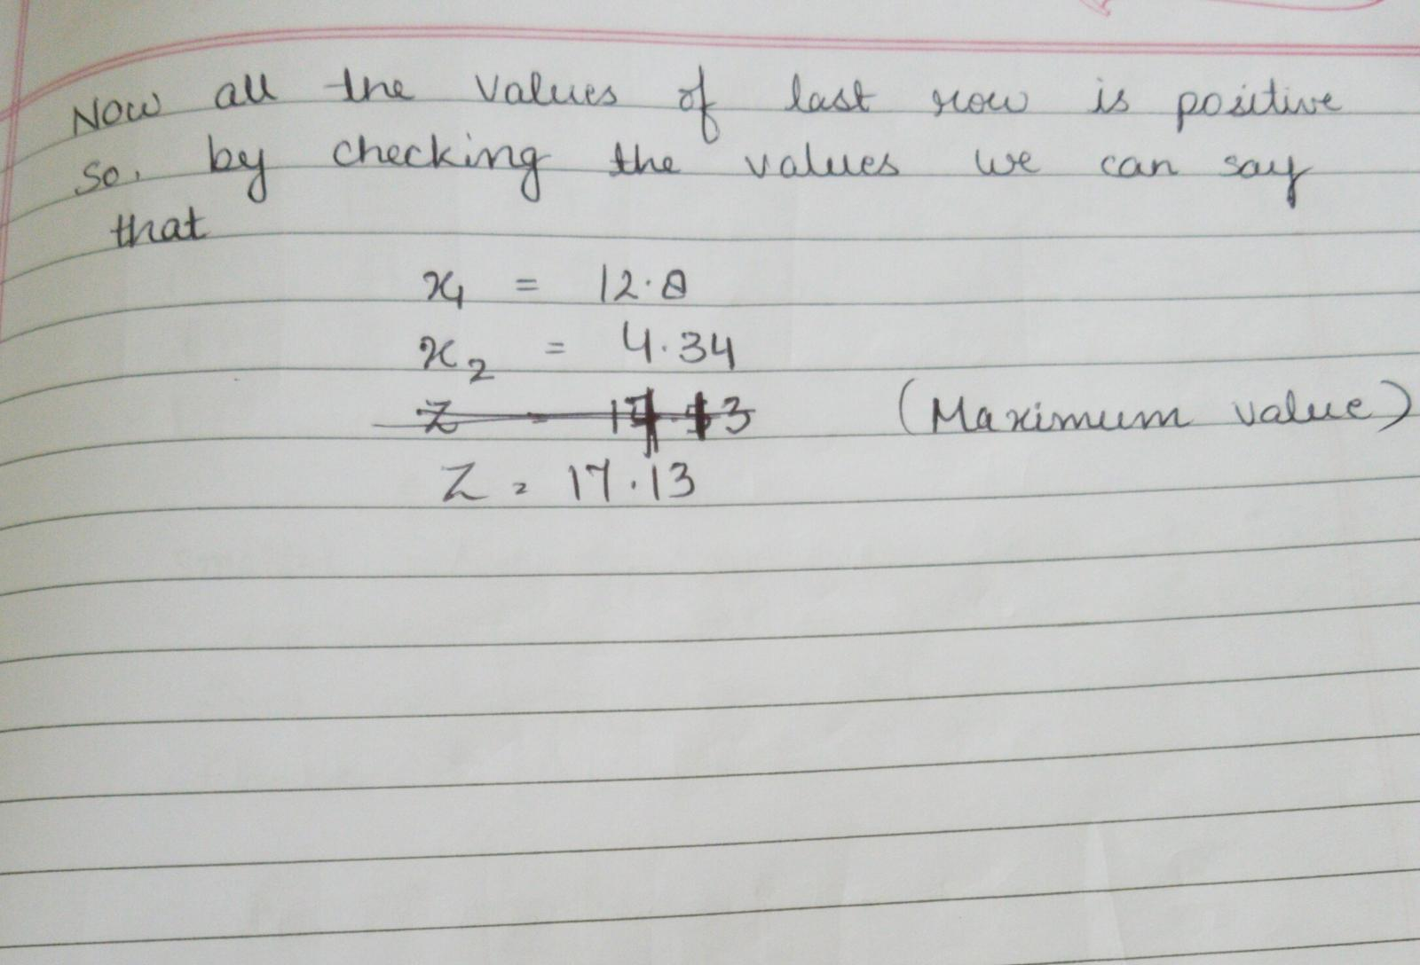

R-26.7 Convert the following linear program into standard form: (using simplex method)

minimize: z = 3y1 + 2y2 + y3

subject to: −3y1 +y2 +y3 ≥1

2y1 + y2 − y3 ≥ 2

y1, y2, y3 ≥0

**Solution**:

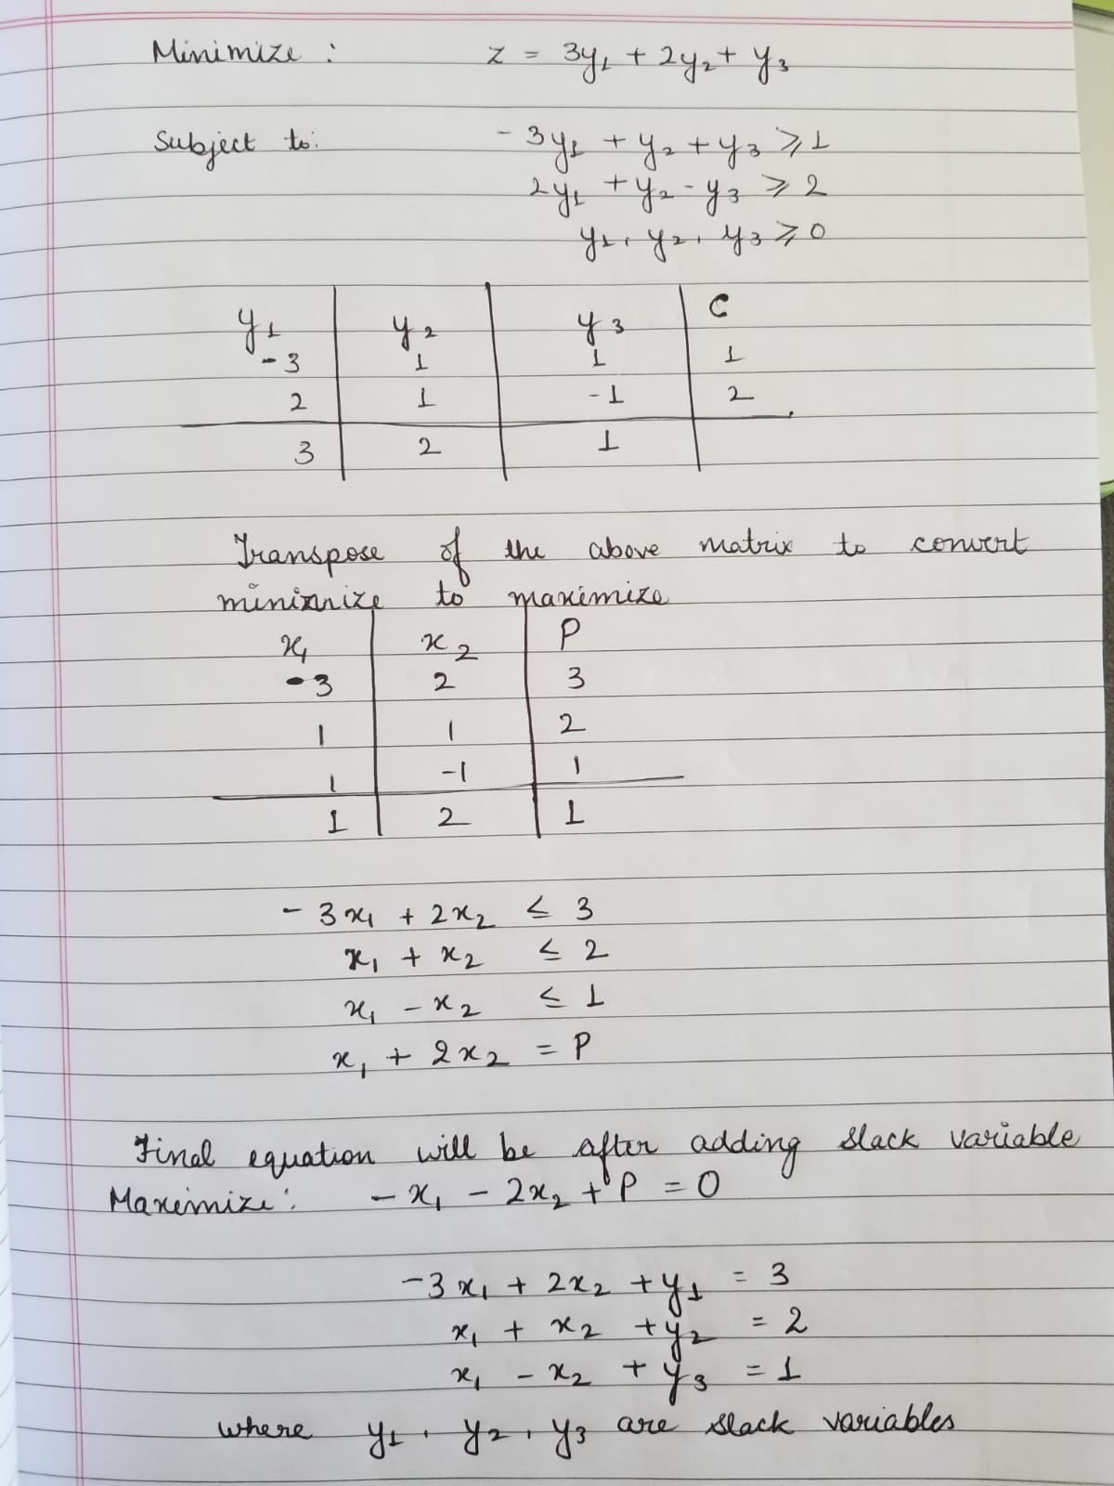

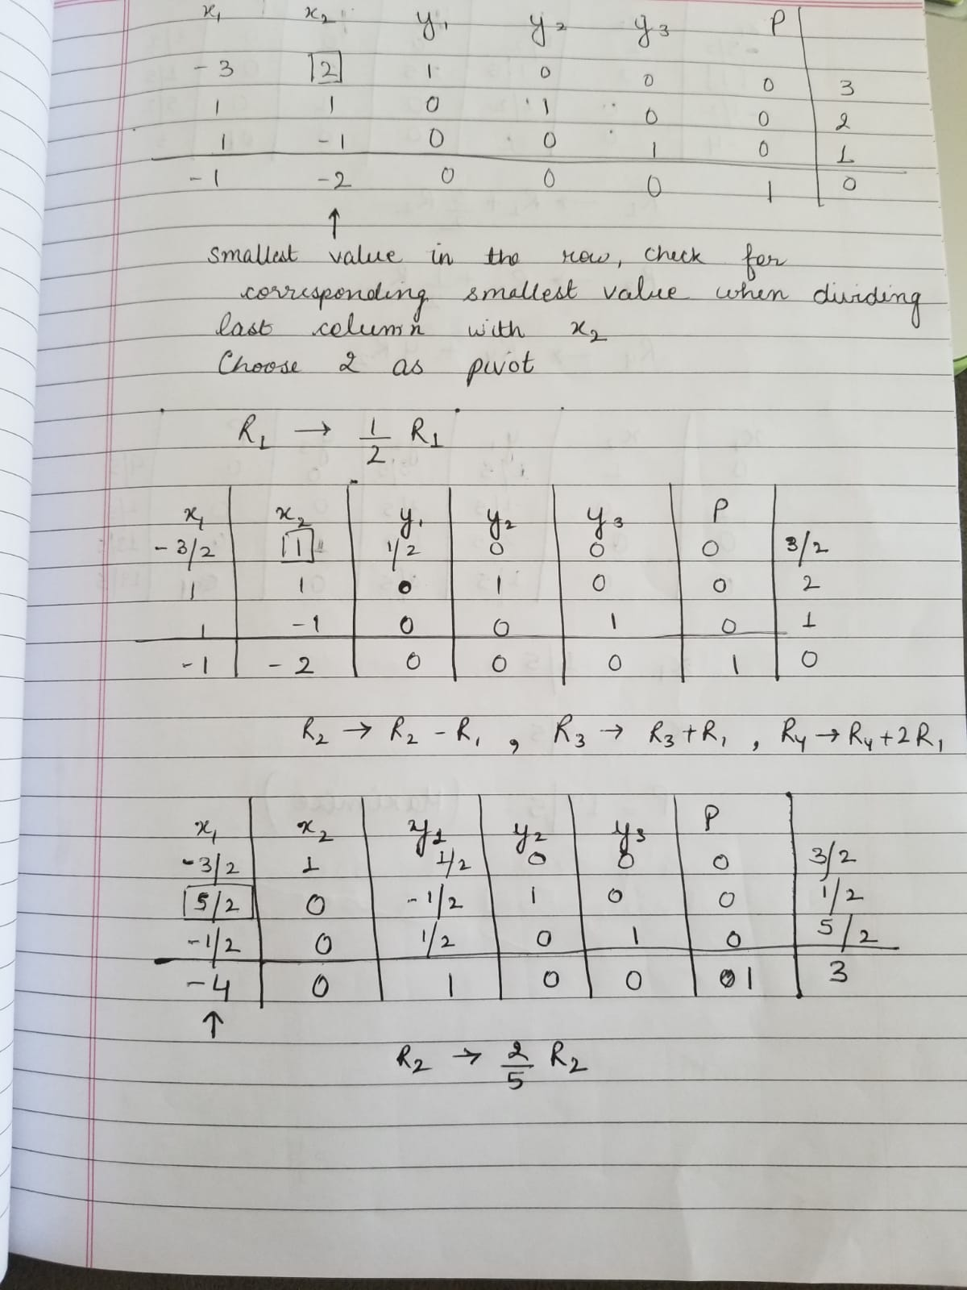

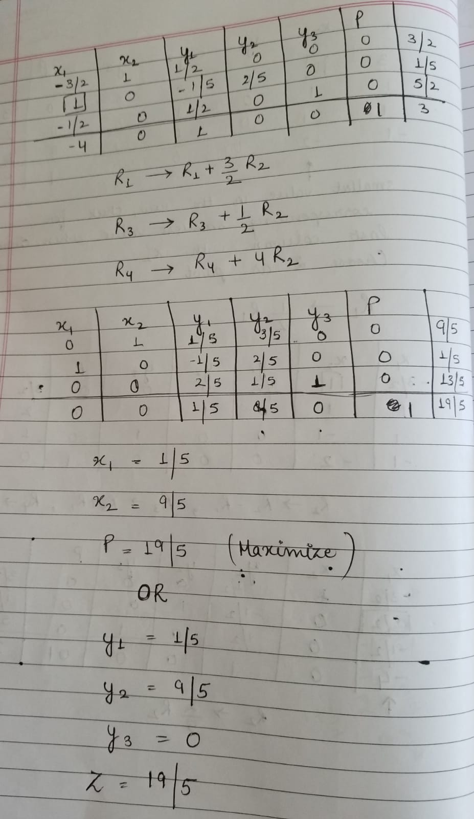

R-26.9 Give a set of linear programming constraints that result in the feasible region shown in Figure 26.9.

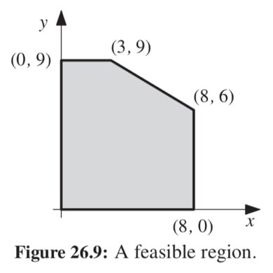

**Solution**:

For coordinates (0,9) and (3, 9), the line formed is a straight line with equation:

y = 9

For coordinates (8, 6) and (8, 0) the line formed is a straight line with equation

x = 8

For coordinates (3, 9) and (8, 6) the line formed by equation

y = mx + b eq:1

where

m = $\frac{y_{2 }- y_{1}}{x_{2 }- x_{1}}$

= $\frac{6- 9}{8- 3}$

= ($\frac{- 3}{5})$

Now substituting the value of m in eq:1

y = mx + b

*y*= ($\frac{- 3}{5})$ ${x+b}_{ }$

putting (3, 9) in above equation to calculate b

9 = **-3**/**5** × 3+b

After solving the value of b

b = **54**/**5**

putting (8, 6) in above equation to calculate b

6 = **-3**/**5** × 8+b

After solving the value of b

b = **54**/**5**

Final equation is: $y= \frac{-3}{5}x+ \frac{54}{5}$

$3x+5y=54$

So the final linear programming constraint for the given feasible region is:

x ≤ 8

y ≤ 9

$3x+5y 54$

x, y ≥ 0