**Q1:** Jerry and Susan have a joint bank account. Jerry goes to the bank 20% of the days. Susan goes there 30% of the days. Together they are at the bank 8% of the days.

a. Susan was at the bank last Monday. What’s the probability that Jerry was there too?

b. Last Friday, Susan wasn’t at the bank. What’s the probability that Jerry was there?

c. Last Wednesday at least one of them was at the bank. What is the probability that both of them were there?

**Solution:**

Susan

Jerry

8

1. P (J ∩ S) = 8%

P(J) = 20%

P (S) = 30%

P (J | S) = P (J ∩ S)/ P(S)

= $\frac{8}{30}$

= 0.267

1. P (S’) = 100 – 30 = 70%

P (J ∩ S’) = P (J) – P (J and S)

= 20 – 8

= 12

P (J | S’) = P (J ∩ S’) / P(S’)

= $\frac{12}{70}$

= 0.171

1. P (J ∪ S) = P(J) + P(S) - P (J ∩ S)

= 20 + 30 – 8

= 42%

P (Both of them were there) = $\frac{8}{42}$

= 0.19

**Q2:** Harold and Sharon are studying for a test. Harold’s chances of getting a “B” are 80%. Sharon’s chances of getting a “B” are 90%. The probability of at least one of them getting a “B” is 91%.

a. What is the probability that only Harold gets a “B”?

b. What is the probability that only Sharon gets a “B”?

c. What is the probability that both won’t get a “B”?

**Solution:**

Sharon

Harold

P (Harold’s getting “B”) = 80%

P (Sharon’s getting “B”) = 90%

P (H ∪ S) = 91%

1. P (H ∩ S) = P(H) + P(S) - P(H ∪ S)

= 80 + 90 – 91

= 79%

P (Only Harold’s gets “B”) = P(H) – P (H ∩ S)

= 80 – 79

= 1%

= .01

1. P (Only Sharon’s gets “B”) = P(S) – P (H ∩ S)

= 90 – 79

= 11%

= .11

1. P (Both won’t get “B”) = 1 – P (H ∪ S)

= 1 – 0.91

= 0.09

**Q3:** Jerry and Susan have a joint bank account. Jerry goes to the bank 20% of the days. Susan goes there 30% of the days. Together they are at the bank 8% of the days. Are the events “Jerry is at the bank” and “Susan is at the bank” independent?

**Solution:**

For two events to be independent the below condition must satisfy:

P (A ∩ B)/ P(B) = P(A)

P (H ∩ S) = 8%

P(S) = 30%

P(H ∩ S)/ P(S) = 8/30

= .26

Or

P (H ∩ S) / P(S) ≠ P(H)

**So, “Jerry is at the bank” and “Susan is at the bank” are not independent events.**

**Q4:** You roll 2 dice.

1. Are the events “the sum is 6” and “the second die shows 5” independent?
2. Are the events “the sum is 7” and “the first die shows 5” independent?

**Solution:** Sample space for rolling 2 dice

Total sample space = 36

{1,1} {1,2} {1,3} {1,4} {1,5} {1,6}

{2,1} {2,2} {2,3} {2,4} {2,5} {2,6}

{3,1} {3,2} {3,3} {3,4} {3,5} {3,6}

{4,1} {4,2} {4,3} {4,4} {4,5} {4,6}

{5,1} {5,2} {5,3} {5,4} {5,5} {5,6}

{6,1} {6,2} {6,3} {6,4} {6,5} {6,6}

1. P (the sum is 6) = **{1,5}** {2,4} {3,3} {4,2} {5,1}

= 5/36

P (second die show 5) = **{1,5}** {2,5} {3,5} {4,5} {5,5} {6,5}

= 6/ 36

= 1/6

Now, checking condition for independent:

P(the sum is 6) P(second die show 5) = $\frac{5}{36}* \frac{1}{6}$ = $\frac{5}{216}$

P(the sum is 6) ∩ P(second die show 5) = $\frac{1}{36}$

Above statement doesn’t satisfy the equation P (A ∩ B) = P(A) P(B)

**So, these events are not independent. They are dependent.**

1. P (the sum is 7) = {1,6} {2,5} {3,4} {4,3} **{5,2}** {6,1}

= 6/36

= 1/6

P (first die shows 5) = {5,1} **{5,2}** {5,3} {5,4} {5,5} {5,6}

= 6/36

=1/6

Now, checking condition for independent:

P(the sum is 7) P(first die shows 5) = $\frac{1}{6}* \frac{1}{6}$ = $\frac{1}{36}$

P(the sum is 7) ∩ P(first die show 5) = $\frac{1}{36}$

Above statement satisfies the equation P (A ∩ B) = P(A) P(B)

**So, these events are independent.**

**Q5:** An oil company is considering drilling in either TX, AK and NJ. The company may operate in only one state. There is 60% chance the company will choose TX and 10% chance - NJ.

There is 30% chance of finding oil in TX, 20% - in AK, and 10% - in NJ.

1. What’s the probability of finding oil?

2. The company decided to drill and found oil. What is the probability that they drilled in TX?

**Solution:**

P (TX) = 60% P (NJ) = 10% P (AK) = 30%

P (Oil | TX) = 30% P (Oil | NJ) =10% P (Oil | AK) = 20%

1. P (Finding the oil) = P (Oil | TX) * P(TX) **+** P (Oil | NJ) * P(NJ) **+** P (Oil | AK) * P(AK)

= 30*60 + 10*10 + 20*30

= 25%

= .25

1. Given: P (Oil | TX) = 30%

P (Oil | TX) = P (TX ∩ Oil)/ P(TX) = 30%

* P (TX ∩ Oil) = 30 * 60
* P (TX ∩ Oil) = 18%

P (TX | Oil) = P (TX ∩ Oil)/ P(Oil)

= $\frac{18}{25}$

= 0.72

**P (TX | Oil) = 0.72**

Q6: The following slide shows the survival status of individual passengers on the Titanic. Use this information to answer the following questions

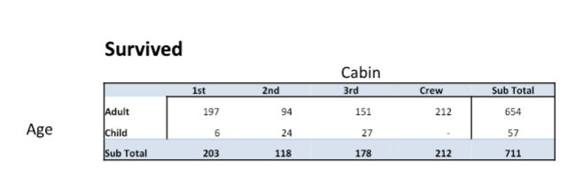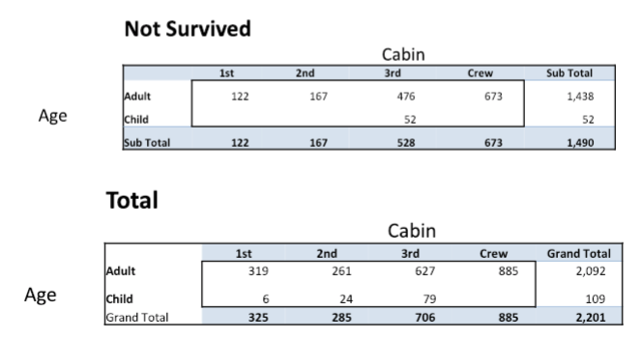

1. **What is the probability that a passenger did not survive?**

$Number of passenger not survived$ = 1490 – 673

= 817

$Total number of passenger$ = 2201 – 885

= 1316

P(Not survived) = $\frac{ number of passenger not survived }{Total number of passenger }$

= $\frac{ 817 }{1316 }$

= 0.62

1. **What is the probability that a passenger was staying in the first class?**

P(Passenger in first class) = $\frac{ number of passenger in first class}{Total number of passenger }$

= $\frac{325}{1316 }$

= 0.246

1. **Given that a passenger survived, what is the probability that the passenger was staying in the first class?**

$Total passenger survived$ = 711 – 212 = 499

P (Passenger survived was staying in first class) =

$$\frac{Passenger staying in first class}{Total passenger survived}$$

= $\frac{203}{499}$

= .406

1. **Are survival and staying in the first class independent?**

P(Total number of people survived) = $\frac{711}{2201}$ = 0.323

P(Total people staying in first class) = $\frac{325}{2201}$ = 0.147

P(People survived) ∩ P(Total people staying in first class) = $\frac{203}{2201}$ = 0.092

Above statement doesn’t satisfy the equation P (A ∩ B) = P(A) P(B)

**So, these events are not independent. They are dependent.**

1. **Given that a passenger survived, what is the probability that the passenger was staying in the first class and the passenger was a child?**

P (Passenger survived in first class and was a child) = $\frac{6}{499}$

= 0.012

1. **Given that a passenger survived, what is the probability that the passenger was an adult?**

Passenger survived and was an adult = 654 – 212 = 442

P (Passenger survived and was an adult) = $\frac{442}{499}$

= 0.8857

1. **Given that a passenger survived, are age and staying in the first class independent?**

Given Passenger survived:

P(Adult survived) ∪ P(Child Survived) = 711

P(Adult survived) ∪ P(Child Survived) = 1

P(First class survived) = $\frac{203}{711}$

P((Adult survived) ∪ P(Child Survived)) ∩ P(First class survived) = $\frac{203}{711}$

Above statement satisfies the equation P (A ∩ B) = P(A) P(B)

**So, these events are independent.**

**Q7**

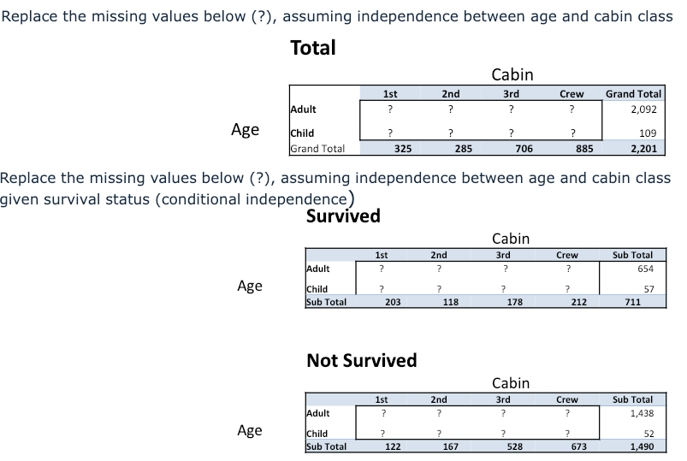

**Solution:**

**Total**

Cabin

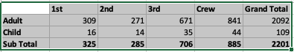

Age

**Survived**

Cabin

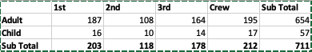

Age

**Not Survived**

Cabin

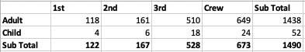

Age