1.

1. Suppose a network exchange theory experiment is run on the graph to the right using the one-exchange rule. Which node or nodes you would expect to make the most money? (i.e. receive the most favorable exchanges)
2. Explain your answer

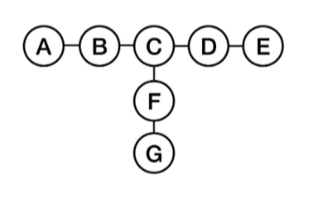

**Solution:**

1. B, F, D are the ones which would make the most favorable exchanges.
2. Because according to 5-Node Path C is actually weak in a one exchange scenario. A, E, G can also be excluded easily. B, F, D has betweenness which can be misleading as a measure of power.

2.

1. Suppose a network exchange theory experiment is run on the graph to the right (i.e. a graph that is a 3-node path), using the one-exchange rule. Now you, playing the role of a fourth node d, are told to attach by a single edge to one of the nodes in the network. How should you attach to the network to put yourself in as powerful a position as possible, where power will be determined by the result of a network exchange theory experiment run on the resulting 4-node network?
2. Explain your answer

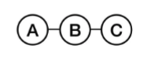

**Solution:**

1. Attach the 4th node D with C.
2. Now two scenarios are possible:
   1. A exchanges with B and C exchanges with D. Every node will get the equal share.
   2. If C excludes D, C is in danger of being excluded by B.

3.

The graphs below represent the outcomes of a network exchange theory experiment. For each, determine whether the outcome is stable or unstable, and explain your answer.

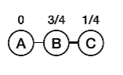 **a. 1**

**b.1 Unstable** outcome, as the edge A to B has the sum < 1.

**a.2**

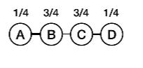

**b.2 Stable,** as the edge between A, B and B, C and C, D has the sum 1 or greater than 1.

4.

The stem graph below represents the outcome of a network exchange theory experiment in which the participants have outside options. In this experiment, A bargained with B and C bargained with D. Use the Nash Bargaining Solution equations to show that this is a balanced outcome. Show your work.

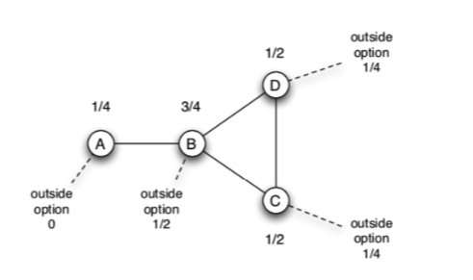

**Solution**

**For edge A to B,** to calculate the Nash Bargaining Solution:

x = 0 y = $\frac{1}{2}$

x + y < 1

s = 1 – ( x + y )

s = 1 – ( 0 + $\frac{1}{2}$)

s = $\frac{1}{2}$

x + $\frac{1}{2}$ s = ( 0 + ( $\frac{1}{2}$ $\frac{1}{2}$* ))

**For node A = $\frac{1}{4}$**

y + $\frac{1}{2}$ s = ( $\frac{1}{2}$ + ( $\frac{1}{2}$ $\frac{1}{2}$* ))

**For node B = $\frac{3}{4}$**

**For edge C to D**, to calculate the Nash Bargaining Solution:

x = $\frac{1}{4}$ y = $\frac{1}{4}$

x + y < 1

s = 1 – ( x + y )

s = 1 – ( $\frac{1}{4}$ + $\frac{1}{4}$)

s = $\frac{1}{2}$

x + $\frac{1}{2}$ s = ( $\frac{1}{4}$ + ( $\frac{1}{2}$ $\frac{1}{2}$* ))

**For node C = $\frac{1}{2}$**

y + $\frac{1}{2}$ s = ( $\frac{1}{4}$ + ( $\frac{1}{2}$ $\frac{1}{2}$* ))

**For node D = $\frac{1}{2}$**

**5.**

Your company has decided to interview two candidates A and B for a single job. A hiring committee was formed to decide which of the two candidates to hire. Everyone on the committee was interested in making the best possible hire, but after the interviews it was clear that members of the committee had different ideas about which of the two candidates was the best choice. When the committee met to make the final decision they decided to go around the room and ask each person on the committee to announce which of the two candidates they believed to be the best choice for the company. In fact, everyone on the committee said that candidate A seemed to be the best choice, so the offer was made immediately to candidate A without additional discussion. Now that candidate A has worked for the firm for a while it is clear that candidate B would have been a better choice.

1. Your boss has asked you to explain how the committee members could have unanimously supported candidate A when she was reasonably certain that before the committee meeting at least some of the members of the committee thought that B was probably the best choice. Based on the teachings of chapter 16, what can you tell her?

**Solution**

Since candidate B was the best choice but because of the **information cascade** committee member chose candidate A as their best choice. When one member voted for candidate A, it influences the other’s member decision and gets cascaded around the room.

1. Can you suggest another procedure that the committee could have used that would have revealed the initially differing opinions about the candidates and which might have avoided the unanimous choice of candidate A and resulted in the actually better choice of candidate B?

**Solution**

According to me the best way to choose the candidate will be written votes. Everybody has to submit their votes by writing the name of the candidate and then counted the votes. Whoever gets the larger number of votes wins.

6.

You have developed a new product which performs the same service as an established product, but your product is much better than the established product. If the number of users of the two products were the same, then each potential purchaser’s reservation price for your product would be twice their reservation price for the existing product. The difficulty that you face is that no one wants to use more than one of the two products. Currently, every potential purchaser is using the established product. Your cost of production and your competitor’s costs of production are exactly the same and they are equal to the price at which your competitor’s product is sold. If all of the potential purchasers switched to your product the maximum price that you could charge (and still have all of them buy your product) would be twice the current price. So clearly you could make a nice profit if you could attract these potential purchasers. Based on the teachings of Chapter 17, what strategies would you use to try to convince users to switch to your product?

**Solution**

To convince user to switch to my product either I will allow **low introductory price** for my product to gain the users attention and establish myself in the market first or I can also promote my product with the help of **fashion leaders** which attract the other following users.

7.

Consider an on-line news site, such as cnn.com, which consists of a front page with links to many different articles. The operators of these sites generally track the popularity of the various articles that get posted. Suppose that the operators of the site are considering changing the front page, so that next to each link is a counter showing how many people have clicked on the link. (e.g., next to each link it might say: “30,480 people have viewed this story,” with the number getting updated over time.)

1. What effect do you think this change will have on the behavior of people using the site?

**Solution**

According to Power Law Distribution, it is easy for popular nodes to grow more popular. So people will prefer to read articles first that contains the more views.

1. Do you expect that adding this feature will cause the popularity distribution of the articles to follow a power-law distribution more closely or less closely, compared to the version of the site before these counters were added?

**Solution**

The popularity distribution of the articles will follow **power-law distribution more closely** compared to the version of the site before these counters were added.

Because it is easy for popular nodes to grow more popular

1. Explain your answer.

**Solution**

Before the implementation of the counters, users would have no indication that other people on the platform had a preference for some content, but because of the counters people will try to read the articles which gets the higher views.

8.

Consider the network to the right. Suppose that each node starts with the behavior B, and each node has a threshold of q = 1/2 for switching to behavior A.

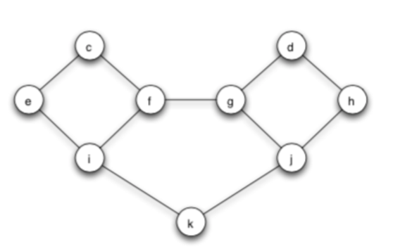

1. Let e and f form a two-node set S of initial adopters of behavior A. If other nodes follow the threshold rule for choosing behaviors, which nodes will eventually switch to A?

**Solution**

**e and f** adopted A,

**For c node,** neighbors are e and f

The fraction of neighbors choosing A is 2/2 = 1 which is greater than .50. So, c will SWITCH to A.

**For i node,** neighbors are c, i and g

The fraction of neighbors choosing A is 2/3 = .67 which is greater than .50. So, i will SWITCH to A.

**For g node,** neighbors are f, d and j

The fraction of neighbors choosing A is 1/3 = .33 which is less than .50. So, g will NOT SWITCH to A.

**For k node,** neighbors are i and j

The fraction of neighbors choosing A is 1/2 = .50 which is equal to .50. So, k will SWITCH to A.

**For d node and h node,**

The fraction of neighbors choosing A is less than .50. So, d and h will NOT SWITCH to A.

**For j node,** neighbors are k, g and h

The fraction of neighbors choosing A is 1/3 = .33 which is less than .50. So, j will NOT SWITCH to A.

1. Find a cluster of density greater than 1-q = 1/2 in the part of the graph outside S that blocks behavior A from spreading to all nodes, starting from S, at threshold q.

**Solution:**

Density of the cluster d, g, h, and j is 2/3 because every node has at least 2/3 fraction of its network neighbors in the set.

Density of cluster = 1-q = ½ which is less than 2/3 = .66, cascade came to stop which blocks behavior A from spreading all nodes.

9. Using several sentences, in general terms, in your own words, explain the effect that a tightly-knit community can have on a cascade.

**Solution**:

1. Tightly knit communities tends to hinder diffusion.
2. Tightly knit community removes the cascade effect which occur when people abandon their own information in favor of inference based on others’ action.
3. Tightly knit communities makes it hard for innovations to arrive from outside densely connected communities.
4. If you have tightly connected group of 4 to 5 people it is difficult to accept the other people in the same group. You try to avoid people that don’t belong to your group.