1.

a. Give an example of a graph in which every node is pivotal for at least one pair of nodes.

b. Explain your answer.

**Solution:**

1. Any graph having nodes greater than 3 and forms a cycle than every node is pivotal for the two nodes adjacent to it. The only way to create a path from any two non-adjacent nodes is by going through the ones in between.

2.

a. Give an example of a graph having at least four nodes in which there is a single node X that is pivotal

for every pair of nodes (not counting pairs that include X).

b. Explain your answer.

**Solution:**

1. In the above graph, X node is pivotal for every pair of nodes. Any star network having nodes greater than 3 will consists of X as a center node is pivotal to every pair of vertices in the graph. Every path will consist of X between other two vertices.

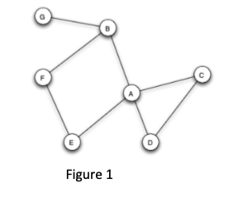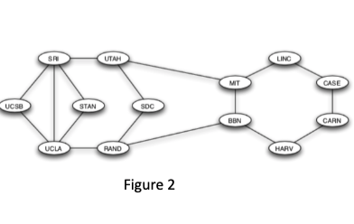

3.

a. Which node or nodes in Figure 1 are pivotal?

b. Explain your answer.

**Solution:**

1. Nodes are pivotal: A, B
2. Considering a path between B to D, C to E, D to E and C to B will go through the one node i.e. A. Similarly, there is a path between G to F and G to A which goes through node B.

4.

a. Which node or nodes in Figure 2 are NOT pivotal?

b. Explain your answer.

**Solution:**

1. Nodes are NOT pivotal: None
2. As every node is forming a cycle. So, every node is pivotal for the two nodes adjacent to it.

5.

a. Which node or nodes in Figure 1 are gatekeepers?

b. Explain your answer.

**Solution:**

1. Nodes are gatekeepers: A, B
2. A and B are gatekeepers because they lie in every path from B to C and G to F respectively.

6.

a. Which node or nodes in Figure 1 are NOT local gatekeepers?

b. Explain your answer

**Solution:**

1. Nodes are NOT local gatekeepers: C, D
2. Because they have two neighbors that are connected by an edge. For example, C has two neighbors A and D and they are connected by an edge.

7.

You will notice that there are no gatekeepers in Figure 2 (Darpanet).

Explain why the network was purposely designed that way.

**Solution:**

The network was purposely designed because if any of the edge fail there would still be a way to go from one node to other node to get the communication flowing. This allow redundancy as they provide an alternate route going from one node to another.

8.

In your own words: In 2-3 sentences, explain what triadic closure is, and how it plays a role in the formation of social networks.

You can draw a schematic picture in case this is useful.

**Solution**:

Triadic Closure is a useful principle or model to predict community growth and network evolution. For example: Friends of my friends are my friends, if two people have a friend in common there is greater probability, they will become friends with each other in future. The social network will strengthen as two people are able to introduce their neighbors to each other.

Diagram:

9. Consider the graph to the right, in which every edge but one is labeled as a strong tie (S) or weak tie (W).

a. According to the theory of strong and weak ties, with the strong triadic closure assumption, how would you expect the edge connecting b and c to be labeled?

b. Explain your answer.

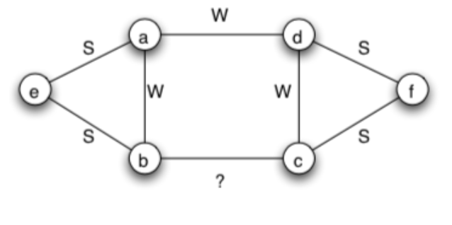

**Solution**:

1. The edge connecting b and c to be labelled as **Weak Tie (W)**
2. Suppose, we label node b and c as Strong Tie (S) it will violate the Triadic Closure property. For example, if edges (e, b) and (b, c) are both strong Ties than there should be an edge present between (e, c) either with Strong tie or a weak tie.

10.

Consider the graph to the right, in which every edge is labeled as a strong tie (S) or weak tie (W).

a. According to the theory of strong and weak ties, with the strong triadic closure assumption, which other link or links would you expect to form over time, assuming that the links formed have strong ties? (consider more than one iteration over time and identify all links that should form)

b. Explain your answer.

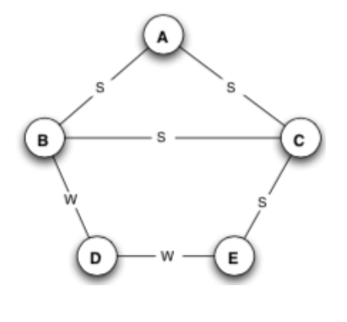

**Solution**:

1. Node A to E and B to E would like to form a connection over time.
2. In the above diagram, node C is connected to A and E by strong tie. According to Strong Triadic Closure property (A, E) will likely to form a connection over time. Similarly node C also connected to B and E by a strong tie, this will likely to form a connection between B to E because of the Strong Triadic Closure.

11. Consider the affiliation network to the right, with six people labeled A–F, and three foci labeled X, Y, and Z

a. Draw the derived network on just the six, joining two people when they share a focus.

b. In the resulting network on people, can you identify a sense in which the triangle on the nodes A, C, and E has a qualitatively different meaning than the other triangles that appear in the network? Explain your answer.

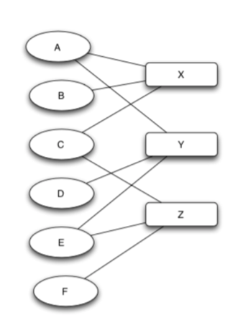

1. In the above diagram, the triangle A, C and E are formed by the three different focus. This triangle is because of the concept of Triadic Closure.

12.

A team of anthropologists is studying a set of three small villages that neighbor one another. Each village has 30 people. Everyone in each village knows all the people in their own village, as well as the people in the other villages. When the anthropologists build the social network on the people in all three villages taken together, they find that each person is friends with all the other people in their own village, and enemies with everyone in the two other villages. This gives them a network of 90 people (i.e., 30 in each village), with positive and negative signs on its edges.

a. According to the definitions in chapter 5, is this network on 90 people balanced?

b. Explain your answer.

**Solution**:

1. According to the given problem say villages A, B and C are 3 villages with 30 people in every village. As people are enemies with everyone in the two other villages will be shown below.

For people living in A, B, C villages separately are friends with each other.

−

−

−

1. The above graph shows that the network of 90 people is weakly balanced. The condition satisfies for the structural balance is there should exist a positive sign either on one edge or all the edges.

13.

In the network to the right, there is an edge between each pair of nodes, with five of the edges corresponding to positive relationships, and the other five of the edges corresponding to negative relationships. Each edge in this network participates in three triangles.

a. For each of the 10 edges, list the following:

* The edge identification (i.e. AB)
* Whether the edge is positive or negative
* The three triangles the edge participates in
* The number of those triangles that are balanced and the number that are unbalanced

(Notice that because of the symmetry of the network, the balanced/unbalanced numbers will be the same for each positive edge, and also for each negative edge; so once you figure it out for one of each, you will have the answer for the others like it.)

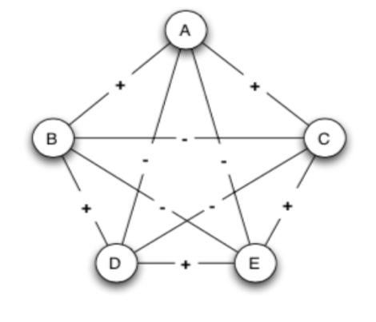

**Solution:**

1. **Edge identification:**

AB, AD, AE, AC

BD, BE, BC

CD, CE

DE

1. **Positive Edges**: AB, AC, BD, CE, DE

**Negative Edges**: AD, AE, BC, BE, CD

1. **Three triangles edges participated in:**

ABC, ABD, ACE, ADE, ABE, ACD

BCD, BCE, BED

CED

1. **Balanced Triangle**: ADE, ABE, ACD, BCD, BCE

**Unbalanced Triangle**: ABD, ACE, BED, CED, ABC