**MANAV RACHNA UNIVERSITY**

**Department of CST**

**(Artificial Intelligence – CSH205B-T & P)**

**(Lab 4)**

Name: Sanchit Bajaj

Class: BTECH CSE 4B

Roll no: 2K19CSUN01108

## Q1) Member of list

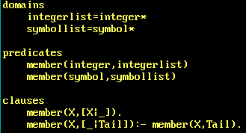

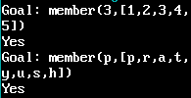

## Q2) Concatenation of lists

