MLOPS LAB-08
1.LAB DATE:06-10-2026
NAME: SANCHIT KUKREJA
ENROLLMENT NO: S24CSEU0458
BATCH: 42
2.REPO LINK: https://github.com/Sanchitk99/S24CSEU0458-MLOPS.git
3. Public Link: https://s24cseu0458-mlops.onrender.com/docs
4. Screenshot of the interactive documentation page of your deployed service: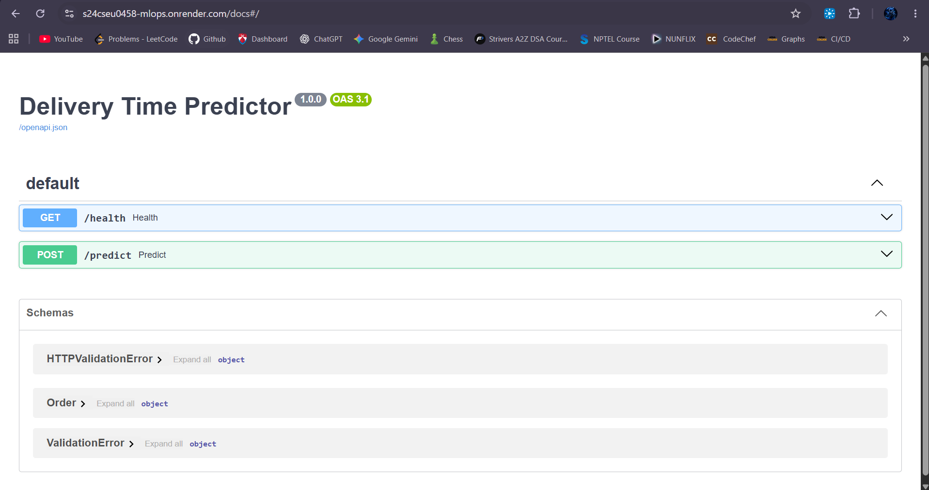

5. Screenshot of a successful call to /predict on the public URL:
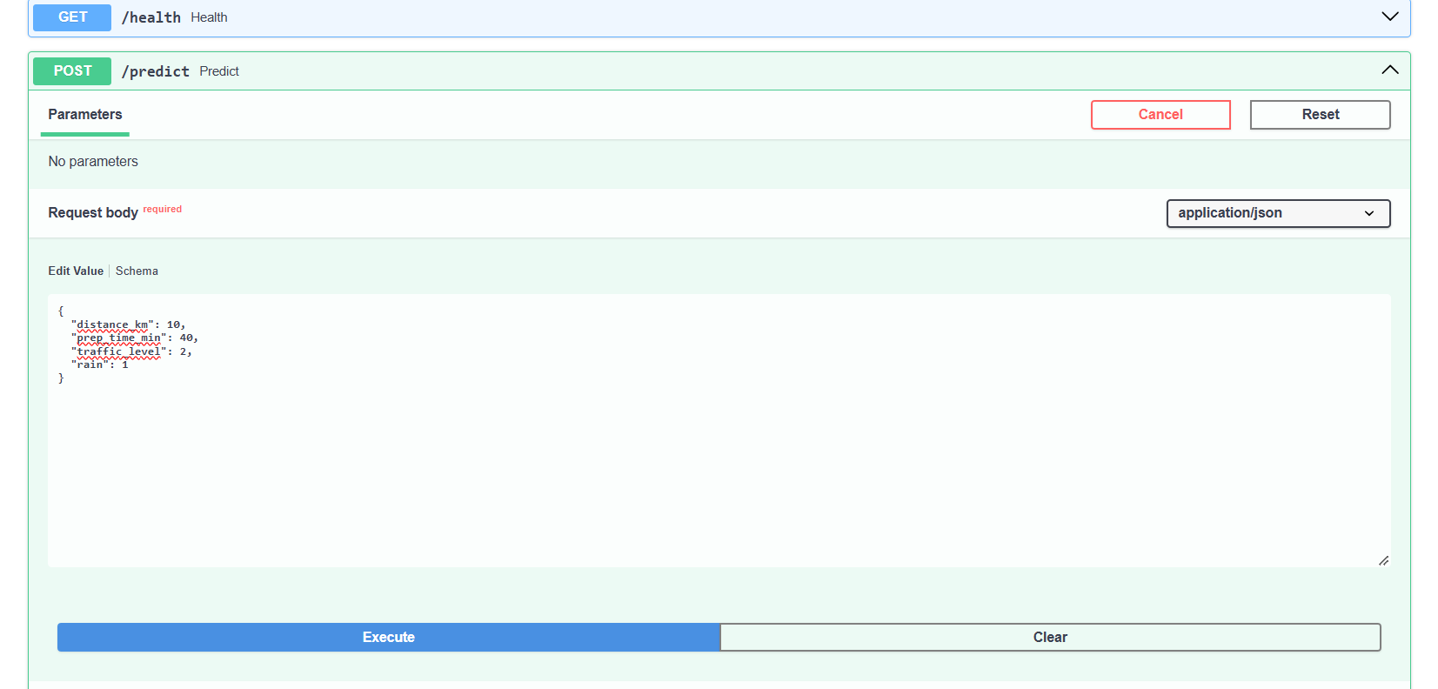
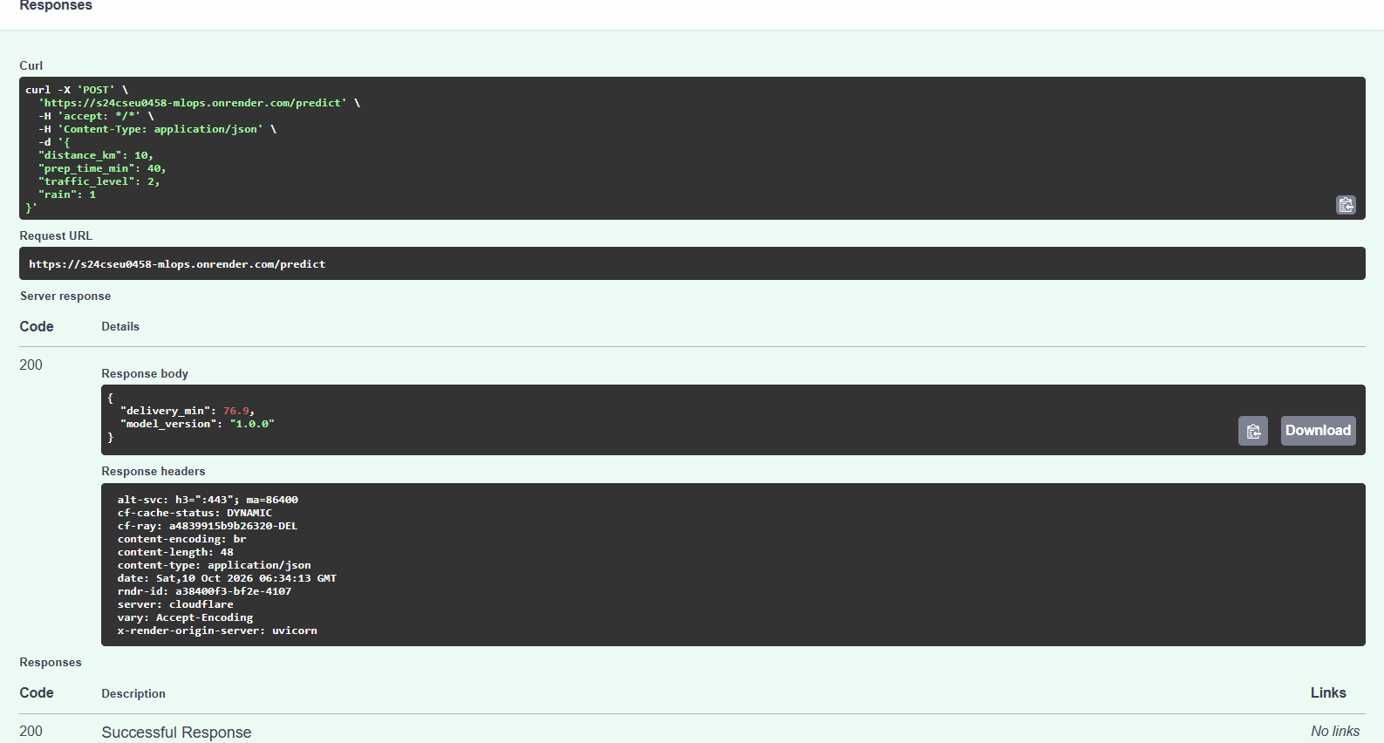
6. Screenshot of a rejected call:
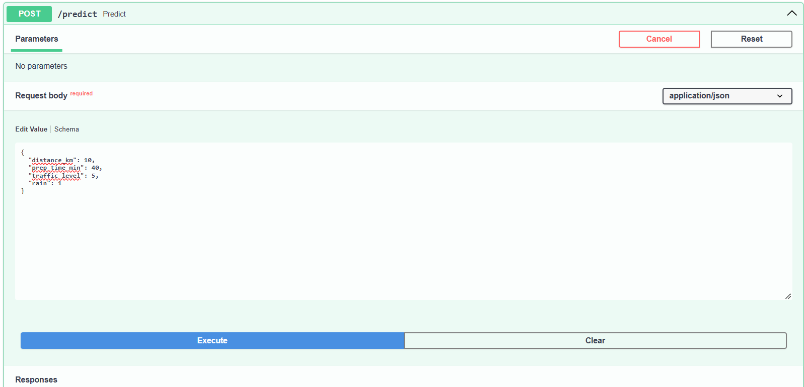
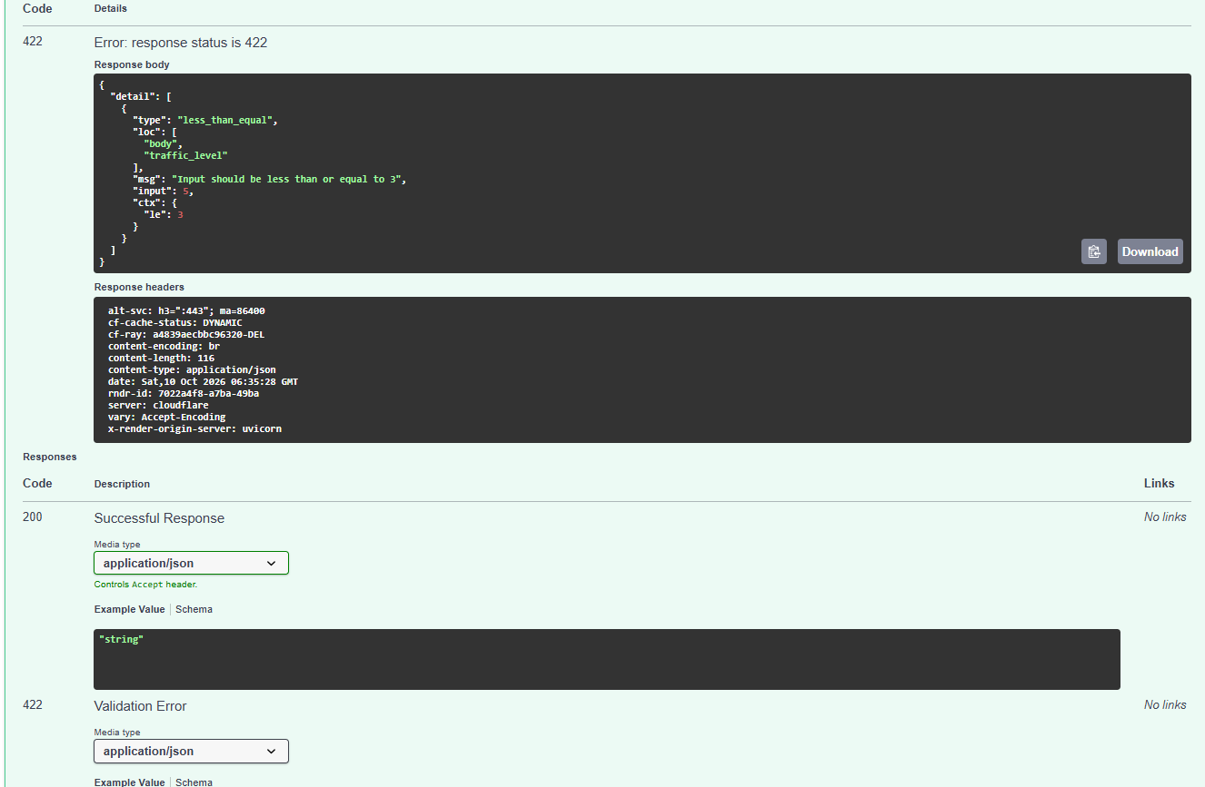

7.Name of the cloud platform deployed on: Render (Render.com)
8.AI use disclosure: ChatGPT was used to assist with understanding the laboratory instructions, interpreting the code and test results, and preparing the submission document. The submitted code and results were reviewed and understood by me, and I can explain and modify the work submitted.

