MLOPS LAB-07
1.LAB DATE:29-09-2026
NAME: SANCHIT KUKREJA
ENROLLMENT NO: S24CSEU0458
BATCH: 42
REPO LINK: https://github.com/Sanchitk99/S24CSEU0458-MLOPS.git
2.
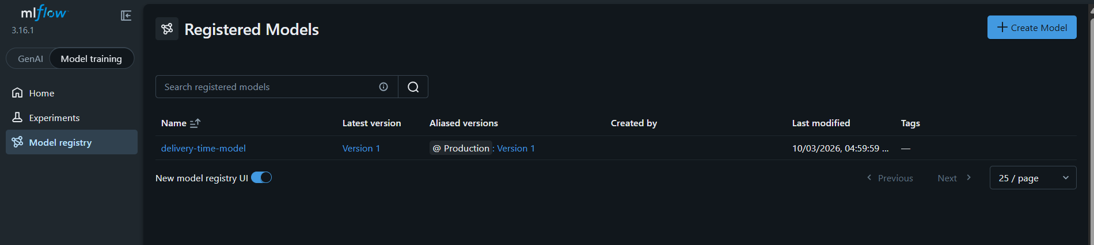
3.
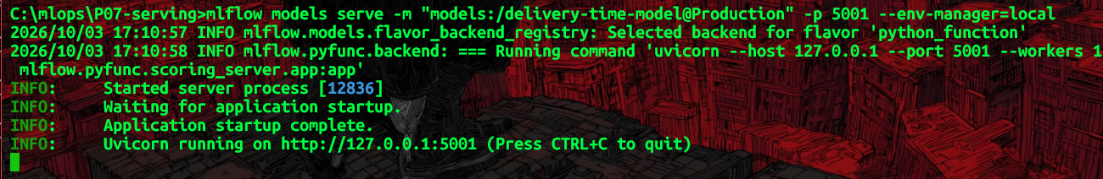
4.
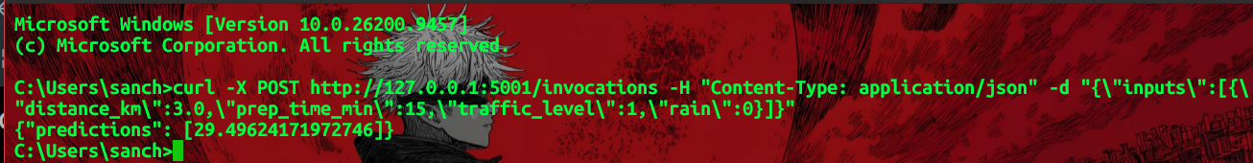

5.
Registered model name: delivery-time-model
Version promoted: 1
Run ID: f35768e281344bd6b936cbe13265ea7b
Serving port: 5001
6.AI use disclosure: ChatGPT was used to assist with understanding the laboratory instructions, interpreting the code and test results, and preparing the submission document. The submitted code and results were reviewed and understood by me, and I can explain and modify the work submitted.

