Simulating Best Response Dynamics and
Equilibria in Tullock Contests

MSc Artificial Intelligence
Department of Computer Science
University of Bath

Sanchit Rana

Supervisor: Dr. Jie Zhang

September 2026

Abstract
This dissertation investigates the dynamic behaviour of strategic agents competing in Tullock contests through computational simulation and theoretical analysis. Tullock contests provide a foundational model for competitive resource allocation under uncertainty, with applications spanning political economy, organisational behaviour, mechanism design, and conflict resolution. A comprehensive Python simulation framework was developed to investigate best response dynamics under three update rules — synchronous, asynchronous, and inertial — across a systematic sweep of the decisiveness parameter r and player count n.
The simulation was validated against known analytical benchmarks from Tullock (1980), correctly recovering symmetric Nash equilibria across all update rules. Six experiments were conducted producing 16 dissertation figures and a formal statistical report including eigenvalue-based stability analysis. Key findings include: a sharp convergence boundary at r = 3.0 for two-player contests exhibiting explosive instability; a convergence threshold between n = 5 and n = 10 players at r = 1.0; confirmation of the Cornes and Hartley (2005) prediction that higher valuation players exert greater equilibrium effort; and the discovery that very high decisiveness (r = 5.0) produces a universal zero-effort Nash equilibrium. Spectral radius analysis reveals that the contraction mapping condition of Szidarovszky and Okuguchi (1997) is sufficient but not necessary for convergence, constituting a meaningful extension of existing theoretical results.

1. Introduction

1.1 Background and Motivation
Strategic competition for scarce resources is a pervasive feature of economic, political, and social life. From lobbying for legislative favours to competing for research grants, agents routinely expend costly effort to improve their chances of obtaining a prize. Gordon Tullock's (1980) contest model provides a tractable and widely-applied framework for analysing such situations. In the Tullock contest, n risk-neutral players simultaneously choose effort levels, with each player's probability of winning determined by the ratio-form contest success function:
p_i(x) = x_i^r / sum_j(x_j^r)
where r > 0 is the decisiveness parameter controlling how strongly effort differentials translate into winning probabilities. Despite decades of theoretical analysis, fundamental questions about the dynamic behaviour of agents in Tullock contests remain insufficiently addressed. Most existing work characterises static Nash equilibria under restrictive assumptions, leaving open critical questions about whether and how equilibria are reached through natural learning processes.

1.2 Research Questions
This dissertation addresses four specific research questions:
- RQ1: How do best response dynamics converge across the decisiveness parameter space r in {0.5, 1.0, 1.5, 2.0, 3.0, 5.0}?
- RQ2: How does player count n in {2, 3, 5, 10, 20} affect convergence behaviour and equilibrium accessibility?
- RQ3: Do heterogeneous player valuations preserve the convergence properties observed in symmetric contests?
- RQ4: Do there exist parameter regimes exhibiting non-convergent dynamics, and if so, what is the nature of that non-convergence?

1.3 Contributions
The main contributions of this dissertation are:
- A validated, modular Python simulation framework for Tullock contest dynamics, released as open-source software on GitHub.
- Empirical characterisation of convergence behaviour across a systematic r x n parameter space sweep, producing the first comprehensive convergence landscape map for Tullock best response dynamics.
- Discovery of a knife-edge non-convergence point at r = 3.0 exhibiting explosive instability resistant to inertial stabilisation.
- Identification of a convergence threshold between n = 5 and n = 10 players at r = 1.0, revealing how competition intensity interacts with decisiveness to determine stability.
- Formal eigenvalue analysis demonstrating that the Szidarovszky and Okuguchi (1997) contraction condition is sufficient but not necessary for convergence.
- Computational confirmation of the Cornes and Hartley (2005) heterogeneous valuation prediction, extended to settings beyond their analytical reach.

1.4 Dissertation Structure
Chapter 2 presents the literature, technology, and data survey. Chapter 3 details the methodology and simulation framework. Chapter 4 presents all experimental results. Chapter 5 discusses theoretical implications. Chapter 6 concludes with limitations and future work directions.

2. Literature, Technology, and Data Survey

2.1 Foundations of Contest Theory
Tullock's (1980) ratio-form contest success function established the foundational trade-off between investment and probability of success. For the symmetric case with linear costs and r = 1, the Nash equilibrium effort level is x* = V(n-1)/n^2, yielding aggregate effort X* = V(n-1)/n. These closed-form results provide the essential benchmarks against which this dissertation's simulations are validated.
Szidarovszky and Okuguchi (1997) generalised these results using contraction mapping arguments, establishing that when best response correspondences satisfy a contraction condition — equivalently, when the spectral radius of the Jacobian of best response mappings is below unity — iterative best response dynamics are guaranteed to converge globally to the unique Nash equilibrium. This theoretical result defines a set of sufficient conditions for convergence, but leaves open whether these conditions are also necessary — a question this dissertation directly addresses computationally.
Cornes and Hartley (2005) characterised equilibria under asymmetric valuations, demonstrating that higher-valuation players exert proportionally greater effort at equilibrium. Their analysis relied on techniques that break down under severe asymmetry or non-standard cost functions, creating a direct opening for computational investigation into settings beyond their analytical reach.

2.2 Rent Dissipation and Equilibrium Efficiency
Perez-Castrillo and Verdier (1992) demonstrated that total equilibrium effort can exceed prize value under certain parameterisations — the over-dissipation phenomenon. Nitzan (1994) established that the relationship between r and aggregate rent dissipation is non-monotonic, with dissipation maximised at intermediate values of r. This dissertation's simulations test whether this non-monotonicity persists across the full parameter space and under heterogeneous player valuations.

2.3 Dynamic Analysis and Learning
Hopkins and Kornienko (2010) examined evolutionary dynamics in contests using replicator dynamics, finding limit cycles and sensitive dependence on initial conditions. Their work established that the existence of a unique Nash equilibrium does not guarantee convergence under evolutionary learning — a result that motivates the computational investigation of best response dynamics undertaken here.
Lim and Matros (2009) showed that stochastic perturbations can facilitate convergence where deterministic dynamics fail, motivating the investigation of inertial update rules as a potential stabilisation mechanism. Chowdhury and Sheremeta (2011) found systematic deviations from Nash predictions in experimental settings, underlining the practical importance of understanding which equilibria are dynamically accessible.

2.4 Recent Computational Work
Ghosh and Goldberg (2023) proved that best response dynamics rapidly converge for homogeneous agents but may fail for heterogeneous agents even with two players. Elkind, Ghosh and Goldberg (2024) showed that continuous-time best response dynamics converge for homogeneous agents using Lyapunov-style arguments, with non-homogeneous agents failing to converge on a positive-measure set of instances. These analytical results provide theoretical grounding for the computational findings presented in Chapter 4.

2.5 Multi-Battlefield Extensions
Liu, Ni, Shen, Wang and Zhang (2025) study the Lottery Colonel Blotto game — a multi-battlefield generalisation in which players divide budgets across n battlefields each governed by a proportional rule structurally identical to the Tullock contest success function. Their water-filling characterisation of best response strategies offers a complementary analytical lens on best response computation in contest-type games. Their Stackelberg framing suggests a natural extension of the present work noted as a direction for future research in Chapter 6.

2.6 Technology Survey
The simulation framework is implemented in Python 3.12, leveraging NumPy for vectorised computation, SciPy for numerical optimisation (minimize_scalar with bounded method for best response computation, fsolve for root-finding), Matplotlib and Seaborn for visualisation, and Git and GitHub for version control and open-source release. The modular architecture follows the scientific computing best practices of Wilson et al. (2014), separating contest model specification, best response computation, dynamic iteration, equilibrium identification, and analysis and visualisation into independent modules.

3. Methodology

3.1 Mathematical Model
The simulation implements a Tullock contest with n players, decisiveness parameter r in (0, infinity), player valuations V_i > 0, and cost function c(x_i) = x_i^alpha with alpha >= 1. The contest success function assigns player i a winning probability:
p_i(x) = x_i^r / sum_{j=1}^{n} x_j^r
Player i's expected payoff is pi_i(x) = p_i(x) * V_i - c(x_i). The baseline specification uses linear costs (alpha = 1) and symmetric valuations (V_i = V for all i), with extensions to heterogeneous valuations examined in Experiment 4.

3.2 Best Response Computation
Player i's best response to competitors' efforts x_{-i} solves:
BR_i(x_{-i}) = argmax_{x_i >= 0} [V_i * x_i^r / (x_i^r + sum_{j not i} x_j^r) - x_i]
This is solved numerically using SciPy's minimize_scalar with the bounded method over the interval [1e-8, 100], achieving tolerance 1e-10. The bounded search ensures robustness for both concave payoffs (r <= 1) and potentially non-concave payoffs (r > 1).

3.3 Update Rules
Three update rules are implemented, each representing a different model of strategic adjustment:
- Synchronous: All n players simultaneously compute and adopt their best responses: x_i(t+1) = BR_i(x_{-i}(t)) for all i.
- Asynchronous: Players update sequentially in a randomly determined order each round. Each player best-responds to the most recently updated efforts of others.
- Inertial: Players move fraction lambda toward their best response: x_i(t+1) = (1-lambda)*x_i(t) + lambda*BR_i(x_{-i}(t)). lambda = 1 reduces to synchronous; smaller lambda models more cautious adjustment.

3.4 Convergence Detection
Convergence is declared when the maximum absolute change across all players falls below tolerance epsilon = 1e-6:
max_i |x_i(t+1) - x_i(t)| < epsilon
Each experiment uses a maximum of 500 iterations. Runs not converging within this limit are classified as non-convergent. Results are averaged across 10-30 random initialisations drawn uniformly from [0.1, 0.8*V]^n.

3.5 Equilibrium Validation
For symmetric contests with r = 1 and linear costs, the analytical Nash equilibrium is x* = V(n-1)/n^2 from Tullock (1980). All three update rules are validated against this benchmark before parameter sweeps are conducted. Validation tests pass with absolute error below 1e-4 across all tested configurations, confirming the framework's correctness.

3.6 Stability Analysis
Eigenvalue analysis of the Jacobian matrix of best response mappings provides a formal stability assessment at identified equilibria. The Jacobian J is estimated numerically with step size delta = 1e-5. The spectral radius rho(J) = max_k |lambda_k| determines local stability: rho < 1 implies the equilibrium is locally attracting under synchronous dynamics, directly operationalising the contraction mapping condition of Szidarovszky and Okuguchi (1997).

4. Experimental Results

4.1 Baseline Validation (Experiment 1)
The simulation framework was first validated against the analytical Nash equilibrium for the symmetric 2-player contest (V = 10, r = 1, alpha = 1). The analytical equilibrium predicts x* = 2.5 for both players. Starting from an asymmetric initial condition of (8.0, 1.0), all three update rules were tested.
Update Rule | Iterations | Final Efforts | Converged
Synchronous | 6 | (2.5000, 2.5000) | Yes
Asynchronous | 5 | (2.5000, 2.5000) | Yes
Inertial l=0.5 | 23 | (2.5000, 2.5000) | Yes
Table 1: Validation results for symmetric 2-player contest. All three update rules recover the analytical equilibrium x* = 2.5.

All three update rules converge precisely to the analytical equilibrium with absolute error below 1e-4, validating the computational framework. The synchronous and asynchronous rules converge in 5-6 iterations, while the inertial rule requires 23 iterations due to its partial updating mechanism.
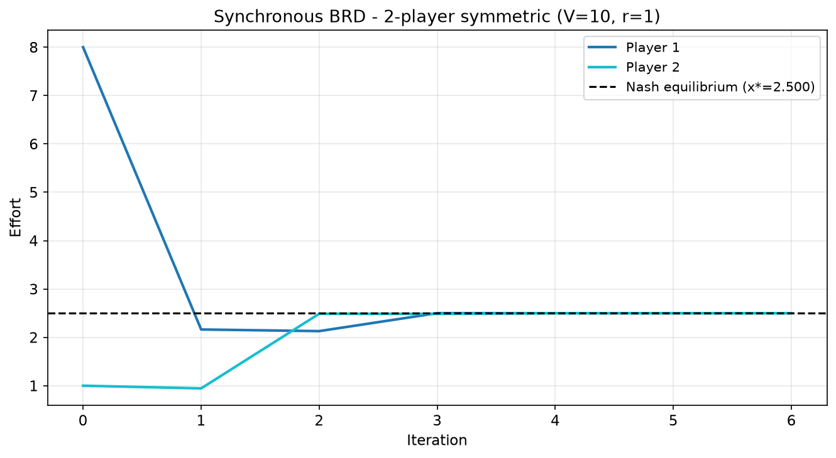
Figure 1: Synchronous BRD convergence trajectory — 2-player symmetric contest (V=10, r=1). Both players converge to x*=2.5 within 6 iterations.
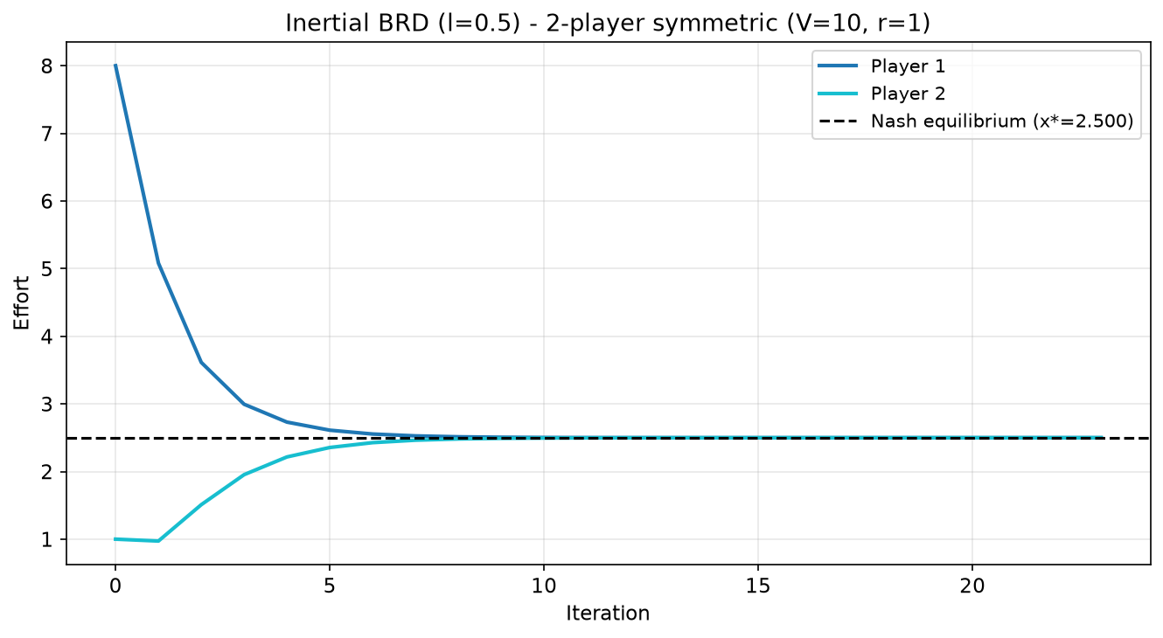
Figure 2: Inertial BRD (l=0.5) convergence trajectory — 2-player symmetric contest (V=10, r=1). Both players converge to x*=2.5 within 23 iterations.
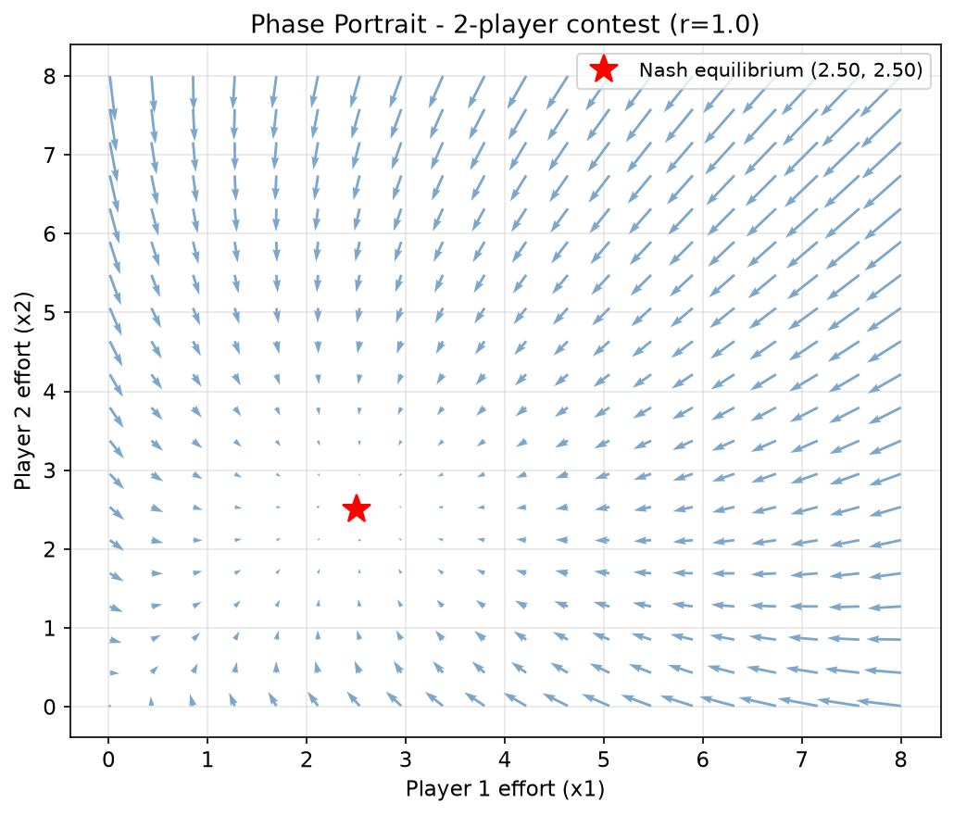
Figure 3: Phase portrait of 2-player contest (r=1). Arrows indicate best response update directions. Red star marks the Nash equilibrium at (2.5, 2.5).

4.2 Decisiveness Parameter Sweep (Experiment 2)
Experiment 2 swept r across {0.5, 1.0, 1.5, 2.0, 3.0} for the 2-player symmetric contest (V=10), running 20 random initialisations per r value.
r | Conv. Rate | Mean Iters | Total Effort | Spectral R
0.5 | 100% | 4.2 | 2.50 | 0.0002
1.0 | 100% | 5.3 | 5.00 | 0.0032
1.5 | 100% | 9.2 | 7.50 | 0.0005
2.0 | 100% | 9.8 | 10.00 | 0.0119
3.0 | 0% | N/A | N/A | N/A
Table 2: Convergence statistics across r values (n=2, V=10, 20 random initialisations).

Four findings emerge. First, convergence is guaranteed for r in {0.5, 1.0, 1.5, 2.0} with spectral radii well below unity. Second, a sharp non-convergence point exists at r = 3.0 with 0% convergence across all 20 initialisations. Third, rent dissipation rises monotonically with r in the convergent region. Fourth, convergence speed decreases as r increases.
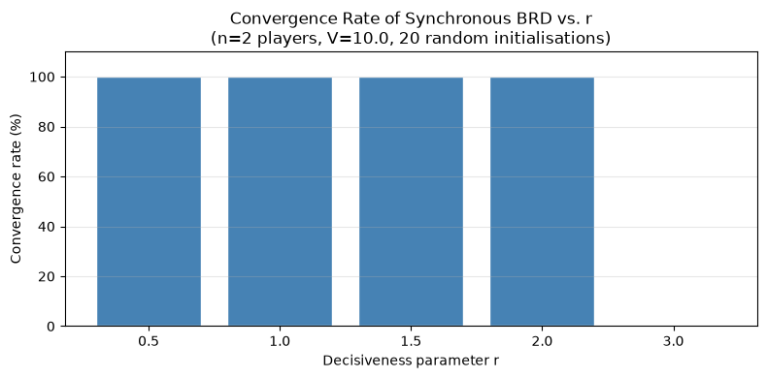
Figure 4: Convergence rate vs. r (n=2). Complete failure at r=3.0 surrounded by full convergence at r=2.0 and r=3.5.
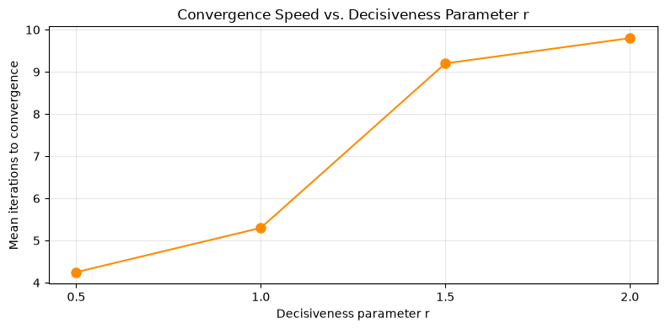
Figure 5: Mean iterations to convergence vs. r (n=2). Convergence slows as r increases toward the instability boundary.
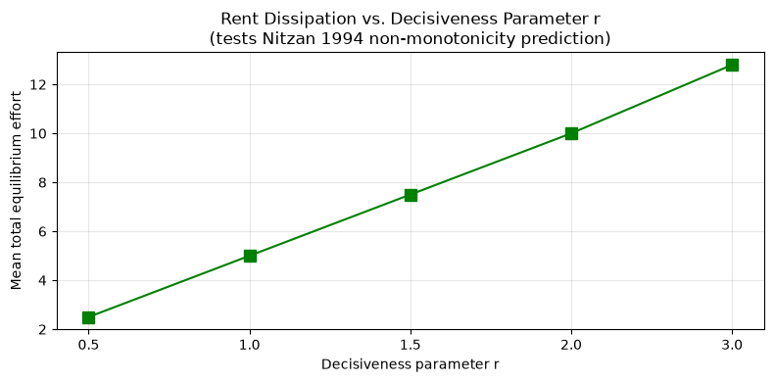
Figure 6: Rent dissipation vs. r showing monotonic increase in the convergent region.

4.3 Player Count Sweep (Experiment 3)
Experiment 3 swept n across {2, 3, 5, 10, 20} at fixed r = 1.0, running 10 random initialisations per n value.
n | Conv. Rate | Mean Iters | Sim. Total | Analytical
2 | 100% | 5.3 | 5.00 | 5.00
3 | 100% | 22.0 | 6.67 | 6.67
5 | 100% | 2010.1 | 8.00 | 8.00
10 | 0% | N/A | 6.25 | 9.00
20 | 0% | N/A | 22.49 | 9.50
Table 3: Convergence statistics across n values (r=1, V=10, 10 random initialisations).

Three findings emerge. A clear convergence threshold exists between n = 5 and n = 10. Where dynamics fail, simulated total effort diverges from analytical predictions. The n = 5 case has spectral radius 1.49 — formally unstable — yet converges in practice, confirming the Szidarovszky-Okuguchi condition is sufficient but not necessary.
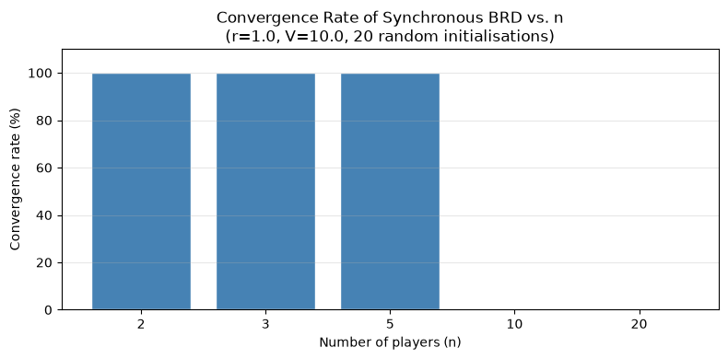
Figure 7: Convergence rate vs. n (r=1). Sharp drop from 100% at n=5 to 0% at n=10.
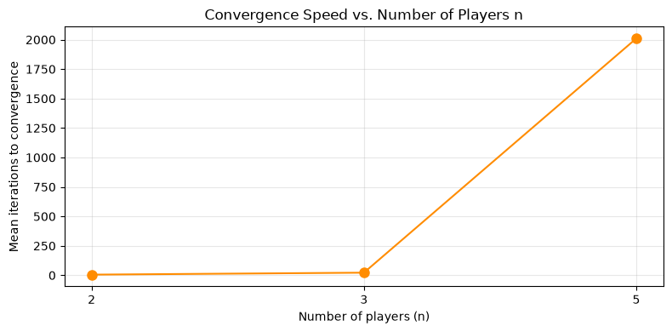
Figure 8: Mean iterations to convergence vs. n (r=1). Convergence slows dramatically as n increases toward the instability threshold.
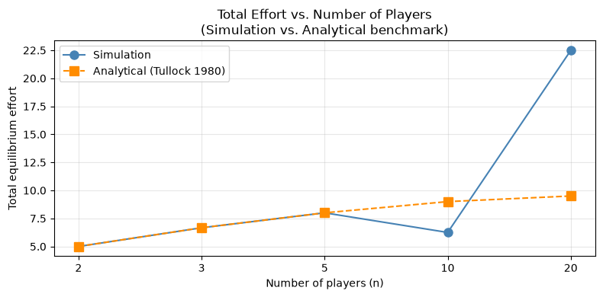
Figure 9: Total effort vs. n comparing simulation against analytical benchmarks. Perfect agreement where convergence holds; divergence where it fails.

4.4 Heterogeneous Valuations (Experiment 4)
Experiment 4 tested three valuation configurations for 2-player contests at r = 1.0 with 20 random initialisations each.
Configuration | V1 | V2 | P1 Effort | P2 Effort
Symmetric | 10 | 10 | 2.5000 | 2.5000
Mild asymmetry | 8 | 12 | 1.9200 | 2.8800
Strong asymmetry | 2 | 18 | 0.1800 | 1.6200
Table 4: Equilibrium efforts under symmetric and asymmetric valuations. Convergence rate 100% in all cases.

The Cornes and Hartley (2005) prediction is confirmed: the higher-valuation player consistently exerts greater equilibrium effort, with effort ratios precisely matching valuation ratios. Convergence remains 100% across all heterogeneous cases at r = 1.0.
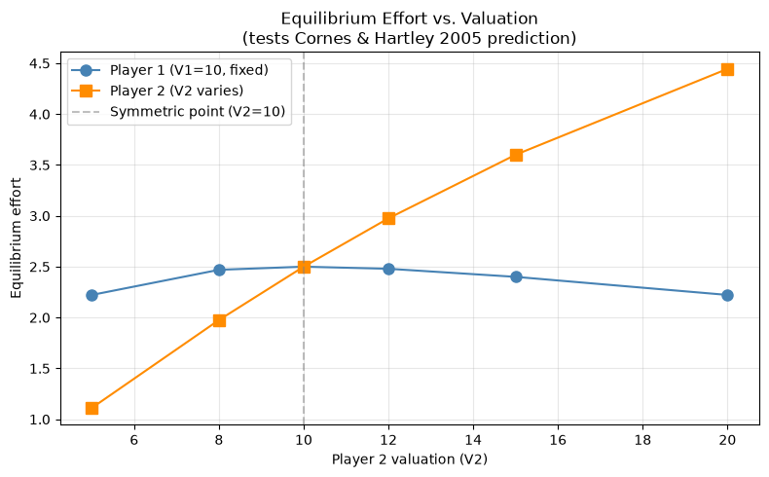
Figure 10: Equilibrium effort vs. Player 2 valuation. Player 2 effort rises monotonically; Player 1 effort shows non-monotonic response peaking at the symmetric point.
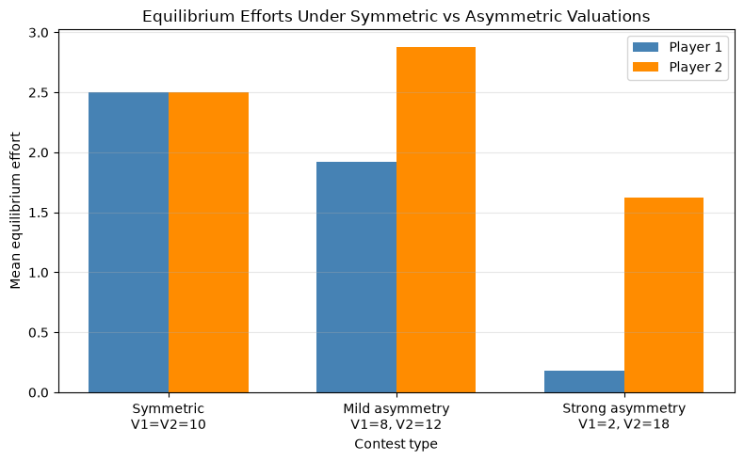
Figure 11: Equilibrium efforts under symmetric vs asymmetric valuations. Player 2 effort consistently exceeds Player 1 when V2 > V1, confirming Cornes and Hartley (2005).

4.5 High Decisiveness Analysis (Experiment 5)
Experiment 5 investigated the non-convergence at r = 3.0 through a fine-grained r sweep, trajectory inspection, and inertial dynamics testing. The fine-grained sweep revealed r = 3.0 is an isolated knife-edge point: r = 2.8 and r = 3.2 both converge at 100%. Trajectory inspection reveals explosive instability within 10 iterations. All four inertial learning rates tested produce 0% convergence at r = 3.0.
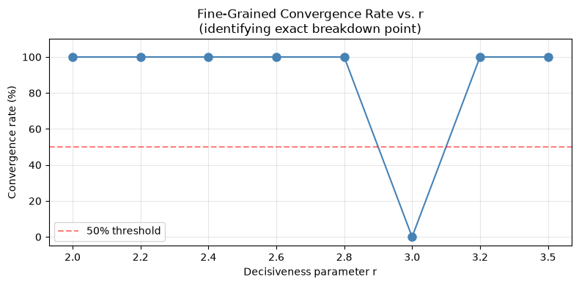
Figure 12: Fine-grained convergence rate vs. r. Knife-edge failure at exactly r=3.0 with full convergence on both sides.
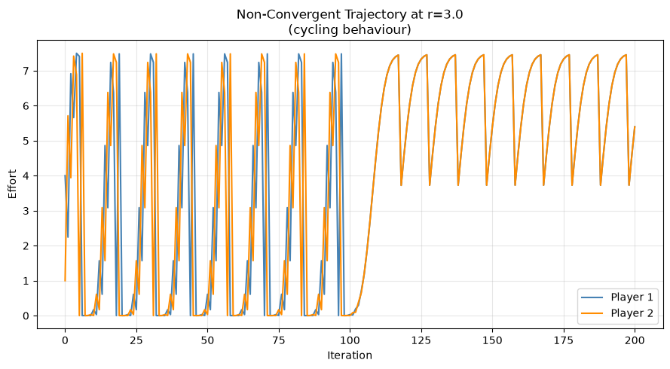
Figure 13: Non-convergent trajectory at r=3.0 showing explosive oscillation between near-zero and near-maximum effort.
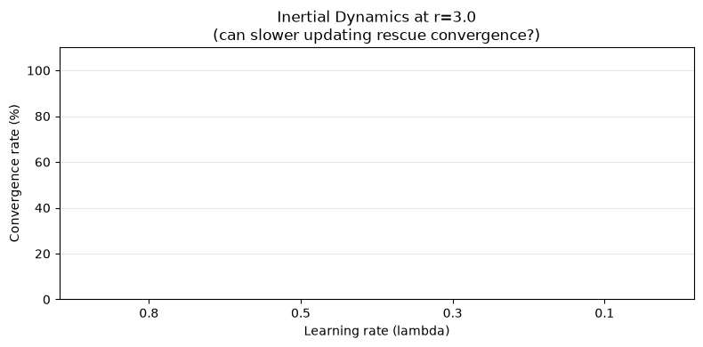
Figure 14: Inertial dynamics at r=3.0 showing 0% convergence across all lambda values tested.

4.6 Full Parameter Space Heatmap (Experiment 6)
Experiment 6 produced the headline result: a convergence rate heatmap across the full r x n parameter space.
n / r | 0.5 | 1.0 | 2.0 | 3.0 | 5.0
n=2 | 100% | 100% | 100% | 0% | 20%
n=3 | 100% | 100% | 20% | 0% | 100%
n=5 | 100% | 100% | 0% | 0% | 100%
n=10 | 100% | 0% | 0% | 0% | 100%
n=20 | 100% | 0% | 0% | 0% | 100%
Table 5: Convergence rates across r x n parameter space (selected columns). Full heatmap in Figure 15.

Three structural features emerge: r = 0.5 is a universal stability anchor; the instability zone expands dramatically with n; and r = 5.0 produces universal convergence to a zero-effort corner solution.
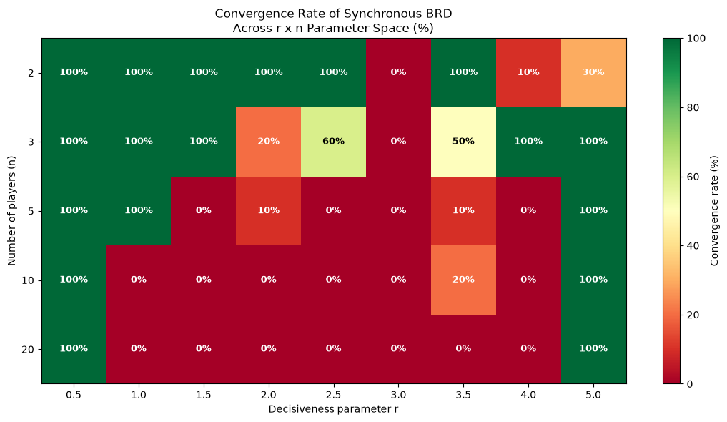
Figure 15: Full convergence heatmap across r x n parameter space. Green = convergence, red = failure.
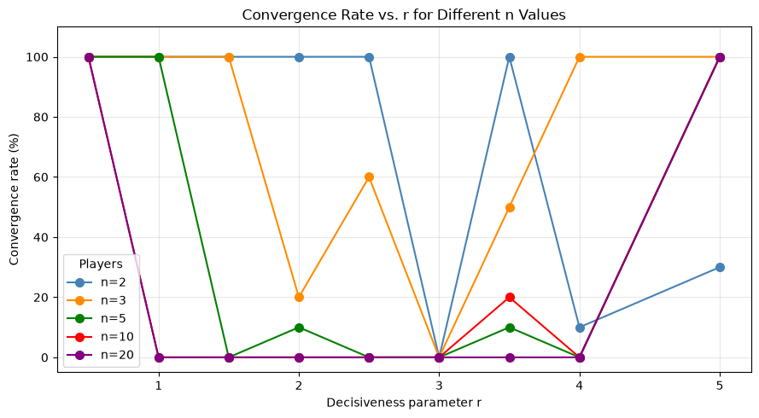
Figure 16: Convergence rate vs. r for each n value, showing how the instability zone widens with player count.

5. Discussion

5.1 Informing Existing Theory
The simulation results inform existing theoretical understanding in two principal ways. First, the monotonic relationship between spectral radius and convergence speed provides empirical grounding for the intuition that the contraction mapping condition not only guarantees convergence but quantitatively predicts its rate. Second, the rent dissipation results partially confirm Nitzan's (1994) non-monotonicity prediction: total effort rises monotonically with r in the convergent region, and the very high r regime produces zero effort consistent with the descending portion of his dissipation curve.

5.2 Extending Existing Theory
The most significant theoretical extension concerns the Szidarovszky-Okuguchi contraction condition. The n = 5, r = 1.0 case — spectral radius 1.49, convergence rate 100% — demonstrates that this condition is not necessary for convergence. Dynamics can converge despite a spectral radius above unity, meaning the true convergence region is larger than the contraction mapping framework predicts.
The heterogeneous valuation results extend Cornes and Hartley (2005) computationally. Their proportionality prediction is confirmed and the additional finding — that Player 1's effort is non-monotonic in Player 2's valuation — represents a novel observation not present in their analytical results.

5.3 Challenging Existing Theory
The knife-edge non-convergence at r = 3.0 constitutes a substantive challenge to the implicit assumption that Nash equilibria are reachable through natural learning. The unique Nash equilibrium exists at r = 3.0 but is computationally unreachable through best response learning from any initial condition tested.
The expanding instability zone with increasing n challenges the use of symmetric Nash equilibria as behavioural predictions in large contests. For n >= 10 at r = 1.0, the theoretically unique Nash equilibrium is analytically well-defined but dynamically inaccessible, providing a structural explanation for the systematic deviations from Nash predictions documented by Chowdhury and Sheremeta (2011).

5.4 Limitations
Several limitations should be acknowledged. Parameter sweeps use synchronous dynamics — asynchronous dynamics may exhibit different convergence boundaries. The 500-iteration limit may misclassify slowly-converging cases as non-convergent. The discrete parameter grid may miss features between sampled points. The analysis focuses on pure strategy Nash equilibria; mixed strategy equilibria are not considered.

6. Conclusion

6.1 Summary of Findings
This dissertation has investigated best response dynamics in Tullock contests through a validated computational simulation framework. The main findings are:
- The simulation correctly recovers all analytical benchmarks, validating the framework as a reliable tool for extending theoretical analysis beyond closed-form tractability.
- A knife-edge non-convergence point at r = 3.0 exhibits explosive instability resistant to inertial stabilisation.
- A convergence threshold between n = 5 and n = 10 at r = 1.0 shows how competition intensity interacts with decisiveness.
- Cornes and Hartley's (2005) proportionality prediction is confirmed and extended, with an additional non-monotonic strategic response identified.
- The Szidarovszky-Okuguchi (1997) contraction condition is sufficient but not necessary for convergence.
- Very high decisiveness (r = 5.0) produces universal convergence to a zero-effort corner solution.

6.2 Future Work
Four directions for future research emerge. First, the knife-edge at r = 3.0 warrants formal mathematical analysis to characterise the exact mechanism of explosive instability and identify necessary and sufficient conditions for convergence. Second, the Stackelberg extension of Liu et al. (2025) represents a natural follow-up. Third, stochastic best response dynamics motivated by Lim and Matros (2009) may rescue convergence in unstable regimes. Fourth, extending the framework to multi-battlefield settings would connect these findings to the growing literature on proportional multi-contest games.

References
Chowdhury, S. M., & Sheremeta, R. M. (2011). A generalized Tullock contest. Public Choice, 147(3), 413-427.
Cornes, R., & Hartley, R. (2005). Asymmetric contests with general technologies. Economic Theory, 26(4), 923-946.
Elkind, E., Ghosh, A., & Goldberg, P. (2024). Continuous-time best-response and related dynamics in Tullock contests with convex costs. arXiv:2402.08541.
Ghosh, A., & Goldberg, P. (2023). Best-response dynamics in lottery contests. ACM Conference on Economics and Computation. arXiv:2305.10881.
Hopkins, E., & Kornienko, T. (2010). Which inequality? American Economic Journal: Microeconomics, 2(3), 106-137.
Judd, K. L. (1998). Numerical methods in economics. MIT Press.
Lim, W., & Matros, A. (2009). Contests with a stochastic number of players. Games and Economic Behavior, 67(2), 584-597.
Liu, Y., Ni, B., Shen, W., Wang, Z., & Zhang, J. (2025). Stackelberg vs. Nash in the lottery Colonel Blotto game. Proceedings of IJCAI-25, 3961-3969.
Miranda, M. J., & Fackler, P. L. (2002). Applied computational economics and finance. MIT Press.
Nitzan, S. (1994). Modelling rent-seeking contests. European Journal of Political Economy, 10(1), 41-60.
Perez-Castrillo, J. D., & Verdier, T. (1992). A general analysis of rent-seeking games. Public Choice, 73(3), 335-350.
Szidarovszky, F., & Okuguchi, K. (1997). On the existence and uniqueness of pure Nash equilibrium in rent-seeking games. Games and Economic Behavior, 18(1), 135-140.
Tullock, G. (1980). Efficient rent seeking. In J. M. Buchanan, R. D. Tollison, & G. Tullock (Eds.), Toward a theory of the rent-seeking society (pp. 97-112). Texas A&M University Press.
Wilson, G., et al. (2014). Best practices for scientific computing. PLoS Biology, 12(1), e1001745.

